The processing of shape-motion associations in inferior temporal cortex

Diana Burk
B.S. Biomedical Engineering, Neuroscience. University of Virginia 2011
M.Phil. Physiology, Development, and Neuroscience. University of Cambridge 2013

A thesis dissertation submitted in partial fulfillment of the requirements for
the degree of Doctor of Philosophy
in the department of Neuroscience at Brown University

Providence, Rhode Island
February 2021

© Copyright 2020 by Diana Burk

This dissertation by Diana Burk is accepted in its present form
by the Department of Neuroscience as satisfying the dissertation requirements
for the degree of Doctor of Philosophy

Date: | David Sheinberg, PhD., Advisor  Department of Neuroscience,  Brown University
Recommended to the Graduate Council
Date:  Date: _______________ | Theresa Desrochers, PhD., Reader  Department of Neuroscience, Brown University  _______________________________________
Thomas Serre, PhD., Reader, Committee Chair
Department of Cognitive, Linguistic, Psychological Sciences, Brown University
Date:
 | Wilson Truccolo, PhD., Reader
 | Department of Neuroscience, Brown University
Date:
Rufin Vogels PhD., External reader
Department of Neurosciences, KU Leuven

Approved by the Graduate Council
Date:
Andrew G. Campbell, PhD.,
Dean of Graduate School, Brown University

Curriculum Vitae
Diana C. Burk
diana_burk@brown.edu
Brown University Department of Neuroscience
185 Meeting Street Box G-LN
Providence, RI 02912

Education_____________________________________________________________

2014-present Ph.D. Neuroscience
Brown University, Providence, RI, USA

09/2016 Advanced Computational Neuroscience Course (aCNS)
Bernstein Center for Computational Neuroscience

08/2015 Methods in Computational Neuroscience (MCN)
Marine Biological Laboratory (MBL)

2013 M.Phil Physiology, Development & Neuroscience
University of Cambridge, Trinity College (UK)
HHMI- Janelia Farm Graduate Program

2011 B.S. Biomedical Engineering (summa cum laude) GPA: 3.878
Neuroscience (Distinguished Major Program, Highest Distinction)
University of Virginia

08/2006-06/2007 Biomedical Engineering GPA: 3.917
Northwestern University

Research Experience____________________________________________________

2014- present Doctoral Candidate
Sheinberg Lab, Department of Neuroscience, Brown University
Neurobiological mechanisms of movement-shape associations during object recognition in humans and non-human primates. Advisor: Dr. David Sheinberg

2013 – 2014 Predoctoral IRTA
NIH National Institute on Drug Abuse, Baltimore, MD
Designing of a new method for targeting molecularly-defined neuronal populations in the mouse brain to study goal-directed behavior
Advisor: Dr. Yeka Aponte

2011 – 2013 HHMI/University of Cambridge Graduate Student
Wolpert Lab, University of Cambridge
The effect of motor effort on a perceptual decision-making task.
Hantman Lab, Janelia Research Campus
The role of the pontine nuclei in a reaching and grasping task in rodents
Advisors: Dr. Daniel Wolpert, Dr. Adam Hantman

2009 – 2011 Research Assistant
Bertram Lab, Department of Neuroscience, University of Virginia
Development of a novel catheter design for targeted drug delivery to treat chronic epilepsy
Assessment of Na+ channel expression and neural degeneration in epileptic rats.
Advisor: Dr. Edward Bertram

Summer 2009 Summer Research Assistant
Taylor Lab, Max-Planck Institute of Immunobiology & Epigenetics
Establishing a novel mouse model for early grade glioblastoma.
Advisor: Dr. Verdon Taylor

2008 Research Assistant
Walker Lab, Department of Biomedical Engineering, University of Virginia
Development of a technique for assessment of whole blood coagulation using ultrasound
Advisor: Dr. William Walker

Summer 2007 Physical Scientist
Ligler Lab, U.S. Naval Research Laboratory
Development of a conductance-based biosensor for flow-cytometry
Advisor: Dr. Frances Ligler

Recent Grants & Academic Honors_________________________________________

08/2019 Best Poster, Neuroscience Graduate Program Retreat ($300)
05/2019 Hyundai Incubation Grant ($50,000 for lab)
11/2018 Hyundai Visionary Challenge ($5,625 personal grant)
02/2016 Elected to Sigma Xi Honor Society
04/2015 National Defense Science & Engineering Graduate Fellowship
01/2015 NSF Temporal Dynamics of Learning Center Small Grant ($2500)
01/2014 Hertz Foundation Fellowship Finalist

Publications___________________________________________________________

Desrochers, TM, Burk, DC, Badre, D, Sheinberg, DL. (2015). The monitoring and control of task sequences in human and non-human primates. Frontiers in Systems Neuroscience, 9(185). doi:10.3389/fnsys2015.00185.

Burk, D., Ingram, I., Franklin, D., Shadlen, M., Wolpert, D. (2014). Motor effort alters changes of mind in sensorimotor decision making. PLoS One, 9(3), e92681. doi:10.1371/journal.pone.0092681

Nasir, M., Ateya, D., Burk, D., Golden, J., Ligler, F. (2010). Hydrodynamic focusing of conducting fluids for conductivity based biosensors. Biosensors and Bioelectronics, 25(6), 1363-1369.

Selected Posters_______________________________________________________

Burk, D., Sheinberg, DL. Movement improves shape discrimination under visual uncertainty. Society for Neuroscience: 11/2018

Burk, D., Sheinberg, DL. How does associating movements with objects affect recognition? Society for Neuroscience: 11/2016

Burk, D., Sheinberg, DL. How does associating movements with objects affect recognition? Gordon Research Conference (Neurobiology of Cognition): 07/2016

Burk, D. (Advised by: Jonathan Pillow, Haim Sompolinsky, Ila Fiete). Estimating causal interactions in hippocampal place-cell sequences with transfer entropy and generalized linear models. Woods Hole MBL, Brown NSGP Retreat in Bristol, RI: 09/2015

Burk, D., Lugert, S., Taylor, V. A novel and clinically relevant mouse glioma model derived from PDGF-ß over expression. Southeast Biomedical Engineering Career Conference (SEBECC), Washington, D.C. 10/2009

Selected Talks_________________________________________________________

Diana Burk (Supervisor: Dr. David Sheinberg). How do shape-motion associations affect neural responses in inferior temporal cortex? Brown “Unconference” on Computational Intelligence & Applications (Virtual): 06/2020

Diana Burk (Supervisor: Dr. David Sheinberg). Can we consider movement as an object feature? EPSCoR Attention Consortium Meeting, Dartmouth College: 07/2017

Diana Burk (Supervisor: Dr. David Sheinberg). How does associating movements with objects affect recognition? Gordon Research Seminar (Neurobiology of Cognition): 07/2016

Diana Burk (Supervisor: Dr. Yeka Aponte). Noninvasive activation of neurons by radio-frequency heating. 06/2014. Fellows Research Talk. NIH National Institute on Drug Abuse

Diana Burk (Supervisor: Dr. Daniel Wolpert). The effect of motor effort on decision-making. Trinity Biologists Seminar 06/2012; HHMI Janelia Symposium 09/2012; Johns Hopkins University 08/2013

Recent Teaching, Mentoring, and Leadership________________________________

06/2020 Q & A Panel for Brown undergraduates (Brown CI&A Conference)
07/2019-present Mentor for undergraduate student in Sheinberg lab
09/2016-09/2017 BGRIPS Mentoring Fellow (Brown University)
01/2015-05/2016 Experimental Neurobiology (NEUR1600) Teaching Assistant (Brown University)
03/2016 Brown University Brain Fair
11/2015-01/2016 Mentor for high school biology student in poster fair (Lincoln School, RI)
02/2015-06/2015 Algebra in Motion: Hope High School In-Class Physics Tutor (Providence, RI)
09/2014-09/2018 Ronald McDonald House of Providence Athlete, Volunteer (Providence, RI)

Conference Attendance_________________________________________________

06/2020 Brown Unconference on Computational Intelligence & Applications (Virtual)
07/2019 EPSCoR Attention Consortium Women’s Conference Bozeman, MT
11/2018 Society for Neuroscience San Diego,CA
07/2018 EPSCoR Attention Consortium Meeting Providence,RI
07/2017 EPSCoR Attention Consortium Meeting Hanover, NH
11/2016 Society for Neuroscience San Diego,CA
07/2016 Gordon Research Conference: Neurobiology of Cognition Newry, ME
11/2015 Perceptual Expertise Network Meeting (TDLC) New Orleans
09/2015 Young Scholars Conference at Brown University Providence,RI
11/2014 Society for Neuroscience D.C.
04/2012 Society for the Neural Control of Movement Venice, Italy
10/2011 The Neural Basis of Motor Control HHMI Janelia
09/2011 Champaulimaud Neuroscience Symposium Portugal
10/2009 Southeast Biomedical Engineering Career Conference D.C

Acknowledgements

Preface

Table of Contents

Curriculum Vitae
Acknowledgements
Preface
Table of Contents
List of Tables
List of Illustrations
Chapter 1: General introduction: visual feature processing, binding, & association 1
1.1 Brief introduction & proposal 2
1.2 Visual shape processing 2
1.2.1 Early visual areas 3
1.2.2 Shape processing in the temporal lobe and inferior temporal cortex 3
1.2.3 Prefrontal cortex during shape discrimination 3
1.2.4 Role of multiple visual cues 3
1.2.5 Shape processing under visual uncertainty 3
1.3 Static visual feature binding 2
1.3.1 Visual binding theory 3
1.3.2 Perception or decision? Binding or integration? 3
1.4 Associative learning in vision 2
1.4.1 Effects of associative experience on perception 3
1.4.2 Associative learning in the temporal lobe 3
1.4.3 Temporal expectation in inferior temporal cortex 3
1.5 Dorsal & ventral streams in object vision 2
1.5.1 Two streams hypothesis 3
1.5.2 Evidence for crosstalk between the two streams 3
1.6 Movement perception 2
1.6.1 What is a motion trajectory? Role of eye movements 3
1.6.2 Movement perception during development 3
1.6.3 Motion sensitivity along the visual pathway 3
1.6.4 Perception of motion trajectories & related psychophysics 3
1.6.5 Perception of physical motion 3
1.6.6 Motion-form associations 3
1.6.7 Motion during object recognition 3
1.7 Biological motion perception 2
1.7.1 Perception of motion with degraded form 3
1.7.2 Perception of animacy 3
1.7.3 Computational models of movement recognition 3
1.8 Specific aims 2
1.9 Project significance 2
Chapter 2: Demonstrating use of shape-motion associations in non-human primates 4
2.1 Introduction 5
2.2 Materials & methods 5

2.2.1 Animal subjects & preparation 6

2.2.2 Eye signal 6

2.2.3 Stimulus presentation & behavioral control 6

2.2.4 Behavioral paradigm & visual stimuli 6

2.2.4 Data analysis 6
2.3 Behavioral results 5
2.4 Discussion 5
2.5 Appendix: 5

2.5.1 Probing behavioral strategy in monkey 1 6
Chapter 3: Coding of shape-motion associations in inferior temporal cortex 4
3.1 Introduction 5
3.2 Materials & methods 5

3.2.1 Animal subjects & preparation 6

3.2.2 Neural data acquisition 6

3.2.3 Eye signal 6

3.2.4 Stimulus presentation & behavioral control 6

3.2.5 Behavioral paradigm & daily recording strategy 6

3.2.6 Neural data analysis 6
3.3 Passive viewing 5
3.4 Active task 5
3.5 Discussion 5
3.6 Appendix 5

3.6.1 Post-hoc receptive field construction from passive viewing 6

3.6.2 Effects of subtle changes in eye position during passive viewing 6

3.6.3 Temporal expectation in passive viewing 6

Chapter 4: Motion-shape associative learning in human psychophysics 4
4.1 Introduction 5
4.2 Materials & methods 5
4.3 Experiment 1: Real objects in salt & pepper noise with translational motion 5

4.3.1 Specific methods 6

4.3.2 Results 6

4.3.3 Discussion 6
4.4 Experiment 2: Associative learning between color & shape, motion & shape 5

4.4.1 Specific methods 6

4.4.2 Results 6
4.4.3 Discussion 6
4.5 Experiment 3: The effect of learned associations on feature extraction 5

4.5.1 Specific methods 6

4.5.2 Results 6
4.5.3 Discussion 6
4.6 Discussion 5
4.7 Appendix 5

4.7.1 Preliminary data from a motion-shape visual search paradigm 6
Chapter 5: Responses in early visual areas during motion-shape associative learning 4
5.1 Introduction 5
5.2 Materials & methods 5

5.2.1 Animal subjects & preparation 6

5.2.2 Neural data acquisition 6

5.2.3 Eye signal 6

5.2.4 Stimulus presentation & behavioral control 6

5.2.5 Behavioral paradigms & daily recordings 6

5.2.6 Data analysis 6
5.3 Neural responses during passive viewing tasks (GM array) 5
5.4 Behavior & neural responses during active tasks 5

5.4.1 Match-to-sample tasks: salt & pepper noise, motion matching 6

5.4.2 Motion-shape association priming task 6

5.4.3 Motion-shape conjunction selection task 6

5.4.4 Modeling behavior in the conjunction selection task 6
5.5 Discussion
Chapter 6: Discussion 4
6.1 Conclusions 5
6.2 Future directions 5
6.3 Final remarks 5
Chapter 7: Appendix 4
7.1 General surgical procedures 5
7.2 Placeholder 5
References 4

List of Tables
Table 2–1. Placeholder 5
Table 2–2. Placeholder 5
Table 2–2. Placeholder 5
Table 2–2. Placeholder 5
Table 2–2. Placeholder 5
Table 2–2. Placeholder 5
Table 2–2. Placeholder 5
Table 2–2. Placeholder 5
Table 2–2. Placeholder 5
Table 2–2. Placeholder 5
Table 2–2. Placeholder 5

List of Illustrations
Figure 1–1. Placeholder 5
Figure 1–1. Placeholder 5
Figure 1–1. Placeholder 5
Figure 1–1. Placeholder 5
Figure 1–1. Placeholder 5
Figure 1–1. Placeholder 5
Figure 1–1. Placeholder 5
Figure 1–1. Placeholder 5
Figure 1–1. Placeholder 5
Figure 1–1. Placeholder 5
Figure 1–1. Placeholder 5
Figure 1–1. Placeholder 5

Chapter 1: General introduction: visual feature processing, binding and association
1.1 Brief introduction & proposal
INTRODUCE VISUAL PATHWAYS HERE TOO, MENTION MORE DETAIL LATER IN D/V DISTINCTIONS

Big picture: how are pieces combined in the visual system?
What we “know” about the bisual system
Ungerleider & Mishkin dogma
Figure
Big questions: (1) Are visual features “bound”? (2) Is motion an object feature?

1.2 Visual shape processing
As one moves along the visual pathway, neurons exhibit selectivity for more complex features (Gallant, Braun, & Van Essen, 1993; Rust & Dicarlo, 2010). In V1, neurons are sensitive to very basic object features, including orientation, size, luminance, and contrast (Hubel & Wiesel, 1968; Schiller, Finlay, & Volman, 1976). Further along the dorsal visual pathway, V4 neurons are selective for simple combinations of these features, such as textures, curvature, and color (although the basis of their selectivity is still not well understood) (Touryan & Mazer, 2015). Likewise, the nature of selectivity of neurons in inferotemporal cortex (IT) is still not understood (Zhivago & Arun, 2016), but it is well known that IT neurons respond to high order features (H. Op de Beeck, Wagemans, & Vogels, 2001; Tamura & Tanaka, 2001), that this area is implicated in representing categorical information (Kriegeskorte et al., 2008; Logothetis & Sheinberg, 1996; Ritchie, Tovar, & Carlson, 2015) and that some object categories are represented topographically (Grill-Spector, 2003; Janssens, Zhu, Popivanov, & Vanduffel, 2014; H. P. Op de Beeck, Deutsch, Vanduffel, Kanwisher, & DiCarlo, 2008; Srihasam, Vincent, & Livingstone, 2014). It has been possible to design an evolutionary stimulus algorithm to identify 3D features that elicit maximal firing in IT neurons (Yamane, Carlson, Bowman, Wang, & Connor, 2008), and extract some computational relationships between features, but the semantic, real-world relationships between features that drive IT neurons remain ambiguous. These findings, in addition to studies involving associative learning, suggest that IT could be a major site for the integration of disparate visual features, including movement and form.

1.2.1 Early visual areas
1.2.2 Shape processing in the temporal lobe and inferior temporal cortex
1.2.3 Role of multiple visual cues
1.2.4 Prefrontal cortex during shape discrimination
Dog/cat study pfc & IT comparisons
Role of feedback from pfc to temporal lobe
1.2.5 Shape processing under visual uncertainty
Fill-in
Role of feedback processing
Blur (V4)

1.3 Static visual feature binding
1.3.1 Visual binding theory
The brain is constantly challenged with complex visual input, and thus seeks mechanisms to reduce the complexity and parse relevant pieces of information for interpretation. One mechanism to reduce complexity is grouping pieces of information together, which is often termed “binding” by cognitive scientists. Binding is a core element of visual recognition and memory, but how and why binding occurs remains an active area of research (Whitney, 2009; Wyatte et al., 2012; Zhang et al., 2016). Add citations

INTRO FEATURE INTEGRATION THEORY Parts and properties of objects can be grouped in many ways, which have been categorized into at least seven types: property binding, part binding, range binding, hierarchical binding, conditional binding, temporal binding and location binding (Treisman, 1996). Each of these definitions of binding simply categorizes the types of information being linked together. Pieces might include the properties of the object (e.g. shape, size, contrast), features of the object (e.g. texture, contours, edges), its structure in time (e.g. global motion, gestures, articulation), or relationship with context and background. EXPAND, more detail, follow up work, more citations alternative theories to FIT?

HIGH-LEVEL FEATURE BINDING OVERVIEW It remains unknown what the underlying neural mechanisms are for binding, and remains an open question whether mechanisms differ based on the features being combined. However, it has been suggested that the combination of visual features might occur through communication between regions selective for those features, as schematized in Figure 1. With regards to binding of visual and non-visual features, where different pieces of information can have different sites of primary processing (e.g. the sound an object makes being processed in auditory cortex versus its size being processed in the visual stream), that the neural mechanism of binding will likely differ (Perrodin et al., 2015; J. X. Wong et al., 2013). However, pieces of “bound” information might elicit similar behavioral outcomes to access remaining features, such as faster reaction times or improved recognition performance (Biederman & Cooper, 1991; Giard & Peronnet, 1999; Groh-Bordin et al., 2005). Moreover, evidence exists for general binding mechanisms that might be evident in different cortical areas (Gray, 1999; Opitz, 2010).
There is evidence that supports two basic mechanisms for binding at the single cell level and population level. One neural signature of binding could be the existence of “conjunction detectors” or “grandmother cells,” that fire in response to two or more simultaneous inputs, and could serve as a single-cell basis for feature association (Larkum, 2013). Other arguments have been made for “dynamic binding” through precise synchrony between neurons (Engel & Singer, 2001; Hummel, 2001). Alternatively, binding might exist at the population level through oscillations between areas representing different pieces of information. In such a framework, neurons in each area could participate in multiple sub-networks and create different local patterns for recognizing different stimulus features. The neurons might switch between networks depending on the stimulus that is driving activity and become phase-locked with activity in distant areas only under certain conditions, which would be another method of detecting previously encountered stimuli (Singer & Gray, 1995; Y. T. Wong et al., 2016).
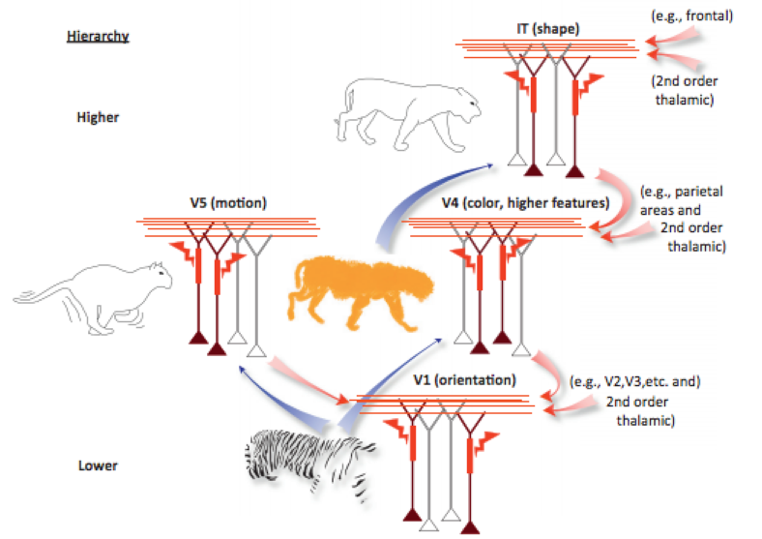
Figure 1. Possible mechanism for feature binding across the visual hierarchy (Larkum, 2013)

Figure 1. Possible mechanism for feature binding across the visual hierarchy (Larkum, 2013)

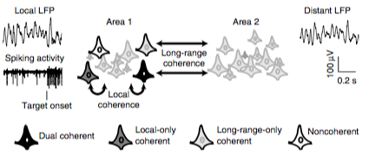
Figure 25. Schematic of possible ways two regions can exhibit local and distant coherence (Wong et al., 2016)

Figure 25. Schematic of possible ways two regions can exhibit local and distant coherence (Wong et al., 2016)

Add more about binding in different visual areas/ set up big picture options for mechanisms at conclusion.
It is important to note that the creation of an association is different than retrieval, however both likely involve top-down and bottom-up mechanisms (Staresina & Davachi, 2006). One study demonstrated that in an object-place working memory task, more salient stimuli were easier for subjects to remember (Fine & Minnery, 2009). Another study demonstrated how local binding between color and dot motion can affect what is perceived in the periphery (Wu et al., 2004). This is one example of how the binding of features can be affected by context and expectation.
Clearly many open questions about feature binding remain. One difficulty lies in making clear distinctions between object categorization, representation, and retrieval of associations that lead to object percepts (Kourtzi & Connor, 2011; Palmeri & Gauthier, 2004). The second difficulty lies in demonstrating whether things are truly “bound” or merely integrated. The next section will discuss how this issue is not mere semantics, rather it highlights the difference between a shift in perception and a shift in judgment, which are known to be primarily managed by separate brain areas.
1.3.2 Perception or decision? Binding or integration?
Auditory study perception v decision

1.4 Associative learning in vision
The neural basis of visual associative learning has been studied from perspectives of both memory and perception. Associative learning is a process that is distributed throughout multiple neural areas (Figure 2). The medial temporal lobe (MTL), which has bidirectional connectivity with inferior temporal cortex (IT) (Webster et al., 1991), is involved in the association between object pairs (Murray et al., 1993; Squire & Zola Morgan 1991). Another visual association study demonstrated that in a cued go/no-go task, activity in neurons in the primate perirhinal cortex was strongly correlated with both predictor and choice stimuli (Erickson & Desimone, 1999). Thus, there is integration between memory-related areas and the visual system, but there is also evidence that at least some forms of long term experience do directly affect representations stored within IT.
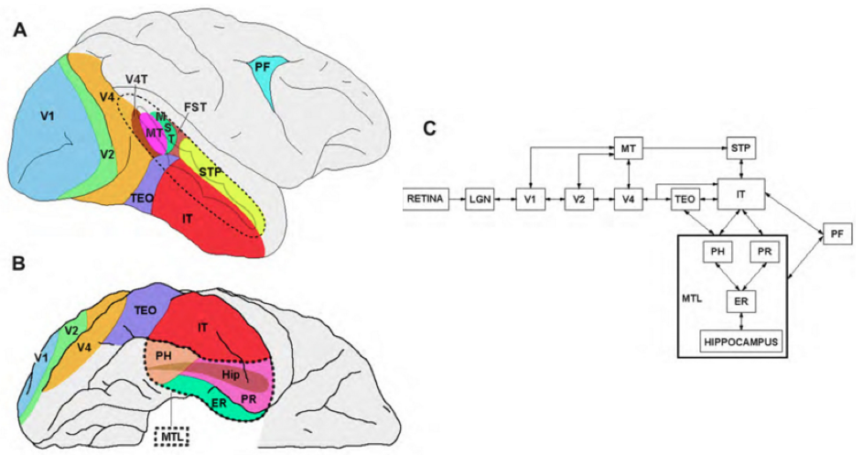
Figure 2. Areas involved in visual associative learning in the non-human primate brain. (A) Lateral view demonstrating select areas involved in visual perception (V1, V2, V4, MT, MST, FST, TEO, IT). (B) Ventral view demonstrating areas IT, MTL and memory-related areas (C) Schematic of connectivity in the visual pathway showing bidirectional projections between many areas. From (Albright, 2012)

Figure 2. Areas involved in visual associative learning in the non-human primate brain. (A) Lateral view demonstrating select areas involved in visual perception (V1, V2, V4, MT, MST, FST, TEO, IT). (B) Ventral view demonstrating areas IT, MTL and memory-related areas (C) Schematic of connectivity in the visual pathway showing bidirectional projections between many areas. From (Albright, 2012)

1.4.1 Effects of associative experience on perception
The binding or association of features can have dramatic effects on perception of previously encountered and new stimuli. From a Bayesian perspective (i.e. integrating the prior probability of a encountering a stimulus with the likelihood to extract the probability of seeing such a stimulus given current sensory evidence), learned associations can guide perception and action by providing improved statistics about the environment (Kersten, Mamassian, & Yuille, 2004). This framework is useful for understanding how previous exposure might contribute to a perceptual experience and the building of an association, as well as the retrieval of an association. Here we present a few examples of how the development of associations and perceptual biases (both short and long-term) pervade perceptual experience across contexts and modalities.
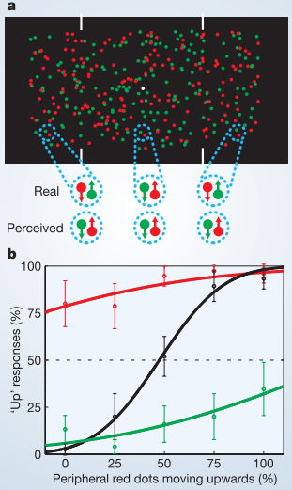
Figure XX. How local binding can affect peripheral expectation. (Wu et al., 2004).

Figure XX. How local binding can affect peripheral expectation. (Wu et al., 2004).

There has been extensive research in the effects of experience on perception with regards to color. In an early theory on binding between colors and objects, Hering (1878) asserted that “memory colors” form through repeated experience with an object that is of a particular color. The main argument was that an observer learns about the typical colors of certain objects and that this could be a tool to probe how tightly color is bound to the object on which it appears, and how the shape of a particular visual stimulus might affect the color perception it elicited. Since then, some studies have focused on the effects of associations between real-world objects and their colors on perception (Hurlbert & Ling, 2005; Siple & Springer, 1983). An example study is Bartleson (1960), in which subjects were first shown an object, and were then asked to recall the object color and match is using Munsell color chips. Subjects were more accurate in recalling colors of objects that were presented in their natural colors (e.g. red brick) than in unnatural matches (e.g. blue brick), and chose more saturated versions of the colors. This study demonstrated the effect of previously made associations on a perceptual task. Other studies have demonstrated how an association established within a task between two features such as shape and color, could extend beyond training to new targets (Gozli, Moskowitz, & Pratt, 2014; Parra, Della Sala, Logie, & Morcom, 2014; Reeves, Fuller, & Fine, 2005; Saiki, 2016). In summary, once a stable association is made between color and form, activating one of these features can affect perception of the other feature.
Another interesting area of research involves the effects of experiencing visualization of stimuli on perception. Visualization of imagery has shown to improve performance on match to sample tasks with target stimuli that match the imagined stimuli (Farah, 1985; Ishai & Sagi, 1997). A similar study with visualization of motion demonstrated that imagined motion can modify the perception of a moving stimulus (Mast, Berthoz, & Kosslyn, 2001). These findings suggest there is interplay between cognitive experience immediately before a visual experience and the perception of visual stimuli.
Associative learning can also guide perceptual experience through second-order associations between features and cues. In a seminal study exemplifying this, classical conditioning was used to drive subjects to perceive a particular direction of motion. Subjects were shown a perceptually bistable rotating Necker cube, and on training trials, depth cues were added to force the perception of rotation direction. In addition, a perceptually irrelevant cue dependent on motion direction was added. On testing trials, the Necker cube was shown without depth cues and only the direction-dependent cue, and subjects showed a strong bias along the motion direction associated with each direction cue, but were unaware of the cues and their meaning (Haijiang, Saunders, Stone, & Backus, 2006).
These findings demonstrate that learned associations can exert dramatic effects on perceptual experience, even without awareness of the associations. Strong associations can be built during tasks; likewise, expectations can be undermined with new experiences. In summary, what we see is not necessarily the image that is projected onto the retina; we see what we want to see and have seen before.

1.4.2 Associative learning in the temporal lobe
MORE GENERAL INTRO. MORE STUDIES ON ASSOCIATIVE LEARNING
Here we will highlight two key studies that demonstrate the potential for IT to play a role in visual associative learning. In a seminal study, Miyashita and colleagues (1991) trained monkeys in a pair-association task using computer generated patterns. They found two types of task-related neurons in anterior temporal cortex: one type responded selectively to each picture within a pair (pair-association, See Figure 4) and another type that responded strongly to one picture as a cue and exhibited increasing activity during the delay period when the associated picture was used as a cue (pair-recall) (Sakai & Miyashita, 1991; Sakai, Naya, & Miyashita, 1994). This study was one of the first to demonstrate visual associative learning at the single unit level in area IT.
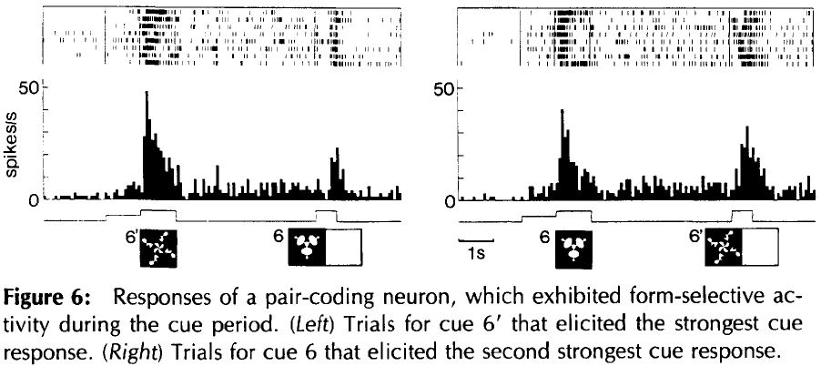
Figure 4. Responses of a pair-coding neuron that exhibited form-selective activity during the cue period of a delayed matching association task. 6 and 6’ were paired stimuli during the task. The neuron responded to both stimuli after the association had been learned (Sakai et al., 1994)

Figure 4. Responses of a pair-coding neuron that exhibited form-selective activity during the cue period of a delayed matching association task. 6 and 6’ were paired stimuli during the task. The neuron responded to both stimuli after the association had been learned (Sakai et al., 1994)

In a subsequent study, Albright and colleagues (Messinger, Squire, Zola, & Albright, 2001) investigated the effect of stimulus associations on TE neurons. They found that the neurons elicited more similar responses to paired stimuli as the monkeys learned the associations. Critically, they found that a stimulus that was previously ineffective at driving a TE neuron could drive the neuron after the association with an effective stimulus had been learned. Thus, these neurons might also be candidates for movement-form pairing if the visual pattern for an object first drives firing, and then over time, coincident movement begins to drive activity upon association with the effective object.
Furthermore, many studies have explored the effects experience on single units and population activity in IT, and have found significant shifts in neural responses to familiarity and the development of perceptual expertise. While this remains an active area of research, previous findings support the capacity for IT neurons to code for experience and associations. For example, IT responses were found to decline as novel stimuli became more familiar in a delayed match-to-sample task (Grill-Spector, Henson, & Martin, 2006; Li, Miller, & Desimone, 1993). Likewise, temporal expectation (Anderson & Sheinberg, 2008) and contextual familiarity (R. E. Mruczek & Sheinberg, 2007b) can increase the sensitivity of IT neurons to visual stimuli. These findings on familiarity and expectation coding in IT, along with the knowledge that IT neurons can exhibit invariance to changes in size, position and luminance (Sáry, Vogels, & Orban, 1993), suggest that IT has the capacity to code for high-level associations between objects and likely plays a critical role in visual memory formation.

1.4.3 Temporal expectation in inferior temporal cortex
Carl Olsen pair stuff (Meyer & Olson 2011)
Longer sequence and deviant stuff

responses in area IT can increase even before the onset of a preferred shape of a neuron, if the stimulus is behaviorally relevant and expected (Chelazzi et al., 1998). Memory guided visual saerch

1.5 Dorsal/ventral streams in object vision
1.5.1 Two-streams hypothesis
The two-streams theory asserts that “what” and “where” information is primarily processed in two parallel pathways (Ungerleider & Haxby, 1994). As previously mentioned, there is extensive evidence for integration of the information carried along these pathways for building and retrieving associations between object features and contexts. In addition to these behavioral findings, there is growing neurophysiological evidence for integration occurring along these pathways, prior to reaching the frontal areas typically implicated in classification and multimodal integration. For example, task constraints and context has been shown to guide information flow differently (Markus Siegel, Buschman, & Miller, 2015), which suggests that information processing is perhaps more flexible than two isolated pathways suggests. Furthermore, there exist multiple anatomical links between dorsal and ventral pathways (Figure 6) and along these paths, neurons exhibit sensitivity to features processed by both “what” and “where” pathways.
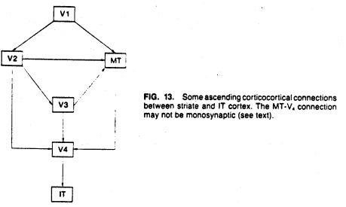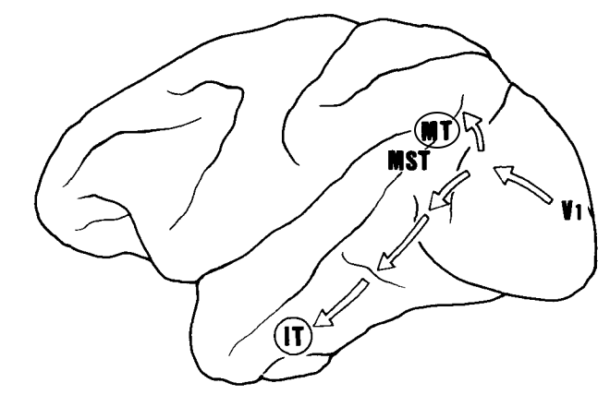
Figure 6. Select afferent corticocortical connections between striate and IT cortex. (A) From (Gross et al., 1984) (B) from (Cornilleau-Pérès & Gielen, 1996)

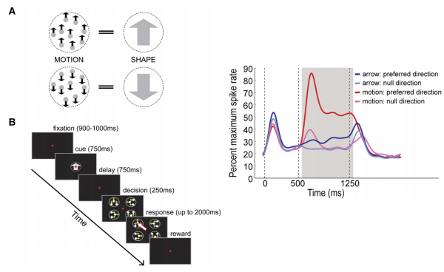
Figure 232. Association of random dot motion stimuli with static arrows drives increased firing rates in MT neurons to static arrows after learning. Modified from Schlack and Albright (2007)
1.5.2 Evidence for crosstalk between the two streams
Research has shown that features primarily processed by each pathway can also drive specific responses in the “other” pathway. For example, there is known shape selectivity in the dorsal stream (Lehky & Sereno, 2007; Schlack & Albright, 2007; Sigurdardottir, Michalak, & Sheinberg, 2014), and motion sensitivity in the ventral stream (Caclin et al., 2012; Grossman, Jardine, & Pyles, 2010).
Overtraining on shape-motion associations has been shown to induce changes in MT responses. Schlack and Albright (2007) made an interesting observation that by associating random dot motion (RDM) stimuli with static arrows (Figure 232, left). In the experiment, they trained animals to associate the two stimuli and tested the proportion of MT neurons that responded to the static arrows before and after training. After training on the association task, animals were required to fixate while a static arrow or static RDM stimulus was shown for 500ms (Figure 20, right). On every trial, after 500ms, the motion was applied to the RDM, or the static arrow remained on the screen. They found an increased proportion of MT neurons (4% before training, 19% after training) had an increased firing rate in response to the static arrow in the preferred direction of motion. Interestingly, the increased firing rate they saw in MT neurons in response to the static arrow only occurred after the 500ms delay.

Furthermore, the superior temporal sulcus (STS), which is anatomically situated between the two pathways and has bidirectional connectivity with them, is well known as a site of integration for shape and motion cues, particularly biological motion (Jastorff et al., 2012; Puce & Perrett, 2003). Thus while the exact neural mechanism for learning associations between objects and movement patterns remains elusive, it is highly unlikely that the information is not integrated in early extrastriate areas.
Original dogma Ungerleider
Greatly expand this section, many Other studies showing cross talk

1.6 Visual processing of moving stimuli
1.6.1 What is a motion trajectory? Role of eye movements
1.6.2 Movement perception during development
A major question in visual perception is not only how information is bound together to form an object representation, but also which properties are used. Research with infants has investigated these questions by measuring the time infants at various stages of development spend looking at objects under certain conditions. These studies not only provide insight into when certain properties of objects can be used by the brain to form object representations, but also give a surfeit of examples of using small amounts of eye movement data to form meaningful conclusions about neural processing. Furthermore, many of these studies rely on using the infants’ expectations, either natural ones or ones built within the task, to drive differences in looking times.
Sensitivity to the movement of objects develops early; infants as young as 2-months of age can recognize 3D structure in random dot motion stimuli (Arterberry & Yonas, 1988). Infants can use motion information to form object categories. In one study, this was demonstrated by displaying objects with rigid motion patterns, followed by objects with non-rigid motion patterns. The objects with non-rigid motion patterns violated infants expectancy and resulted in longer viewing times (Gibson, Owsley, & Johnston, 1978). It also appears that integration of an object’s identity and its location occurs in the developing visual system. One study that directly investigated this integration in infants demonstrated that 9 mo- infants could use form information to identify two objects and could follow their movement trajectories behind occluders (Kaldy & Leslie, 2003). These studies suggest that the use of movement information for categorization requires very little experience or development of expertise.
Likewise, infants are capable of recognizing animate and inanimate motion. Animacy has been a major focus of many studies investigating how movement information is used by the infant brain to individuate and identify objects. In Träuble et al., (2014), animate and inanimate movements (spatiotemporally changing or constant linear trajectories, respectively) were paired with animate (dog) and inanimate (truck) objects. The infants were first shown the two stimuli statically, then each stimulus separately with a mask while it moved. After the movement ended, the stimulus was revealed to be one of the two static stimuli. The infants looked longer at the incongruent pairs (e.g. dog + inanimate movement, truck + animate movement) than the congruent pairs (e.g. dog + animate movement). This suggests that an expectation for how objects moved is formed early in development, and might be independent of significant experience.
BALL/CUBE BABY STUDY
While it is difficult to determine which features of vision come from the innate structure of the visual system and experience, research suggests that the use of motion information for object categorization is a combination of both. With our project, we will take advantage of the capability of the visual system to build associations between features through experience, but when analyzing the neural data, will continuously keep in mind the innate ability of the visual system to create associations and natural divisions between object categories based on movement information.

1.6.3 Motion sensitivity along the visual pathway
Both the middle temporal (MT) and middle superior temporal (MST) areas have been well studied in the context of visual motion. Not only are both dorsal regions accessible for recordings, but multiple neurophysiological studies have demonstrated a strong link between perceptual abilities during motion discrimination tasks and activity in MT and MST neurons ( for a thorough review of MT: Born & Bradley, 2005; Britten, Newsome, Shadlen, Celebrini, & Movshon; Britten, Shadlen, Newsome, & Movshon, 1992; Celebrini & Newsome, 1994; Liu & Newsome, 2005; Palmer, Marre, Berry, & Bialek, 2015; Treue & Maunsell, 1996).
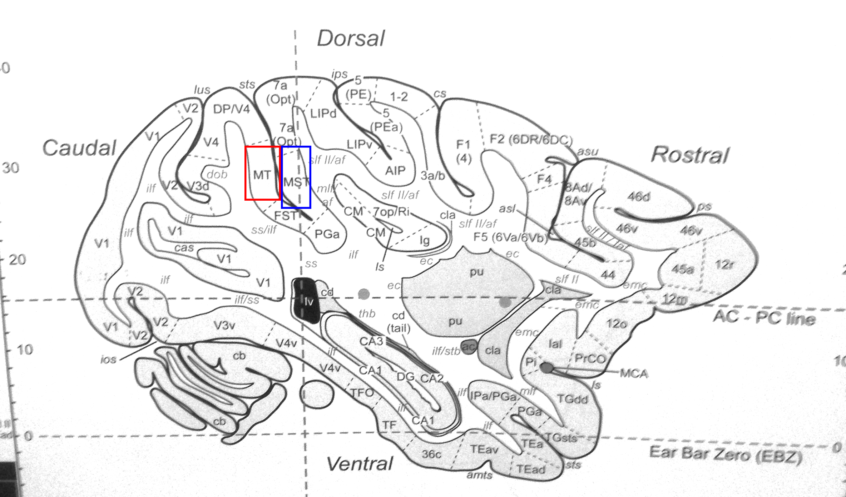
Figure 5. Locations of areas MT and MST. Sagittal view about 15mm from the midline. Reproduced from Atlas of the Rhesus Monkey Brain (Saleem & Logothetis, 2012)

Figure 5. Locations of areas MT and MST. Sagittal view about 15mm from the midline. Reproduced from Atlas of the Rhesus Monkey Brain (Saleem & Logothetis, 2012)

Area MT is one of the most extensively studied areas in the visual pathway. It is well positioned anatomically to receive and transmit information about motion to various areas in the brain. Area MT receives inputs from earlier visual areas (V1,V2, V3) and projects extensively to areas along the superior temporal sulcus (STS), various parietal areas (LIP,VIP), frontal areas (FEF, SEF), and extracortical areas (Felleman & Van Essen, 1991; Maunsell & Van Essen, 1983). Another anatomical feature of MT is the columnar organization; similarly tuned neurons form cortical columns (T D Albright, Desimone, & Gross, 1984). The neurons in MT are direction sensitive and selective; they respond robustly to motion in a particular direction. Anti-preferred directions of movement can also suppress MT neuron responses; this can also lead to complex interactions between neurons with overlapping spatial selective fields and opposite direction selectivity (T D Albright, 1984; Britten, Shadlen, Newsome, & Movshon, 1993; Perge, Borghuis, Bours, Lankheet, & van Wezel, 2005). In addition to motion direction selectivity, MT neurons are also speed selective. They exhibit differential sensitivity above and below about 10º V.A./s (T D Albright, 1984; Lagae, Raiguel, & Orban, 1993; Maunsell & Van Essen, 1983) and adaptation to persistent motion (Price & Born, 2013). Additionally, as the eccentricity of the spatial receptive field increases, the neuron’s preferred speed tends to increase (Maunsell & Van Essen, 1983). As a result of these interactions, many studies have investigated the responsiveness of single units in MT to various combinations of speed, direction and spatial parameters.
The responses of MT neurons to motion parameters have been very thoroughly studied, and these experiments provide an important basis for understanding motion sensitivity in the brain. MT neurons tend to have larger receptive fields than earlier visual areas, and a general rule is their size is about 0.8*eccentricity (Maunsell & Van Essen, 1983). The shortest latency of responses to visual stimuli is about 35ms and the median latency is about 90ms (Heuer & Britten, 2002; Raiguel, Xiao, Marcar, & Orban, 1999). Prolonged exposure to motion in the preferred direction can sharpen directional tuning curves (Kohn & Movshon, 2004) and some neurons show gradual development of a response to more complex motion patterns, such as moving plaids (consisting of two superimposed sinewave-gratings with different orientations) (Pack, Berezovskii, & Born, 2001; Smith, Majaj, & Movshon, 2005). Furthermore, microstimulation studies in MT have shown that MT neurons are directly related to motion perception and decision confidence in a motion discrimination task (Ditterich, Mazurek, & Shadlen, 2003; Fetsch, Kiani, Newsome, & Shadlen, 2014; Salzman, Murasugi, Britten, & Newsome, 1992). These findings suggest that MT neurons have the capacity to quickly respond to moving stimuli and to perform at the minimum, basic spatial and temporal integration.
Despite the extensive research in MT neuron responses to simple moving stimuli, the relationships between speed, eccentricity, direction and firing rates do not appear to be independent. MT neurons can be affected by stimuli outside their classically defined receptive fields (Allman et al., 1985), and others can exhibit center-surround properties (R T Born & Tootell, 1992). There is evidence for heterogeneity in MT neurons, as speed and direction selectivity appear to be separable in some but not all neurons (Smolyanskaya, Ruff, & Born, 2013). Furthermore, some MT neurons do respond to motion patterns, such as plaids (Jazayeri, Wallisch, & Movshon, 2012), but increased temporal and spatial separation in patterned motion can lead to decreased MT firing rates and selectivity (Kumbhani, El-Shamayleh, & Movshon, 2015; Perrone, 2012). Thus, while MT neurons appear to somewhat perform integration across basic motion parameters, area MT might not have the capacity for temporal integration to code for motion patterns. Current research suggests that more neurons in MST are pattern selective and might integrate over longer time scales (Khawaja, Liu, & Pack, 2013).
Area MST is located across a sulcus from MT (Figure 5) and receives direct input from MT neurons. MST neurons show direction selectivity similar to MT neurons, but have larger receptive fields and appear to integrate across MT inputs (Saito et al., 1986). MST neurons also respond to more complex patterns of motion, such as rotation (Sakata et al., 1994), spiral motions (Graziano, Andersen, & Snowden, 1994), other optic flow stimuli (Duffy & Wurtz, 1991; Orban et al., 1992), and the speed of the stimuli (Duffy & Wurtz, 1997). Dorsal and ventral MST neurons have been shown to have differential selectivity; ventral MST neurons appear to prefer movements of a background behind a small object (Sugita & Tanaka, 1991) while dorsal MST neurons appear to prefer movement signals related to self-movement (Tanaka, Sugita, Moriya, & Saito, 1993). Some dorsal MST neurons appear to be invariant for changes in the position of complex motion patterns, unlike MT neurons (Lagae, Maes, Raiguel, Xiao, & Orban, 1994). Similar to the findings in MT, microstimulation in MST has also shown to have significant effects on performance in a motion discrimination task (Celebrini & Newsome, 1995).
In summary, MT and MST are both sensitive to visual motion, but their respective roles in coding for motion trajectories remains ambiguous. MST neurons appear to have the capacity for more coding more complex motion patterns and trajectories, but as MT neurons are forming an earlier representation of the same information, we should not discredit their role in the process. Thus, a comparison of MT and MST responses to moving objects will be invaluable to understanding how the brain processes motion trajectories.
1.6.4 Perception of motion trajectories and relevant psychophysics
Movement perception has been widely explored with human psychophysics tasks, and we have made significant strides in understanding both cognition and vision through behavioral tasks that involve simple, degraded stimuli such as random dot motion, moving lines and gratings. However, we rarely encounter stimuli with such reduced or consistent dimensionality. With our project, we aim to build on findings that use degraded stimuli make a step forward towards real-world stimuli. Thus, we will review some key findings from the psychophysics literature regarding movement perception that we are considering when designing our experiments.
First we will focus on what might make trajectories difficult to learn. Research has shown that the perception of movement involves prediction (Badler & Heinen, 2006; den Ouden, Kok, & de Lange, 2012; Jogan & Stocker, 2015; Wexler & Klam, 2001), as subjects use temporal statistics of visual movement to anticipate upcoming reactions to moving stimuli. Trajectory estimation can be achieved with covert attention to moving objects, but without directed attention to the general location, tracking is more difficult (Baurès, Bennett, & Causer, 2015). This suggests that spatial attention could play a role in trajectory learning, if trajectories are learned through repeated exposures and reinforced estimations. Another feature affecting trajectory estimation is the relationship between true speed and object features. For example, one study demonstrated that perceived angular velocity (rotational speed) depends on the shape of the object, and the rotation speed is affected by the edges of an object. The larger the object, the faster it is perceived to rotate, despite the true speed being the same (Blair, Goold, Killebrew, & Caplovitz, 2014), which shows an important interaction between object features and perceived movement. Furthermore, the number of changes (e.g. direction, speed) in a trajectory can affect the ability for subjects to track the movement of an object along a trajectory (Ericson & Beck, 2013) and can lead to ambiguity between trajectories if they share the same number of changes, independent of the type of change (Wickelgren & Bingham, 2008). These findings all suggest that when considering tracking of a moving object, object features, trajectory features, and an interaction between these could affect tracking ability and trajectory estimation.
Context can also play a role in the perception of a visual stimulus. A recent study investigated the relationship between the object features, the background, and perception of motion of the two objects with streaming and bouncing movement patterns. Researchers found that subjects could disambiguate between objects easier as the object feature differences increased and contrast between objects and their surrounds increased. The experiment suggests that the relationship between an object and the background it is moving on can affect movement perception (Caplovitz, Shapiro, & Stroud, 2011). A more recent study used a dynamic version of the Ebbinghaus illusion to demonstrate that motion of the inducers surrounding the target elicited uncertainty about the size of the center target. (Mruczek, Blair, Strother, & Caplovitz, 2015). Together, these studies demonstrate that the perception of a visual stimulus is not independent of the context in which it is presented, and suggest that more research will be required to disambiguate the effect of complex backgrounds, like those we experience in our natural environment, on moving object perception.
Transition cut off, add more here
Psychophysics from Tse/ Sebastian and refer to Chapter 4

1.6.5 Perception of physical motion
Another interesting area of movement psychophysics is the role of natural laws of motion on perception. Research suggests that trajectories that abide by Newtonian laws are recognized as categorically different than artificial trajectories. Multiple studies involving interactions with objects have shown that the brain is capable of extrapolating and predicting trajectories to appropriately interact with objects, but prediction improves for familiar trajectories and those that abide by natural rules, such as gravity (Mijatović, La Scaleia, Mercuri, Lacquaniti, & Zago, 2014; Zago & Lacquaniti, 2005). It has been suggested that gravitational events during a task allow for judgment of object size and distance, and that human subjects relate these experiences to what is previously known or expected about the object identities (Jokisch & Troje, 2003; Mcconnell, Muchisky, & Bingham, 1998; Muchisky & Bingham, 2002; Pittenger, 2010). However, while these studies suggest that there might be perceptual differences between artificial and natural trajectories, a neural mechanism for this remains unknown.
Baby box/ ball study (previously mentioned during development section)
Doris tsao/ josh tenenbaum
Aarit’s stuff physics
1.6.6 Motion-form associations
1.6.7 Motion during object recognition
Twisting/turning bending pigeons

1.7 Biological motion perception
Taking previous findings in binding features and motion perception, we now consider the binding of features across space and time, which is termed visual motion integration in neuroscience. Beyond using movement information to individuate and detect objects, one problem that has attracted scientists from various fields is using movement for recognition. In particular, biological motion (movement of biological classes of objects) has been of major interest because of the ability for humans and animals to easily recognize differences between objects with animate and inanimate movements. Just as it is possible for someone to recognize a friend by their gait, animals likewise can recognize their prey from movement patterns (Ewert, 1987) and even insects can use movement to recognize members of their own species to initiate complex behavior such as courtship and mating (Crane, 1957). Thus, as recognition of biological motion and actions is critical for survival of many species, this particular type of motion provides a useful entryway to understanding basic mechanisms underlying visual processing of motion.

1.7.1 Perception of motion with degraded form
Early research has shown that biological motion can be represented by simple degraded stimuli. Complex percepts could arise from simple degraded stimuli as long as key features of objects were represented. One example of such a stimulus that has been a tool widely used in understanding biological motion is the point-light display. These displays involve using markers at the joints and moving parts of objects and contain almost no direct information about form (however the perception of form from motion can arise). The entire display can move, or subsets of the markers can move to create articulated (Johansson, 1973). These displays have been incredibly useful for understanding how a vivid perception of a moving object can arise even when form information is not directly available. These displays have been useful to understand action recognition, as they can represent complex motion well enough to elicit depth perception, perceptions of gender, emotion and abnormal actions(de Lussanet & Lappe, 2012; Kim, Jung, Lee, & Blake, 2015; Masselink & Lappe, 2015; Reid, Brooks, Blair, & van der Zwan, 2009; Shipley, 2003). Furthermore, these displays are useful for decoupling the of local motion features from movement of the entire display for action recognition (Thurman & Grossman, 2008) and other parameters, such as the effect of orientation on biological motion perception (Pavlova & Sokolov, 2000) and environmental cues (Scholl & Tremoulet, 2000).
As the point light display experiments demonstrate, simple degraded stimuli can evoke complex percepts of biological motion. However, articulated actions are not required for biological motion perception, as simple shapes can also evoke perceptions of animacy based on their trajectories. Heider & Simmel (1944) were among the first to demonstrate that simple shapes can lead to perceptions of emotion and intention in objects based on their movement patterns and interactions. More recent research has shown that a dot that takes on the movement pattern of an animate (e.g. fly) or inanimate (e.g. leaf) object can evoke perceptions of animacy (Schultz & Bülthoff, 2013), and furthermore, that the animacy can be parametrized using movement features, which can lead to a gradient in human perception of an object’s animacy. In particular, sudden changes in acceleration, speed and direction can make an object appear more animate (Tremoulet & Feldman 2000). These studies suggest that there is rich information in the (x,y) positions of objects that can provide diagnostic information as to whether an object is animate or inanimate. However, it remains unclear to what extent these associations between movement patterns and perceptions of animacy are shaped by experience or are innately detected by the visual system.
Although the exact neural mechanism underlying the perception of biological movement remains unknown, there is significant evidence suggesting that the superior temporal sulcus (STS) and nearby superior temporal poylsensory area (STP, see Figure 3A) play a significant role. STS is anatomically situated between the dorsal and ventral visual pathways. Neurons in this area are sensitive to both form and motion features(Hein & Knight, 2008; Jastorff, Popivanov, Vogels, Vanduffel, & Orban, 2012; Jellema, Maassen, & Perrett, 2004; Oram & Perrett, 1996; Tanaka et al., 1986) and in particular, activation of the posterior STS has been directly correlated to perceptions of animacy (Schultz, Friston, O’Doherty, Wolpert, & Frith, 2005). Furthermore, transcranial magnetic stimulation of STS disrupts biological motion perception (Grossman, Battelli, & Pascual-Leone, 2005). Although this area clearly represents both form and motion related information and biological motion, it remains unknown whether this is the only site for integration of object form and motion, and whether this area is actually specialized for biological motion.
Thus, it remains unclear whether biological motion is processed differently than other types of motion by early visual areas. It is possible that frontal areas play a large role in contributing to classifying types of motion patterns, and that the motion itself is not classified as biological or non-biological by areas such as MT/MST. Furthermore, it remains unknown how biological motion might be processed differently along the visual pathway. As previously mentioned, there are brain areas (along STS) that have been implicated in prioritizing the processing of biological motion. However, recent work suggests that biological motion, object motion (e.g. trajectory motion) and local motion might be processed differently in a fundamental way, perhaps even earlier in the visual pathway (Koerfer & Lappe 2020). If different kinds of motion are actually differentially processed, then this also implies that object information associated with these motion patterns might also be routed to different areas, or processed in isolation from motion. By investigating the neural mechanisms underlying visual association between objects and arbitrary movement patterns, we aim to shed light on this open question. If area IT has the capacity to process trajectory motion arbitrarily associated with objects, this implies that articulated motion and biological motion, which are even more linked to object shape, would likely also be processed there under certain conditions, demonstrating a convergence of different kinds of motion information related to objects.

1.7.2 Perception of animacy
Butterfly/dot
Characterizing animacy with motion alone
1.7.3 Computational models of movement recognition
Movement based recognition is not only of interest to vision researchers, but also computational researchers who seek to build accurate models of motion perception and moving object recognition. Some models are biologically inspired, while are designed more for optimal performance and focus less on biological implementation. Both classes of models aim to relate spatial and temporal changes in images across frames to track objects. Just as the visual system has multiple goals, these models can also have particular goals, such as tracking objects across multiple frames to build trajectories (which often requires prior knowledge of an object’s identity), segmenting objects from their background or distinguishing one object from others for the purposes of recognition.
Tracking moving targets is of interest to various fields, including identification of objects and humans from a distance, crowd flux statistics, interactive surveillance, understanding abnormal behaviors in animals, and even speech recognition from video. A general and useful definition of a trajectory is “variations in the position and speed of a moving point” (Wickelgren & Bingham, 2008), and most algorithms extrapolate this idea to many points and label points that do and do not belong to define an object. There are two main focuses of movement algorithms: building trajectories from sequential frames and detecting differences between trajectories. Some motion detection algorithms use a sequence of frames and assess discontinuities in direction, speed and acceleration to build categories of trajectories (Gould & Shah, 1989; Johnson & Hogg, 1996)). There are many algorithms available to assess similarities between movement trajectories, including distance measurements (Liu & Schneider, 2012) clustering subtrajectories (Lee, Han, & Whang, 2007) and dynamic time warping for analyzing periodic motion (Hu, Tan, Wang, & Maybank, 2004). These algorithms can be adapted for different types of data, but movement recognition and comparison of similarity still remains an active area of research, as there is still plenty of room for optimization.
Algorithms for motion estimation often struggle to maintain accuracy in the presence of perceptual noise, changes in luminance and across multiple object perspectives. However, the visual system is able to achieve such invariances, and thus biological data can be highly informative for improving computational models. There have been many attempts at building computational models of motion perception and in particular, biological motion perception (Cedras & Shah, 1995; Johansson, 1973; Lange, Georg, & Lappe, 2006; Lange & Lappe, 2006). While models of biological motion are incredibly useful, they are also limited in how they can process other types of moving stimuli. We therefore want to highlight a hierarchical, biologically inspired model that has been applied to various tasks involving biological motion, but would be able to process other types of movement patterns and objects (Giese & Poggio, 2003). In short, this model consists of two feed-forward, hierarchical pathways that model dorsal and ventral streams of the visual system and process the visual stimulus in parallel.
This review made testable predictions, for which this thesis provides data:
- Arbitrary complex movement patterns can be learned, as long as they provide suitable stimulation of the mid- and low- level feature detectors of the two pathways (Chapters 2, 3)
- In the dorsal stream, we expect to find neurons tuned to instantaneous optic-flow field patterns that are characteristic…for position- and scale- invariant recognition of complex optic-flow patterns (some preliminary work, Chapter 5)
- The neural substrates for stationary object recognition and recognition of action snapshots/ movement trajectories might overlap (Chapter 3)

EXPAND THIS SECTION

1.8 Specific aims
Disclaimer: There were 3 specific aims of this project at the end of 2019. The third aim was centered around human psychophysics, and was going to become an undergraduate’s thesis project that unfortunately did not get off the ground before Covid-19. Thus the third aim was dropped from the thesis, as data could not be collected in time for analysis and completion of this thesis.
Recognition of moving objects is critical for visual processing in the real world, and this ability generally relies on our expectations of how things should move. For example, humans can recognize friends by their walk, even when other familiarity cues and non-gait cues are controlled (Cutting & Kozlowski 1977). Similarly, animals in the wild must quickly judge the identity of a moving object to determine whether it is a dangerous predator or friendly mate. These perceptual decisions rely on a learned association between a movement pattern and object shape.
How the visual system integrates movement and shape remains an open question. The binding of movement and shape is just one example of the more general question of how our brains create wholistic representations of objects. This gap in our understanding is perhaps surprising, given the vast literature on how the visual system processes different components of visual stimuli (DiCarlo et al., 2012; Logothetis & Sheinberg 1996), and which regions of the visual hierarchy are involved (Felleman & Van Essen 1991). And although there have been many investigations of motion processing at various stages of the visual system, (Ibos & Freedman 2017; Zanto et al., 2011), and many investigations of object recognition (Review: Gauthier & Tarr 2016), remarkably little is known about the perception and recognition of moving objects. Previous motion studies generally use tractable, but simple moving stimuli (e.g. gabors, random dot motion, point light displays), which are different than the movements we encounter in the natural world. There are multiple theories on how features (e.g. shape, color, size) are bound to form an object percept (Ashby et al., 1996; Kahneman et al., 1992; VanRullen et al., 2005), but there has been little consideration of how a movement might also be an object feature, despite the every-day relevance of moving objects.
To bridge this gap, I will develop a task and recording strategy to investigate the processing of movement-shape conjunctions in inferior temporal cortex during object recognition. I will also develop a task to investigate perceptual learning of shape-motion conjunctions during visual search. With the completion of this project, we will gain a better understanding of how motion might be integrated as a feature of an object, and processed in the ventral stream, in particular by area IT, which is traditionally known for processing shape information.
Aim 1: Demonstrate that monkeys can learn to associate movement patterns and shapes
Hypothesis: With training, movement-shape conjunctions can be learned, but some movement and shape features encourage learning more than others. Associations will be easier to learn if the shapes and movements are discriminable and differentiable.
Approach: A paradigm for teaching and testing movement/shape associations will be developed through iterative piloting in human and monkey. Closed, open, periodic and non-periodic motion patterns will be tested for efficacy of learning. Everyday 2d objects and random polygons will be used to determine whether subjects can learn shape-movement associations with shapes containing only contour (not texture or local contrast) features.
Aim 2: Determine if neurons in inferotemporal (IT) cortex carry information about movement during moving object recognition
Hypothesis: As stimulus shape information is reduced, IT neuron response magnitude will decrease. However, if the motion of the stimulus is informative for recognizing the shape, then IT neuron responses will be enhanced despite the reduction of shape information.
Approach: Aim 2 will involve collecting and analyzing neural responses during a shape matching task. Shape information will be reduced in a graded manner by blurring the stimulus until only motion information remains. Recordings from single cells made during the task will be used to characterize how movement can drive or modulate IT neuron responses to variable levels of shape information. These data will provide key insights into how area IT can carry information about object movement.

1.9 Project significance
The overarching goal of this project was to bridge the gap between multiple subfields of neuroscience related to visual perception. In particular, gaining a greater understanding of how neural areas are involved in processing related, but independently coded, aspects of visual objects – movement and form– can address open questions in the sub-disciplines of psychology, neuroscience and computation. The combined behavioral and physiological approach provides insight into mechanisms of associative learning in the non-human primate brain, which has rarely been studied due to the difficulty of task design and the limitations of chronic recording techniques. Furthermore, understanding how these disparately coded features are connected, or bound, during perception might provide key insights into disorders of higher mental function, where normal integration may be impaired.
If there is evidence for motion information in area IT, we should revise our view of how objects are represented and consider a model that has a more distributed representation than previously acknowledged. On the other hand, if the data does not support motion processing in area IT, then we have still created a starting point for investigating the extent to which area IT truly does not have access to motion information. It is possible that with a different task structure, movement patterns, or shapes, that area IT might carry motion information, and that possibility is worth investigating with more experiments. The human psychophysics experiments described in the Appendix of Chapter 4 begin to address the possibility that a different task structure might lead to implicit learning of shape-motion associations, and that kind of learning might promote a different neural response than explicit teaching of shape-motion associations. Together, the results from these experiments will unite cognition with basic visual processing and provide a foundation for understanding how moving objects are represented in the brain.

Chapter 2: Demonstrating use of shape-motion associations in non-human primates

2.1 Introduction
This chapter will discuss the main behavioral task and resulting data used to demonstrate that monkeys can learn and use associations between trajectory motions and shapes during object recognition. Previous work involving motion during object recognition has focused largely on other kinds of motion, including structure from motion, random dot motion, articulated motion, and complex naturalistic movies as previously discussed in Chapter 1. While tasks using these kinds of motions can be informative, it remains largely unknown how trajectory motion plays a role in object recognition. Thus, we sought to strike a balance between degraded forms of motion, such as simple linear movements, and complex moving scenes, with the development of a task that used translational trajectories. Due to the lack of previous existing tasks, this took multiple years of iteration and led to many other open questions, such as the role of rotation, heading, articulation and real-physical rules during translational motion.
There were multiple goals for task design. We desired a task that was learnable for monkeys, within a reasonable timeframe. Pilot studies with monkey 1 and human subjects (see Chapters 4 & 5) demonstrated that this was not trivial, and that certain features, such as movement periodicity, anecdotally appeared to help subjects learn and remember the movement patterns. Furthermore, we wanted no interference from real-world associations (e.g. rabbits and hopping), although this might be a useful direction for future experiments, so motions and shapes were generated rather than extracted from any real-world sources. Furthermore, we assessed that starting with 2D would be a more tractable initial approach than working with objects and motions in three dimensions. Lastly, the categorical task design emerged from the single electrode recording strategy and associated needs. Having multiple shapes that the monkey was trained on precluded the need for training new objects each session and dealing with partial learning (see Chapter 5 pilot data). Having a moderately sized shape set allowed for control of novelty (all objects could become familiar) while simultaneously allowing for the heterogeneity required to drive a randomly selected IT neuron (see Chapter 3).
Our initial assumption was that like other visual features, such as color, texture, and size, motion would be a salient cue and easily learned feature for the monkeys to use during an otherwise basic matching task. The extensive training and shaping required (see Chapter 2.2.4) for both monkeys to learn the deterministic mapping between groups of shapes and translational motion patterns supports an alternative possibility - that motion is only used during object recognition when absolutely necessary (e.g. other features are not available), and that it does take explicit training to learn. Nonetheless, this section discusses the task that remained after many versions and iterations with both human and monkey subjects, and the behavioral data that demonstrates the use of translational motion trajectories to select related object shapes.

2.2 Materials & methods
2.2.1 Animal subjects & preparation
Two adult macaque monkeys participated in the experiments. All procedures including training and surgeries followed the guidelines published by National Institutes of Health Guide for the Care and Use of Laboratory Animals and was approved by the Brown University Institutional Animal Care and Use Committee. Each animal was chair trained and habituated to sit calmly for an extended duration (1-2 hours) in the behavioral rig. Following this training, each animal had a head post implanted for head fixation. Six to eight weeks after head post surgery, the monkeys began training on eye fixation, button pressing, and a basic match-to-sample task. Once the animal’s task performance reached a criterion (correct rate higher than 80%), the animals either had a surgery for implanting new recording chambers (Monkey Y) or neural recordings began in existing chambers (Monkey H). Monkey Y participated in 3 years of training on other versions of this task (see Chapter 5) before beginning training on the task described in this chapter.
Both monkeys were trained on a subset of the conditions to build up to the final version of the task. This was necessary, as the difficulty of the trials was highly variable, and the monkeys would ignore the more difficult trials (and learning difficult associations) where possible. While it would be ideal to have a linear plot of the learning across sessions for both monkeys, the reality of training through shaping meant adapting their training to each monkey’s personal difficulties with the task, in order to reach a common end point in as little time as possible. Furthermore, it is difficult to discount the years of experience that the first monkey had with both training style and various related tasks, and the influence (whether positive or negative) this had on the first monkey learning. Anecdotally, the second monkey spent more time learning the associations and building up to all of the task conditions interleaved.
Both monkeys were first trained on shape-matching. Monkey Y had extensive training on both motion matching tasks and other moving object tasks over the course of three years (see Chapter 5). Monkey Y showed signs of learning the associations between the movements and shapes in the task described in this chapter, after approximately one month of daily sessions (~25 training sessions). Monkey Y continued training on the associations, generalizing across shapes, and control conditions before a recording chamber was placed over area IT (2 months after starting training on the task). Monkey Y’s exposure to the task described in this chapter lasted for approximately 7 months total, including the time spent collecting the data used in the final dataset was (the simultaneous neural and behavioral data was acquired over the course of 5 months). Unfortunately, Monkey Y experienced an ongoing battle with infection and chamber instability with this (second) ball-and-socket chamber, and this severely limited data collection.
Monkey H experienced other visual tasks that involved button pressing, but the only task with moving objects is the one described in this section. Monkey H began to show signs of learning the associations between movements and shapes after 3 months of near-daily training. Monkey H had a ball-and-socket chamber over the left hemisphere from previous experiments, and recordings started 8 months after beginning training. Monkey H’s exposure to the task described in this chapter lasted for approximately 12 months total, including the time spent collecting the data used in the final dataset was (the simultaneous neural and behavioral data was acquired over the course of 4 months). There were minimal health issues that interrupted data collection.

2.2.2 Eye signal
The animal’s eye position was sampled at 1kHz and moving averages were continuously stored to disk at 200Hz using a camera-based eye tracking system (Eyelink). At the beginning of each behavioral session, the eye position was calibrated to the computer monitor coordinates by running a nine-point calibration procedure. The eye position was recorded throughout any behavioral tasks the subjects performed during each session, both for online evaluation of maintaining fixation during a task and for future analysis with other behavioral and neural data.

2.2.3 Stimulus presentation & behavioral control
The behavioral apparatus consisted of a multi-node computer system to display visual stimuli and record subject responses and eye movements. The subjects sat in a chair facing the main monitor and had access to two buttons for responses (one for the left hand, one for the right hand).
Visual stimuli were generated using an OpenGL-based software system (STIM) written in C with a scripting layer developed in Tcl (http://www.tcl.tk) by the Sheinberg lab. Visual stimuli were displayed on a 100-Hz LCD monitor (Cambridge Research Systems Display++) at a viewing distance of 120 cm. The experimental variables and behavioral data storage were controlled by a hardware and software state system (QPCS) running on the QNX 4.2 real-time operating system (QNX Software Systems). Both the stimulus generator and the control system sent real-time synchronizing signals to the neural recording system (Tucker-Davis Technologies, described in Chapter 3).

2.2.4 Behavioral paradigm & visual stimuli
Visual stimuli: shapes
Two dimensional (2D) geometrical filled shapes were used in the behavioral tasks. Other important shape stimuli, such as real world objects, 3D shapes, and line drawings were used in early phases of training with monkey 1, but the main study was limited to the 2D geometrical filled shapes to control for color, texture, spatial frequency, complexity and any real-world associations. The shapes used in the final study were randomly generated from the union of 4 overlapping polygons consisting of 3 control points. Shape area was fixed to be approximately 25% of the total 256x256 pixel square such that shapes were scaled to equal area. 50 shapes were kept as the original polygons and became the “spikey” shape class. The other 50 shapes were derived from a spline interpolation between the union control points for spikey shapes, and were called the “blob” class. Blobs have been previously used in several other studies in 2D and 3D (e.g. Sigurdardottir et al., 2014; Op de Beeck et al., 2008). The shape-generating algorithm was based on the General Polygon Clipper library (v. 2.32) which is freely available for non-commercial use (Murta 2000; Vatti 1992). The diameter of each shape was then scaled to be approximately 3° visual angle. An example pair is shown in Figure 2-1. The shape set consisted of 50 pairs of shapes, or 100 shapes in total, such that the animals would become familiarized with the shapes in task conditions and novelty would not be an issue during daily recordings. The shape set was made large enough to have a reasonable amount of heterogeneity to find neural responses that respond to at least one of the shapes in the set.
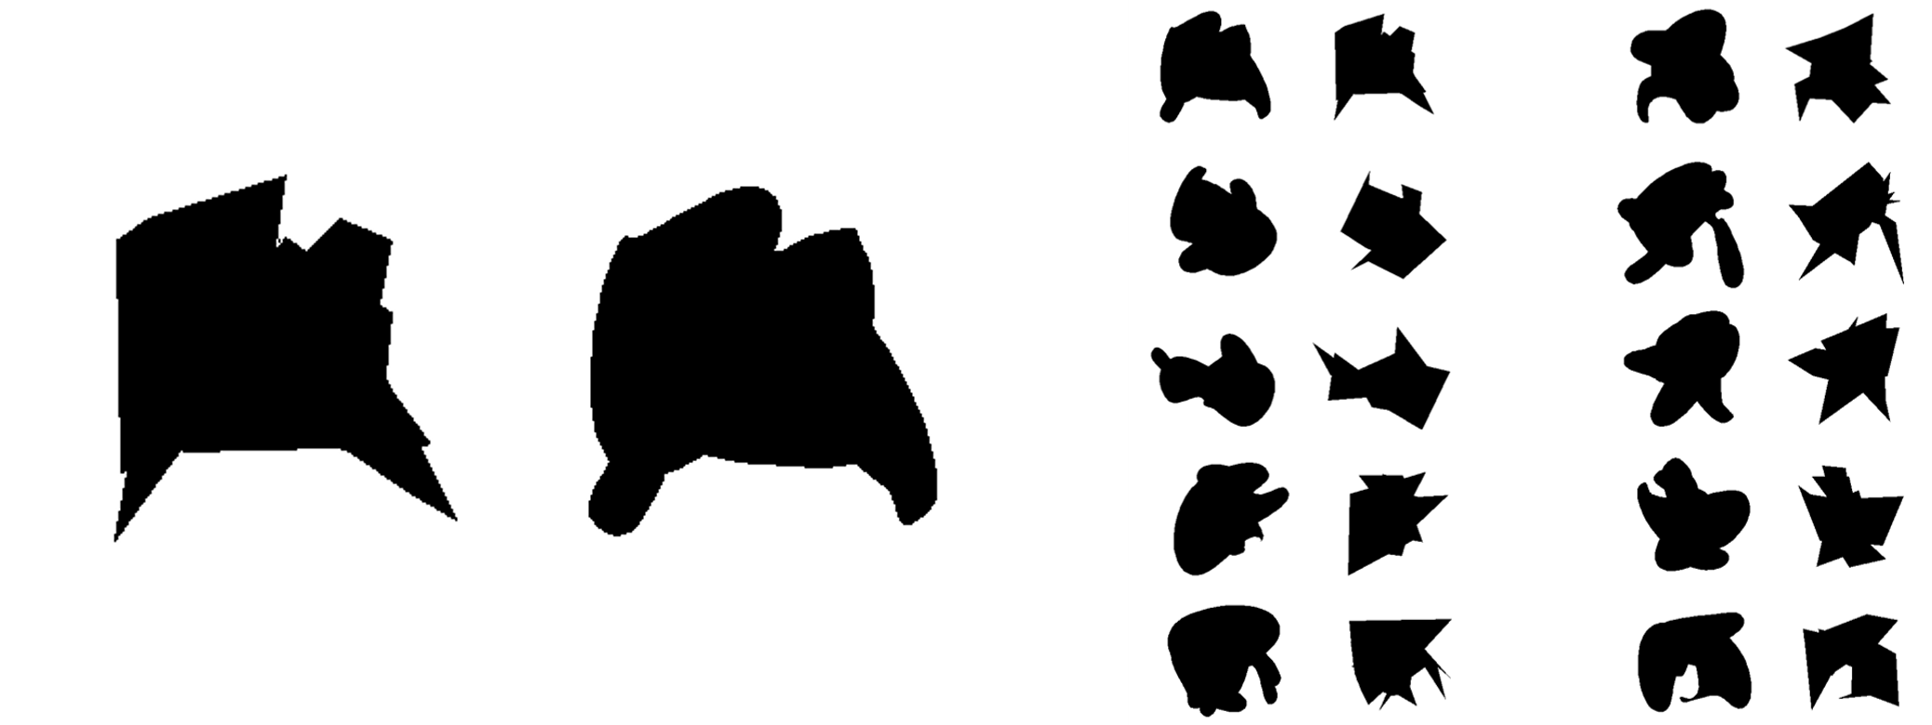
Figure 2-1. Example 2D shapes used in behavioral task. 50 pairs of randomly generated 2D shapes were used in the behavioral task. Each pair, as shown here, consisted of one “blob” (far left) and one “spikey” (middle), and were generated from the same randomly overlapping polygons (n=4). 10 example pairs are shown (right).

Visual stimuli: Blur/shape clarity
Shape stimuli were blurred by convolving the shape images with a circular 2D Gaussian blur kernel with variable standard deviation (Oleskiw et al., 2017). Five blur levels (i.e. clarity levels) were chosen based on each animal’s behavioral task performance, such that there were three levels between the two extremes of no blur (100% clarity) and 0% shape clarity.
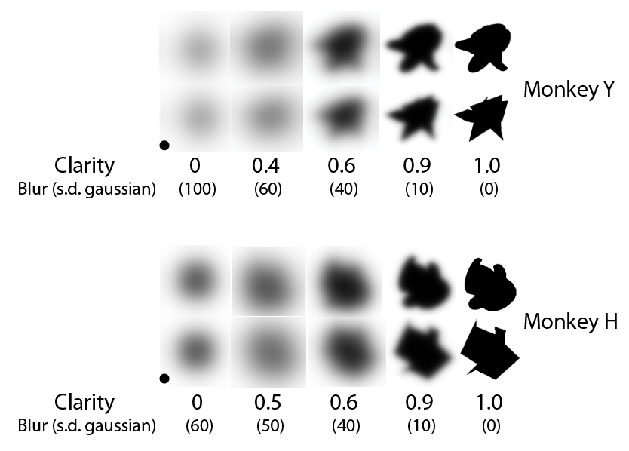
Figure 2-2. Shape clarity levels used in behavioral task for each monkey. Clarity (blur) levels are shown for both Monkey Y (top) and Monkey H (bottom). Shape stimuli were made more ambiguous by using a gaussian blur with a particular standard deviation (s.d.) in pixels. Clarity was defined as 1-(blur/100), except in the 0 clarity case. In this condition, for both monkeys, a black circle was the underlying stimulus, such that there was no diagnostic shape information that could be extracted from the stimulus. Monkey Y had a much fainter stimulus at 0 clarity than Monkey H.

Visual stimuli: motion trajectories
The 2D motion trajectories were generated to be discriminable yet similar in their spatial extent and average velocity. The trajectories were based on earlier work demonstrating that human subjects could recognize and discriminate between similar closed shape patterns (Wickelgren & Bingham 2008). Early pilot experiments in a motion matching task with Monkey Y led to the observation that periodic trajectories were easier to recognize than random trajectories. There were three trajectories and a static condition where the shape stimulus stayed in the same location throughout the target period. The x,y positions and x,y velocity patterns of the three trajectories, circular trajectory, triangular trajectory, and bimodal (figure eight) trajectory are shown in Figure 2-3. The periodic trajectories were designed to last 1500 ms and have a 750 ms period (2 cycles total). This corresponded to 150 total frames (10ms/frame). We needed functions that formed patterns with no discernable beginning or ending that could share a common starting location.
The circular trajectory was created using the equations x=r*cos(t), y=r*sin(t), where r=1.5º V.A. The triangular trajectory was constructed from an equilateral triangle inscribed inside the circle with three smaller circles (r=0.2250) at each corner, tangential to the outer circle (see Figure 2-3). The trajectory was assembled piecewise such that each smaller circle lasted 9 frames (90ms) and each side of the triangle lasted 16 frames (160ms) for a total of 75 frames per cycle (750ms). The bimodal (figure-eight) trajectory was created using the equations x=r*cos(t), y=r*sin(t)cos(t), such that it was also inscribed within the circle. The trajectories had two points at which they all overlapped. The starting point for each trajectory during the task was not identical, but approximately their bottom-left point of overlap. Note that the shapes were large (3º V.A.) compared to the small differences in starting location (within 0.3º V.A.) due to the equations used for the trajectories. The motion patterns went counter-clockwise. On static trials, the shape stimulus stayed at (-1.2, -0.75), which was the approximate starting location for the motion trajectories.
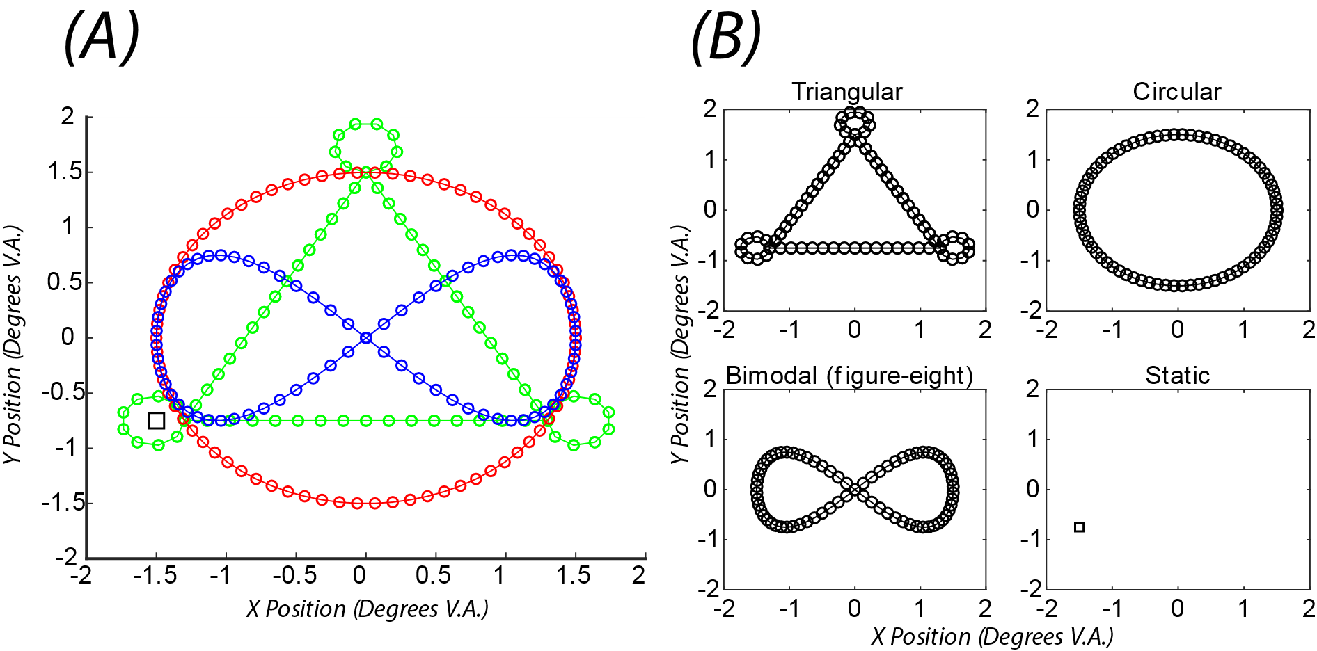
Figure 2-3. Four target motion patterns (triangular, circular, bimodal, static). (A) Trajectory x,y positions overlapped demonstrating how trajectories were designed to cover a similar spatial extent while retaining discriminability. Green=triangular, Red=circular, Blue=bimodal, Magenta=static. Stimuli started in the bottom left near the overlap of the three motion trajectories, except in the static case, where the location is marked with the square. (B) x,y positions of the four motion patterns separately. In both (A) and (B), the plotted markers represent actual positions on each frame for a single cycle (750 ms).
Match-to-sample task
In this two-alternative forced-choice (2AFC) task, subjects were required to report which of two choices best matched a target stimulus. On each trial, the monkey was first required to acquire the fixation spot (~200ms), after which a target object appeared for 1500ms duration. At target onset, the fixation spot was extinguished, and the fixation window was expanded to +/- 4º V.A to encourage pursuit of the target. The target either moved in one of three ways, or not at all, and the monkey was encouraged to pursue the target with the expansion of the invisible fixation window. After 1500ms, the target was extinguished and the monkey was required to reacquire the fixation spot during the delay. After the delay (500ms), two choices appeared. The monkey was then required to press a right or left button to select which option of the shape pair best matched the target. (Figure 2-4). The sides that the choices appeared were counterbalanced, so the spikey or blob appeared on the left or right side of the screen equally often.
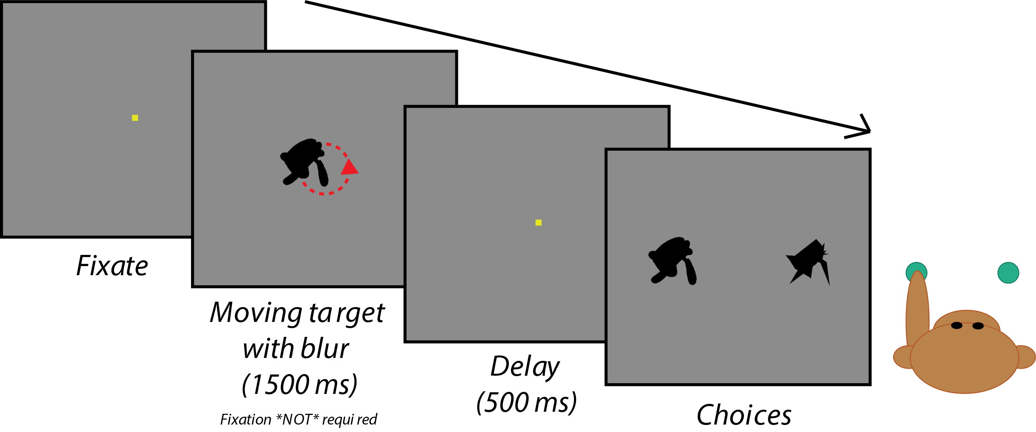
Figure 2-4. Basic structure of match to sample task with moving shapes. The monkey first had to acquire fixation for ~200ms, after which the fixation spot disappeared and a moving target appeared for 1500ms. The allowable eye position window (not shown) during the target period was -4º +4ºV.A. in x and y to encourage pursuit of the moving target. After 1500 ms, the target disappeared and the fixation square reappeared for 500 ms for a delay period. At the end of the delay, the two static choices appeared and the monkey had 2 seconds to select an answer using a button press.
Each shape category was associated with a motion pattern (Monkey Y: blobs-circular, spikey-triangular; Monkey H: blobs-bimodal, spikey-triangular). Both shape categories were associated with the remaining motion pattern and static condition. The number of trials per condition was slightly different for monkey Y and monkey H. Monkey Y completed blocks of 180 trials with the trial structure shown in Table 2-1. 90 trials were from a single shape pair (for neurophysiology, see Chapter 3), while the other half of the trials were randomly selected shape pairs. Monkey H completed blocks of 126 trials (performance suffered with longer blocks) but the number of trials of the single shape pair was still 90. There were only 36 random pair trials per block for monkey H (Table 2-2). Monkey H also had more trials of the harder shape clarity levels. Trials at the hardest shape clarity level (0), were rewarded randomly 50% of the time, as there was no correct answer. During training, both monkeys worked for as long as they maintained motivation (performance reasonably above chance). During recording sessions, both monkeys completed approximately 5 task blocks.
Monkey Y
Shape Clarity | Shape Category/ # trials | Motion Pattern | # Trials
0 | n/a  36 | Triangular | 10
0 | n/a  36 | Circular | 10
0 | n/a  36 | Bimodal | 8
0 | n/a  36 | Static | 8
0.4 | Blob  18 | Triangular | 0
0.4 | Blob  18 | Circular | 10
0.4 | Blob  18 | Bimodal | 4
0.4 | Blob  18 | Static | 4
0.4 | Spikey  18 | Triangular | 10
0.4 | Spikey  18 | Circular | 0
0.4 | Spikey  18 | Bimodal | 4
0.4 | Spikey  18 | Static | 4
0.7 | Blob  18 | Triangular | 0
0.7 | Blob  18 | Circular | 10
0.7 | Blob  18 | Bimodal | 4
0.7 | Blob  18 | Static | 4
0.7 | Spikey  18 | Triangular | 10
0.7 | Spikey  18 | Circular | 0
0.7 | Spikey  18 | Bimodal | 4
0.7 | Spikey  18 | Static | 4
0.9 | Blob  18 | Triangular | 0
0.9 | Blob  18 | Circular | 10
0.9 | Blob  18 | Bimodal | 4
0.9 | Blob  18 | Static | 4
0.9 | Spikey  18 | Triangular | 10
0.9 | Spikey  18 | Circular | 0
0.9 | Spikey  18 | Bimodal | 4
0.9 | Spikey  18 | Static | 4
1 | Blob  18 | Triangular | 0
1 | Blob  18 | Circular | 10
1 | Blob  18 | Bimodal | 4
1 | Blob  18 | Static | 4
1 | Spikey  18 | Triangular | 10
1 | Spikey  18 | Circular | 0
1 | Spikey  18 | Bimodal | 4
1 | Spikey  18 | Static | 4
Table 2-1. Number of trials of each condition in a single 180 trial block for Monkey Y. More trials were assigned to associated motion patterns ( blob- circular, spikey- triangular). The number of trials was counterbalanced across clarity levels and shape classes. For Monkey Y, for half of the trials, the choices were the same single pair of shapes. For the other half of all trials, the choices were a random pair, but always a blob and a spikey from the same shape pair.

Monkey H
Shape Clarity | Shape Category/ # trials | Motion Pattern | # Trials
0 | n/a  36 | Triangular | 10
0 | n/a  36 | Circular | 8
0 | n/a  36 | Bimodal | 10
0 | n/a  36 | Static | 8
0.5 | Blob  18 | Triangular | 0
0.5 | Blob  18 | Circular | 4
0.5 | Blob  18 | Bimodal | 10
0.5 | Blob  18 | Static | 4
0.5 | Spikey  18 | Triangular | 10
0.5 | Spikey  18 | Circular | 4
0.5 | Spikey  18 | Bimodal | 0
0.5 | Spikey  18 | Static | 4
0.7 | Blob  9 | Triangular | 0
0.7 | Blob  9 | Circular | 2
0.7 | Blob  9 | Bimodal | 5
0.7 | Blob  9 | Static | 2
0.7 | Spikey  9 | Triangular | 5
0.7 | Spikey  9 | Circular | 2
0.7 | Spikey  9 | Bimodal | 0
0.7 | Spikey  9 | Static | 2
0.9 | Blob  9 | Triangular | 0
0.9 | Blob  9 | Circular | 2
0.9 | Blob  9 | Bimodal | 5
0.9 | Blob  9 | Static | 2
0.9 | Spikey  9 | Triangular | 5
0.9 | Spikey  9 | Circular | 2
0.9 | Spikey  9 | Bimodal | 0
0.9 | Spikey  9 | Static | 2
1 | Blob  9 | Triangular | 0
1 | Blob  9 | Circular | 2
1 | Blob  9 | Bimodal | 5
1 | Blob  9 | Static | 2
1 | Spikey  9 | Triangular | 5
1 | Spikey  9 | Circular | 2
1 | Spikey  9 | Bimodal | 0
1 | Spikey  9 | Static | 2
Table 2-2. Number of trials of each condition in a single 126 trial block for Monkey H. More trials were assigned to associated motion patterns (blob- bimodal, spikey- triangular) and difficult shape clarity levels (0, 0.5).
Monkey Y tended to try to abort and skip difficult (low shape clarity) trials, even after associations were learned. Thus, Monkey Y was continually forced to repeat trials that were aborted until they were completed. The original goal was to use this tactic to break the habit, but when given the option, Monkey Y repeatedly chose to abort difficult trials, so Monkey Y did have to repeat trials throughout behavioral training. Monkey H did not exhibit this behavior, so any aborted trials were put randomly back into the remaining trial pool and completed at random.

2.2.5 Data analysis
Behavioral performance was calculated as the proportion of correct trials out of the possible number of trials for a given task condition. Average reaction times were calculated across all incorrect and correct trials for a given condition. Performance across sessions was calculated by averaging the performance across sessions for a given condition (i.e. trials from different sessions were not pooled to get a single mean).

2.3 Behavioral results
Both monkeys were trained for multiple months on parts of the task before all the conditions were combined into a single task and trial types were randomly interleaved. Both monkeys eventually learned to use the motion-shape associations in difficult shape clarity levels (Figure 2-5). Each of the full behavioral sessions consisted of approximately 900 trials. Reaction times varied slightly across the motion conditions despite the 500ms delay before choice period. Importantly, reaction times were fastest for both monkeys in the conditions that involved use of the motion-shape associations (red & green curves, Figure 2-5, right side). This suggests that perhaps the animals were preparing their response before the choice period. This is also supported by a decrease in reaction time for the clearest shapes (shape clarity 1.0) across all motion conditions.
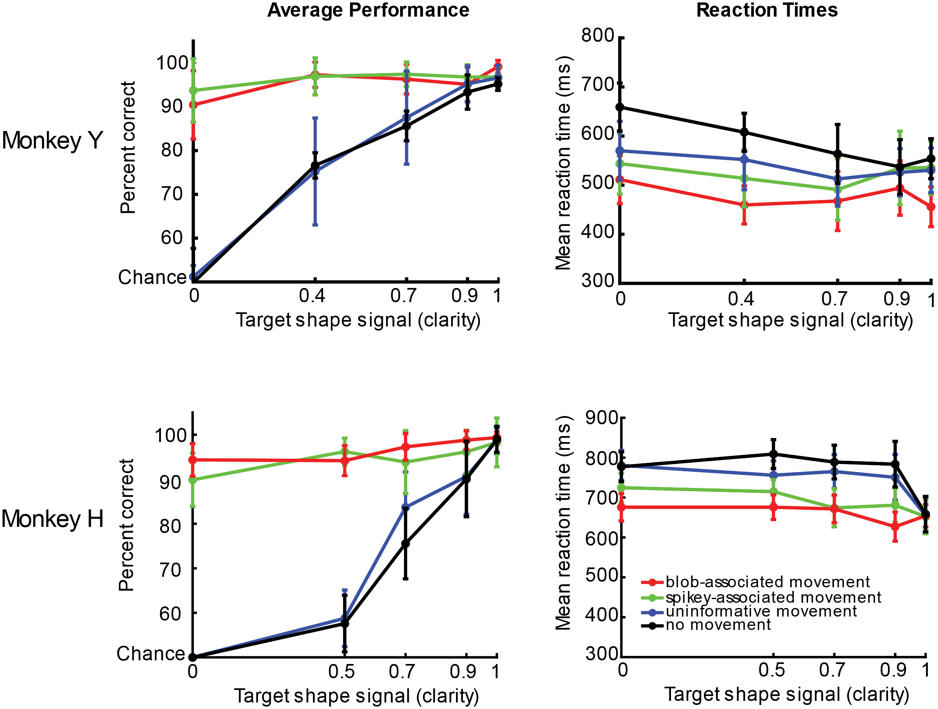
Figure 2-5. Overall behavioral performance across sessions included in neural data analysis for both Monkey Y (28 sessions) and monkey H (33 sessions). Average performance for each monkey (left) across the four motion conditions demonstrates the use of the motion-shape associations in low shape signal (clarity), as performance stayed near ceiling for the hardest clarity levels when the target was moving with the two associated motions. Performance decreased to chance for the most difficult clarity level (target shape signal 0) for the uninformative motion and static conditions. Reaction times were slightly slower for the static condition for both monkeys (right, black curves). Error bars s.e.m. across sessions.

Even after the monkeys demonstrated they could use the motion-shape associations to select the correct shapes following a blurry, no-shape target, both monkeys still made mistakes. The retrieval and use of the associations was not trivial or as easy as 1.0 clarity, despite overtraining. This can be observed by breaking down performance into individual blocks and looking at percent correct for the associated motion conditions with 0 shape clarity and 1.0 shape clarity (Figure 2-6). For most of the blocks across the sessions for both monkeys, performance was at or near 100% for both the associated motions with no shape clarity and 1.0 shape clarity. However, for some blocks, performance could be significantly worse, and this happened much more often for 0 shape clarity (Figure 2-6A) than in 1.0 clarity trials (Figure 2-6B). This happened more often for Monkey Y than Monkey H.
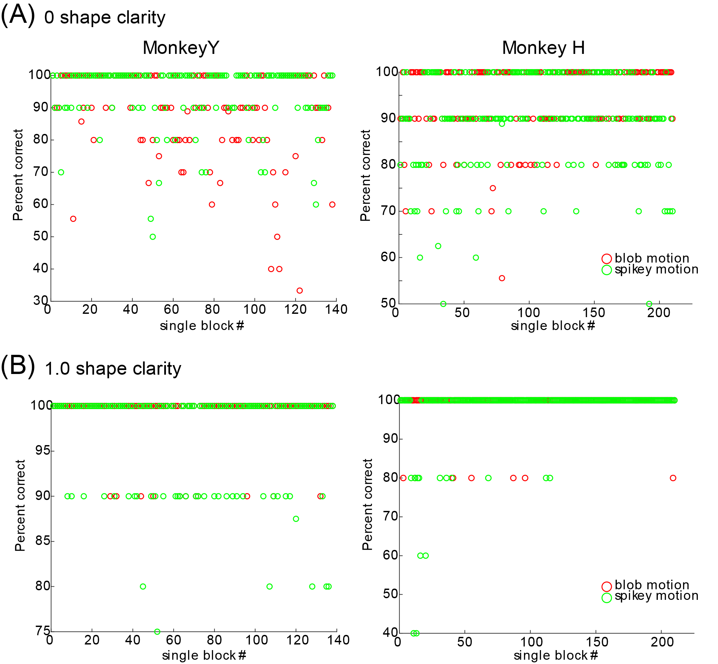
Figure 2-6. Average performance on 0 shape clarity and 1.0 shape clarity, associated motion trials broken down by individual trial blocks for both Monkey Y (138 blocks) and monkey H (210 blocks). (A) Each dot represents average performance on approximately 10 trials of 0 shape clarity, associated motion. Blocks are sorted in time from earliest to latest, left to right on the x-axis. Both monkeys performed near 100% on the majority of trials in these conditions, but on some blocks, performance could be near chance, even after clear demonstration of knowledge of the associations in earlier blocks. (B) Same as (A) but for 1.0 clarity
As there were no truly correct trials in the uninformative and static conditions with 0 shape clarity, the monkeys could have selected the same choice every time with little consequence (bias) or could have alternated between the two options. Monkey Y showed a consistent and strong bias for selecting the spikey shapes in these conditions (proportion of choices spikey for static condition= 0.98 of 1046 trials, proportion of choices spikey for uninformative motion = 0.97 of 1045 trials). Monkey H did not have a consistent bias for choosing the spikey or blob shapes across both of the uninformative conditions (proportion of choices spikey for static condition= 0.3705 of 1652 trials, proportion of choices spikey for uninformative motion = 0.6095 of 1649 trials).
The monkeys were encouraged to pursue the moving targets with a large fixation window requirement. However, they were not forced to track the targets for the duration of the target period, rather just required to stay within the 8º x 8º V.A. invisible window on the screen. Eye movement data demonstrated that both monkeys pursued the targets, and a transform of the original trajectory patterns were visible in the eye movement patterns (Figure 2-7). Eye positions show anticipatory rightward saccades near the end of the target period (red line rightward) for both monkeys but more consistently for Monkey Y. Eye positions are a transform of the motion trajectories and are not perfectly overlapping with the motion trajectories, as shapes are 3ºV.A. Both monkeys show some drift in eye position during the static conditions. Overall, the eye movement patterns were very stereotyped and did appear to cover a smaller spatial range as clarity decreased (i.e. smaller eye movements were made). This means that although the motion trajectory is staying the same across clarity levels, the eye movements in response to the motion and clarity are changing across conditions. This will be important for interpreting the neural responses to motion, discussed in Chapter 3.
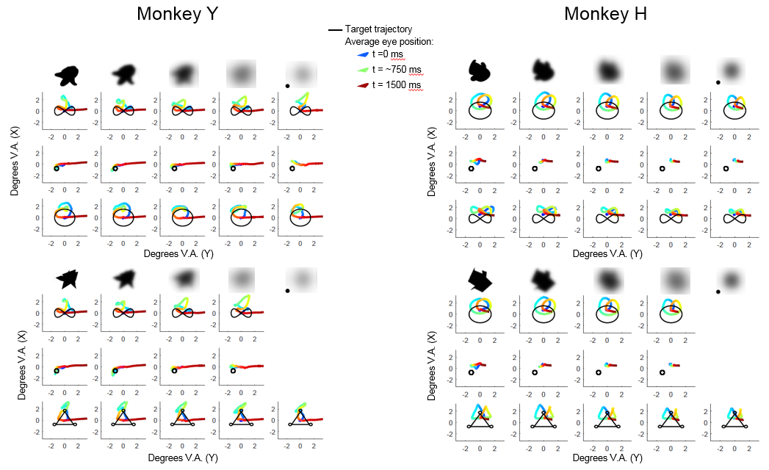
Figure 2-7. Eye movement data demonstrate that both monkeys pursued the moving targets. Average eye positions during the target period (1500ms, color) overlaid with the actual shape trajectories (black) across all shape + motion + clarity conditions. Top rows show average eye movements for blob shapes across the three motion conditions (bimodal, static, associated motion). Bottom rows show average eye movements for spikey shapes across all three motion conditions (bimodal, static, associated motion). Average eye position is color coded from early to late (blue green red). Left: Monkey Y, Right: Monkey H.

2.4 Discussion
The behavioral data from this task demonstrates that monkeys can learn associations between 2D motion patterns and shapes and use them to select shapes in a matching task. The task, although seemingly simple in design, was the result of many iterations in human subjects (see Chapter 4) and Monkey Y. The task was not trivial to train, as both monkeys (and human subjects in earlier designs) tended to ignore motion information at the expense of accuracy. Both monkeys required extensive shaping in the associated motion conditions with very little to no shape information before they could demonstrate use of the motion information. Furthermore, both monkeys required extensive training in order to flexibly complete blocks with randomly interleaved trials with the static and uninformative motion and the associated motion patterns. Both monkeys continued to make mistakes on trials that required use of the associations even after demonstrating knowledge of them. This suggests that this task does not necessarily probe the “binding” of shape and motion information, and it remains an open question whether binding naturally occurs between these visual features.
The goal was to create a behavioral task for monkeys that demonstrated the use of motion to select corresponding shapes. The behavioral task described in this chapter provided an avenue for investigating whether motion information can be processed in inferior temporal cortex, because the use of motion was required on certain trials. There were some benefits to the design- the categorical nature made adding new shape exemplars easy. Unfortunately designing similar, but discriminable motion patterns turns out to be not as trivial. There are many metrics one can use to discriminate between motion trajectories (Dodge et al., 2012), and exposure can improve discriminability (Liu 1999), but motion features that lead to perceptual discriminability remain ambiguous, and this should be a future direction of research in itself. The task is only a starting point for this investigation, as there were many design choices that preclude generalizability. Would open paths be perceived differently than closed motion paths? How does an object’s orientation along a path affect learnability and discriminability of motions and shapes? Because the animals found the associations difficult to learn, we avoided crossing the associated motions and shape categories, as not to confuse or potentially cause unlearning of the associations. Crossing the motions and shapes would allow for asking interesting questions about the dominance of motion and shape information both at the behavioral and neural level. These are just some of the questions that have arisen during the design and completion of this portion of the project.
It would have been ideal to arrive at a task where motion and shape seem naturally combined, or “bound,” as this would be the most likely case for neural integration at the level of inferior temporal cortex. We currently have no ability to read out the discriminability of the motion patterns for the monkeys except from their performance in the current design, but it is possible that the motions themselves made learning difficult. A separate study might look at the perceptual similarity of motion patterns and map the space of 2D trajectory similarity and select motion patterns accordingly. Anecdotally, there appeared to be a clear, natural separability in the shape classes. Both monkeys learned the differences between static shape categories quickly (within 1-2 sessions after already knowing how to match shapes). This suggests that there was a natural category boundary between the spikey and blob shapes that the monkeys could leverage without excessive training. It remains unknown what category boundaries might be in the realm of 2D motion patterns. Furthermore, previous work has demonstrated that while category learning can facilitate perception within a stimulus dimension (e.g. shape), and that two kinds of effects can be observed depending on whether the perceptual dimensions were integrated: acquired distinctiveness (exemplars become more different in perceptual space) or acquired equivalence (exemplars become more similar to each other but more different than exemplars in other categories) (Goldstone 1994). Results from more recent work have suggested that category learning across shape and motion features leads to acquired distinctiveness, not acquired equivalence (Folstein et al., 2014). This could be one reason why shape and motion were not easily unified in the context of this task, as the task construction put acquired equivalence and acquired distinctiveness against each other. Shapes were acquiring distinctiveness during the individual matching task with familiar pairs, and motion was actually supporting acquired equivalence.
Perhaps any arbitrary motion and shape associations can be learned with enough practice, but are not naturally combined under the described conditions. There multiple factors we have considered that might serve as a metaphorical “glue” between motion and shape information, that would not only allow for easy learning of such associations, but perhaps binding of the features. First, this task does not account for the real-world physics of the shapes and motion patterns. Perhaps a critical feature of moving objects is their physical nature- a particular motion constrains what shape can take on that motion, and vice-versa, a shape can only complete certain motion patterns in the realistic physical world. These shapes were all in isolation from any visible external forces, which previous work (Scholl &Tremoulet 2000; Tremoulet & Feldman 2000; see Chapter 1) suggests leads to a perception of animacy in some cases. Therefore, while these motions were not designed to be animate, and the shapes were devoid from any animate features, the combination of these motions and shapes in isolation partly fulfill the definition of animacy. Secondly, this task explicitly divorces trajectory motion from articulated motion; this was by design. Previous work has focused heavily on articulated motion, gestures and changes in conformation of objects; little work has focused on the movement of entire objects or shapes in space, either in 2D or 3D, and the associations that can be learned between these shapes and motions. But perhaps articulated motion is a key ingredient to trajectory motion perception during object recognition, and to slice off a single component of motion is too artificial to promote a natural binding of motion and shape information. Recent work in computer science in the area of image (and motion) segmentation has suggested that object geometry and spatial location are actual properties of trajectory data (Yan & Pollefeys 2006). Third, the task asked the subjects to indicate “what” the shape was, not how it moved. Perhaps the task context itself promotes ignoring motion information, and using it only when absolutely necessary, thus promoting task switching. Previous work by a member of the lab has shown that in multimodal feature integration, weaker features of equal strength are more likely to be integrated (Miller et al., 2015). In the task described in this chapter, motion is always “strong” and shape is varied. Perhaps “weak shape” + “weak motion” leads to more natural integration. Further investigation into each of these factors could improve our understanding of how motion and shape could be more easily combined.
Despite some of the drawbacks of the task design described here, this task is still a useful starting point for understanding the effect of motion on neurons in inferior temporal cortex. Behavioral data demonstrates that the monkeys are able to flexibly use motion information when shape information is not available, in order to select corresponding shapes. What happens to neurons selective for those shapes, when only motion information is available? This will be discussed in Chapter 3.

2.5 Appendix
2.5.1 Probing behavioral strategy in Monkey Y
Although knowledge of the shape-motion associations is required for maximizing performance on the task, there are still multiple strategies that the monkeys could have used to complete the trials when both motion and shape information were available. For high clarity, associated motion trials, the monkeys could have used motion or shape information to arrive at a correct answer. Moreover, it remains unknown exactly what information the monkeys were using from the motion trajectories to arrive at the correct answers for the two associative conditions with no shape information. Were the monkeys gathering information during the entire 1500ms target presentation? Could the monkeys generalize to slightly larger motion trajectories, or motions in the opposite direction? This section discusses investigating these questions with Monkey Y with four small side tasks that were completed after neural recordings ended. Unfortunately the same tasks could not be completed with Monkey H, so this data is only preliminary evidence of strategy from one monkey.

Direction Reversal
In this task probe, the direction of motion was reversed to test whether Monkey Y was able to generalize across both directions of motion, or whether he had learned only one direction. There were 140 trials of the two associated motion conditions with 0 shape clarity (70 circular motion, 70 triangular motion). Half of those trials went in the previously trained direction (counter-clockwise) and the other half went in the untrained direction (clockwise). Performance and reaction times are shown in Figure 2-8. Performance dropped to chance level in the untrained direction, showing that Monkey Y did not generalize from the trained direction.
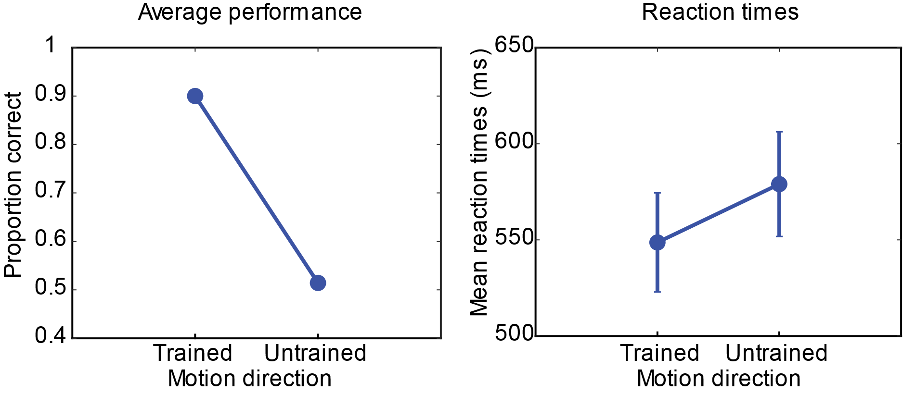
Figure 2-8. Direction reversal experiment demonstrates monkey Y did not generalize across both motion directions. Left: Average performance for trials in the trained and untrained motion direction. Right: Average reaction times in the trained and untrained motion direction. 70 trials per data point

Variable Target Duration
In this task probe, the target time was varied from 100ms to the full trained target duration of 1500ms across all trial types to try to investigate how much of the target period Monkey Y was using to achieve good performance. To limit the possibility of learning and adapting to new target durations, these trials were interleaved randomly in normal sessions across 17 different blocks, across 4 different behavioral sessions. Counter-balancing of the original task design was kept constant, which resulted in a variable number of trials for each target duration, with a minimum of 15 trials per data point and a maximum of 115 trials per data point in the average performance and reaction time plots in Figure 2-9. These plots are of the informative motion conditions only (2AFC), and demonstrate that the monkey performed best in shape clarity 0 when the target was near or at its trained duration (dark blue data). It is important to note that training experience could account for these results, but the linear increase in performance as target duration increased, and other shape clarity conditions were not significantly affected, which suggests that the monkey was using most of the motion information in the 1500ms to achieve best performance.
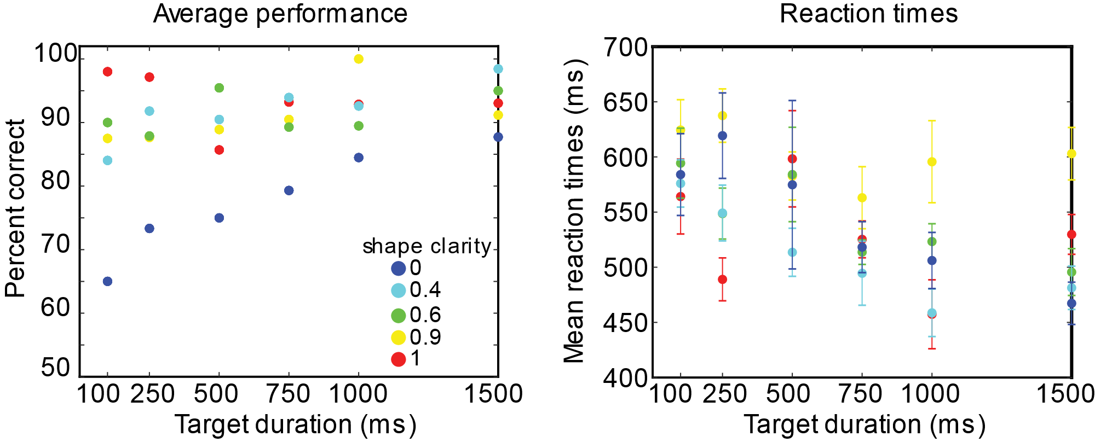
Figure 2-9. Variable target duration behavioral probe demonstrates that the monkey was likely using most of the 1500ms of the target display. Left: average performance across clarity levels and target durations for the informative motion trial conditions (two associated motions). Right: average reaction times for the same trials. Each data point is the average at least 15 trials, maximum 115 trials.

Changes in trajectory size (and speed)
In this task probe, the motion trajectories were scaled to be 50% larger (and faster) and 50% smaller (and slower) than the trained trajectories to test whether Monkey Y could generalize across slight changes in trajectory speed and size. The trials were blocked such that all the trajectories were smaller or larger for a given block, and blocks were interleaved across two different sessions. Performance and reaction times are shown in Figure 2-10. Monkey Y’s performance and reaction times were not significantly affected by change in the trajectory size (and speed), except in the lowest shape clarity condition, where performance dipped but remained above chance, when the motion trajectory was made smaller and slower. This demonstrates there was some generalization across speed and trajectory size.
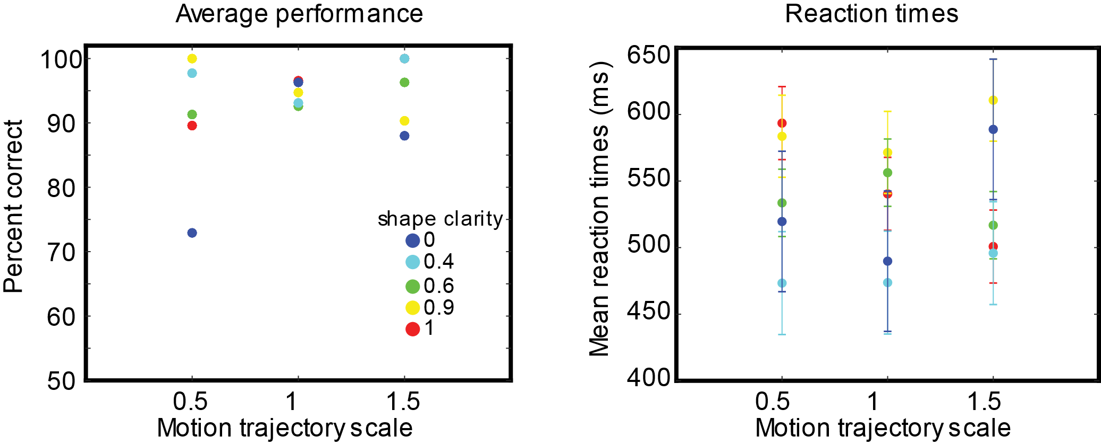
Figure 2-10. Small changes in trajectory size (and speed) did not significantly disrupt task performance except in the lowest clarity condition. Left: average performance across clarity levels and target scale (size) for the informative motion trial conditions (two associated motions). Right: average reaction times for the same trials. Each data point is the average at least 20 trials, max. 50 trials

Categorical choices instead of identical matches
In this task probe, the choices were changed to categorical shape matches instead of identical matches, to test whether the monkey was doing categorical matching (i.e. blob to blob, spikey to spikey) or looking for an exact shape match to the target. By definition, the lowest clarity level (0) is a categorical match task, because there is no shape information, just motion information (or no information at all) about which choice is correct. It is possible then, that Monkey Y could have completed the original behavioral task by doing all trials with a category-match strategy. In this task probe, trials of exact match choices and category match choices were interleaved randomly, and the behavioral results are shown in Figure 2-11. Performance and reaction times were affected for all clarity levels, but performance decreased and reaction times became slower with increasing shape clarity. At the highest shape clarity (no blur), and one level just below, performance dropped significantly below chance (Figure 2-11, left, red and yellow). Monkey Y was actually choosing the opposite shape class as a better match than the category match. This means that as there was more shape information in the target, it was more likely that Monkey Y was looking for an exact match during the choice period, and was task switching between the motion-only trials (which were category match by definition) and the high shape clarity trials that had both motion and shape information.
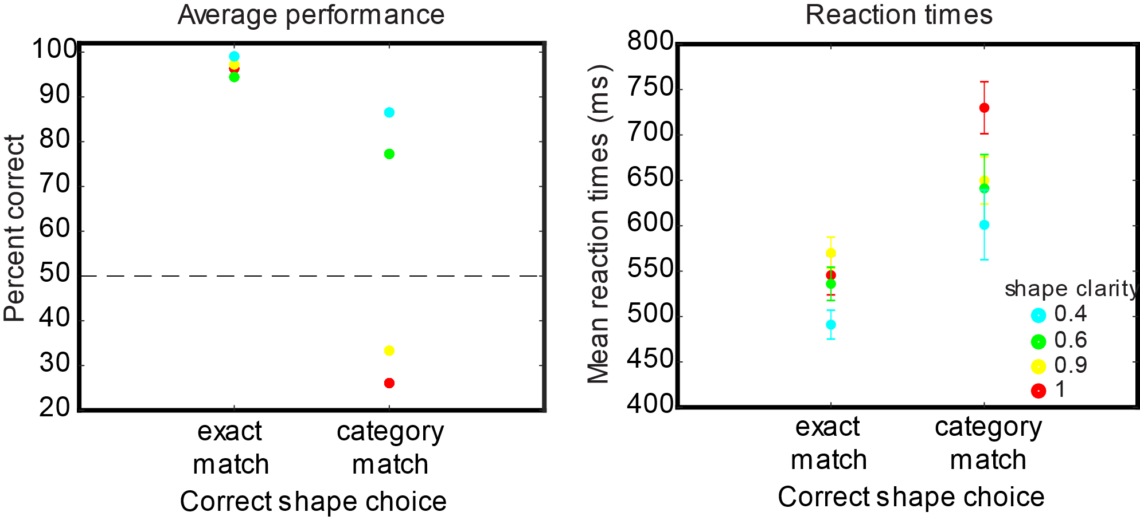
Figure 2-11. Changing choices to categorical matches instead of exact matches affected performance and reaction times in high clarity conditions. Left: average performance across clarity levels and target scale (size) for the informative motion trial conditions (two associated motions). Right: average reaction times for the same trials. Each data point is the average at least 50 trials, maximum 100 trials.

Overall, these subtasks suggested that Monkey Y was using individual shape information and doing a shape match to sample at higher clarity levels, and using motion only when necessary in the lowest clarity level. The results from the direction and size subtasks suggest that Monkey Y did not memorize the exact trajectories, but rather learned the approximate sequence of locations in time such that a reversal of position in time was not perceptually equivalent. Furthermore, somewhat surprisingly, it seems most of the target movement was used to improve behavioral performance at 0.0 clarity, but even 100 ms of the target was enough in the other clarity conditions, further reinforcing that Monkey Y was likely using primarily shape information at clarity levels other than 0.0, for the majority of trials.

Chapter 3: Coding of shape-motion associations in inferior temporal cortex
3.1 Introduction
What we know about typical responses in inferior temporal cortex to complex combinations of static features
Motion processing not far away, STS. Role in object recognition?
By what routes could IT have access to motion information ?
Behavioral task to demonstrate use of motion information when shape information is degraded
Main question is to test the capacity for coding for motion, not to conclude that it always happens, or that motion information is necessarily combined with shape information in only this way (seems unlikely anyway).

3.2 Materials & methods

3.2.1 Animal subjects & preparation
Two adult macaque monkeys participated in the experiments. All procedures including training and surgeries followed the guidelines published by National Institutes of Health Guide for the Care and Use of Laboratory Animals and was approved by the Brown University Institutional Animal Care and Use Committee. Each animal was chair trained and habituated to sit calmly for an extended duration (1-2 hours) in the behavioral rig. Following this training, each animal had a head post implanted for head fixation. Six to eight weeks after head post surgery, the monkeys began training on eye fixation, button pressing, and a basic match-to-sample task. Once the animal’s task performance reached a criterion (correct rate higher than 80%), the animals either had a surgery for implanting new recording chambers (monkey Y) or neural recordings began in existing chambers (monkey H). To gain access to area IT, we placed a custom ball-and-socket chamber (Figure 3-1) over either the right hemisphere (monkey Y) or the left hemisphere (monkey H) at +17 anterior, +20 lateral, Horsley-Clark stereotactic coordinates). All surgeries were performed under isoflurane anesthesia, in accordance with the guidelines published in the National Institutes of Health Guide for the Care and Use of Laboratory Animals, and approved by the Brown University Institutional Animal Care and Use Committee (see Chapter 7-Appendix for more general surgery details).
Chamber location was verified using CT scans for both animals and the data was processed using a CT-MRI merge in NIH-AFNI software or the Brainsight system (Rogue Research). CT-MRI merge showed that most recordings took place over the anterior middle temporal sulcus (amts), (Figure 3-2). Anterior locations in Monkey Y tended to produce more successful recordings. In Monkey H, successful recording locations were slightly more posterior. Figure 3-2c shows the location of the guide tube and one of the recording electrodes close to the IT target in Monkey Y. Figure 3-2d shows the chamber and guide tube in Monkey H. Note that the guide tube location could move, and was moved every 1-3 sessions depending on quality of signal. This was to avoid too many repeated penetrations down the same tract that could cause damage and potentially preclude collecting good data.
Figure 3-1. Custom ball and socket recording chamber used for both monkeys to target inferior temporal cortex. Custom titanium chamber allowed for modifying guide tube position to approach different locations in inferior temporal cortex. (A) Sample guide tube pointing down the center of the chamber (B) Neck of the plastic ball that held the guide tube in place and allowed for rotation and change in guide tube angle. (C) Retaining cap that held the plastic ball in a fixed location but could be loosened to allow for rotation of the plastic ball. (D) Chamber base with three legs that were screwed into the skull to hold the chamber in place.
Although common coordinates were used for both surgeries, the nature of the ball and socket chamber allowed for slightly different recording locations in inferior temporal cortex in both animals to maximize the recorded units that were task relevant. Recording locations were noted and documented using a grid that attached to the chamber base and sat above the entrance to the guide tube and a sterile pointer that pointed from the guide tube to the grid.
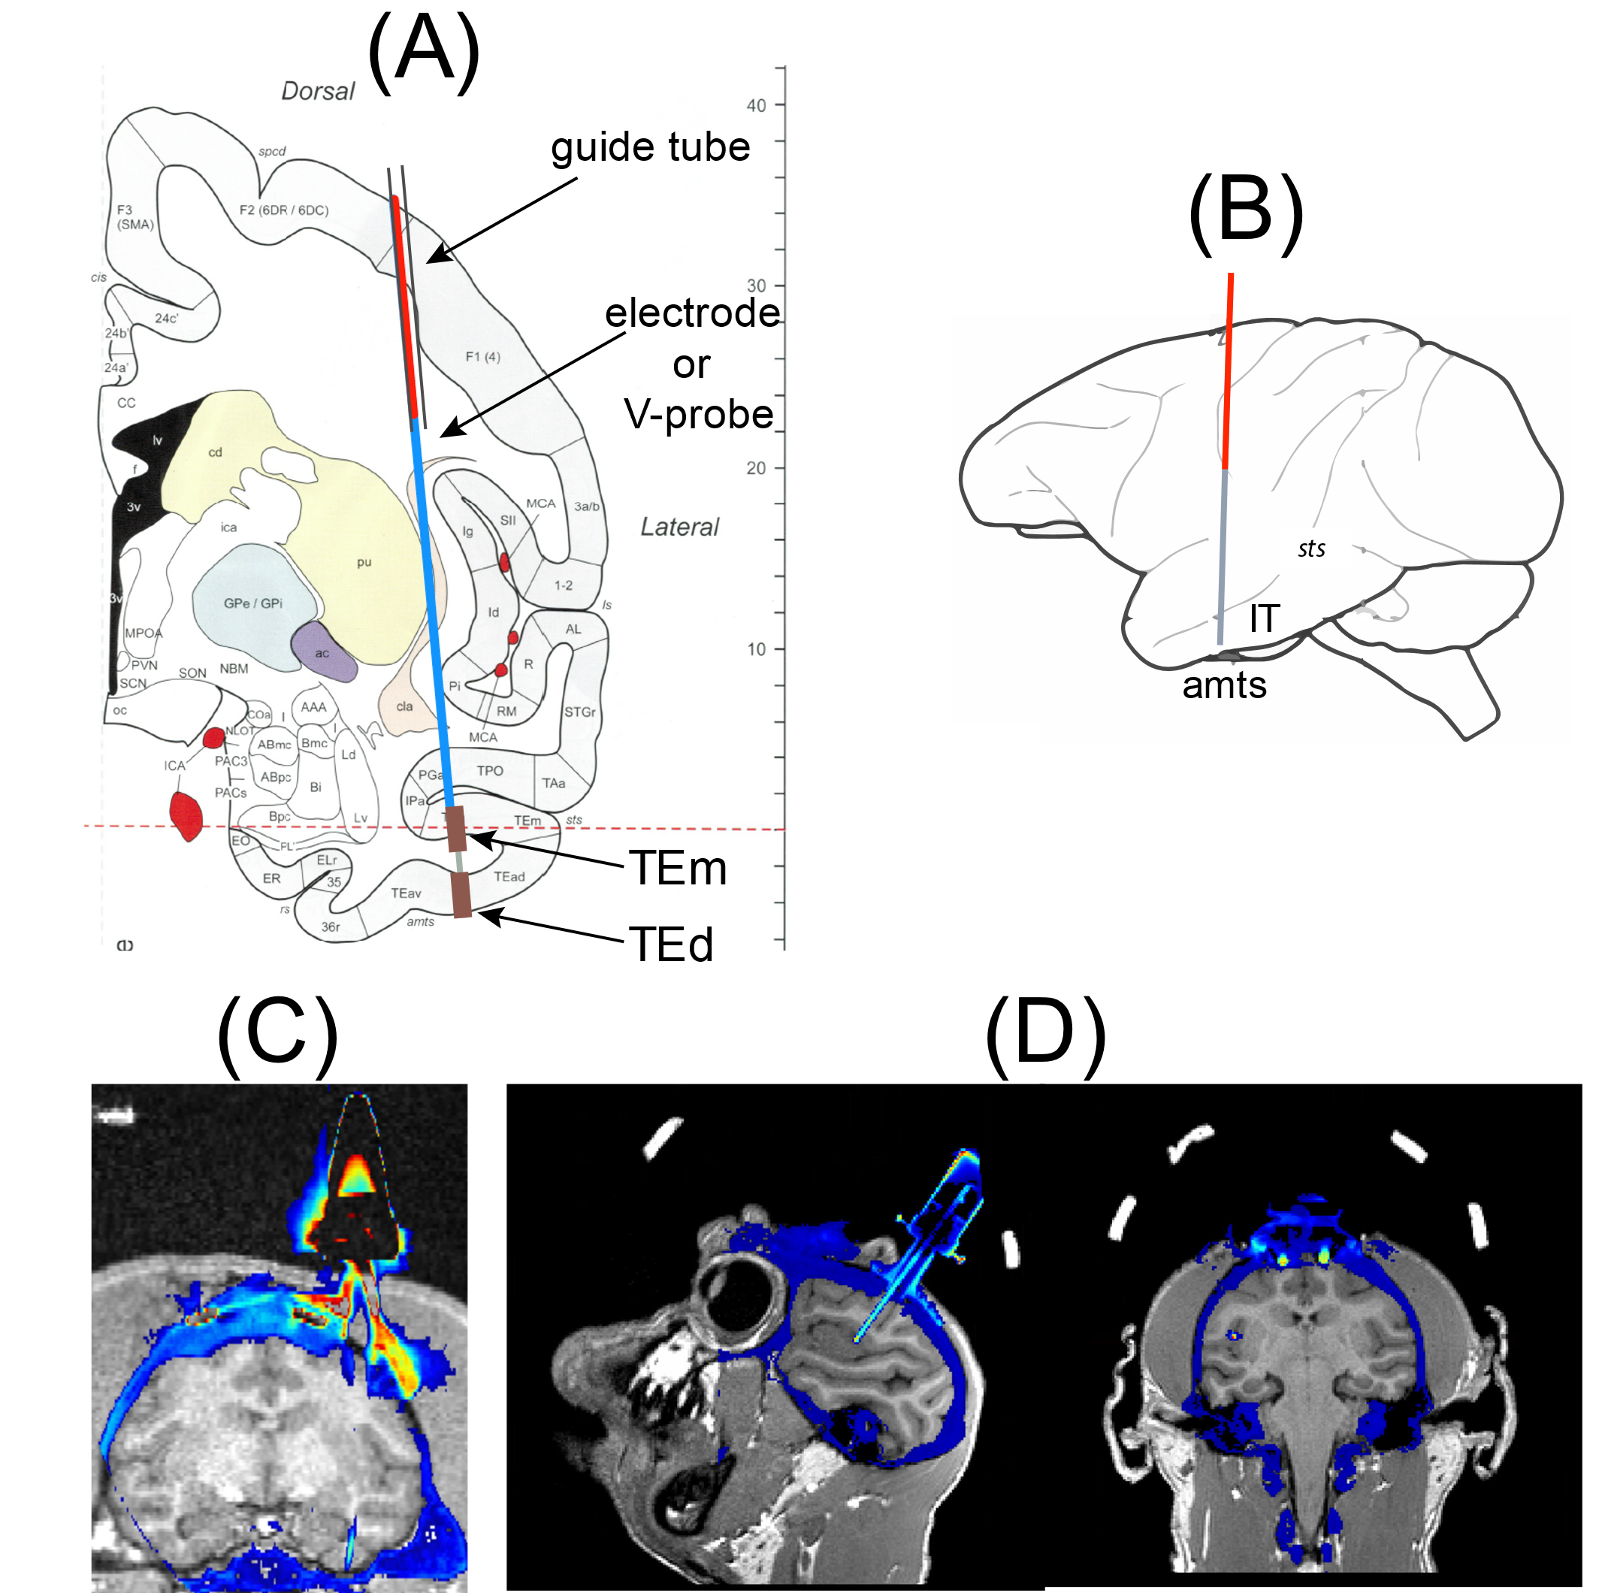
Figure 3-2. Custom ball and socket recording chamber used for both monkeys to target inferior temporal cortex. (A) Primate atlas, coronal view, showing schematic of guide tube and recording electrode and targets in area IT near the amts. (B) Sagittal atlas view of approximate recording approach (C) CT-MRI overlay for monkey Y, coronal view. (D) CT-MRI overlay for Monkey H, sagittal view (left), coronal view (right). Parts (A) and (B) modified with permission from S. Guan.

3.2.2 Neural data acquisition
Each recording session began with the lowering of a single tungsten electrode (FHC, code: UEWLEESM7N4G) or 16-channel plexon V-Probe with 100 um electrode spacing (code: PLX-VP-16-15SE(100)-(185-100)(460-25)-CT-300-(2)CON/8o50m-10P) through the guide tube of the ball and socket chamber to area IT, which sat ~15mm below dura. Electrodes were lowered gradually with a hydraulic micropositioner (David Kopf Instruments). Distance to IT cortex was estimated based on the total length of the guide tube, anatomical landmarks (i.e. gray/white matter transitions, upper and lower STS transitions), the magnitude of the visually evoked potential, and visual selectivity of neurons encountered along the electrode/probe path. Total depth out of the guide tube was approximately 18-22mm; there was some variance depending on the angle of the guide tube. On some sessions, distance to IT was also confirmed using an electrode retraction profile; spontaneous spikes were also recorded during electrode retraction, and then binned across the entire tract to see where bands of activity were at different depths relative to the tip of the guide tube. This was also a useful tool for tracking whether a particular electrode path was overly used or damaged, to know when to move the guide tube. The adjustable guide tube allowed for exploration of an area approximately ±5 mm in radius in the x–y plane of the brain at full depth. A single electrode was advanced until either a stable and strong single unit could be heard in the target region. The V-Probe was lowered to a depth of previously successful single unit recordings, and was left to sit for 45 minutes before recording began, to allow for tissue to stabilize. This time prevented drift that was evident in sessions where not as much time was allowed before starting the behavior. There was minimal wait time before the start of the behavioral session on single electrode recording days.
The neural data was amplified and digitized (25 kHz), and then processed in a Tucker-Davis Technologies (TDT) neurophysiology system. The raw data from each channel (electrode) was band-filtered with two frequency ranges: local field potential (LFP, 0.3-300Hz) and single units (SU, 300-3000Hz). Thresholding was used to detect spikes from the SU signal. Thresholds for single tungsten electrodes were set dependent on the quality of the signal, but in most cases 5.0x standard deviation of the raw signal for well isolated single units. The threshold was set lower (3.5-4.0x s.d) on days when the single electrode only picked up a smaller signal or mixture of multiunit and single unit activity that was not clearly separable online. The threshold for spike detection for V-Probe recordings was typically 3.5x s.d., as the impedance of the V-Probe contacts was much lower than the impedance of a single tungsten electrode. Plexon offline software was used for both initial clustering followed by manual spike sorting. The raw traces of the single-unit and multi-unit signals, waveforms and times of spikes detected were recorded throughout each session.

3.2.3 Eye signal
See Chapter 2.2

3.2.4 Stimulus presentation & behavioral control
Stimuli were presented as described in Section 2.2.3

3.2.5 Behavioral paradigm & daily recording strategy
The main behavioral task was described in Section 2.2.4, however, this was not all of the behavior done during neural recordings. There were also multiple passive viewing tasks during each session. Each behavioral session consisted of passive viewing, followed by the active task, followed by more passive viewing. The daily strategy is outlined in Figure 3-3.
Figure 3-3. Daily strategy for neural recordings during behavior. Workflow for recording session to collect neural data from area IT during both passive viewing and the active behavioral task.

Passive viewing paradigms
During the three passive viewing tasks, a fixation spot was shown on the screen for the monkey to acquire fixation for ~250 ms before a stimulus appeared. Multiple stimuli (up to 9) were shown during a single trial, during which the monkey maintained central fixation. If fixation was broken during the stimulus presentation, the stimulus was put back into the pool of stimuli and randomly presented again in another trial. During passive viewing of the 50 shape pairs without motion, each shape was shown at the center of the screen (size approximately 3 degrees visual angle) for 200 ms and there was 100ms between stimuli. Each shape was shown 5-10 times. Online peristimulus time histograms were used to select a stimulus pair for the rest of the session. The shape pair was selected based on its ability to drive the neuron (or multiple neurons on an array). In the ideal case, a single shape was effective at driving the maximum rate, and its paired shape was ineffective in driving a response, or drove a weaker response. In some cases, shape pairs were either effective or ineffective, and the most effective pair was selected.
During passive viewing of the single pair across clarity levels, each shape was shown for 200 ms with all the clarity levels used during the match-to-sample task. Again there was 100 ms between stimuli. Each shape was shown at least 10 times.
During passive viewing of the moving blur (no shape clarity), followed by a shape flash, each trial lasted 1700ms- the first 1500ms were of the moving blur with one of the four motions and the last 200ms were one of the two shapes of the daily pair with full clarity.

3.2.6 Data analysis
Pre-processing/ data cleaning, exclusion criteria
After each recording session, neural data was processed using Plexon Offline Sorter, unless there was a known disruption that would compromise data quality. Neural data was excluded if the signal was contaminated with excessive noise or in cases of instability (Figure 3-4). Plexon offline sorter was used to determine whether there was more than one unit on an electrode, and to assess signal stability. In some cases, a neuron was only present for some trials during the session; in this case this data was excluded from further analysis. Other reasons data were excluded from final analysis included poor behavioral performance (too few trials) or lack of task modulation during any of the task periods. Task relevance was calculated in the simplest sense, as any significant modulation above pre-stimulus baseline (200 ms before stimulus onset) in five task time windows (typical IT visual: 50-200ms, late visual 200-350ms, very late visual 800-950ms, early delay 1550-1700ms, late delay: 1700-1850). It was clear that some neurons were not visual in the traditional sense, so we sought to remain agnostic to their role in the task without testing too many time windows (Welch’s t-test corrected for multiple comparisons α=0.008).

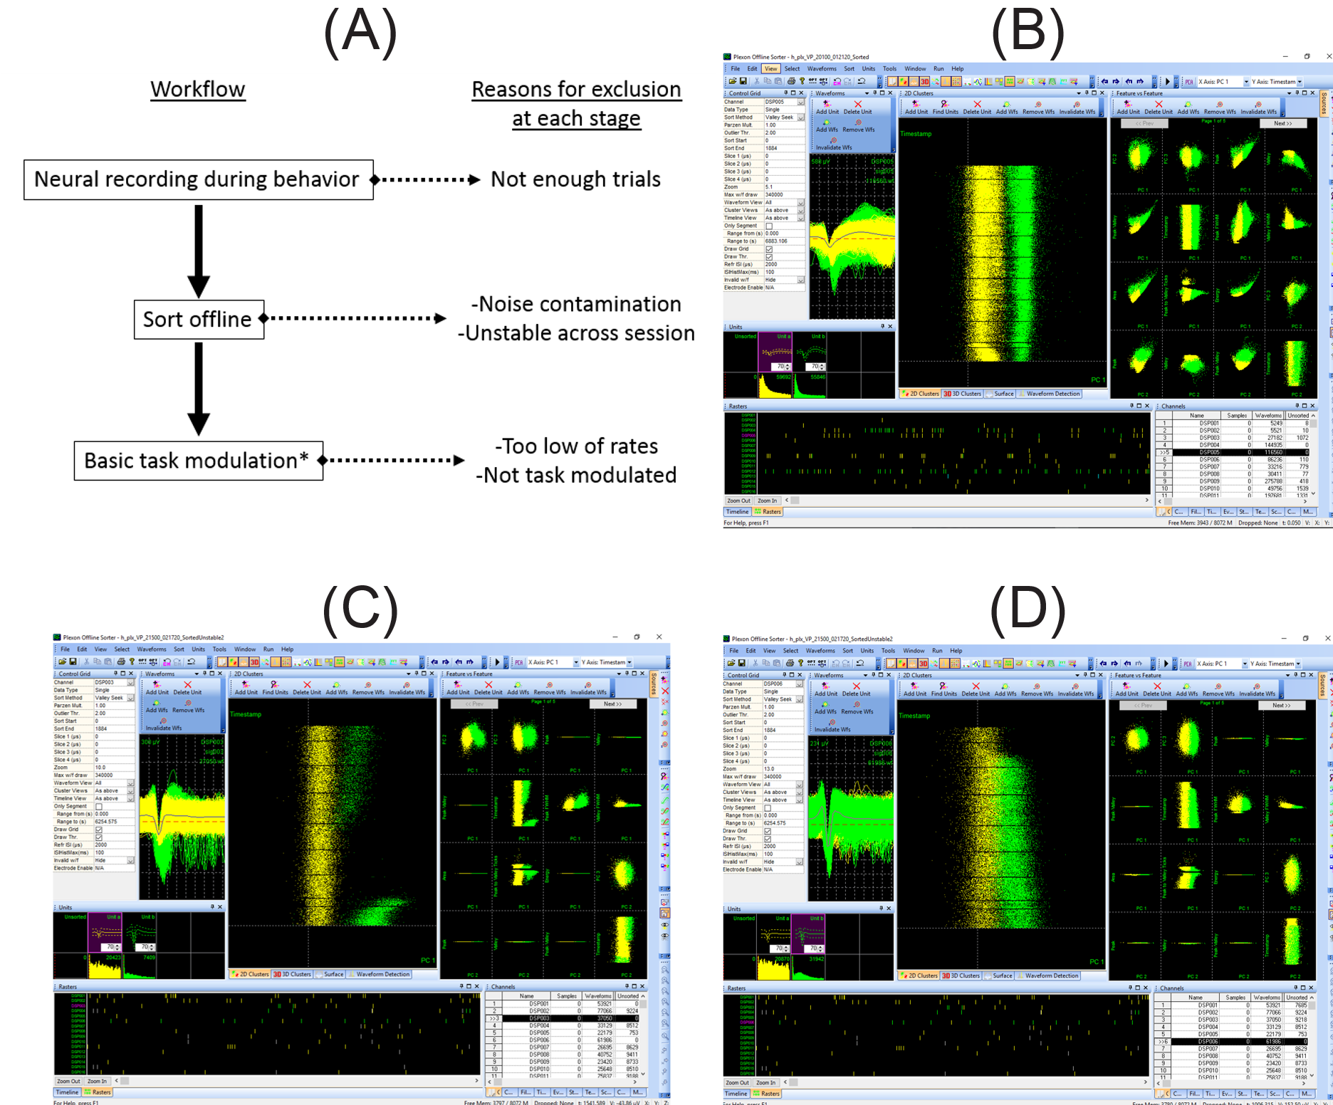
Figure 3-4. Exclusion criteria for neural data. (A) Workflow for recording session and possible points at which data could be excluded for poor quality. (B) Screenshot of Plexon offline sorter showing two clusters of neural activity (yellow: multiunit activity, green: single unit activity) from a single electrode. Middle panel shows the timeline across behavioral blocks. (C) Screenshot of Plexon offline sorter showing an unstable single unit signal (green); this kind of signal would be excluded from further analysis. (D) Another example of an unstable single unit signal that decayed near the end of the recording session (green) that would be excluded from analysis.
Firing rate analysis
Spontaneous firing rates were measured in a 150 ms or 200 ms time window prior to the onset of a stimulus. Typical area IT, stimulus-evoked responses were measured in a 150-ms time window starting 50 ms after stimulus onset. Rates were also calculated during later time windows in the active task (as previously described above) to test for task relevance. Otherwise, to analyze the spike data, raw binned rates or smoothed spike density functions were used. For any statistical comparisons, normalized, raw rates were used. To visualize activity across multiple trials and conditions, binned rates (5 or 10 ms bins) were convolved with a truncated Gaussian kernel with σ=5 or 10 ms, edge=10 ms. Firing rate was calculated as this convolution divided by the number of trials x bin size.

Assessing neuronal responsiveness to shapes and blur/shape clarity
Multiple metrics were used to assess neuronal selectivity to the 100 shapes (50 pairs) during passive viewing. These metrics: depth of selectivity (DOS), breadth, selectivity index (SI), and broadness, have been previously used in visual neurophysiology studies (Freedman et al., 2006; Moody et al., 1998; Mruczek and Sheinberg, 2012; Rainer and Miller 2000). Equations 3-1 through 3-3 show three of these relationships, where R is the firing rate, n is the number of stimuli presented.
$$Equation 3-1 DOS=[n-(∑Ri/Rmax)]/[n-1]$$

$$Equation 3-3 SI=(Rmax-Rmin)/(Rmax+Rmin)$$
$$Equation 3-2 breadth=1-median(Rnorm)$$
Broadness (values 0 to 1) was defined as the proportion of stimuli eliciting a significant response from the single or multi-unit response, with values closer to 0 indicating a more selective response. Broadness_{Wilcoxon} was defined as the proportion of stimuli as indicated by a Wilcoxon rank-sum test (α = 0.01). Broadness_{%max} was defined as the proportion of stimuli that induced responses >25% of the baseline to peak firing rate difference. It was not uncommon for some neural responses to have poor passive viewing responses, but robust active task responses, or responses to moving stimuli, so these metrics could not be computed for all neural responses.
Neural responses were roughly classified by whether they exhibited a decaying response to decreasing shape clarity during passive viewing of static stimuli. An exponential and gaussian function were each fit to raw response rates to each of the shape stimuli under the five clarity levels (using Matlab function fit). Goodness of fit was measured using R-squared coefficient of determination.
Fano factor (FF) was also calculated to assess reliability of responses using the following equation, where σ is the variance in the spike count and μ is the mean spike count during a 150 ms window, 50 ms after stimulus onset:
$$Equation 3-4 FF=σ/μ$$
Latency to peak firing rate was calculated using the smooth spike density functions (σ=5 ms, edge 10 ms) and the time from stimulus onset to the maximum response during the first 300 ms after stimulus onset, to allow for late visual responses that were observed during recording. For comparison of rates and latency to peak firing rate in passive viewing data, any stimulus or condition that was labeled as “most effective,” also met the criterion previously described for broadness, that is the rate was at least 25% greater than the baseline, pre-stimulus period. This was an important additional test because units could be selective for specific shapes or for clarity levels, and otherwise could be confounded.

Decoding
Preparation of trials to input to decoding: Because neurons were recorded across sessions and not all simultaneously, a pseudopopulation of neural responses to representative trials had to be constructed to represent the data across multiple sessions, and to feed into the decoding analysis. For each condition of interest, a subset of representative trials was randomly selected based on the maximum number of available trials across all sessions (this iteration process is described further below). For each 150ms time window, neural firing rates were concatenated as features for decoding each trial (# features = # of neural responses in the pseudopopulation). Figure 3-5 shows a schematic of this process. The process was repeated for multiple iterations (see below for more details) to capture more of the data in the decoding analysis and to smooth the decoding accuracy results. Most sessions for both monkeys had many more trials than could be pulled for a single decoding iteration. Using a single iteration with random sampling led to abnormally high or low decoding accuracy depending on the random sampling of trials. By doing multiple iterations with random sampling of the data (2 to 10 depending on the number of trials in decoding versus the number of available trials), the decoding accuracy was less susceptible to variability due to sampling.
Figure 3-5. Population decoding method overview. Steps for creating representative trials of neural activity (across all recording sessions) to input in to decoding, training and testing, and iteration across datasets. Step 1: Randomly sample across each behavioral session for the number of trials that could be consistently pulled across all sessions. For example, many decoding analyses use 8 trials of a single motion condition, but 20 or so were available for most sessions. Neural activity during each time window was concatenated across all sessions for the representative 8 trials that were randomly chosen. Step 2: Train and test a support vector machine (SVM) on each time window with leave one out cross validation. Step 3: Repeat step 1 with a different subset of trials and neural activity patterns, randomly selected across all sessions. These iterations were averaged to determine the final decoding accuracy.

Model training and parameters: Support vector machines (SVMs) were trained with a linear kernel using the Matlab function fitcecoc.m for multi-class decoding (i.e. motion decoding) and fitcsvm.m for binary decoding (i.e. shape category). Binary learners with ‘onevsone’ approach were used, meaning for each binary learner, one class was labeled as the positive class and another was labeled as the negative class; others were ignored. Cross validation within each step was done using crossval.m with a constant partition generated using cvpartition.m with kfold=# of trials, which resulted in leave-one-out training and testing of each trial repeatedly, across all trials in the single decoding analysis. Accuracy was computed using kfoldLoss.m of the cross-validated result, which produced a value of 0 or 1 for each trial indicating whether the individual trial was labeled correctly during the testing phase. Variance of the decoding accuracy was computed at this phase, and was averaged across iterations (over re-selection of trials) to get the standard error of the mean decoding accuarcy. A separate model was fit for each 150ms time window (50 ms sliding window), following previous work that that demonstrated success in using these timing parameters for decoding neural responses in area IT (Babolhavaeji et al., 2014). Default parameters were used if not otherwise stated. Attempts to optimize hyperparameters to reduce the possibility of overfitting did not appear to change decoding performance, but it is possible that further optimization of decoding setup could improve the quality of results from the decoding analyses.
Multiple iterations: The number of trials that could be fed into each decoding analysis was limited by the minimum number of trials in a single condition across all behavioral sessions, as the pseudopopulation of responses was generated by pulling an exemplar trial and concatenating the neural activity across all sessions that corresponded to a trial of that type. For both monkeys, there were 2-4 behavioral sessions that had ended early but had useful, task relevant, neural data. Instead of eliminating these sessions that had significantly fewer trials for some conditions, the subsequent analyses pulled fewer than the maximum number of trials for the majority of sessions. For example, the number of trials in the blob-static condition for a full session was around 20 trials for both monkeys at clarity levels other than 0.0. However, for decoding analyses, only 8 decoding trials were pulled from this condition. Using so few trials for decoding (i.e. 8 trial exemplars for a class) led to jittery results that changed across repetitions of random selection at the trial phase. Thus, multiple iterations of decoding were performed using randomly selected subsets of trials to capture more of the data and to make the final, average decoding accuracy reflect the original data more accurately and completely. Critically, this iterating did not improve overall accuracy, it only smoothed the final result.
Shuffled label tests: Previous work has shown that comparing performance to only theoretical chance level can lead to misinterpretation of decoder performance, as an increase in sample variance of data values will also increase the chance of rejecting the null hypothesis when compared against theoretical chance (Allefield et al., 2016; Combrisson & Jerbi 2015). Thus, following other recent developments in decoding toolboxes (Bode et al., 2019), repeats of all original analyses using the original data (i.e. randomized trial selection, # iterations of a k-fold cross validation) were conducted using a random assignment of labels to exemplars to produce the “shuffled labels” level of chance. This accounted for any potential biases in the original data that might affect true chance level accuracy and would not be accounted for using theoretical chance levels (although both are shown in each decoding figure). The original and shuffled label analyses were otherwise identical. This allowed for statistical comparison of the decoding accuracy of the original data to a chance level that captured any bias in the data.
Decoding using eye movement data: Support vector machines were trained with identical procedures to those previously described, with the one difference being the features assigned to the trial labels. Features were binned eye movement data (150 ms bins), either average x and y positions, or average x and y velocities as features instead of neural responses. Instead of using data from each neuron, data was collected across sessions to create the pseudotrials of input features, where the number of total features was 2x the number of sessions (to account for x and y).

LFP analysis

3.3 Data Summary
Neural responses were recorded during the task described in Chapter 2 over the course of multiple months. Both monkeys were well versed in the task by the time neural recordings began. The neural populations that were recorded were slightly different between the two monkeys in size and content, despite having a similar number of recording sessions. Table 3-1 provides a summary of the number of recording sessions, multichannel recording sessions (using Plexon V-Probe, see Section 3.2), and the basic properties of the neural responses. The recordings from Monkey Y were mainly conducted with single tungsten electrodes, which resulted in fewer overall units and a larger proportion of units having responses that were typical of area IT, as stimuli for the behavioral task could be selected to drive the majority of units. For Monkey H, more units were recorded without tuning the stimuli to drive responses, as this optimization was not feasible during multi-channel probe recordings. During these sessions, stimuli were chosen to maximize the number of units along the set of 16 electrodes, and thus were not necessarily the most effective stimuli for any one of those neurons. This led to weaker early visual responses, but increased the yield across recording sessions.
 | Monkey Y | Monkey H
# total units | 54 | 116
# recording sessions | 26 | 33
# V-Probe sessions | 1 | 13
# well-isolated single units (SU) | 24 | 22
% with (typical IT) visual response in 50-200 ms after stimulus onset. * | 85% | 65%
# of units excluded from analysis of active task data (V-probe electrodes with no units not included in this value) | 13 | 7
Table 3-1. Summary of neural data collected from Monkey Y and Monkey H. The number of single unit and multiunit responses that passed the criteria for inclusion in analysis. *Welch’s t-test corrected for multiple comparisons at α=0.008

3.4 Passive viewing
Both monkeys completed three passive viewing tasks during each behavioral session: static presentation of the 50 shape pairs (100 stimuli), static presentation of a single pair at the 5 clarity levels used in the task, and a “sequence” task with the moving blur (no shape information) followed by one of the shapes in the daily pair.
50 shape pairs
Each of the 100 task shapes were shown 5-10 times at the beginning of each session to assess the neuron’s (or neurons’) selectivity for the shape classes, and to select a shape pair to use for the active task. The neurons varied in their selectivity, but once a good recording had been acquired from a particular guide tube location, it was rare to encounter a neuron that did not respond to any of the 100 shapes. Figure 3-6 shows an example of a typical response to the shape set. The most effective stimuli from each shape class were often not from the same shape pair. In this case, the shape with the best response and its corresponding pair would be used for the rest of the session.
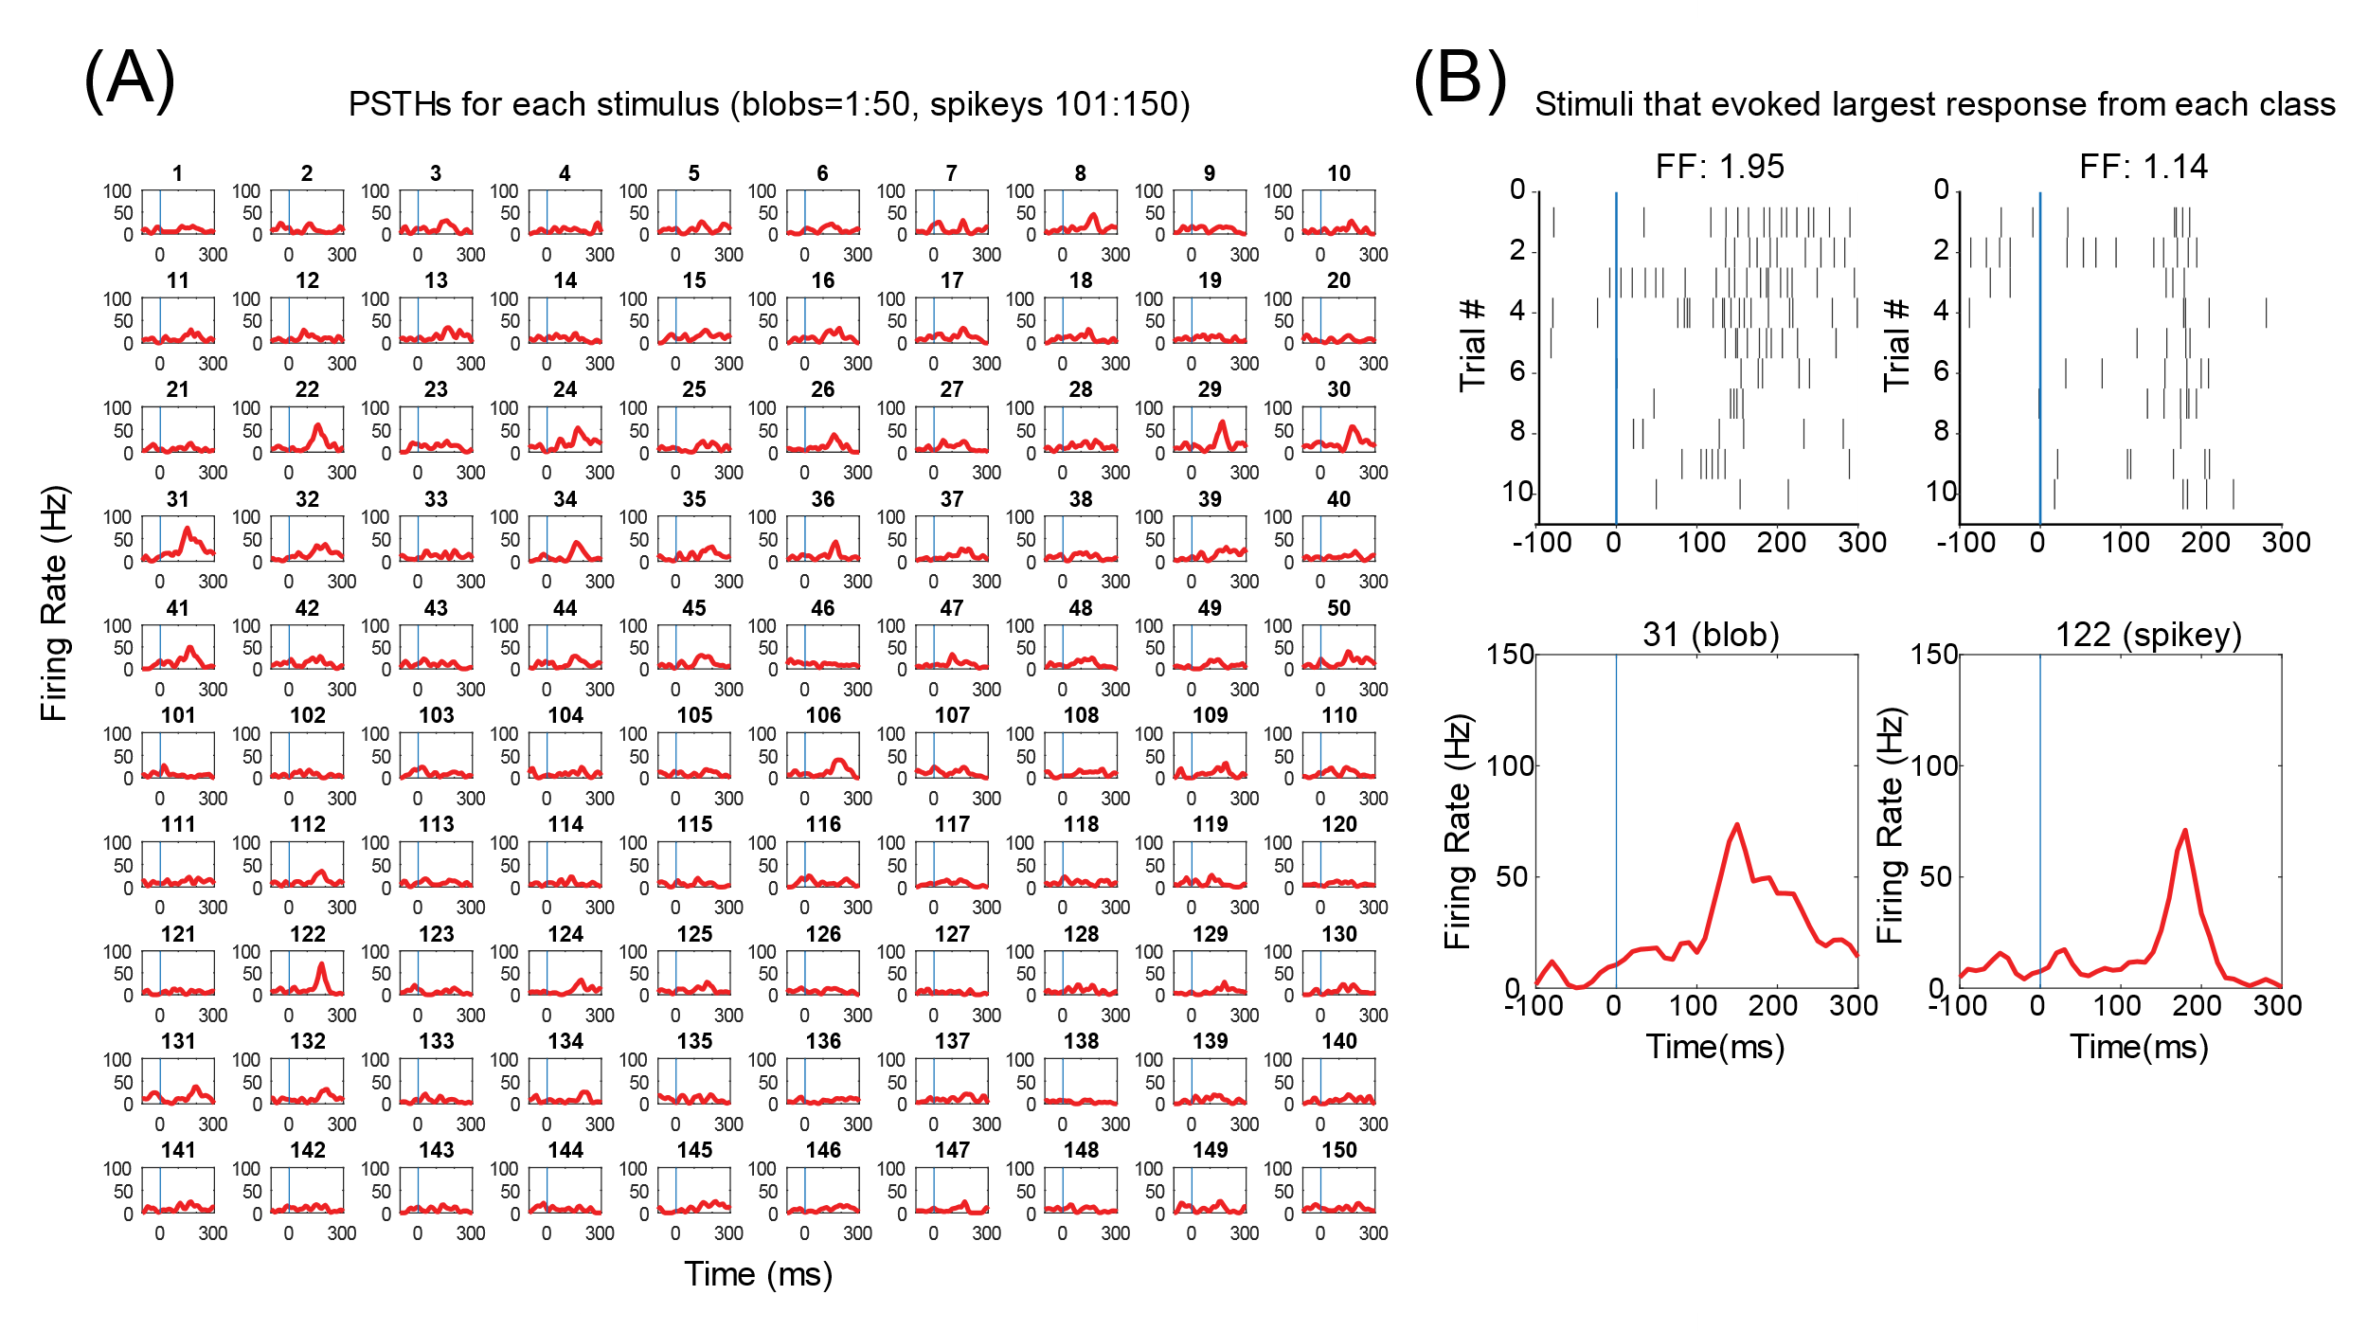
Figure 3-6. Sample response to all shape pairs. (A) Responses of single neuron from Monkey Y to all 100 shape stimuli. 1-50 are blob shapes, 101-150 are the corresponding spikey shapes. (B) Most effective stimuli from each shape class by raw rate in 150 ms window, 50 ms after stimulus onset, and the corresponding fano factor across the 10 trials for each stimulus. Top: raster plots of each trial for each stimulus. Bottom: PSTHs for each of the stimuli.
Five selectivity metrics were calculated for the neural responses to passive viewing of the 100 shape stimuli. The selectivity metrics were calculated for each class of shape stimuli. Table 3-2 shows the average values for the metrics for all units from Monkey Y and Monkey H, and multi-unit responses and single units separately. Subscripts indicate whether it was for the blob class (b) or spikey class (s) of shapes. Selectivity indices (SI) and broadness measures show that generally, units from Monkey H were more selective and fewer shape stimuli were effective in modulating the neural responses.
Metric | Monkey Y |  |  | Monkey H
Metric | All units  N=54 | Single units (SU) N=24 | Multi-unit N=30 | All units  N=113* | Single units (SU) N=20* | Multi-unit N=93*
DOS_{B} | 0.62±0.02 | 0.70±0.02 | 0.56±0.02 | 0.55±0.01 | 0.62±0.03 | 0.54±0.01
DOS_{S} | 0.61±0.02 | 0.70±0.02 | 0.54±0.02 | 0.56±0.01 | 0.62±0.04 | 0.54±0.01
breadth _{B} | 0.71±0.01 | 0.76±0.02 | 0.66±0.02 | 0.64±0.01 | 0.70±0.03 | 0.62±0.01
breadth _{S} | 0.70±0.02 | 0.77±0.02 | 0.65±0.01 | 0.64±0.01 | 0.69±0.03 | 0.63±0.01
SI_{B} | 0.82±0.02 | 0.91±0.02 | 0.75±0.03 | 0.81±0.02 | 0.90±0.04 | 0.79±0.02
SI_{S} | 0.82±0.02 | 0.91±0.02 | 0.76±0.03 | 0.81±0.02 | 0.89±0.04 | 0.79±0.02
broadness_{Wilcoxon_B} | 0.38±0.02 | 0.34±0.05 | 0.41±0.04 | 0.16±0.02 | 0.15±0.04 | 0.16±0.02
broadness_{Wilcoxon_S} | 0.32±0.03 | 0.30±0.05 | 0.33±0.04 | 0.15±0.02 | 0.15±0.05 | 0.16±0.02
broadness_{%max_B} | 0.53±0.03 | 0.48±0.05 | 0.56±0.04 | 0.31±0.02 | 0.36±0.04 | 0.30±0.02
broadness_{%max_S} | 0.45±0.03 | 0.41±0.05 | 0.49±0.04 | 0.30±0.01 | 0.34±0.05 | 0.29±0.02
Table 3-2. Summary of selectivity metrics calculated from passive viewing data for neural responses from Monkey Y and Monkey H. Selectivity metrics were calculated for each shape class blobs (B subscript) and spikeys (S subscript). Average values ± S.E.M. are shown. *Six neural responses from Monkey H passed criteria for inclusion in task-data but did not have quality passive viewing data; metrics could not be calculated for these units, so the N is lower than in Table 3-1.

Single pair: two kinds of responses to shape clarity
After a shape pair was selected, the pair was shown with variable levels of shape clarity using the same passive viewing paradigm. The pair was shown using at least the same clarity levels as those used in the active task. Sometimes additional clarity levels were shown to get a smoother distribution of responses. During a recording session with Monkey Y, it was first discovered that blurry shapes could be more effective in driving a neural response than crisp shapes. These units were more difficult to encounter using traditional surveying methods, as those usually use crisp shapes (as was done in this study). After discovering that some neurons would have poor responses in passive viewing using these stimuli, if a neuron did not respond to any of the 100 shapes, the shapes were run again with a lower shape clarity to rule out the possibility of finding a neuron that responded to lower shape clarity. Figure 3-7a,b shows examples of the two main kinds of responses to shape clarity: increased firing rate with increasing shape clarity or maximum rate with intermediate clarity. Neural responses were not of only these two kinds, rather, responses were more along a gradient of possibilities between these two extremes Sometimes a crossover was observed, where intermediate clarity was most effective for one shape, as if the unit was almost confusing a blob with 1.0 clarity and a spikey with intermediate clarity, when of the same pair (Figure 3-7c).
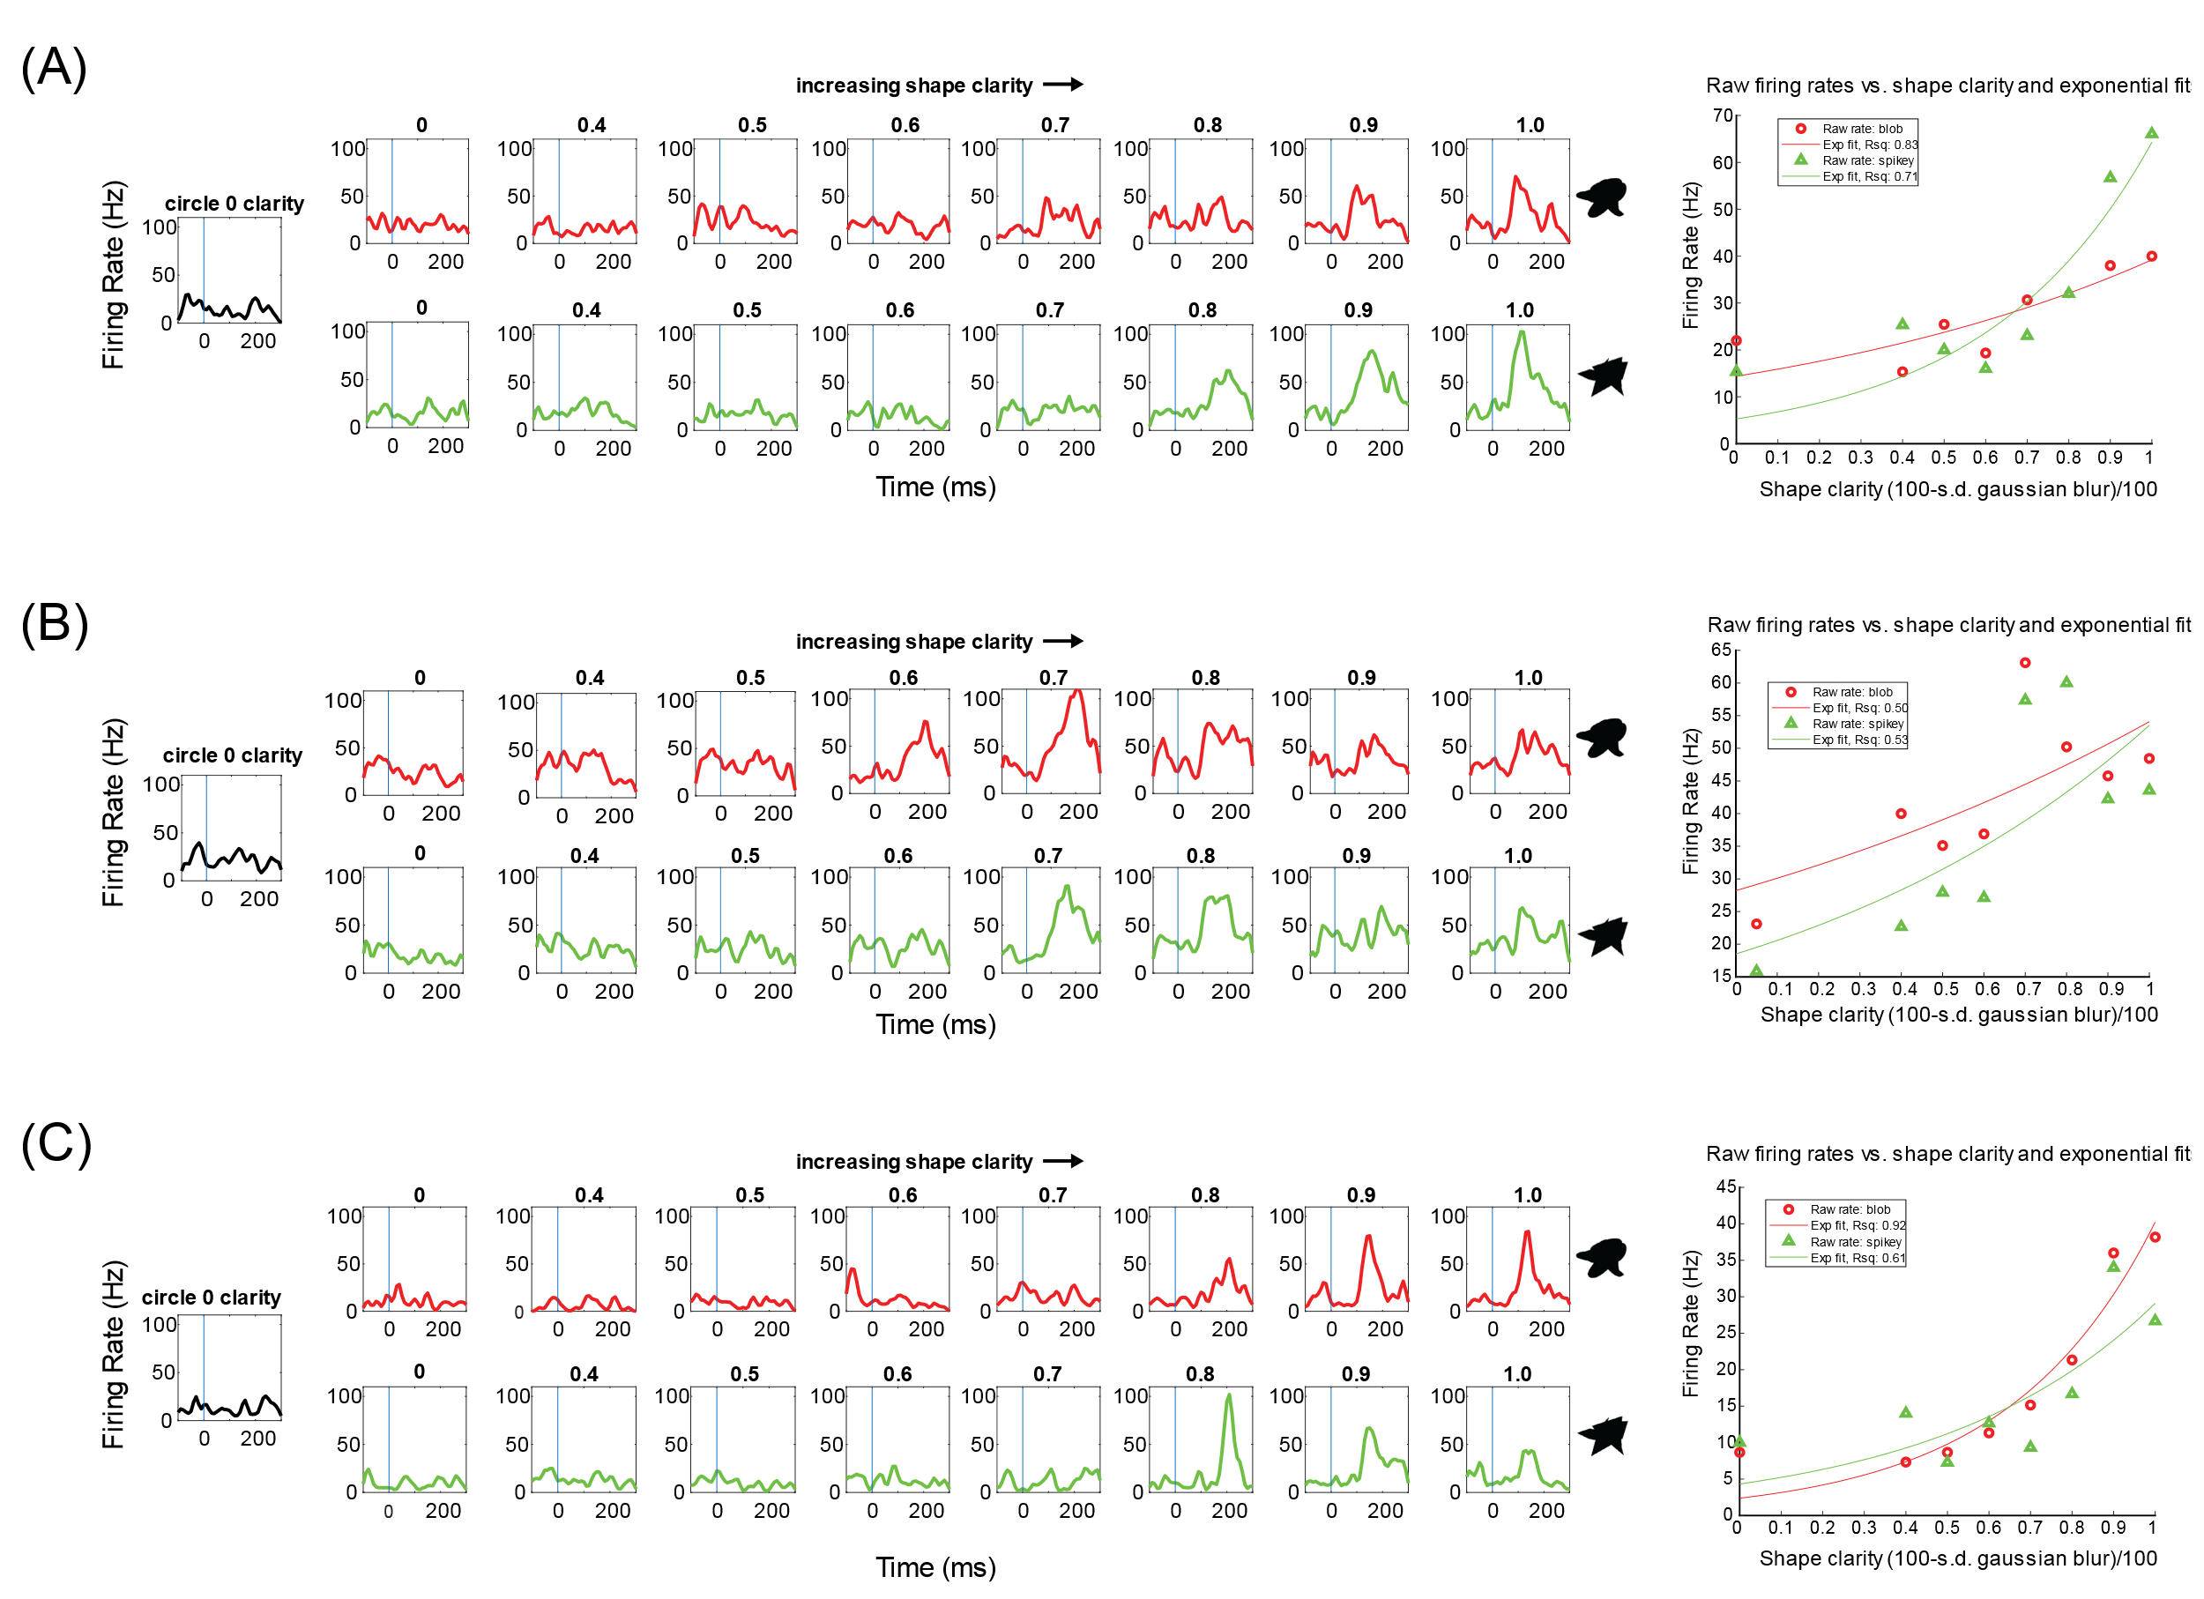
Figure 3-7. IT neurons can respond differently to varying shape clarity. (A) An example of a neuron whose rate increases with increasing shape clarity for both shapes in a pair. Best response is at 1.0 shape clarity (no blur). Left: average firing rates for each shape (blob, red; spikey, green) at clarity levels ranging from 0 to 1.0, including all clarity levels in the task. Neuron101318Y (B) An example of a neuron that responds best to 0.7 clarity for both shapes. Neuron012119Y (C) An example of a neuron with a mixture of the kinds of responses seen in a) and b), that responds best to the blob with 1.0 clarity and spikey with 0.8 clarity. Neuron103018Y

While it appeared that some stimuli evoked responses with longer latencies (e.g. Figure 3-7c, bottom row spikey PSTH at 0.8 clarity), no significant differences in stimulus onset to peak firing rate latency were found for the three main kinds of responses. This data is summarized in Table 3-3, which also shows the percentage of each kind of response for both monkeys. There was a much higher proportion of units that responded best to 1.0 shape clarity for both shapes in Monkey Y than Monkey H, but not a higher number of overall units. There were many more units that responded best to intermediate levels of shape clarity in Monkey H.
 | Monkey Y | Monkey H
# total units that passed criteria for active task relevance | 54 | 116
# units with max response to 1.0 clarity for both shapes (%)  Average latency to best stimulus (ms) | 34 (63%)  142±8 | 41 (35%)  132±7
# responding best to another shape clarity (%)  Average latency to best stimulus (ms) | 9 (17%)  143±20 | 50 (43%)  130±8
# with max response to 1.0 clarity for one shape and not the other (%)  Average latency to best stimulus (ms) | 11 (20%)  139±11 | 25 (22%)  132±14
Table 3-3. Summary of neural responses to shape clarity during passive viewing and latencies to peak firing rates for the most effective stimulus (shape + clarity). Neural responses were classified into three main categories based on their maximum responses. Latency of stimulus onset to the peak of the response was calculated for each unit for the most effective stimulus (shape and clarity), average values for each sub-group of units is shown; no significant differences in latency were found.

Moving blur
This task was an attempt to have a “motion-only” condition to assess how neurons responded to the different movement patterns without any shape information or active task demands. In this passive viewing condition, the black circle with 0.0 shape clarity (moving blur) was shown for 1500 ms while the monkey fixated at the center of the screen. Then, without a delay, a shape was shown (see Section 3.7.3 for analysis of the responses to these shapes). Figure 3-8 shows the average responses to the four motion conditions (blob-associated motion, spikey-associated motion, shared motion, and static) for both monkeys. There is an obvious difference in the early visual response for the two monkeys across their respective subpopulations. All three motions enhanced the visual transients in Monkey Y, and suppressed the visual transients in Monkey H. This might arise from the fact that the stimulus for 0.0 clarity was darker for Monkey H than Monkey Y, as although the shape clarity was 0.0 for both (the underlying shape was a circle and not a blob or spikey shape), the standard deviation of the gaussian used to blur the stimuli was 100 for Monkey Y (more blur) and 60 for Monkey H (less blur), which also affected the stimulus luminance. Monkey H’s behavioral performance on the matching task dropped near chance at stdev=50 (see Chapter 2, Figure 2-5), so less blur was needed for the monkey to attend to motion over the underlying circle shape. Nevertheless, the suppression of responses in all motion conditions is not necessarily to be expected, as those were also the same luminance as the other stimuli. It is also possible that differences in attention to motion/ interpretation of motion between the two animals could explain these differences. Previous work has shown that neural responses to ambiguous stimuli in area IT can be manipulated based on what stimuli they are interpreted as being (Liu & Jagadeesh 2008). Chelazzi et al., demonstrated that responses in area IT can increase even before the onset of a preferred shape of a neuron, if the stimulus is behaviorally relevant and expected (Chelazzi et al., 1998). It is possible that Monkey H was truly “passive” whereas Monkey Y was attending more during the passive task.
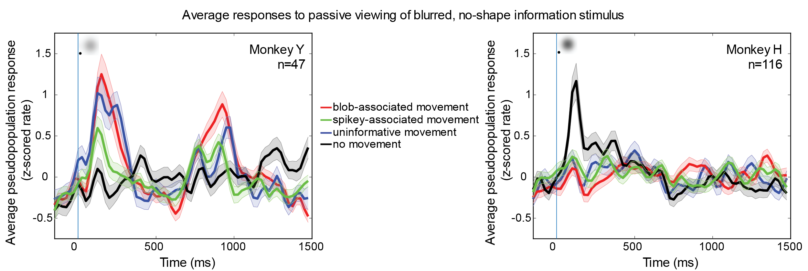
Figure 3-8. Average responses of each pseudopopulation of neurons to 0.0 clarity, moving blur while monkeys held central fixation. Left: Average responses for Monkey Y (n=47) showing that all motion conditions increased the initial transient response and elicited a peak around the start of the second cycle of motion (750ms). Right: Average responses for Monkey H (n=116) showing that all motion conditions suppressed the initial transient response. Firing rates were computed for each neural response using 25ms, non-overlapping bins, and each response was z-scored across all four motion conditions across all time bins before computing the population average. Blue bar indicates stimulus onset and the inset blurred stimuli are shown for each monkey. Error bars s.e.m.

3.5 Active task
Average firing rates across motion patterns and clarity levels
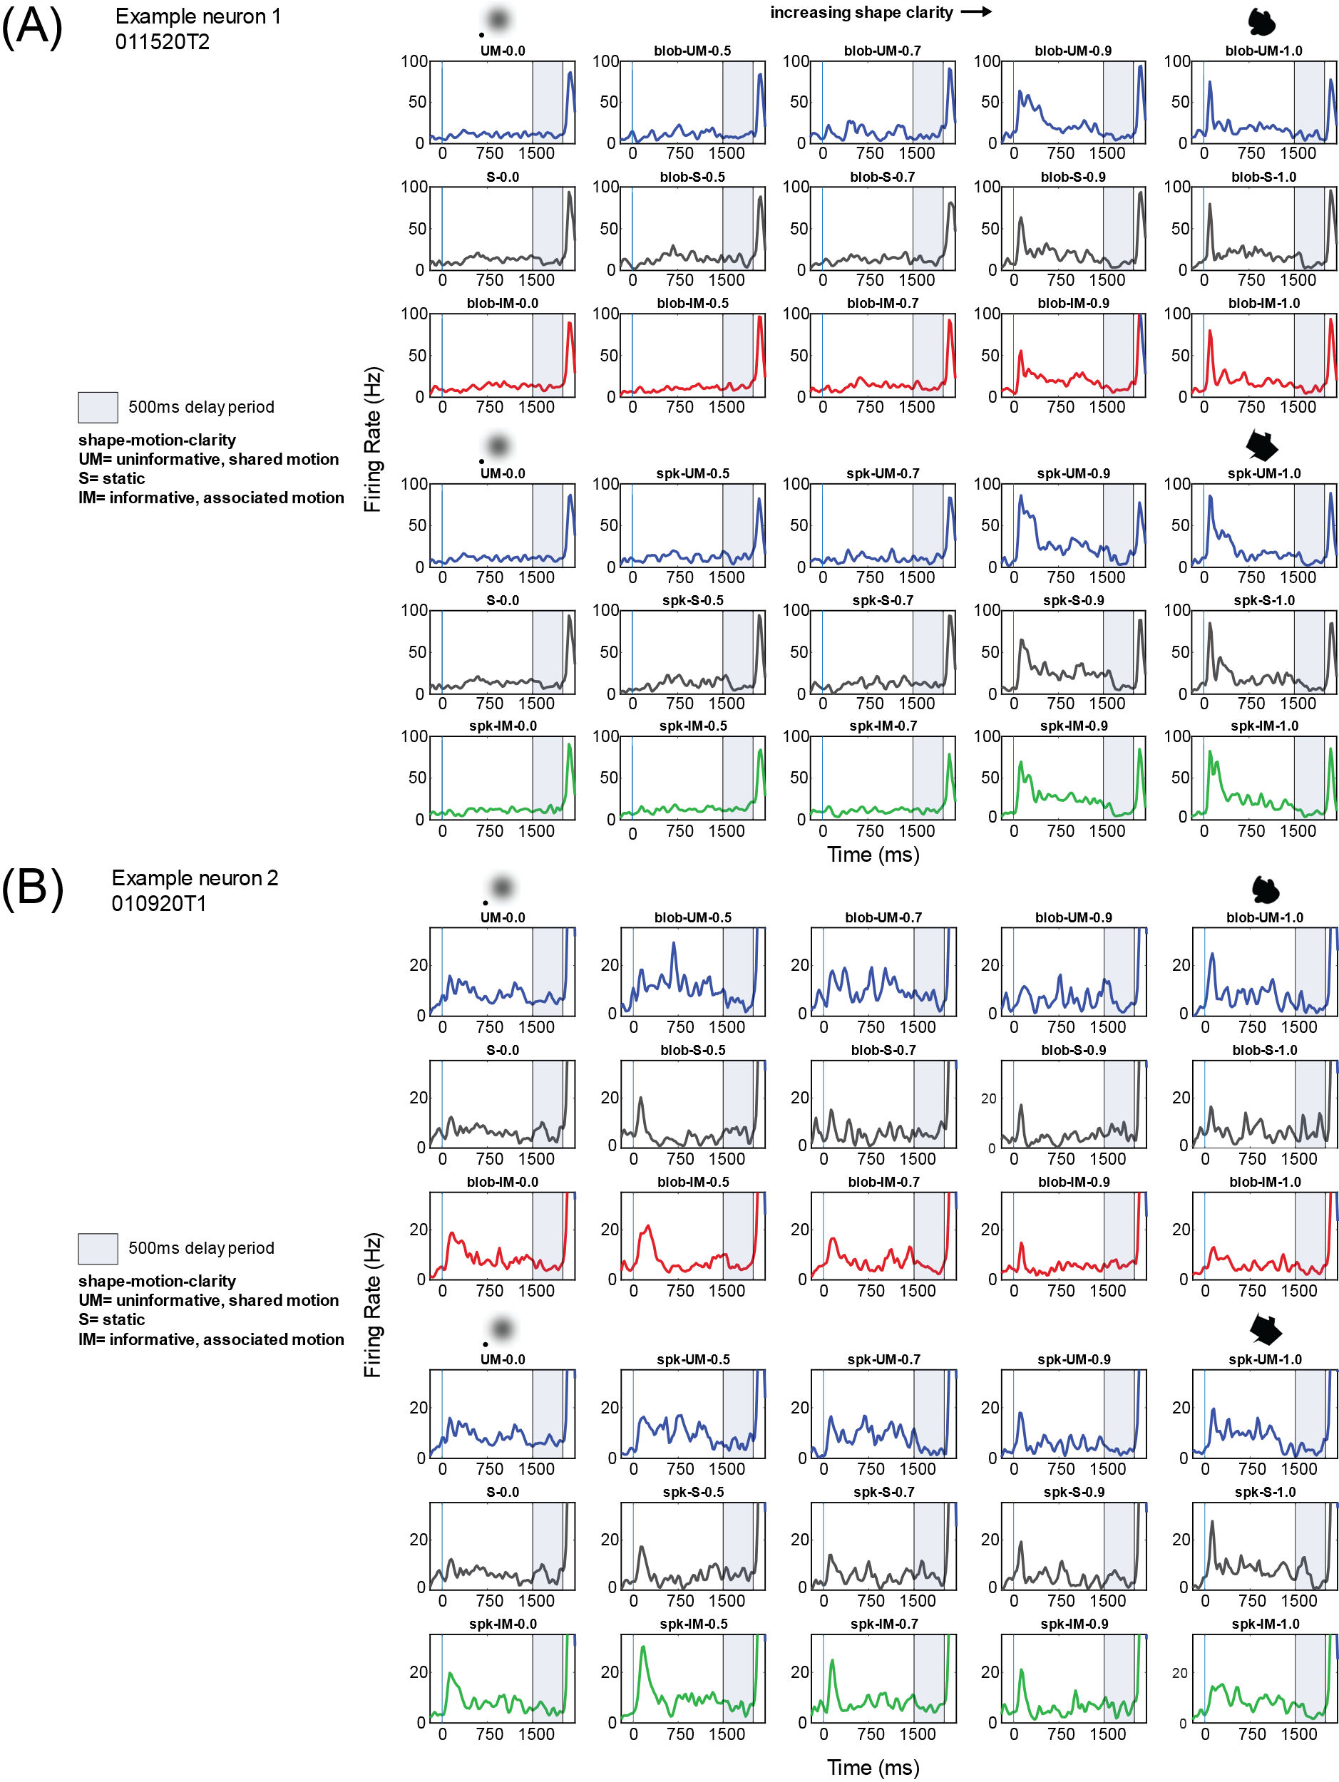
Figure 3-9. Examples of how IT neurons can respond differently to combinations of shape clarity and motion. (A) Average firing rates for a single neuron from Monkey H across all shape clarity and motion conditions. Initial firing rate increases as shape clarity increases (left to right) across all motion

Figure 3-9 legend continued:: …conditions. Choice onset at 2000 ms evokes the largest response across all clarity levels and motion conditions. (B) A different neuron that has a larger initial response to lower shape clarity, particularly in the informative/associated motion conditions ( red and green). Interestingly, the choice onset still evokes a large initial transient. 25 ms bins were used to calculate firing rates. Error bars s.e.m.
The first question we sought to answer in the active task data was whether any neurons responded to shape clarity in a similar manner to the passive task, and how motion affected responses to different shape clarity levels. Similar to what had been observed in the passive data, there were multiple kinds of responses to variable shape clarity. Two examples of such responses are shown in Figure 3-9. The first example (Figure 3-9a) is that of a neuron that responded with a transient response to target onset across all motion conditions (blue, gray, red, green) and shape conditions at 1.0 shape clarity. This transient response decayed as shape clarity decreased, across all motion conditions. The second example (Figure 3-9b) shows a similar transient response, but the magnitude and presence of the response is contingent on the shape clarity and motion condition. This neuron exhibited a maximum response at 0.5 clarity, which still had some shape information, but was at a level at which Monkey H was using motion information (see Chapter 2 behavior). Interestingly, the onset of the choices (2000ms) still evoked a large increase in firing rate across all shape, clarity, and motion conditions. Knowing that these different kinds of responses existed within the population, it seemed clear that a population average would probably not be very informative, as it would combine these very different responses that might blunt selectivity to motion and shape clarity. However, the population averages serve as a useful starting point.
The average firing rates (z-scored) of each pseudopopulation across shape-clarity and motion conditions are shown in Figure 3-10. It is visible from this figure that the population averages do not show obvious differences between the motion conditions, despite seeing differences at the single neuron level (there are more examples than the one shown in Figure 3-8). In particular, the population average does not appear to reflect differences in the motion conditions at the lowest clarity level, where the monkeys were both using knowledge of the shape-motion associations to guide their responses.
It would be possible to repeatedly plot subpopulations of units, and for example, look at those that only respond maximally to a certain level of shape clarity, and look for differences between motion conditions at that clarity level. (Single and multi unit sub populations were plotted and no obvious differences were found, data not shown). Perhaps differences could be highlighted about those subgroups (perhaps using the groups from Table 3-3), but that would be missing the point as there appears to be an interaction between shape clarity and motion. There are not consistent differences visible at the pseudpopulation level across all shape clarity levels and motion patterns, as shifts in firing rates are not consistently happening at a single shape clarity or in a single motion condition. Even a simple example of averaging the responses from two example neurons shown in Figure 3-9, it would be easy to see how an average response of these two neurons might look fairly invariant to changes in shape clarity, similar to what is seen in Figure 3-10. This would not be the first study of its kind to assert that the population average might misrepresent what information is available in the population (Ince et al., 2013). Thus the population average becomes more about the proportion of responses of one kind versus another. And with 5 clarity levels, two shape classes, and four motion conditions, the proper way to do subgroup averaging begins to break down. Thus, further analyses will continue to analyze the whole population, but ask whether neurons are sensitive to shape clarity, motion, or the conjunction of the two, and ask whether the pseudopopulations can discriminate between motion conditions as a whole, using population decoding analysis.
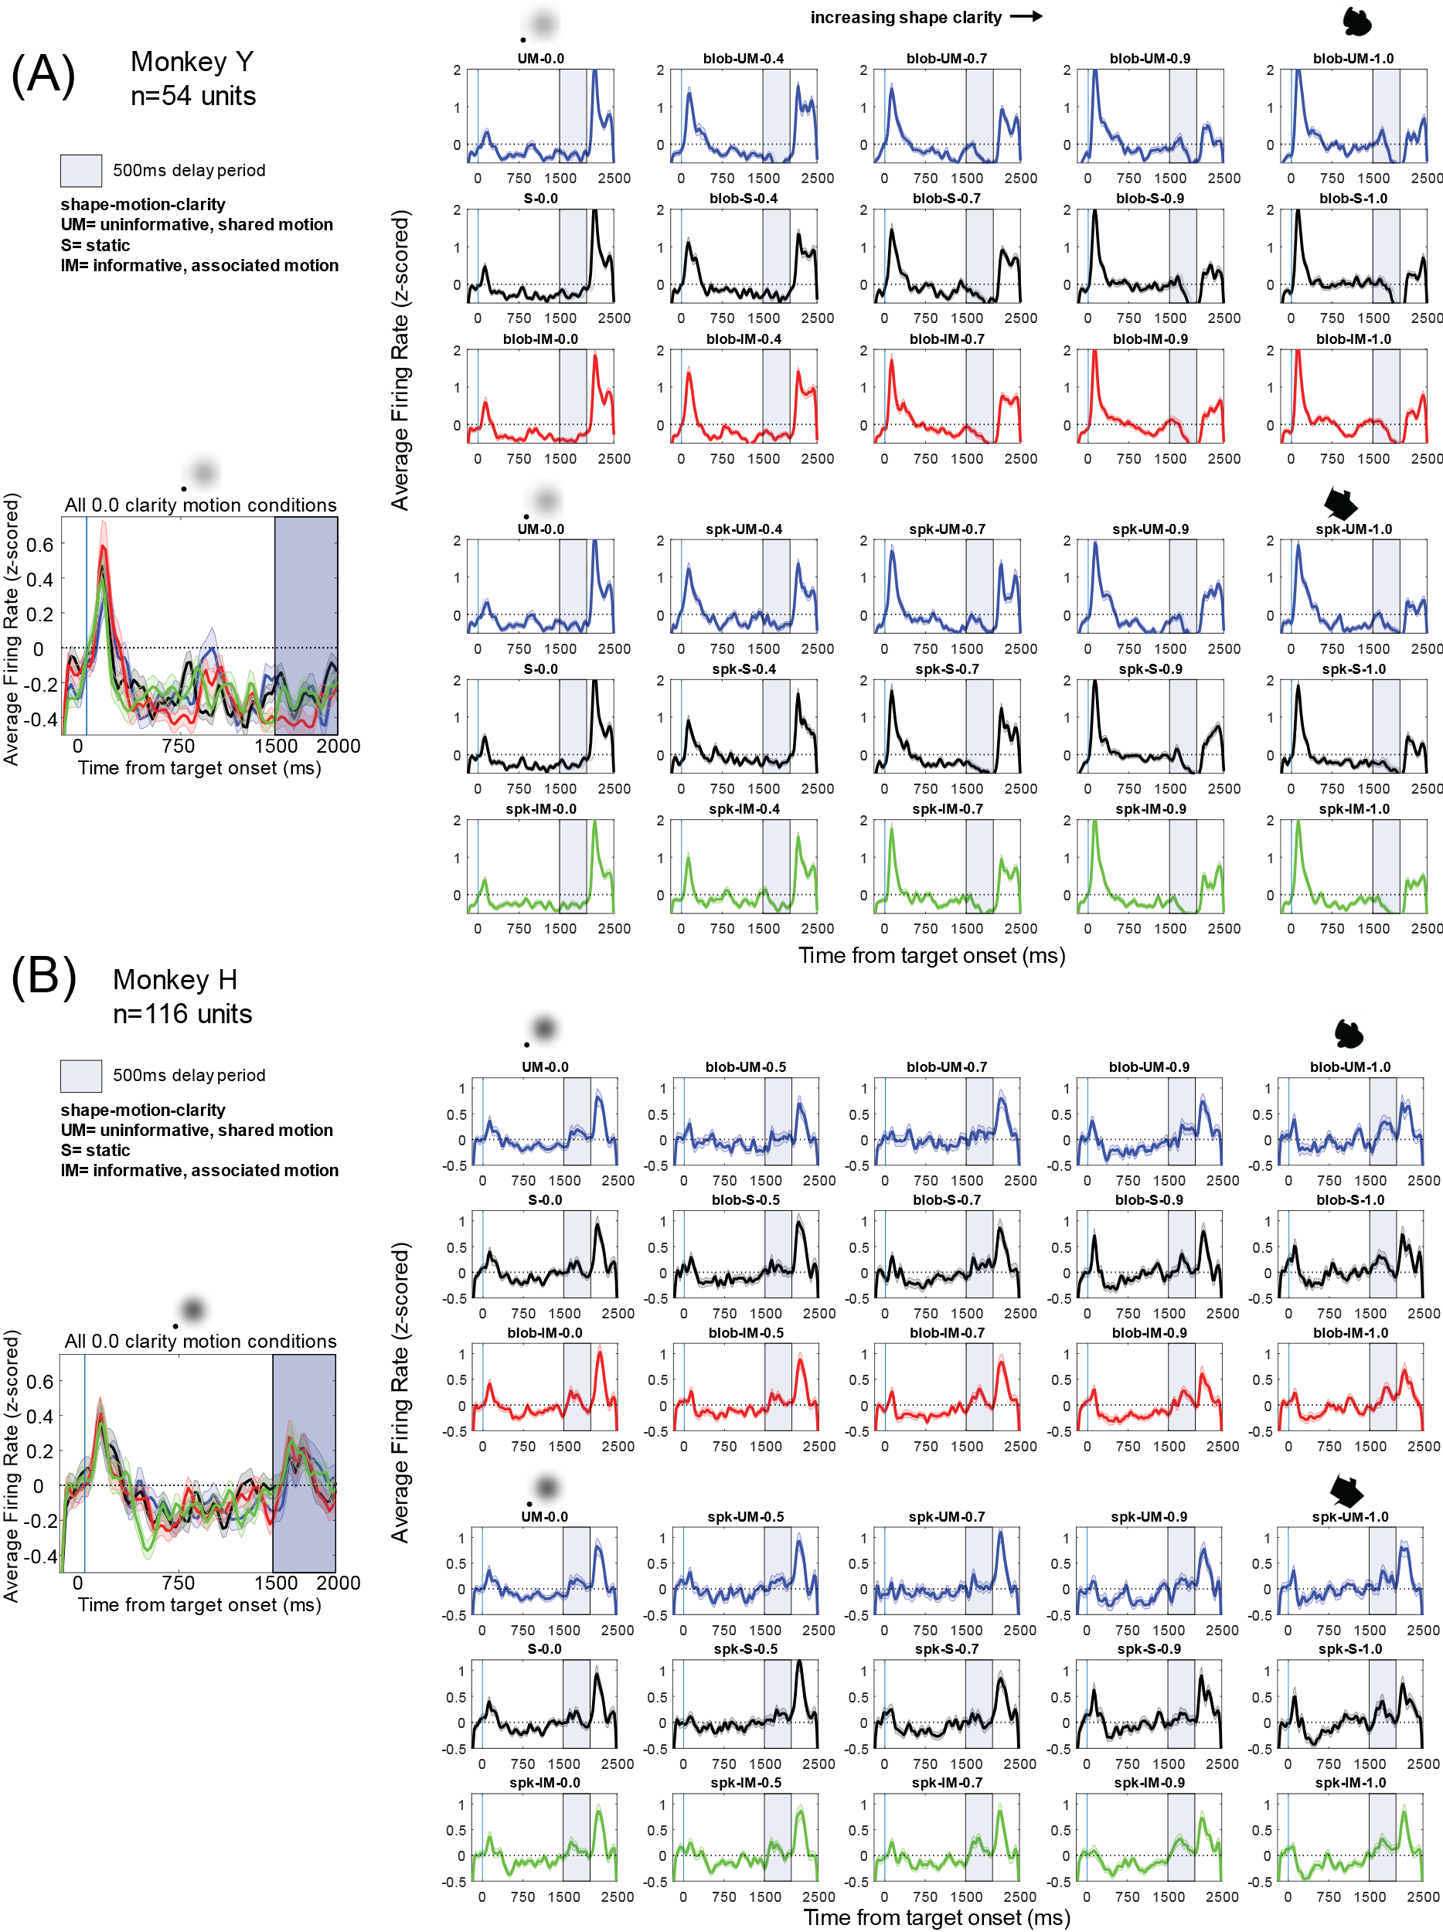
Figure 3-10. Average firing rates of the pseudopopulations from each monkey during the active across clarity and motion conditions. (A) Monkey Y (n=54). Average firing rates (individually z-scored) for all motion, shape and clarity conditions. Each row is a motion pattern, either uninformative/shared, static, or informative/associated, for each shape class. Shape clarity increases from left to right. Average magnitude of initial visual transient increased with increasing shape clarity. Average response to choice onset (2000ms) increased with decreasing target shape clarity. Inset figure is the overlay of the first column, all motion conditions at 0.0 shape clarity. (B) Same population averages for Monkey H (n=116). 25ms bins were used for calculating average rate, and each unit was z-scored before computing the population average. Error bars s.e.m.

Motion can shift the preferred shape clarity of IT neurons
It is typical in recording studies done in area IT to consider neuronal preference and selectivity to features and conjunctions of features. It is fairly well understood that an IT neuron that responds to a red house may or may not respond to red, a house, or the door of that house in isolation. Often it is the complex (perhaps non-intuitive) combination that makes for the most effective stimulus. In this section, the responsiveness of neurons to shape, clarity, and motion is considered. The populations from both monkeys had units with various levels of shape selectivity- on the rare occasion a neuron would respond to only one or two shapes in the set of 100, and on the other extreme, some had very little selectivity were responsive to all shapes in set; all kinds of responses in between were also observed. Shape selectivity could also vary by clarity level, but not always (as previously shown in the example neurons and passive viewing data in Figure 3-7). Thus, in the simplest sense, lower shape clarity did not always make blobby shapes seem like spikey shapes (nor was this bias reflected in the monkey behavior, see Chapter 2 for a description of behavioral biases at 0.0 clarity). Therefore, the focus of this section is on preferred shape clarity and shifts in this preference due to motion, and the sensitivity to shape, motion and conjunctions of shape and motion.
Figure 3-11 shows the proportion of units that had their maximum response during the early visual period (50->200ms after stimulus onset) at a given clarity level, for each shape category, and the effects of the shared motion and associated motions on this preference. Each neuron is represented in each of the plots, so that the shift in the preference distributions can be observed without labeling the neurons as “blob-preferring” or “spikey preferring,” neurons. Clarity preference was assessed as the maximum rate at least 25% greater than pre-stimulus baseline. This means that any neurons that were inhibited during the early visual period in response to target stimuli, or that did not exhibit excitation above the threshold criterion, were labeled as having no-preference in a given motion condition. Furthermore, if a neuron exhibited weak but consistent responses in the early visual period across all clarity levels (a rare outcome), then this unit would also be classified as having “no preferred” shape clarity. There are two questions that can be answered with these plots: what is the effect of any motion on preferred shape clarity (comparing blue and black traces, shared motion and static conditions, respectively) and what is the effect of the associated motion on preferred shape clarity (comparing red and black for blob trials and green and black for spikey trials). For both monkeys, there were changes in shape clarity preference with motion conditions, notably decreasing the preference for 1.0 shape clarity and increasing both preference for 0.0 clarity and no preference (meaning conditions were more similar or lower rate). The orange arrows in Figure 3-11 point out the increases in the proportion of units having no preference due to motion. This is particularly interesting, because it means that the different levels of shape information are less important when there is motion, and even more so when the motion is associated with the shapes. Although it cannot be concluded that this effect is supporting behavior directly, it could be linked to the monkeys’ use of shape-motion associations during the behavioral task and their increased attention to motion when the motion is relevant for shape selection.
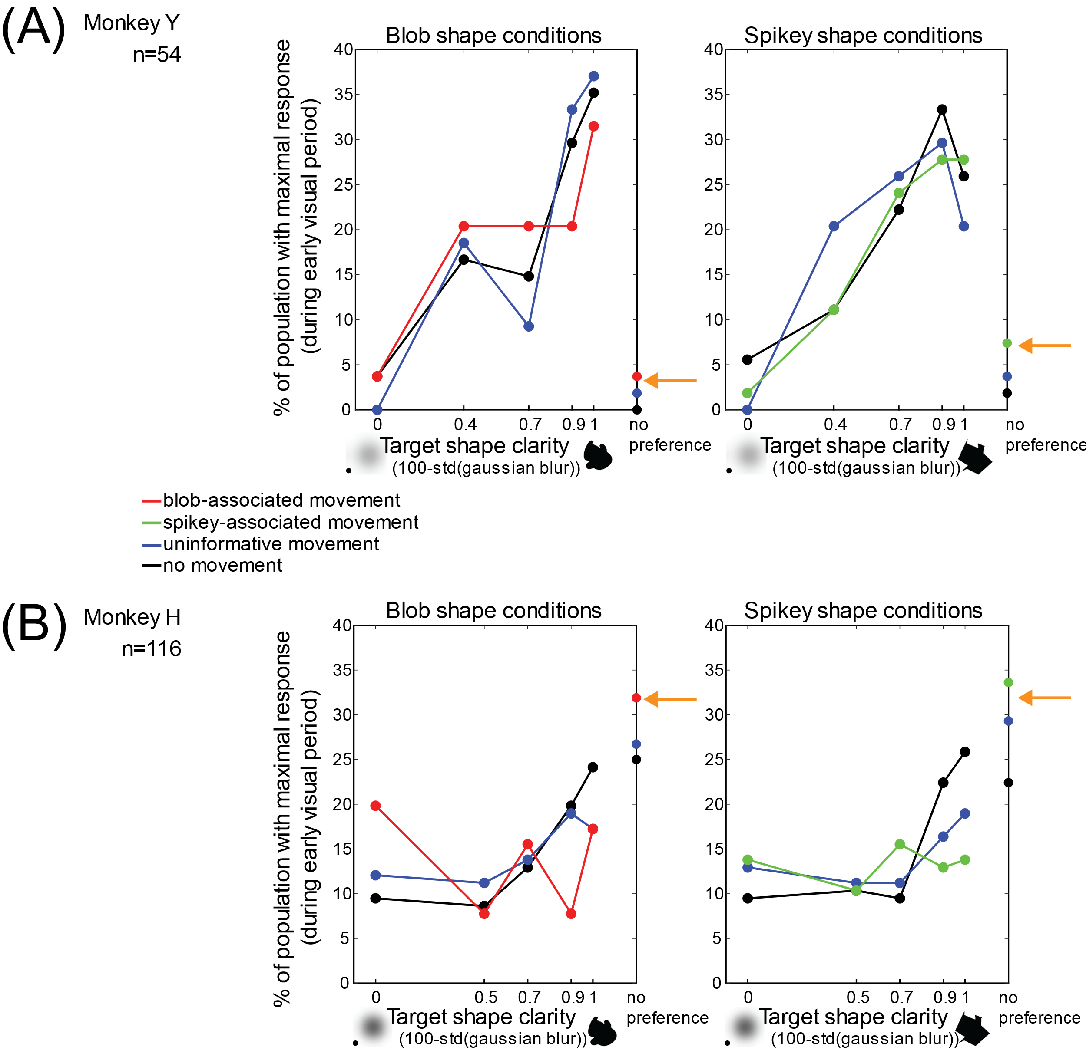
Figure 3-11. Population proportions that respond best to each clarity level, and the effect of motion on this preference. (A) Percentage of population that had its maximal response to each clarity level (during the initial visual period, 50->200ms after stimulus onset), for each shape category and its corresponding motion conditions, for Monkey Y (n=54 units). Left: Blob shape conditions (static, shared motion, associated motion). (B) Same plots as in (A) for Monkey H. Orange arrows highlight a small but consistent effect observed in both monkeys for both shape categories, an increase in the proportion of no-preference units in the population. Rates were calculated using a single 150ms bin and were only significant if 25% higher than the baseline pre-stimulus rate.
We next asked if neurons were motion sensitive, and whether the same neurons that were motion sensitive and how this changed with target shape clarity. Figure 3-12 shows the proportions of units that were motion sensitive at each clarity level, which was assessed with a one-way ANOVA for each shape class (p<0.05) across trials in each of the three motion conditions for each shape class. Monkey Y had a larger proportion of units that were motion sensitive at intermediate clarity levels (but fewer units overall). There was a slight increase in motion sensitivity for both monkeys as clarity increased, but a divergence in trends at the highest level of shape clarity.
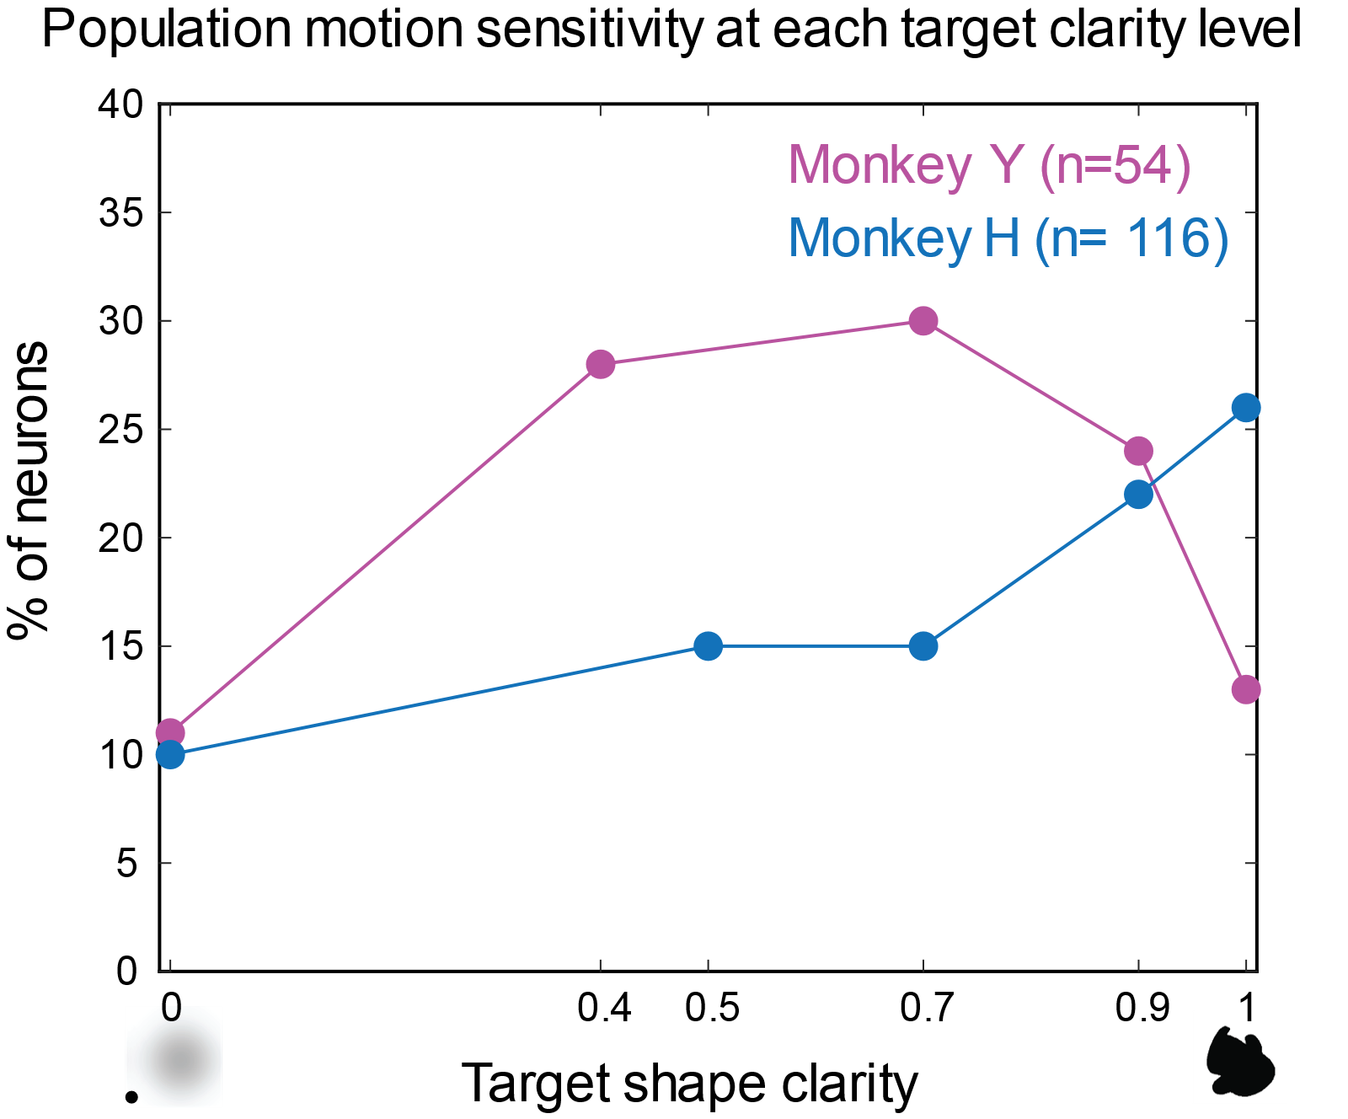
Figure 3-12. Motion sensitivity during the early visual period as a function of shape clarity. This plot shows the percentage of units at each clarity level that were sensitive to motion during the early visual period (50-200ms after stimulus onset). Magenta=Monkey Y, Cyan=Monkey H. One-way ANOVA for each shape class p<0.05 across the raw rates extracted from each trial for each of the three motion conditions.
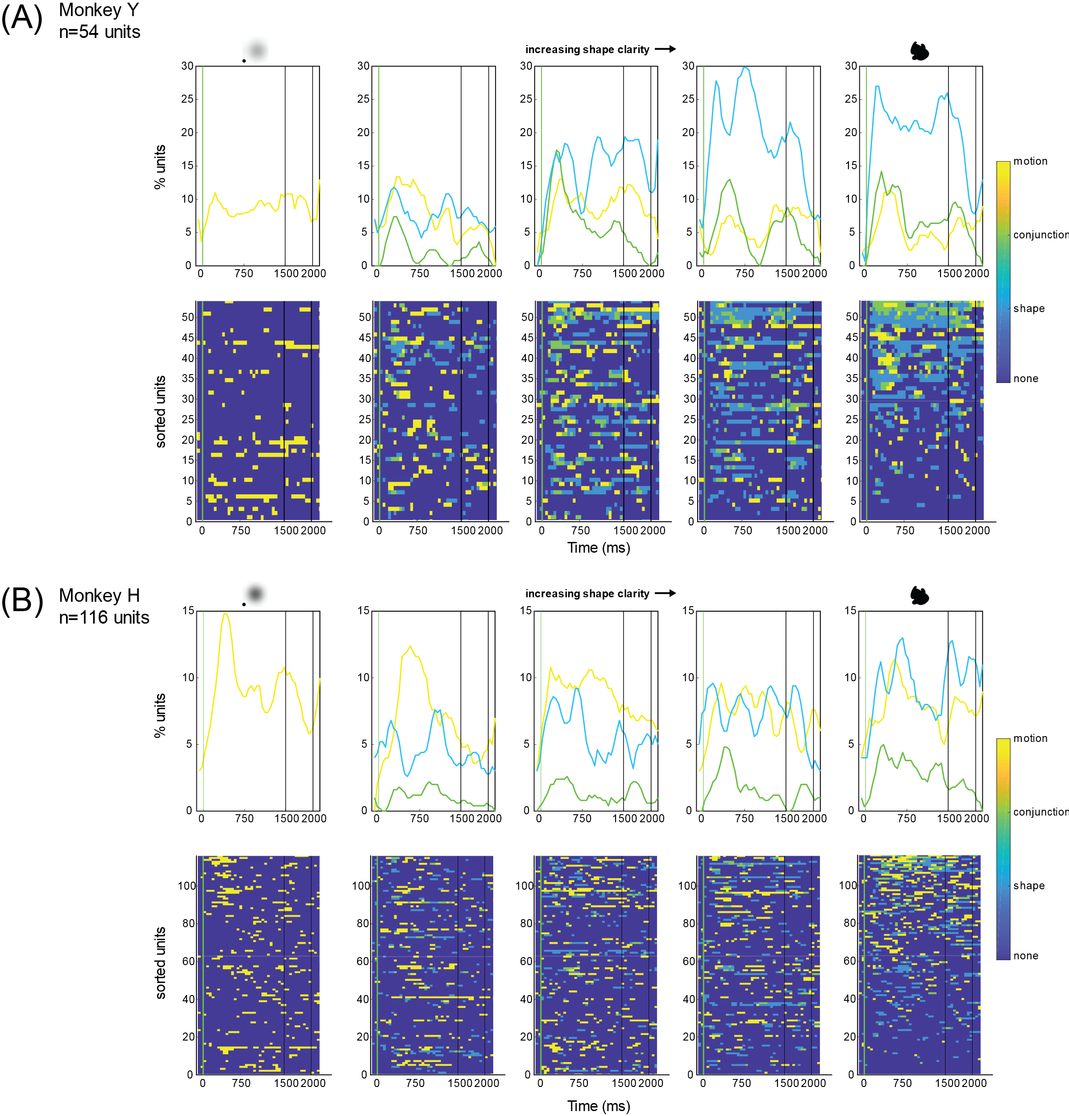
Figure 3-13. Heatmaps of sensitivity to motion, shape or conjunction changes with target shape clarity and time after target onset. (A) Top: Proportions of units that are sensitive (not necessarily selective) to motion, conjunction, or shape information during the target and delay period. Bottom: heat maps of sensitivity to motion(yellow), shape (light blue), and shape+motion (green), through the target and delay period for each neuron for Monkey Y. (B) Same analysis for Monkey H. Sensitivity to these three features was done for 150ms windows that slid by 50ms across the entire target and delay period. Average firing rates were first assessed for whether they were significantly different across motions patterns within a shape class (one way ANOVA p<0.05). If motion sensitive, then the neuron was tested for conjunction sensitivity by testing whether there was a difference in all blob conditions and all spikey shape conditions (one way ANOVA p<0.05). If p>0.05, then the unit was only motion sensitive. If p<0.05, the unit was classified as conjunction sensitive. If the unit was originally deemed not motion sensitive, then it was assessed for shape sensitivity with the same comparison of rates across blob and spikey conditions(one way ANOVA p<0.05). If p>0.05 then the unit was not sensitive (in a statistically significant manner) to motion, shape or conjunctions.
Although sensitivity to shape clarity and motion have been assessed somewhat independently thus far, it is clear that there is an interaction between these features at the neural level. Furthermore, analysis has focused on the initial visual period, which is the time of typical visual responses in area IT. Previous work in the lab has suggested that ambiguous stimuli (such as the blurred ones used in this task) promote recurrent processing that might happen beyond the initial visual period. Thus we hypothesized that sensitivity to motion and shape information might fluctuate in time, and that the participation of units across the trial period might also fluctuate. Thus, the next analysis assessed whether selectivity for motion, shape, and shape-motion conjunction (e.g. blob+shared movement might drive the best response) changed as a function of time during the target and delay periods by using a sliding window analysis and sequential assessment of sensitivity to motion, shape class, or the combination of these two features. Each unit was assessed as either being motion or shape selective (p<0.05), and if it was, then the corresponding shape class for which the neuron showed sensitivity was used to assess whether there was sensitivity to shape+motion conjunctions. Figure 3-13 shows the heatmaps of these results and the proportion of units with sensitivity to each feature (shape, motion, conjunction, none) at each clarity level, for both monkeys. The heatmaps are sorted by overall approximate most sensitivity across the duration of the entire trial (using the total sum of the sensitivity values 0=none, 1= shape, 2=conjunction, 3=motion) at 1.0 clarity. Thus the same neurons are in the same rows across all heatmaps. It is visible from the heatmaps that the same neurons that are motion sensitive at 1.0 clarity (near the top) are not the same units that are motion sensitive at 0.0 clarity, as more units are active near the bottom of the heatmaps. Sensitivity to motion and shape information also appears to fluctuate in time.
The analyses thus far have shown that some neurons in area IT can respond to motion conditions differently, and that shape class, clarity, and motion conditions interact to bring rise to neural responses. Furthermore, it appears that the units that are motion sensitive are not necessarily consistently motion sensitive across the entire trial or all shape clarity conditions. However, average firing rates across the pseudopopulations from both monkeys did not reveal obvious differences across motion conditions. Likewise, correlations between conditions at the single neural level, when averaged across the population, did not show any obvious differences in correlation strength on average (data not shown). These results jointly suggested that perhaps the population had access to motion information and could discriminate between motion conditions, and that an analysis of patterns of activity at the population level without averaging out differences in individual neurons, might demonstrate the capacity for the population to code for different motion conditions. This led to the use of decoding analysis of the population activity, which is described in the next section.

Population decoding of shape classes correlates with task performance
The first question we needed to answer before proceeding with a decoding analysis for motion information was how the population activity reflected shape information and how this would be reflected in decoding these populations. Although these responses do come from a shape sensitive area IT, we could not be sure before running the decoding analysis that these small populations would necessarily represent the category boundary between the shape classes in a way that relates to task performance. First a decoding analysis was used to decode the shape classes across the four clarity levels potentially holding shape information (0.0 clarity had 0 shape information, so decoding for these trials would fail). We hypothesized that as shape clarity increased, decoding performance of shape class should also increase, but it was unknown how the population coding of shape information would change with clarity, and how this would relate to the monkeys’ behavior. Figure 3-14 shows the results of decoding the neural pseudopopulations for the two shape classes and the relationship between peak decoding accuracy and task performance. Critically, the trials that were used in this decoding analysis came from only the static and shared motion conditions. Representative pseudotrials of the two motion conditions were combined in equal frequencies across the shape classes (i.e. 32 trials per panel consisted of 8 blob+static, 8 blob+shared motion, 8 spikey+static, and 8 spikey+shared motion trials). Each of these trials had concatenated neural activity from the neural responses across all of the sessions. Figure 3-14a shows decoding performance increases as clarity increases for Monkey Y. Interestingly, at the weakest clarity level still containing shape information, the decoder does fairly well during the delay period (1500 ms- 2000ms) for Monkey Y, which also correlates with longer reaction times in these conditions (correlation not shown, but in Figure 2-5, right, in Chapter 2 static and shared motion trials have longer reaction times than the associated motion conditions). Figure 3-14b also shows an increase in decoding performance with increasing shape clarity for Monkey H, but very weak decoding accuracy compared to that of Monkey Y. Summaries of task performance described earlier (See Figure 2-5 in Chapter 2) showed that on the static and shared (uninformative) motion trials, Monkey Y was more sensitive to shape information than Monkey H. This is formalized in Figure 3-14c, which shows the positive correlations between maximum decoding accuracy (peaks of each of the curves in 3-14ab), and average task performance across all sessions for the static and shared motion trials, for both monkeys. While this does not indicate that these neural populations are responsible for fluctuations in task performance, it does suggest that population activity and the decoding analysis do relate to the task behavior. This suggested that decoding the pseudopopulations for motion information could potentially elucidate the capacity for these same neurons to carry information about the different motion patterns.
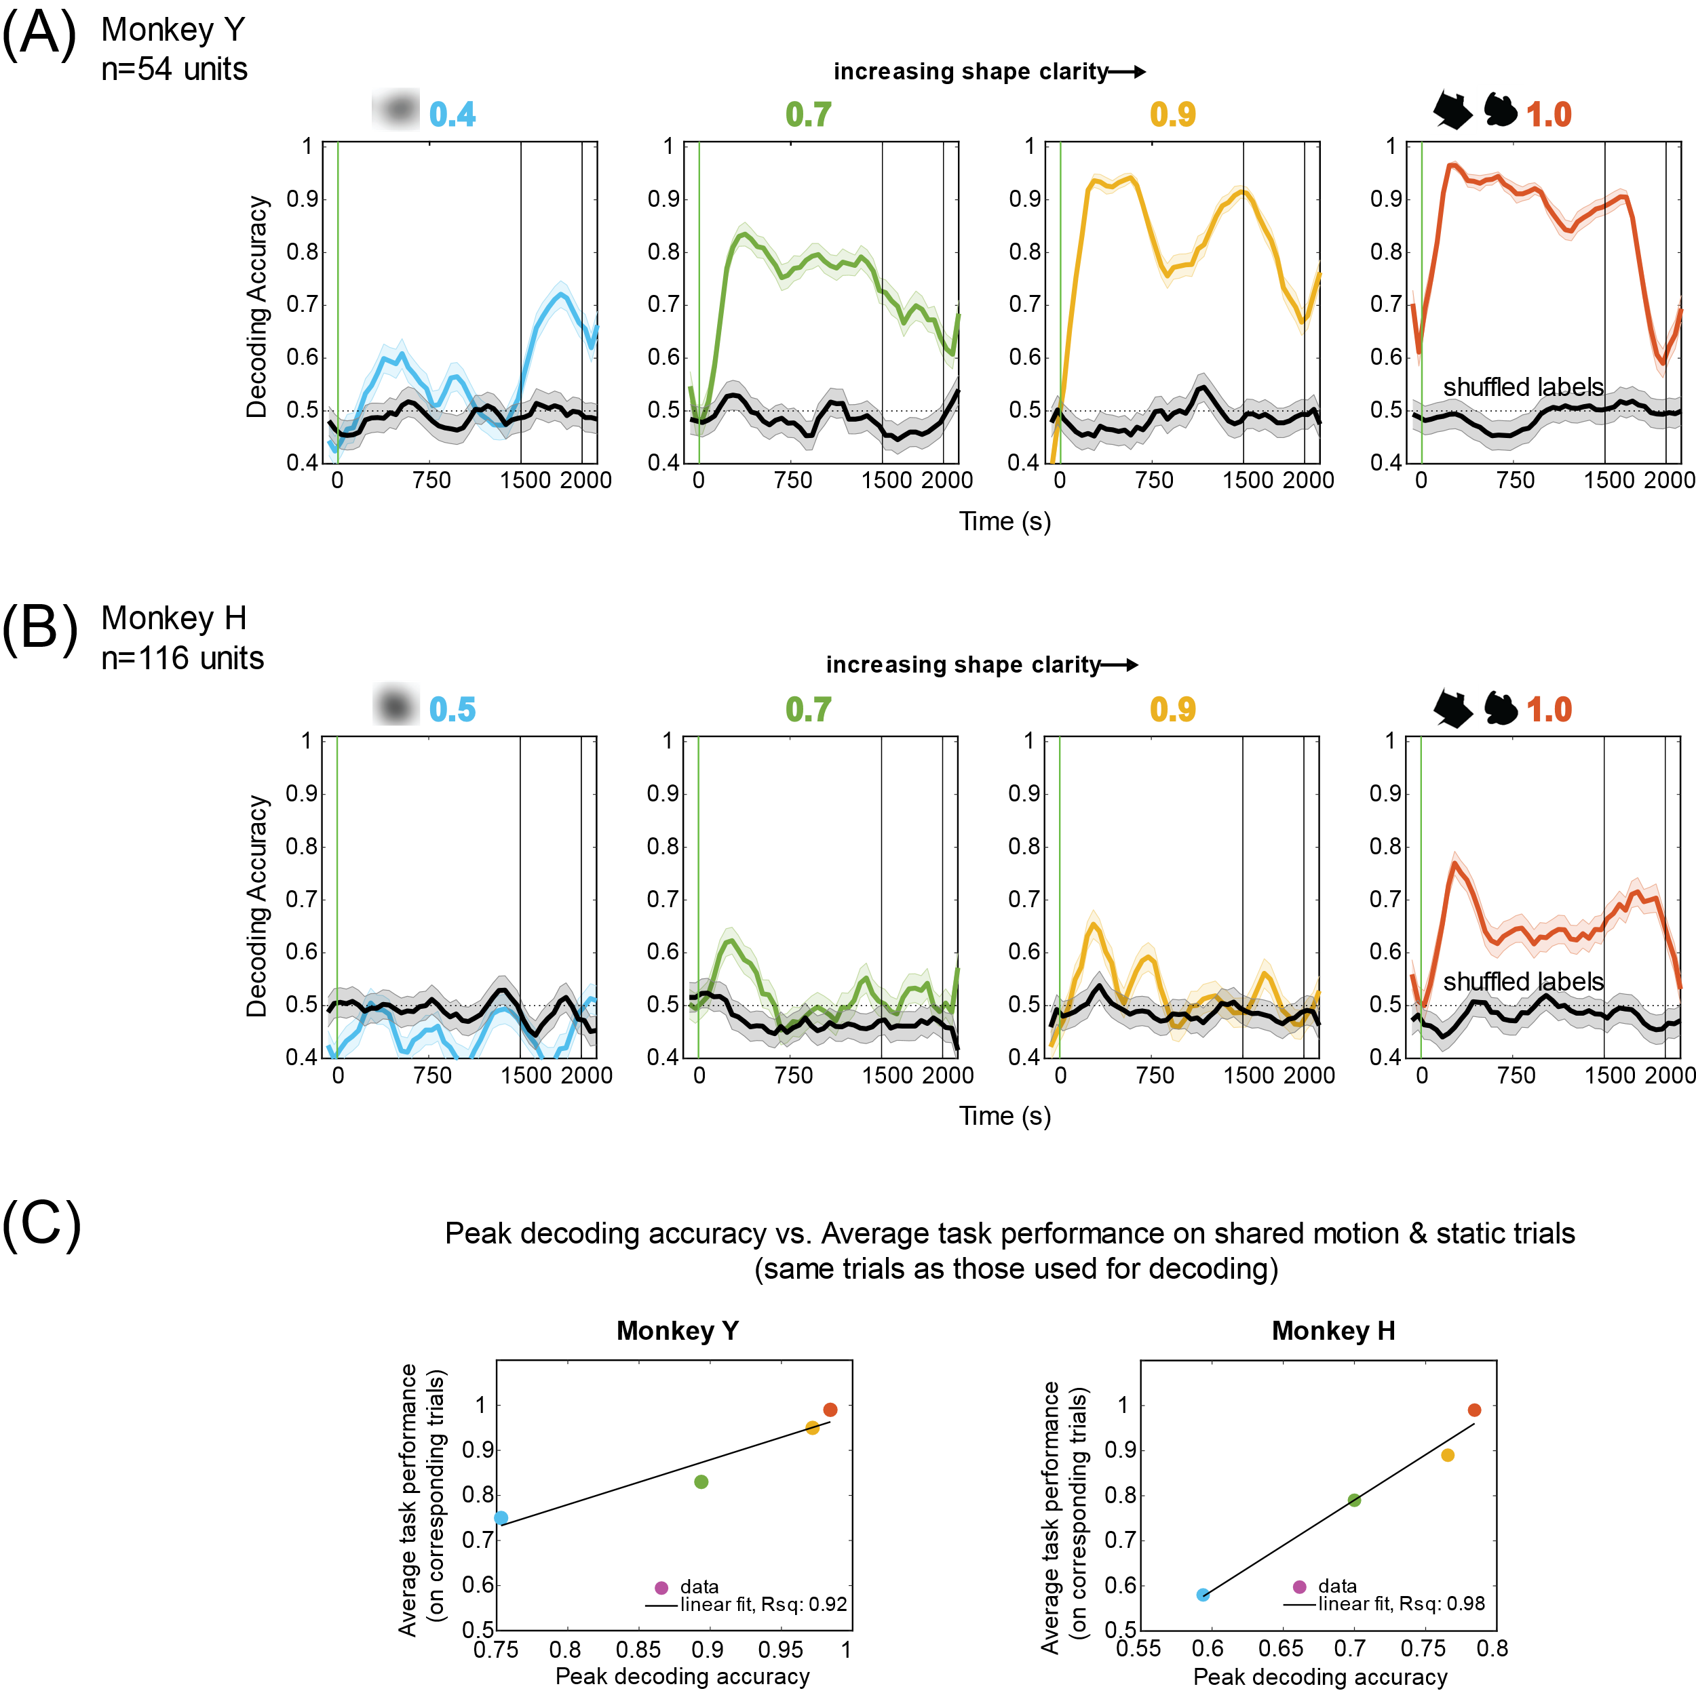
Figure 3-14. Decoding shape class from neural population activity and correlation between max decoding performance and task performance. Binary decoding of shape class (blob vs. spikey) was done using 150ms windows, 50ms sliding window; a separate model was used for each time window. Each panel is the average performance across 5 iterations (of random resampling across trials and sessions) to decode 32 trials of combined neural activity across the ~30 recording sessions (see 3.2 Methods). Error bars are s.e.m. across the 5 iterations. (A) Average decoding performance for clarity levels 0.4 through 1.0 for Monkey Y. (B) Average decoding performance for clarity levels 0.5 through 1.0 for Monkey H. (C) Peak decoding accuracy versus average task performance on static and shared motion trials for both monkeys. The maximum accuracy in each plot in (A) and (B) was plotted against the average accuracy on corresponding trials at the same clarity level. Linear fits to the data are shown with R² values showing a strong positive correlation between task accuracy and decoding performance.

Population decoding of motion patterns: all 4 motion conditions
Next, population decoding was carried out for the four motion conditions (static, shared, blob-associated, spikey-associated) for all clarity levels. In this analysis, the number of trials per decoding analysis was 64 for all clarity levels other than 0.0 and frequency of shape even across these trials (8 blob+static, 8 blob+shared, 16 blob-associated, 8 spikey+static, 8 spikey+shared, 16 spikey+associated). For 0.0 clarity, 96 trials were used for decoding (24 static, 24 shared 24 blob- associated, 24 spikey-associated) because there were more trials of this type available. Figure 3-15 shows the results of decoding of 4 motion patterns. Figure 3-15a shows the average decoding performance is best at intermediate clarity (0.7, 0.9) for Monkey Y, and appears to have a bimodal shape in time, cycling around the time of the two cycles of motion (with some blurring from the smoothing and window size). Decoding accuracy is low for 0.0 clarity but above both theoretical chance and shuffled label decoding. Figure 3-15b shows the average decoding accuracy for Monkey H, which changes less with shape clarity and seems not to have the bimodal character that the decoding of Monkey Y had. Figure 3-15c shows decoding for the three motion patterns, not including static, at 0.0 clarity, to demonstrate that the decoder is not solely picking up on moving versus static. One thing to note about this analysis is that when static trials were removed for Monkey H, the shape of the decoding trace started to have a bimodal character (Figure 3-15c, right), similar to the decoding traces of Monkey Y (Figure 3-15a). The second peak emerges around the time of the second peak of the motion trajectories (750ms).
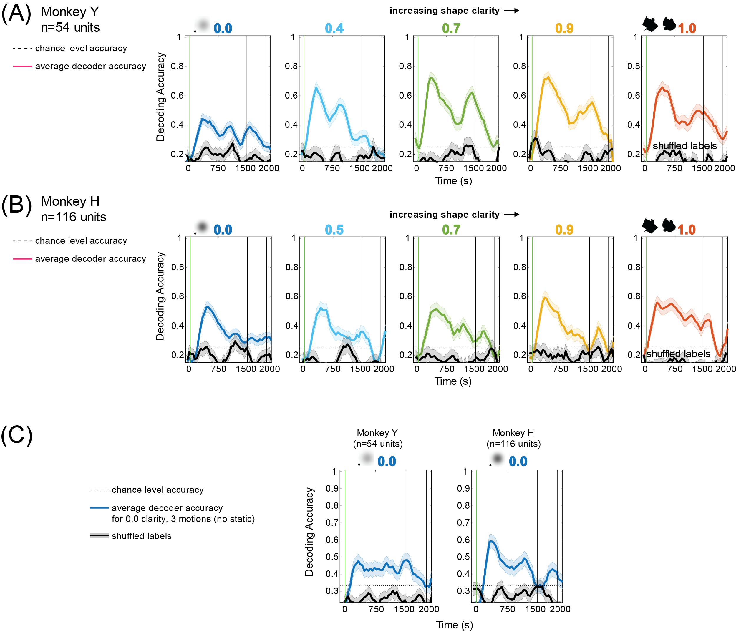
Figure 3-15. Decoding motion conditions from neural population activity. Multi-class (four-way) decoding of motion condition (static, shared, blob-associated, spikey-associated) was done using 150ms windows, 50ms sliding window; a separate model was used for each time window. Each panel is the average performance across 2 iterations (of random resampling across trials and sessions) to decode 64 trials of combined neural activity across the ~30 recording sessions (see 3.2 Methods). 0.0 clarity panels (far left) used 96 trials for decoding. Error bars are s.e.m. across the 2 iterations. (A) Average decoding performance for clarity levels 0.0 through 1.0 for Monkey Y. (B) Average decoding performance for decoding 4 motion conditions clarity levels 0.0 through 1.0 for Monkey H. (C) Multi-class (three-way) decoding of motion condition without static trials (shared, blob-associated, spikey-associated) at 0.0 clarity for both monkeys, using 72 trials for decoding.
While this decoding was a useful starting point, there is shape information inherently embedded in the way this analysis is structured, as the associated movements are also differentiable due to their difference in shape information. Thus, we needed a way to decode motion while keeping shape information constant, so that a decoder would not be using those features of the neural data. This analysis is described in the next section.

Population decoding of motion patterns for each shape class
To further investigate the capacity for the pseudopopulations to represent motion information, trials with the same shape were pooled and motion information was decoded. This meant that any differences in the neural activity due to shape information (blob vs. spikey) were no longer available for a decoder to use for class assignment. Population decoding for the three motion patterns for each shape class (blob-associated, shared motion, static for blobs, spikey-associated, shared motion, static for spikeys) was conducted for each shape clarity level; results are shown for both monkeys in Figure 3-16. Decoding in this case was fairly limited by the available number of trials (8 per motion, 24 total trials per clarity level), except in the 0.0 clarity condition, where 24 trials were available for each of the three motion patterns (total of 72 trials used for decoding results). Decoding performance was highest for Monkey Y in the intermediate clarity levels 0.4 through 0.9, and lower for 1.0 and 0.0 clarity (even despite having more trials). For Monkey H, decoding performance was best for 0.0 clarity (although this could be due to having more trials for this analysis) and only went above shuffled and theoretical chance inconsistently in other conditions. Despite the reduced amount of data available for this analysis, results showed that decoding motion was still possible for both neural pseudopopulations when shape information was held constant. However, the link between behavior and decoding performance remained unclear from this analysis. Both monkeys demonstrated that they could use motion information at 0.0 clarity to retrieve and use their learned shape-motion associations. Exploratory side tasks with Monkey Y suggested that Monkey Y was primarily using shape information where possible, yet decoding for motion is decent at 1.0 clarity (Figure 3-16a, red traces). Average behavioral performance for Monkey H showed that Monkey H was using motion-shape associations, and thus motion information, at clarity levels 0.0 and 0.5 (See Chapter 2, Figure 2-5), yet decoding performance at 0.5 clarity was weak. This led us to the major question: what about motion is actually being decoded? The next few sections attempt to answer this question, and discuss the investigation of the differences between (1) decoding active and passive tasks at 0.0 clarity (motion-only stimuli) (2) decoding using neural responses versus eye movement data, and (3) shape decoding and motion decoding.
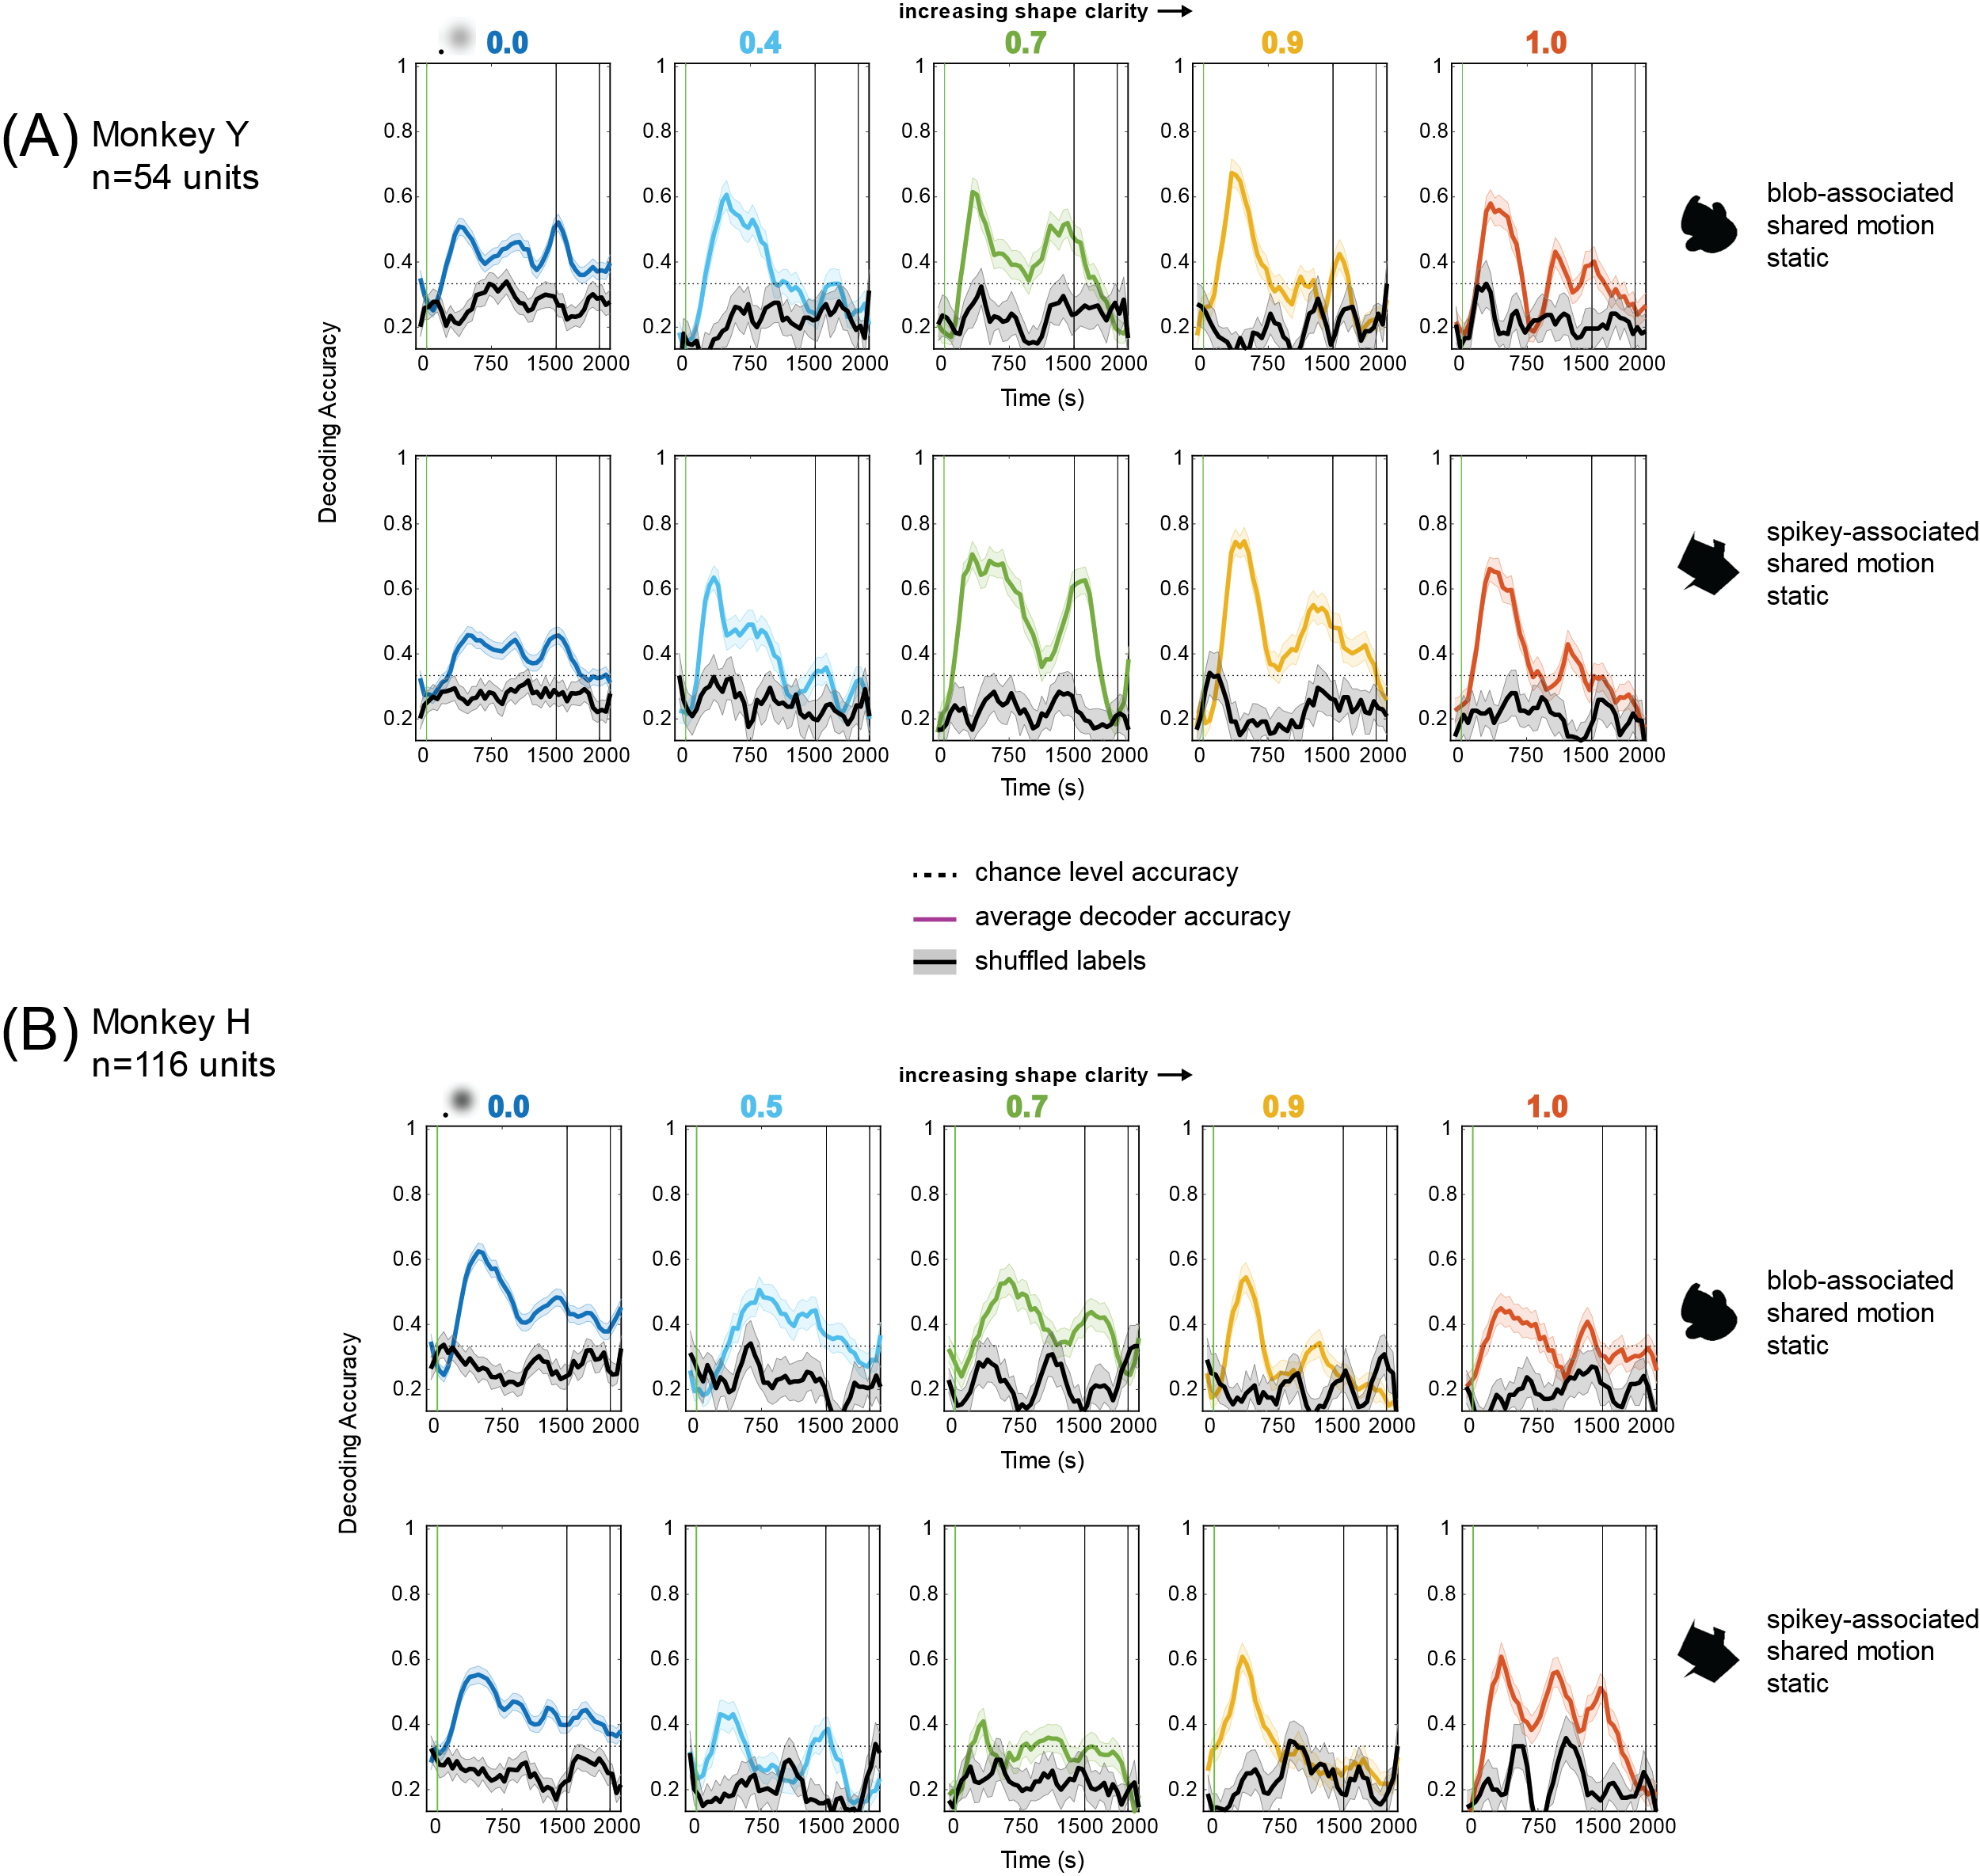
Figure 3-16. Decoding motion patterns from neural population activity for each shape class to remove shape information as a potential decodable feature. Multi-class (three-way) decoding of motion condition (static, shared, associated motion) was done using 150ms windows, 50ms sliding window; a separate model was used for each time window. Each panel is the average performance across 5 iterations (of random resampling across trials from sessions) to decode 24 trials of combined neural activity across the ~30 recording sessions (see 3.2 Methods). 0.0 clarity panels (far left) used 72 trials for decoding. Error bars are s.e.m. across the 5 iterations. (A) Average decoding performance for clarity levels 0.0 through 1.0 for Monkey Y. (B) Average decoding performance for clarity levels 0.0 through 1.0 for Monkey H.

Comparing decoding and average responses in active and passive tasks
During the active task, the monkeys could move their eyes during the target period and were encouraged to pursue the target stimuli. Thus, one possible answer to what the decoder is truly decoding during the decoding analyses for motion is that the decoder is picking up on differences in eye movements during the active task. This would imply that during the passive motion task, where the monkeys were not allowed to leave the central fixation spot, that decoding accuracy should be diminished if not completely reduced to chance. This possibility was tested by using the same populations of neurons and decoding parameters to decode the motion conditions in the 0.0 clarity condition for the active task and compare that to the decoding of the active task at 0.0 clarity. Figure 3-17 shows the results of this decoding the three motions involving smooth pursuit at 0.0 clarity for active and passive datasets, for both monkeys. Interestingly, decoding performance improved for both monkeys, especially for Monkey Y, in the passive task. (Note: decoding performance is more variable across time for the passive decoding dataset because there are fewer trials per condition relative to the number of iterations than in the active dataset). Furthermore, if eye movements were the feature that the decoder was using for classifying trials, one would expect the average performance in the 0.0 condition during the active task to be higher and more similar to lower clarity levels, as the eye movements do not become less differentiable at 0.0 clarity compared to other clarity levels, and remain stereotyped, transformed versions of the original trajectories (see average eye movements in Chapter 2, Figure 2-7). Taken together, the results suggest that the decoder was not likely to be solely picking up on population activity related to eye movements.
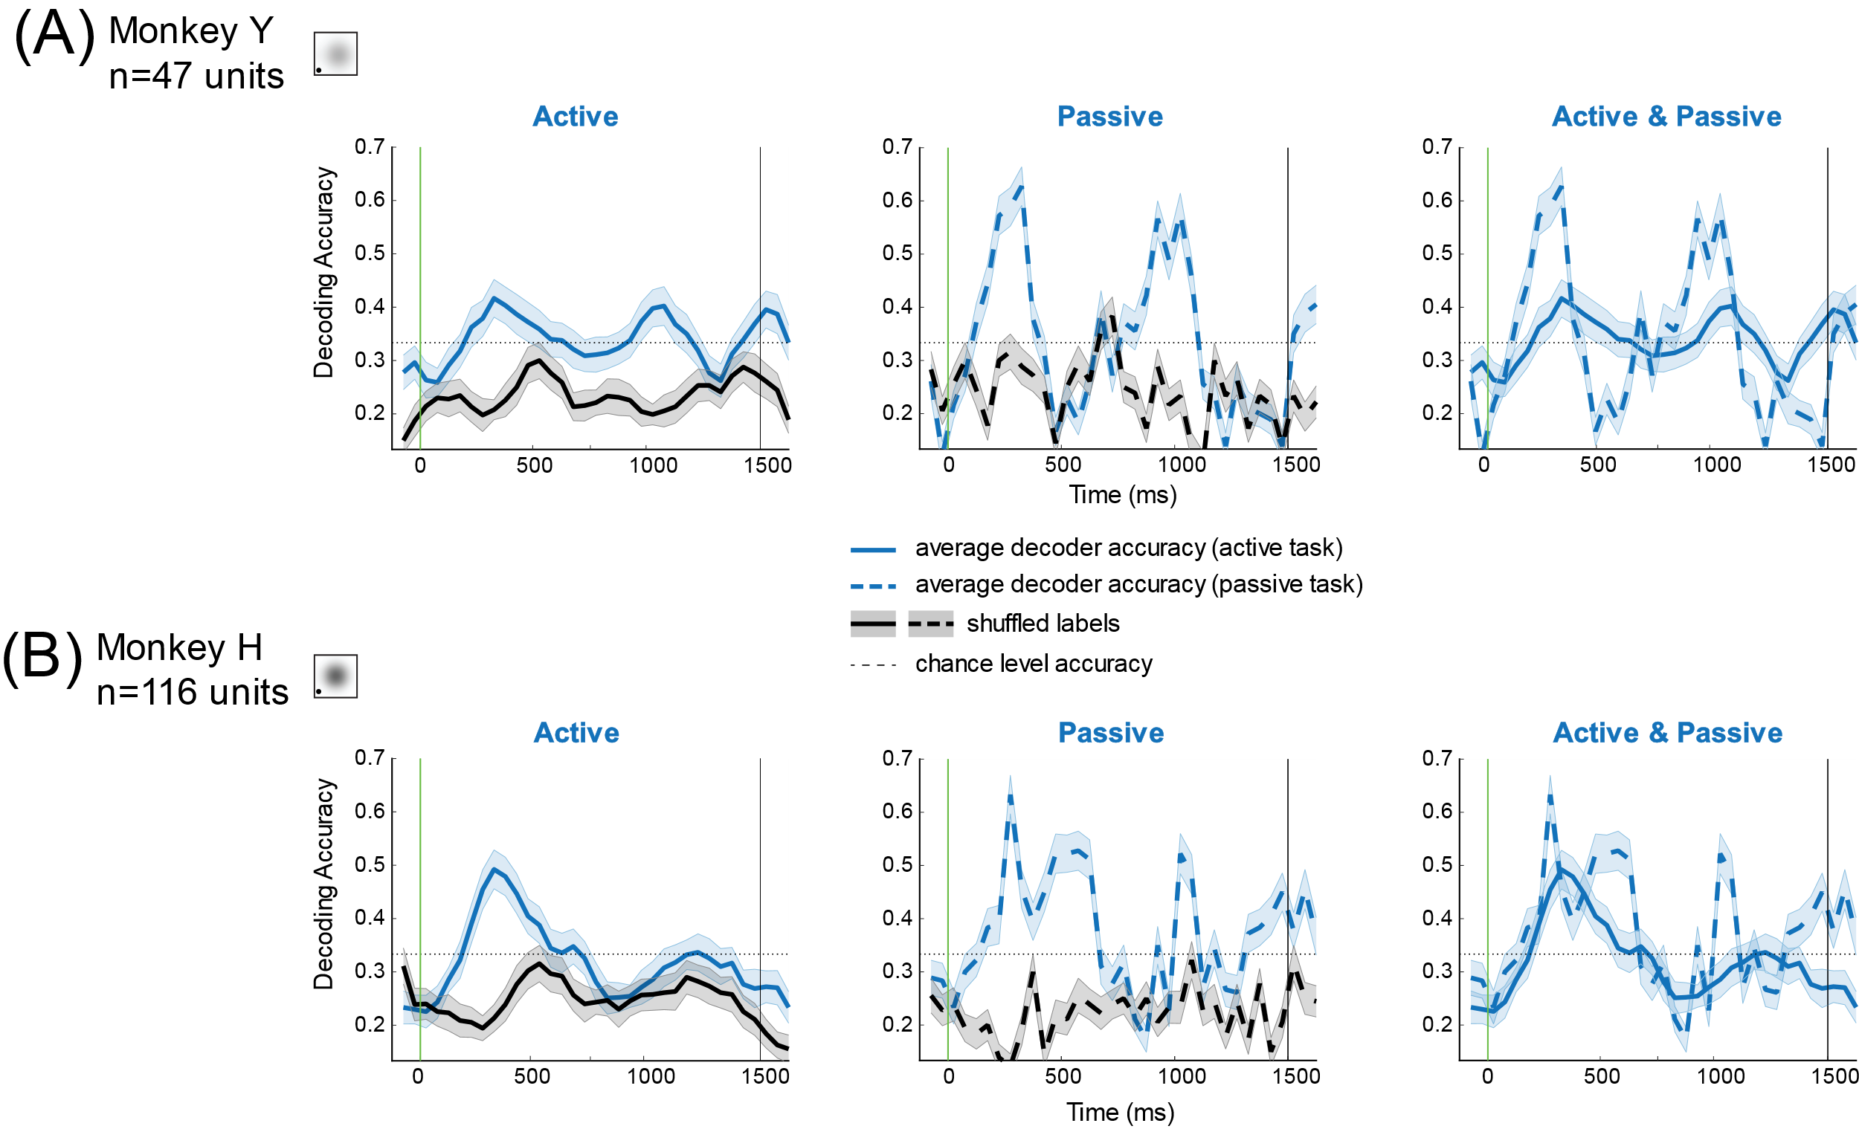
Figure 3-17. Comparing accuracy of decoding 3 motion conditions (shared, blob-associated, spikey-associated) in 0.0 clarity in active and passive tasks. Multi-class (three-way) decoding of motion condition (shared, blob-associated motion, spikey-associated motion) was done using 150ms windows, 50ms sliding window; a separate model was used for each time window. Each panel is the average performance across 5 iterations (of random resampling across trials from sessions) to decode 36 trials of combined neural activity across the ~30 recording sessions for each monkey. Exact same neural responses and decoding parameters were used for both active (solid blue) and passive (dashed blue) datasets in order to be able to make a direct comparison between results. Trial labels were shuffled and decoding analysis was repeated with the same parameters and numbers of iterations to create statistical chance level accuracy. Error bars are s.e.m. across the 5 iterations. (A) Decoding results for active (solid blue) and passive (dashed blue) 0.0 clarity stimuli for Monkey Y (n=47 units). (B) Decoding results for active and passive datasets for Monkey H (n=116 units).
Previous work has suggested that passive viewing is a useful proxy for understanding neural activity and has suggested that neurons in area IT are not as sensitive to task context as other areas (McKee et al., 2014). On the contrary, the data collected for this study suggests that active and passive conditions are not always comparable. Figure 3-18 shows the average responses of the pseudopopulations for both monkeys in the active and passive contexts for the four motion conditions. Although the average rates were much higher for Monkey Y than Monkey H, and the transient profiles are different, rates were consistently higher during passive viewing than the active task, following the initial visual transient response. The initial transients were similar in all motion cases; only the static (black traces) differed in the transient response between active and passive task contexts (and differently for each monkey). However, in the conditions where the stimulus moved, the initial firing rates of the populations were nearly identical during the initial visual transient and diverged between active and passive contexts. The target and passive viewing stimuli were much longer (1500 ms) than typical stimuli used in area IT passive viewing paradigms (on the order of 100-300 ms). Perhaps previous work has missed the influence of task context in area IT through the use of stimuli presented only briefly, or there are more effects on neural responses in area IT due to eye movements than previously known. Further work would need to be done to separate the “passivity” in the passive task context, versus lack of smooth pursuit eye movements to understand what exactly is causing the differences observed in Figure 3-18. Thus, we continued to probe the eye movement data for their ability to explain the motion decoding results.
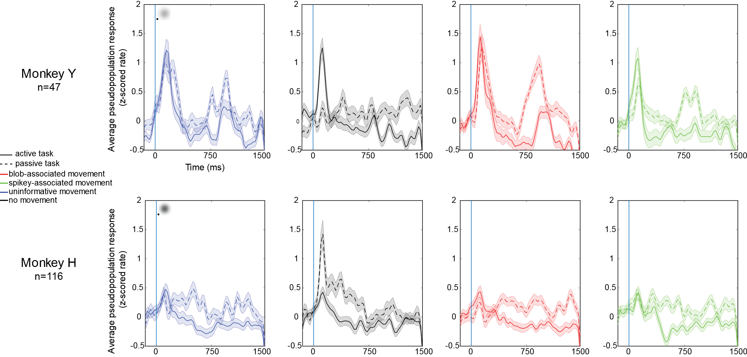
Figure 3-18. Comparison of average firing rates for identical no-shape clarity stimulus in active task and passive viewing across the four motion conditions. Top row: Average responses for Monkey Y (n=47) showing that average firing rates were higher late in the stimulus period during passive viewing (dashed lines) than during the active task (solid lines). Bottom: Average responses for Monkey H (n=116) showing that average firing rates were higher in passive viewing than the active task for all motion conditions, and the static case there was a large initial transient only present during passive viewing (black traces). Firing rates were computed for each neural response using 25ms, non-overlapping bins. Mean pre-stimulus, spontaneous rate was subtracted for active and passive conditions separately, to account for any differences not due to stimulus presentation, but overall shift in baseline activity. Each neural response was then z-scored across all four motion conditions, active and passive tasks, and all time bins before computing the population average. Blue bar indicates stimulus onset and the inset blurred stimuli are shown for each monkey. Error bars s.e.m.

Comparing decoding of motion using eye movement data and population activity
Although the active and passive decoding comparisons suggested that eye movements were not what the neural population was coding for across the motion conditions, it remained possible that the small differences in retinal position of the stimulus across the conditions (perhaps due to quality of pursuit) could explain the decoding performance of motion patterns. This would mean that the neurons in area IT would have had spatial selectivity, and in the passive viewing case, there were larger differences in retinal position moment by moment than in the active case, where monkeys were attempting to keep the target stimulus foveated the entire time. Post-hoc reconstruction of the receptive fields suggested this is not the case (see Appendix 3.7.1). Nevertheless, it seemed possible that the eye movements themselves might have temporal features that could elucidate when eye movements became separable in time. Although the motion trajectories were heavily overlapping in space and time (see Figure 2- 3 in Chapter 2), and this was accentuated by the fact that the shapes moving along the trajectories were large compared to the size of the trajectories, it was clear the eye movement patterns diverged in character within the first cycle of the motion pattern (750 ms). To investigate this further, the absolute x,y eye position and x,y velocities during the active task were used for as features for a decoder in lieu of using neural population activity for decoding analysis. The eye movement data was averaged using the same bin sizes as the neural activity (150ms, 50ms sliding window) and the decoder parameters were identical to that used for motion condition decoding. The results of this decoding analysis and direct comparison to 3-motion decoding using neural data are shown in Figure 3-19. Decoding accuracy is much higher using eye movement features and increases with time, in contrast, the decoding accuracy improves sooner, peaks earlier, and decays with time. These differences in both decoding accuracy and dynamics suggest that the motion decoding performance is not solely due to eye movements.
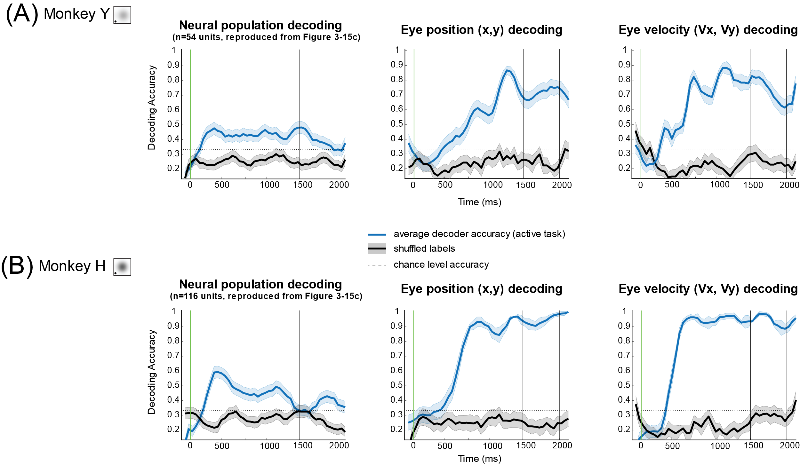
Figure 3-19. Decoding of 3 motion patterns (shared, blob-associated, spikey-associated) using eye movement position and velocity and comparison to decoding using neural populations. Multi-class (three-way) decoding of motion condition (shared, blob-associated motion, spikey-associated motion) was done using 150ms windows, 50ms sliding window; a separate model was used for each time window. Each panel is the average performance across 5 iterations (of random resampling across trials from sessions) to decode motion patterns from 36 trials of combined neural activity, x,y eye position or x,y eye movement velocity, across the ~30 recording sessions for each monkey. Exact same decoding parameters were used for each of the datasets in order to be able to make a direct comparison between results. Trial labels were shuffled and decoding analysis was repeated with the same parameters and numbers of iterations to create statistical chance level accuracy. Error bars are s.e.m. across the 5 iterations. (A) Monkey Y (B) Monkey H

Comparison of shape and motion decoding
In addition to considering the capacity for area IT neurons to carry information about shape and motion information, we also wanted to consider the similarity of how this information might be coded, and thus decoded using the previously mentioned analyses. First the time course of decoding accuracy was considered, by determining the latency to peak accuracy for shape class decoding (Figure 3-14). In this analysis, average latency to peak accuracy decreased as clarity increased (Monkey Y: 375ms, 375ms, 275ms, 225ms for 0.4, 0.7, 0.9, 1.0 clarity, respectively; Monkey H: 275ms for all clarity levels above 0.0). A direct comparison of decoding latency to shape class (blob vs. spikey) and to associated motions (blob-associated, spikey-associated) was unfortunately not possible as the shapes and motions were not crossed, so these were identical trials. However, we could determine the latency to disambiguation of the associated motion patterns from other trials with the same shape moving with the shared motion or not at all (Figure 3-16). Average latency to peak for 3 motion patterns was slower for both shape classes, for both monkeys: (Monkey Y, blob motions (375ms, 475ms, 325ms, 325ms, 325ms), spikey motions (475ms, 325ms, 325ms, 375ms, 325ms); Monkey H blob motions (475ms, 725ms, 625ms, 375ms, 325ms), spikey motions: (475ms, 275ms, 325ms, 325ms, 325ms). These values are plotted as traces in Figure 3-20. These plots suggest that the decoding models fit for the data at 0.0 clarity and 1.0 clarity are likely picking up on different features within the neural population, as motion decoding is significantly slower (400-500ms) than shape decoding to reach peak accuracy (~250ms). Motion decoding at 0.0 clarity reached peak accuracy around a similar time for both monkeys (400-500ms). It is possible that the long latency to peak decoding accuracy in the motion case is reflecting a feedback process of categorization, (e.g. from areas known to be involved in categorization, such as prefrontal cortex), as the monkeys recall the motion trajectory and the corresponding shape categories to select the correct shape. This would fit with previous work that has demonstrated that neurons in inferior temporal cortex can show late increases in category selectivity without increases in firing rates (McKee et al., 2014).
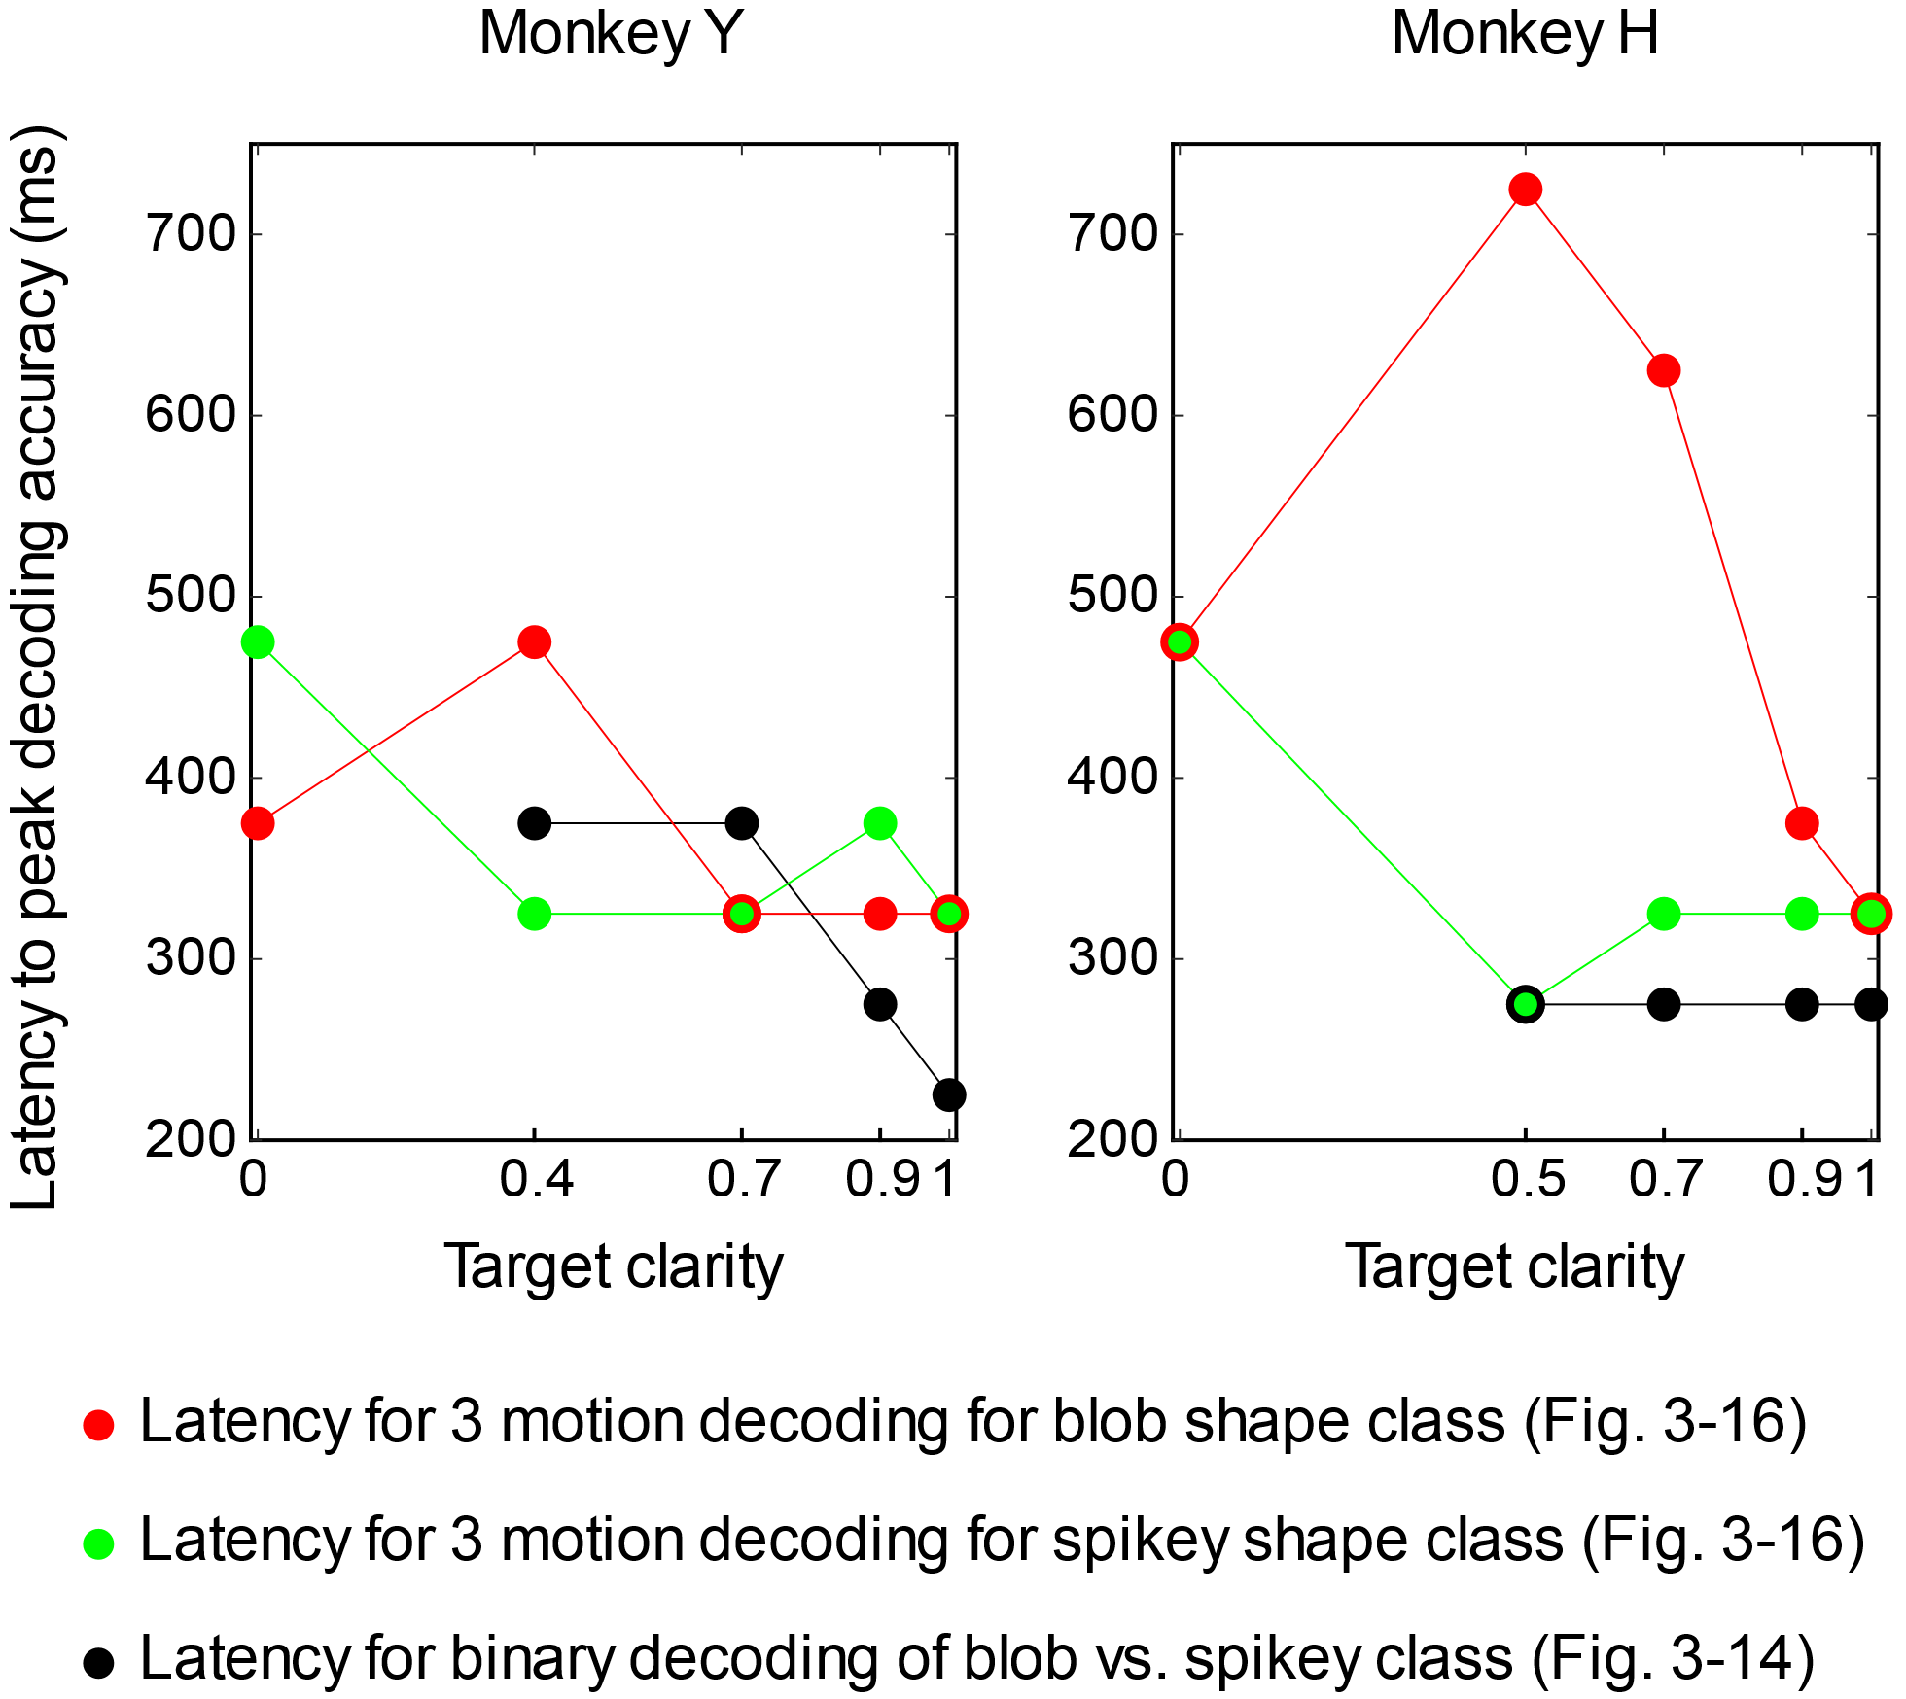
Figure 3-20. Comparison of latency to peak decoding accuracy for decoding shape classes versus 3 motion patterns per shape class. The time from stimulus onset to peak decoder accuracy was measured for all possible clarity levels from decoding shape classes (shown in Figure 3-14) and decoding three motion patterns for each shape class (shown in Figure 3-16). Latencies were plotted against shape clarity to show that motion decoding latencies (red, green) decreased as clarity increased for both monkeys Left: Decoding latencies for Monkey Y. Latency to peak decoding accuracy decreases across shape (black) and motion (red, green) conditions. Right: Decoding latencies for Monkey H. Latency to peak decoding accuracy is constant across clarity levels for shape decoding, but increases drastically for motion decoding when target clarity is low.

We also compared decoding of shape classes and motion patterns using a decoding model that was trained on shape decoding, and tested on separation of the two associated motion patterns. The decoders used were from the shape decoding analysis that is summarized in Figure 3-14. The trials used for training were from the shared motion and static motion classes, with equal frequency of blob and spikey trials at 1.0 clarity for both motion patterns, such that shape information was balanced across the two motion patterns, and no associated motion trials were used in training. Training trials were blob-associated and spikey-associated trials at 0.0 clarity (motion only trials).

Figure 3-21. Shape model to decode motion if it works. Description.

Changes in LFP ß Power during associated motion conditions

3.6 Discussion
Our central finding is that neurons in area IT have the capacity to code for 2D trajectory motion information when shape information is ambiguous or absent, potentially supporting the recognition of visually presented objects based on motion information.
Firing rate analyses demonstrated that individual neurons had mixed sensitivity to motion, shape and conjunction (combinations of shapes and motion patterns) during a match to sample task with variable levels of shape and motion information available. Support vector machines were used to decode activity of the pseudopopulations recorded from both monkeys to determine the extent to which the populations carried shape and motion information across different levels of shape clarity. Motion information appeared to be available in most clarity conditions, although monkey behavior suggested that the monkeys were using motion information primarily when shape information was not available, at lower shape clarity levels. Eye movements were encouraged during the task to make the moving object recognition more natural for the subjects, but this was slightly confounding for interpretation of the decoding results. However, decoding motion from the passive viewing of motion showed that eye movements were not solely responsible for the decoding of the active task. Furthermore, decoding eye movement features (i.e. position and velocity) also did not reproduce the same decoding profiles in time as decoding from the neural populations. These analyses suggest that the population does indeed carry information about the motion patterns during the task.
The data from this experiment cannot be used to discern whether the neurons that respond to motion information at lower levels of shape information are only motion sensitive, or whether they are sensitive to all secondary features that might support object recognition when shape information is weak or unavailable. Although such responses have not been commonly reported, it is not surprising that some neurons in area IT respond better to degraded images than crisp ones, as the brain must be capable of somehow recognizing objects under suboptimal conditions, with limited information, and it is well understood that area IT plays a critical role in object recognition (Annual Rev Vis Sci: Conway 2018). A recent study demonstrated that neurons in area IT indeed play a role in recognition of degraded patterns, and although onset latencies were not affected by the level of noise, neurons seemed to be doing evidence accumulation (Kuboki et al., 2016), which would mean these neurons have the ability to integrate over time, a critical feature required for coding for motion information. Furthermore, recent work has also demonstrated that neurons in area IT can also encode category-orthogonal properties, including those that are often considered lower level features, when behaviorally relevant (Hong et al., 2016). Thus, we hypothesize that the neurons we found to be motion sensitive are likely to be sensitive to other features as well, but perhaps play a larger role in population responses in area IT when the primary feature of the area, shape, is degraded or unavailable. One major open question arises from this interpretation: are such response properties (i.e. responding to features other than those traditionally coded in area IT) inherited through training, or built into area IT before any learning has taken place? It might be possible to determine this with a task requiring the monkeys to learn to recognize new objects under ambiguous circumstances while recording from the same neurons during learning.
In addition, the comparison of active and passive contexts using the same stimulus showed that neural responses to active and passive task stimuli were not identical. Although the initial visual transient response was similar between active and passive contexts across most motion conditions for both monkeys, the population responses diverged around 200-500ms after stimulus onset, and average firing rates were lower in the active task context. It remains unknown whether the differences were due to the context (active vs. passive) or the eye movements that were allowed/encouraged during the active task. Either outcome could be possible, as previous work has demonstrated minimal differences between active and passive contexts compared to other areas well-known for coding behavioral relevance (Emadi & Esteky 2014; McKee et al., 2014), and there have been very few published studies demonstrating effects of eye movements on IT neuron responses. Most tasks require animals to maintain fixation as images are presented. This is surprising, given the obvious importance of eye movements during object recognition and the slow time course at which object recognition can take place (i.e. when recognition is difficult). One study found that IT neuron responses to pictures of objects were indeed different between an isolated presentation and an embedded presentation in a natural scene that involved a long series of eye movements before target acquisition (Sheinberg & Logothetis 2001). However, a different study analyzed the effects of saccadic eye movements on IT neuron responses and found no effects of the eye movements on transiently presented targets (DiCarlo & Maunsell 2000). The stimuli in this task were very different than those used in either of those studies, and different than most studies involving recordings in area IT, as they were longer than usual (1500ms) and encouraged smooth pursuit. Further work would be needed to determine whether smooth pursuit modulates response magnitudes in area IT, or whether the task context was responsible for the reduced firing rates observed in our data. However, as object recognition can involve smooth pursuit and longer exposure than a few hundred milliseconds, we think that using such stimuli is useful for understanding natural visual processing, and that this finding opens multiple doors for future exploration.
The data described here are very rich and have potential for even more analyses than those described. Multiple analyses, including population averages and decoding analyses of subpopulations (i.e. multi-unit and single unit responses, by low clarity responses and high clarity responses) were also conducted but did not bring about any additional insights. Two major directions of future analysis could include assessing noise correlations and decoding using LFP data. Because the data was recorded with a mixture of single electrodes and multi-channel V-probe recordings, it was unclear how exactly to set up the noise correlation analysis properly, however it would be fairly straightforward in a follow up experiment where the recordings were done with larger arrays and simultaneously.
Finally, the task design prevented some analyses that would have been useful in determining exactly what the decoding models were using to classify motion conditions. Although there were two informative motion conditions (blob-associated, spikey-associated) and two uninformative conditions (shared motion, static), the static condition was too different to fairly combine with the shared motion responses. A future task could include more motion patterns with periodicity, and potentially differing periodicity, to determine more precisely how the neural populations were responding to the “uninformative” versus “informative” movements. In addition, because the monkeys found the associations challenging to learn, we did not cross the motions and shapes during the active task or passive viewing, as not to weaken the learned associations. This would have allowed for us to look at the competition between features at the single neuron level. The asymmetry in categorical structure of the task also precluded investigating how category boundaries in the motion domain might be represented in area IT. Making discriminable, yet similar motion trajectories is not trivial. However, it might be possible to generate categories of motion patterns using the three described here by making simple adjustments in space and time to the trajectories, thus making the mapping category:category instead of category:1. In summary, we believe the task and data described here provide a useful platform for future investigation of motion information in area IT.

3.7 Appendix
3.7.1 Post-hoc receptive field reconstruction from passive viewing
One suggestion that arose from the ambiguity of what was truly being decoded in the motion decoding analyses was the consideration of spatial receptive fields of the recorded units. There is mixed literature on receptive field size and spatial invariance in area IT. Some studies report spatial invariance due to the large (on the order of 50º V.A.) receptive fields of most neurons in the area (Gross et al., 1972; Tovee et al., 1993), especially during presentation of a single object on a plain background. However, other studies have reported that some receptive fields can be much, much smaller, even down to 3º V.A. (Op de Beeck et al., 2000), especially those of neurons in more posterior locations within area IT (Ito et al., 1995), and during certain conditions such as natural scenes (Rolls et al., 2003), thus making IT neurons spatially selective on the order of 5º V.A. Furthermore, previous work has also shown that response magnitude can change within the receptive field (Op de Beeck et al., 2000). While spatial receptive fields were not directly assessed or quantified during recording sessions, receptive fields were reconstructed using the passive viewing of all the 100 shape stimuli was conducted, to assess whether any of the recorded units had obvious spatial selectivity on the order of 3º V.A. (the size of the shapes used during the task). For each neuron that had response modulation during passive viewing (this analysis was not possible for units that had no response to any of the 100 stimuli during passive viewing), the change in neural activity with respect to baseline for each of the shapes was calculated for each trial, and then averaged across trials, during the 150ms visual response period 50ms after stimulus onset. The changes in firing rates with respect to baseline were used as weights for each of the stimuli to create a weighted average image, which served as a proxy for the spatial receptive field. Stimuli that evoked an increase in firing rate were weighted positively, while stimuli that inhibited neural responses were weighted negatively. Images were summed to create the mean spatial response. Figure 3-XYZG shows the result of this analysis for both monkeys. Each panel represents a single reconstructed receptive field proxy for a single neuron that has been normalized to that unit’s level of activity. Some neurons were extremely shape selective and the outline of the individual shapes is visible for those units. Other neurons were driven by multiple shape stimuli and had a central, bright spot (yellow) or inhibited by multiple shape stimuli (blue). There are no obvious asymmetries that would indicate spatial selectivity across all shape stimuli for the units recorded. However, it is still possible that the neurons exhibit subtle variations in response due to stimulus position on the retina when the stimuli are moving and there is possibility for retinal slip. If this experiment were to be repeated, it would be useful to assess the receptive fields of the units directly using static and moving shapes used in the task. During the preliminary recording sessions (described in Chapter 4, in conjunction with the Gray Matter array) random dot motion stimuli of various sizes (patches to full screen) failed to modulate IT neuron responses. This suggested at the time that units did not normally respond to commonly used motion stimuli, and reduced concern for subtle shifts in stimulus location due to retinal slip. However, it is possible there is interaction between an effective stimulus and this retinal slip, and this was not explored in this experiment. If this experiment were repeated, it would be useful to collect data on how subtle shifts of an effective stimulus affect the firing rates of each neuron.
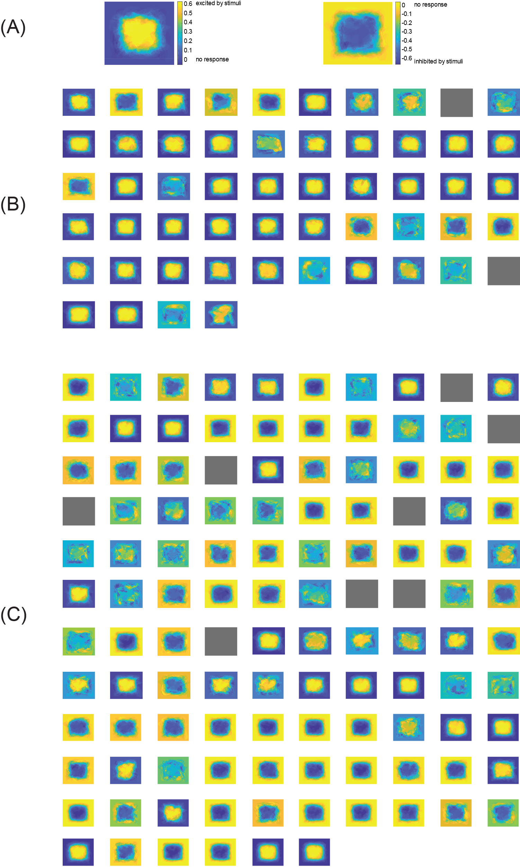
Figure 3-XYZG. Post-hoc receptive field reconstruction from passive viewing stimuli. Passive viewing data of the 100 shape stimuli was used to generate heatmaps of spatial selectivity for each neuron (some units had to be excluded). The change in firing rate from 50->200ms after stimulus onset was used as a weight for each image and the weighted sum of all images was used to generate the heatmaps. Activity was normalized from -1.0 -> 1.0 for each neuron. (A) Expanded heatmaps showing a neuron that was excited by most stimuli (left) and another inhibited by most stimuli (right). (B) Heatmaps for all units from Monkey Y (n=51 of 54 units used in most analyses). (C) Heatmaps for all units from Monkey H (n= 108 of 116 units used in most analyses).

3.7.2 Effects of subtle changes in eye position during passive viewing
Additional analysis was conducted on the passive viewing data to determine whether any neural responses were significantly modulated by small shifts in eye movements during passive viewing, which could indicate sensitivity to small shifts in retinal location of shape stimuli. To investigate this, the firing rate change due to eye position was quantified using passive viewing data. Although both monkeys were holding fixation, there were still small shifts in eye position, which would also mean a small shift in stimulus location on the retina. For each presentation of the 100 static shape stimuli, during passive viewing, eye movements were collected and binned into three quantiles in X and Y with their corresponding firing rates, to give a rough estimate of how firing rate might change with a shift in eye position. Figure 3-GGG shows that there were no significant differences in firing rate across the population for either monkey due to small shifts in eye position.
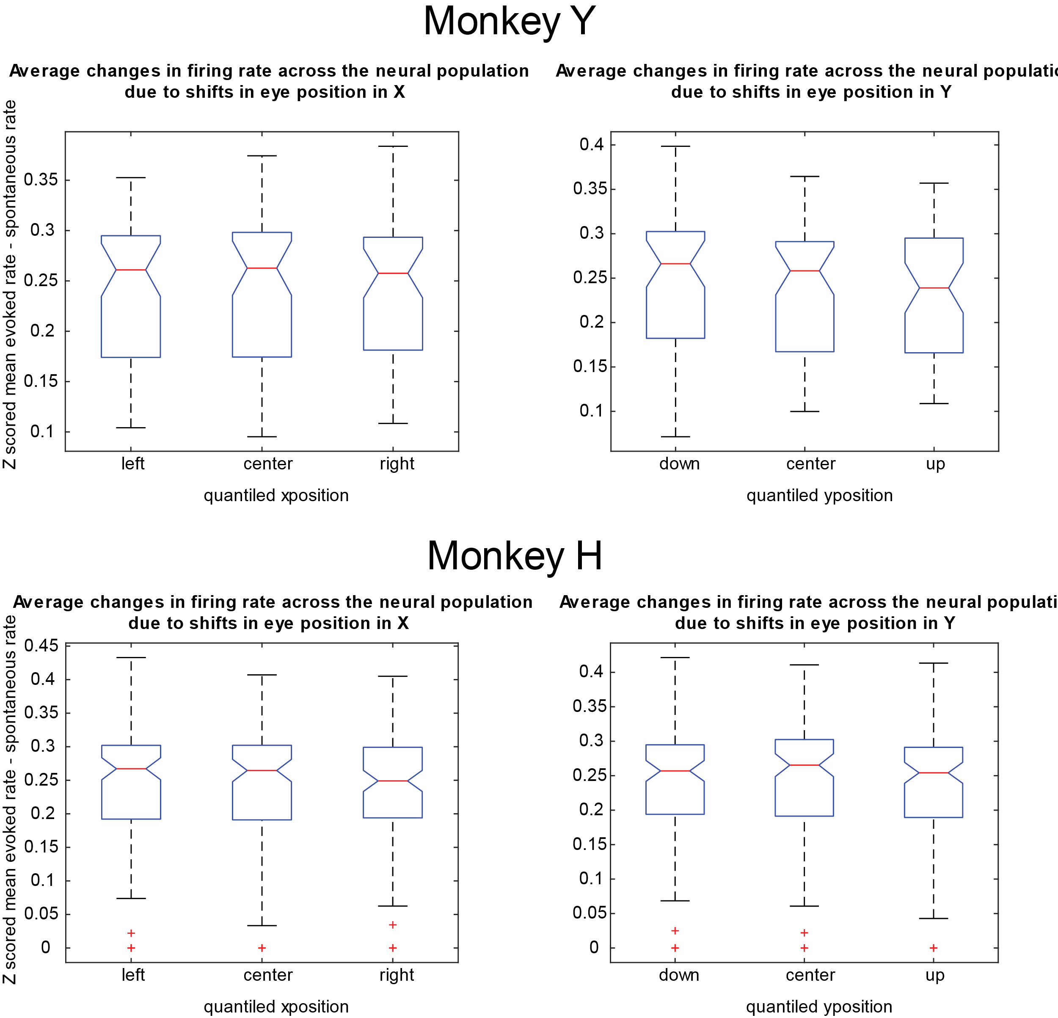
Figure 3-GGG. Analysis of eye-position evoked changes in firing rates during passive viewing. Left column, box plots of changes in firing rate from baseline (z-score) versus the corresponding eye position range in the X direction. Right column, box plots of changes in firing rate from baseline (z-score) versus the corresponding eye position range in the Y direction. Top row: Monkey Y (n=54). Bottom row: Monkey H (n=116). Plots show no significant changes in firing rates due to small shifts in eye position during passive viewing of static stimuli.

3.7.3 Temporal expectation in passive viewing

Chapter 4: Motion-shape associative learning in human psychophysics
4.1 Introduction
Many previous studies have demonstrated that monkeys can judge the direction of motion of moving stimuli (Britten et al., 1996; Palmer et al., 2005), perform a visual search in the presence of distractors (Bichot et al., 2015; Mruczek & Sheinberg 2005), recognize associated pairs of objects (Rainer et al., 1999; Sakai & Miyashita 1991) and attend to different features of objects (Martinez-Trujillo & Treue 2004; Moran & Desimone 1985). However, to investigate the recognition of movement-shape conjunctions, we need a task that combines all of these components. Through iterative testing on humans and non-human primates, we designed a two-alternative forced choice task that requires subjects to recognize and use motion information to select the correct shape when shape information is not available. This section describes the iterative process with human subjects to determine how block structure and task parameters affect learning of shape-motion conjunctions (2AFC selection tasks) or associations (2AFC matching tasks under variable levels of noise). This section does not include all versions of the tasks run with human subjects, but the key pivot points at which a major insight was made into how shape and motion information is processed. The main starting assumption was that shape and motion information would be simultaneously accessible and naturally combined in a matching task containing only those two pieces of information. Nearly every paradigm described in this section showed us that this assumption is wrong.

4.2 Materials & methods
This section covers general methods applicable to all the experiments in this chapter. Details on the participants and visual stimuli used in each study are described in the subsection that corresponds to that experiment. All experiments were conducted under the human psychophysics protocol for the Sheinberg lab that was previously approved by the IRB at Brown University. All human subject participants had self-reported normal or corrected-to-normal vision and normal color vision. Subjects were compensated a minimum of $10 per hour with some opportunities for bonus compensation dependent on performance. Each subject signed a consent form before a session and signed a receipt for payment after each experimental session.
The visual stimuli shown in the tasks were generated using the STIM (a stimulus generating system) running on Windows 10, and the experimental tasks were controlled with the ESS state system running on QNX4 real-time operating system, both developed by Dr. David Sheinberg and colleagues. All stimuli were presented on a Display++ LCD monitor (68 cm * 38 cm) at a 100 Hz refresh rate, positioned in front of the subject with a 70 cm viewing distance. In most cases, subjects had access to a button response board to make a response. Eye position was recorded using the EyeLinkII video tracking system (SR Research) running at 500 Hz. The analog output from the eye-tracking system was sampled at 1 kHz and stored to disk as a running average at 200 Hz.

4.3 Experiment 1: Real objects in salt & pepper noise with translational motion
The experiment described in this section was the main starting point for task development. There were a few pilot iterations with a single subject before this “first” experiment, that led to tweaks in task design, but the overall structure was the same. We sought to develop a task that would train subjects to learn associations between shapes and motion patterns and test the associations by removing shape information. In addition, a recent (at the time of starting this project) study demonstrated the effect of degrading shape information using salt and pepper noise on neural responses in area IT (Emadi & Esteky 2013). We sought to design a task that would allow us to leverage this result and potentially recover the degradation of responses by using motion-shape associations.

4.3.1 Specific methods
34 human subjects (with ages ranging from 24 to 35) in total participated in (multiple versions) of Experiment 1 described here. All subjects participated in the same basic match to sample task (Figure 4-1), but some experienced different block structures. Importantly, subjects were not given instructions about the associations between motions and shapes, and were only instructed to do their best to match one of the choices to the target. Visual stimuli consisted of greyscale, normalized pictures of everyday objects from an image database (Hemera Technologies). Each subject experienced a different set of objects. “Salt and pepper-like” pixelated noise was added to some of the targets using a proportion of image pixels and proportion of randomly selected greyscale pixels (Emadi & Esteky 2013). The noise levels were 10%, 50%, 85%, 95% and 100%. During training, subjects only experienced 10% and 100% noise levels. During testing, subjects experienced a mixture of all the noise levels. The motion patterns were generated from simple geometric shapes (heart and 5-pointed star), and were selected as easily distinguishable, having comparable speed, and area coverage, without being recognizable by their original closed shapes (earlier versions of the experiment used geometric closed paths, and these were deemed to be problematic after subjects began linking semantic names for the motion patterns with the objects). At the beginning of each trial, one of the six possible targets appeared for 500ms. The target then disappeared for 500ms, and the subject was then presented with two choices to select from using a corresponding button press.

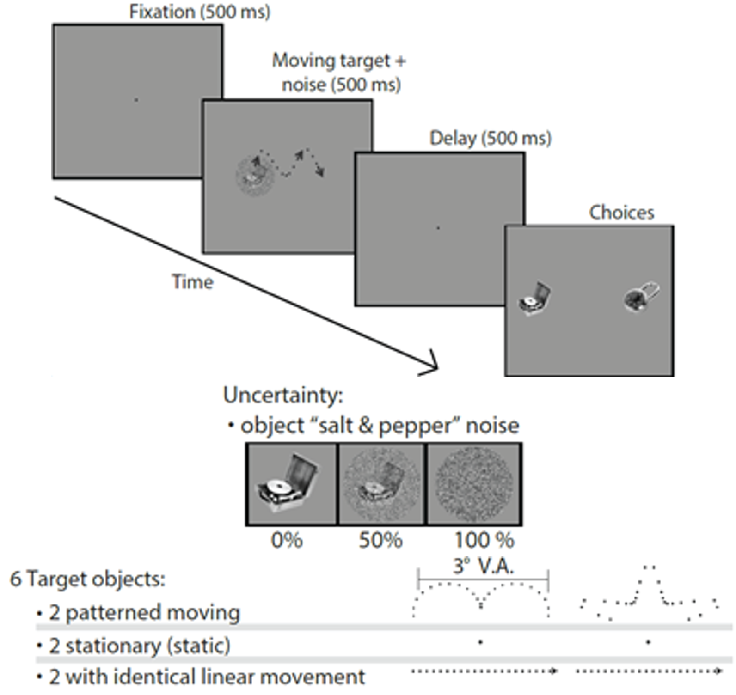
Figure 4-1. Basic structure of match to sample task with moving shapes. There were four phases of each trial: fixation, target period, delay, and choice period (top). Subjects were asked to match the object seen in the target period to one of the two choices and indicate their choice with a button press. Targets could be occluded with perceptual noise (middle). There were 6 different target objects in each experiment (bottom). Two objects were associated with translational motion patterns whose x,y patterns are shown. Two target objects did not move, and the remaining two moved from left to right on the screen at approximately 6ºVA/s and then disappeared at the onset of the delay.
After multiple subjects failed to learn the associations between the shapes and movements (data not shown), a training schedule was designed to highlight the importance of the noisiest targets (100% noise). Subjects would cycle through the training until they were at least 80% correct on the trials with the two patterned-moving, 100% noise trials (Figure 4-2). There were two kinds of training blocks: alternating (block 1) and mixed (block 2). In the alternating block, the targets alternated between 10% and 100% noise and randomly between the 2 possible patterned-moving objects. In the mixed block, the target could be either 10% or 100% and any of the 6 possible targets. Criterion was defined for at least 80% correct on the trials with the patterned-moving targets with 100% noise. In retrospect, the linear-moving and static targets are also small categorical associations, and should’ve been incorporated into the learning criterion.
Figure 4-2. Block structure of training and testing for learning shape-movement associations. Subjects were not instructed on the motion-shape associations. After multiple subjects struggled to learn the associations between the shapes and movement patterns (data not shown), this training schedule was designed. Subjects cycled through Block 1 (108 trials) and Block 2 (108 trials) until they reached at least 80% criterion performance on the two patterned-moving targets with 100% noise. This training structure was designed to avoid having to use explicit verbal instructions to attend to motion, since this task was being designed for neural recordings in monkeys.

4.3.2 Results
Only two subjects failed to reach the associative learning criterion using the described training structure within an hour. The average number of trials to criterion was 408, or between 3 and 4 blocks of trials. Six subjects were exposed to pre-testing and post-testing to demonstrate the differences in reaction times and performance due to training. Performance across all targets increased and reaction times decreased (Figure 4-3). Associative learning between targets and particular movement patterns was evident from the increase in performance across all noise levels, including 100% shape noise. Associative learning of targets to movement categories (line-moving, static) was evident from an improvement in performance across the harder noise levels, however, these trials with these targets and 100% noise could only be completed correctly if the wrong choice option was not of the same target category (e.g. patterned-moving and static, but not static & static). Reaction times also reflected the same associative learning- reaction times were constant across noise levels for the patterned-moving targets, but were slower for the static and line-moving targets in higher noise levels.
Figure 4-3. Performance and reaction times before and after training. Subjects were not instructed on the motion-shape associations. Subjects cycled through Block 1 and Block 2 of training (Figure 4-2) until they reached at least 80% criterion performance on the two patterned-moving targets with 100% noise. Accuracy and reaction times demonstrate that subjects learned both the particular patterned-moving target associations and the categorical associations of the line-moving and static targets.
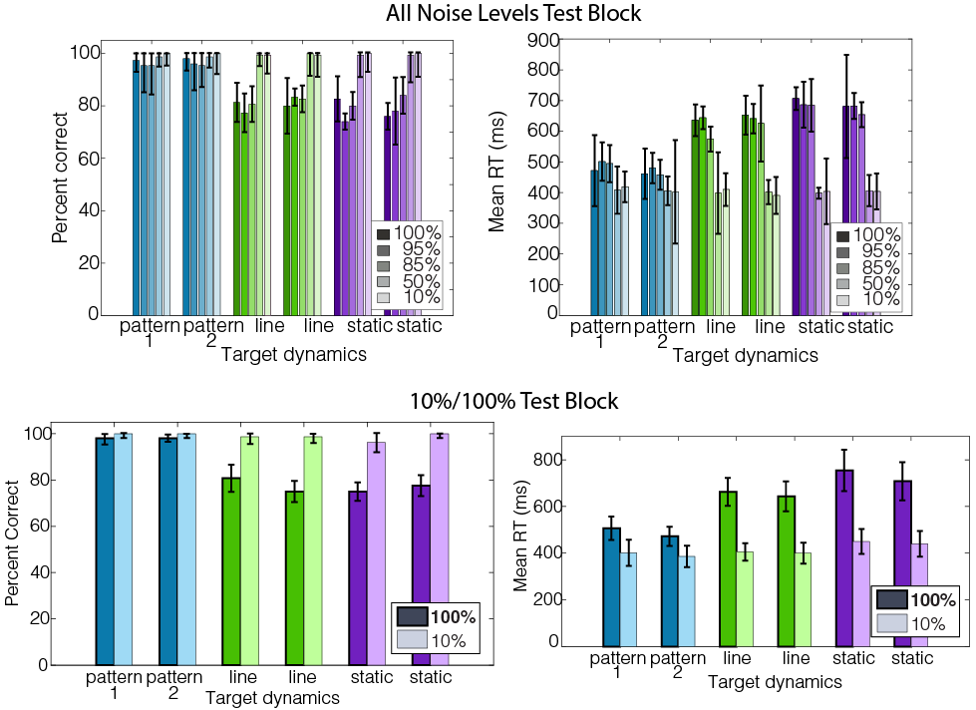Figure 4-4. Performance and reaction times on two types of testing blocks: all noise levels block and 10%/100% block. Accuracy and reaction times in the testing blocks demonstrate that subjects learned both the particular patterned-moving target associations and the categorical associations of the line-moving and static targets. The associations between the two motions and shapes of the patterned-moving targets remained stable in the 10%/100% block (bottom) despite exposure to many trials where the associations were not used in the mixed noise block (top). (n=13 subjects)
Lastly, earlier experiments suggested that these associations were not only difficult to learn without explicit training (or instructions), but that they were potentially susceptible to decay if unused. Thus, subjects were exposed to two types of testing blocks (Figure 4-4): mixed noise and 10%/100% noise that matched one of the training blocks (for direct comparison). In this case the associations between the target shapes and their motion patterns remained stable, despite exposure to the mixed noise block where the associations were not necessarily as useful.

4.3.3 Discussion
With the series of experiments described here, we tested whether arbitrary motion-shape associations could be learned without instruction, and iterated to find a task structure that made learning the associations possible for human subjects. Early designs made it apparent that human subjects did not naturally pick up on shape-motion associations easily without structured training or a verbal cue (data not shown for this contrast). As we sought to teach monkeys a shape-motion task of a similar nature, we did not push further with the use of direct instructions (e.g. “Pay attention to how the stimuli move, it may or may not be useful), rather, we leveraged the task blocking structure to teach the monkey motion-shape associations.
The data from this experiment also demonstrated multiple things that were useful for designing the monkey task. First, that the associations could be stable, even after learning. Intermixing more conditions into the task did not cause subjects to forget the original associations. The task also highlighted two potential strategies: direct match and exclusion during the choice period. For example, subjects could use the linear motion to exclude static objects during the choice period. Thus we chose to try 1:1 mappings for shapes and motions, or completely categorical mappings (e.g. shape class to a motion pattern) as not to compare the strength of a 1:1 mapping to a categorical mapping during the monkey’s task. This set of pilot experiments also showed that both closed and open trajectories were viable options for the motion trajectories, and that motion on its own was not necessarily helpful for matching shapes under noise (subjects did not perform better on linear motion versus static objects).
These pilot studies were the beginning of task development for the monkey task, and Monkey Y did a similar version to this task for many months. Unfortunately Monkey Y did not benefit from the 10%/100% training structure and did not learn the associations with salt and pepper noise over the objects (also described in Chapter 5). This led us to ask whether it was the learning of the conjunctions itself that was posing the challenge (i.e. the task rule) or the motions themselves. This led to the series of experiments that are described in the next section, where human subjects were asked to learn shape-color conjunctions without task instructions, and only through reinforcement, and then subsequently asked to learn shape-motion conjunctions. This allowed us to see whether learning the motion-shape conjunctions was still challenging after learning the task rule (to learn conjunctions).

4.4 Experiment 2: Associative learning between colors & shapes, motions & shapes
By the time this experiment was executed, the first monkey subject and many human subjects had gone through many versions of an associative shape-motion learning task. These task iterations mostly stemmed from the fact that the training regimens and tasks that were effective in training human subjects, did not work for the first monkey. The versions of the monkey experiment are discussed in more detail in Chapter 5. The motion patterns had become open, left-to-right periodic trajectories (see 4.4.1 and Chapter 5), and the matching and delay components of the task had been removed. This section discusses a small, but ultimately informative experiment that was designed to investigate whether the difficulty of learning shape-motion combinations was from the motion patterns being used, or the lack of instructions and task structure. We sought to do this by comparing the learning of shape-motion conjunctions with shape-color conjunctions. Subjects were first asked to do the color-shape task, and once they reached 80% correct on the four conjunctions, and could verbally express the rule correctly (these things occurred at the same time for the 5 subjects) they did the motion-shape task. This allowed us to test whether learning the rule first made learning the motion-shape associations trivial, or whether the motion-shape task posed its own challenges.

4.4.1 Specific methods
5 human subjects (with ages ranging from 24 to 35), participated in this experiment. The subject was given no instructions except to select the best answer using a button press, and that they would learn the rule of the game over time through feedback on each trial. The hidden goal was to learn four conjunctions: either four shape-color conjunctions or four shape-motion conjunctions. Each block consisted of 80 trials.
The basic task setup and example stimuli for the color-shape conjunction task are shown in Figure 4-5. The subject was asked to select one of two choices using a button press and learn from the auditory and visual feedback provided as to whether the answer was correct. As shown in Figure 4-5a, subjects were being trained to learn that particular combinations of shapes and colors (e.g. diagonal) were correct, and others were not to be selected. The task was self-paced; subjects were given more than 2 seconds to respond to the choices. There were three types of possible trials: where the shapes and colors were both different, shapes were the same but the colors were different, and colors were the same but the shapes were different. Only trials that changed a single feature at a time were used in the experiment; these trial types were randomly interleaved.
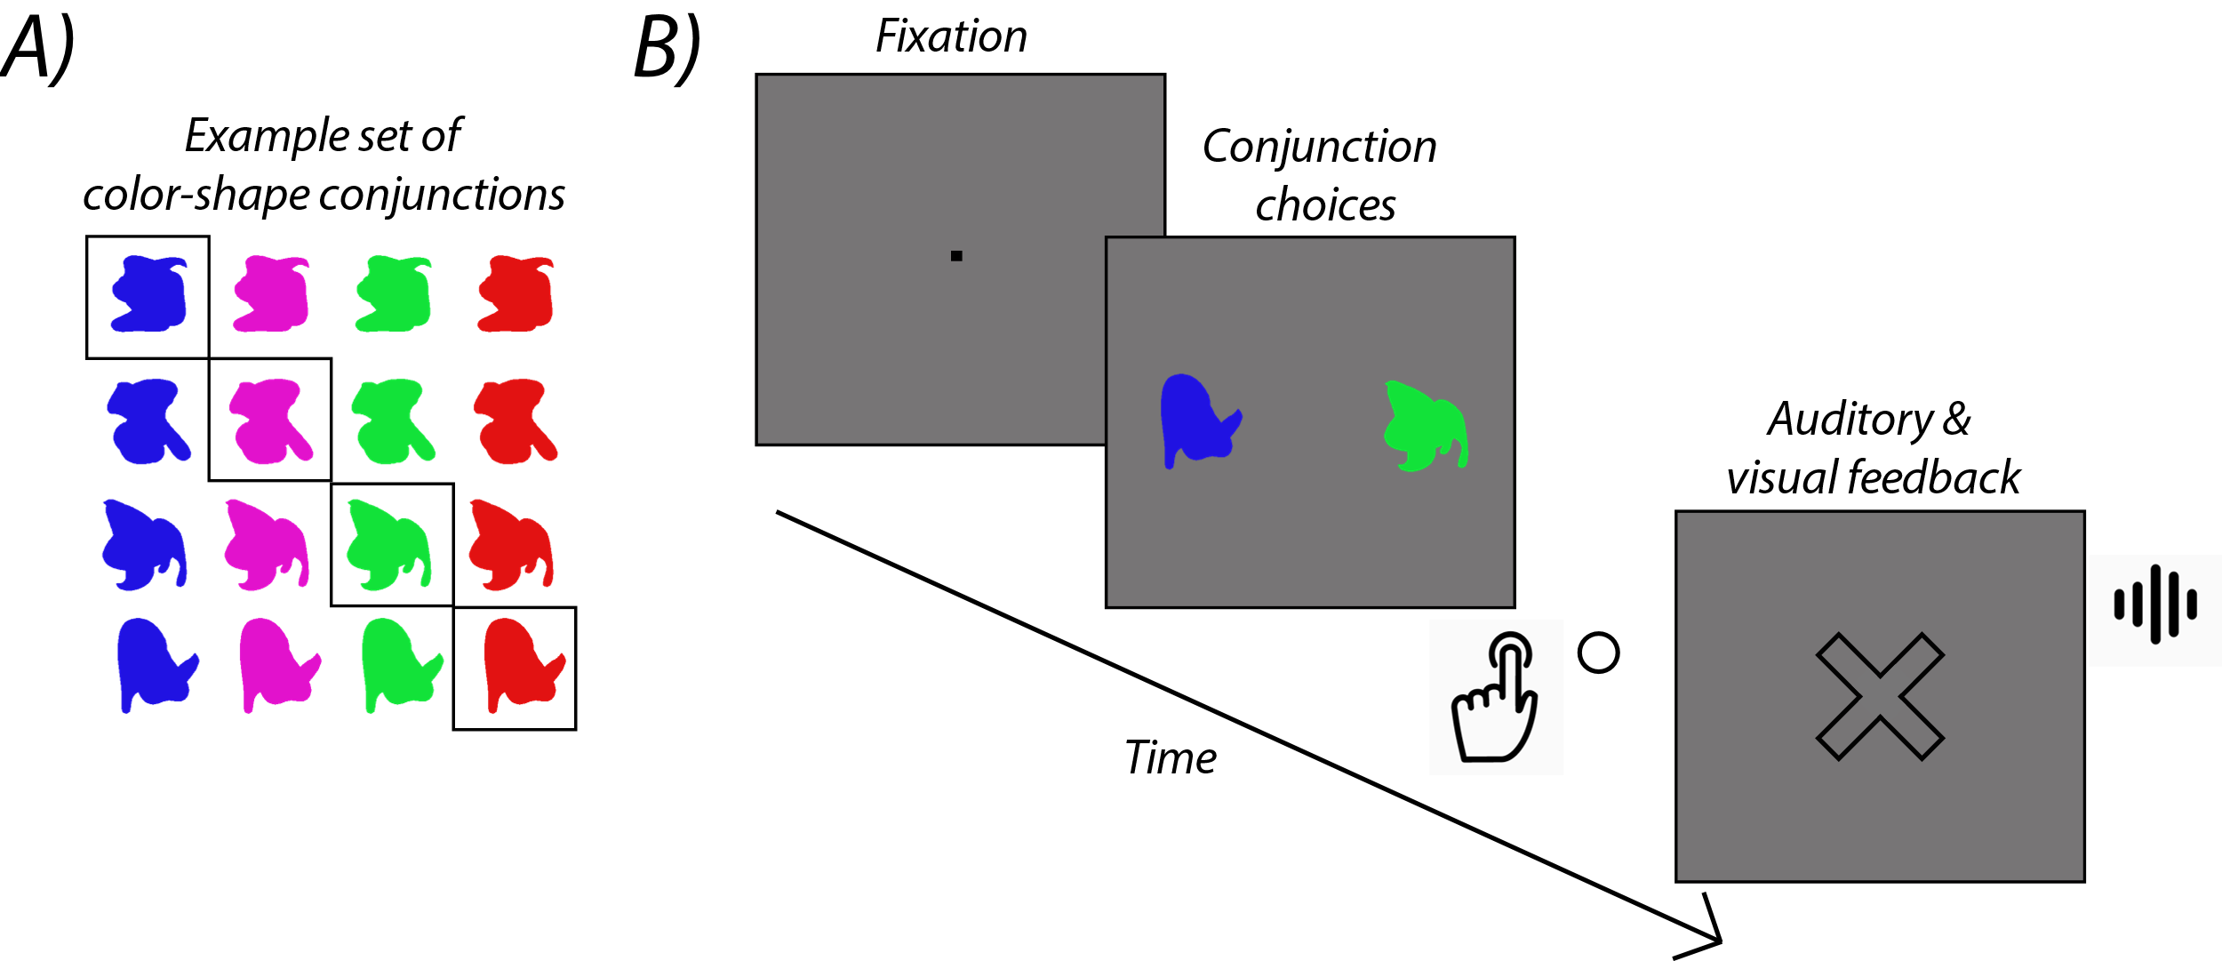
Figure 4-5. Conjunction selection task. Subjects were not given instructions as to the underlying rule of the task, but were told that when presented with two options, to select the option they thought was correct with a corresponding button press. A) Example set of stimuli used in color-shape conjunction experiment. Four of the sixteen combinations were correct and elicited a chime and empty screen when selected. The other twelve options were incorrect and elicited a beep and big X during the feedback period. (B) Task structure for the conjunction task. Example shows an incorrect trial. Shapes were 4ºV.A.
The motion conjunction task operated the same way, except that instead of the shapes having different colors, they were all black and moved with different 2D-periodic trajectories. The movement patterns spanned 8º V.A. and lasted 1500ms. Each cycle lasted 500ms. Shapes were still 4º V.A. in size. The trajectories were generated from a combination of sinewaves, square waves, triangular waves, and looping patterns (Figure 4-6).
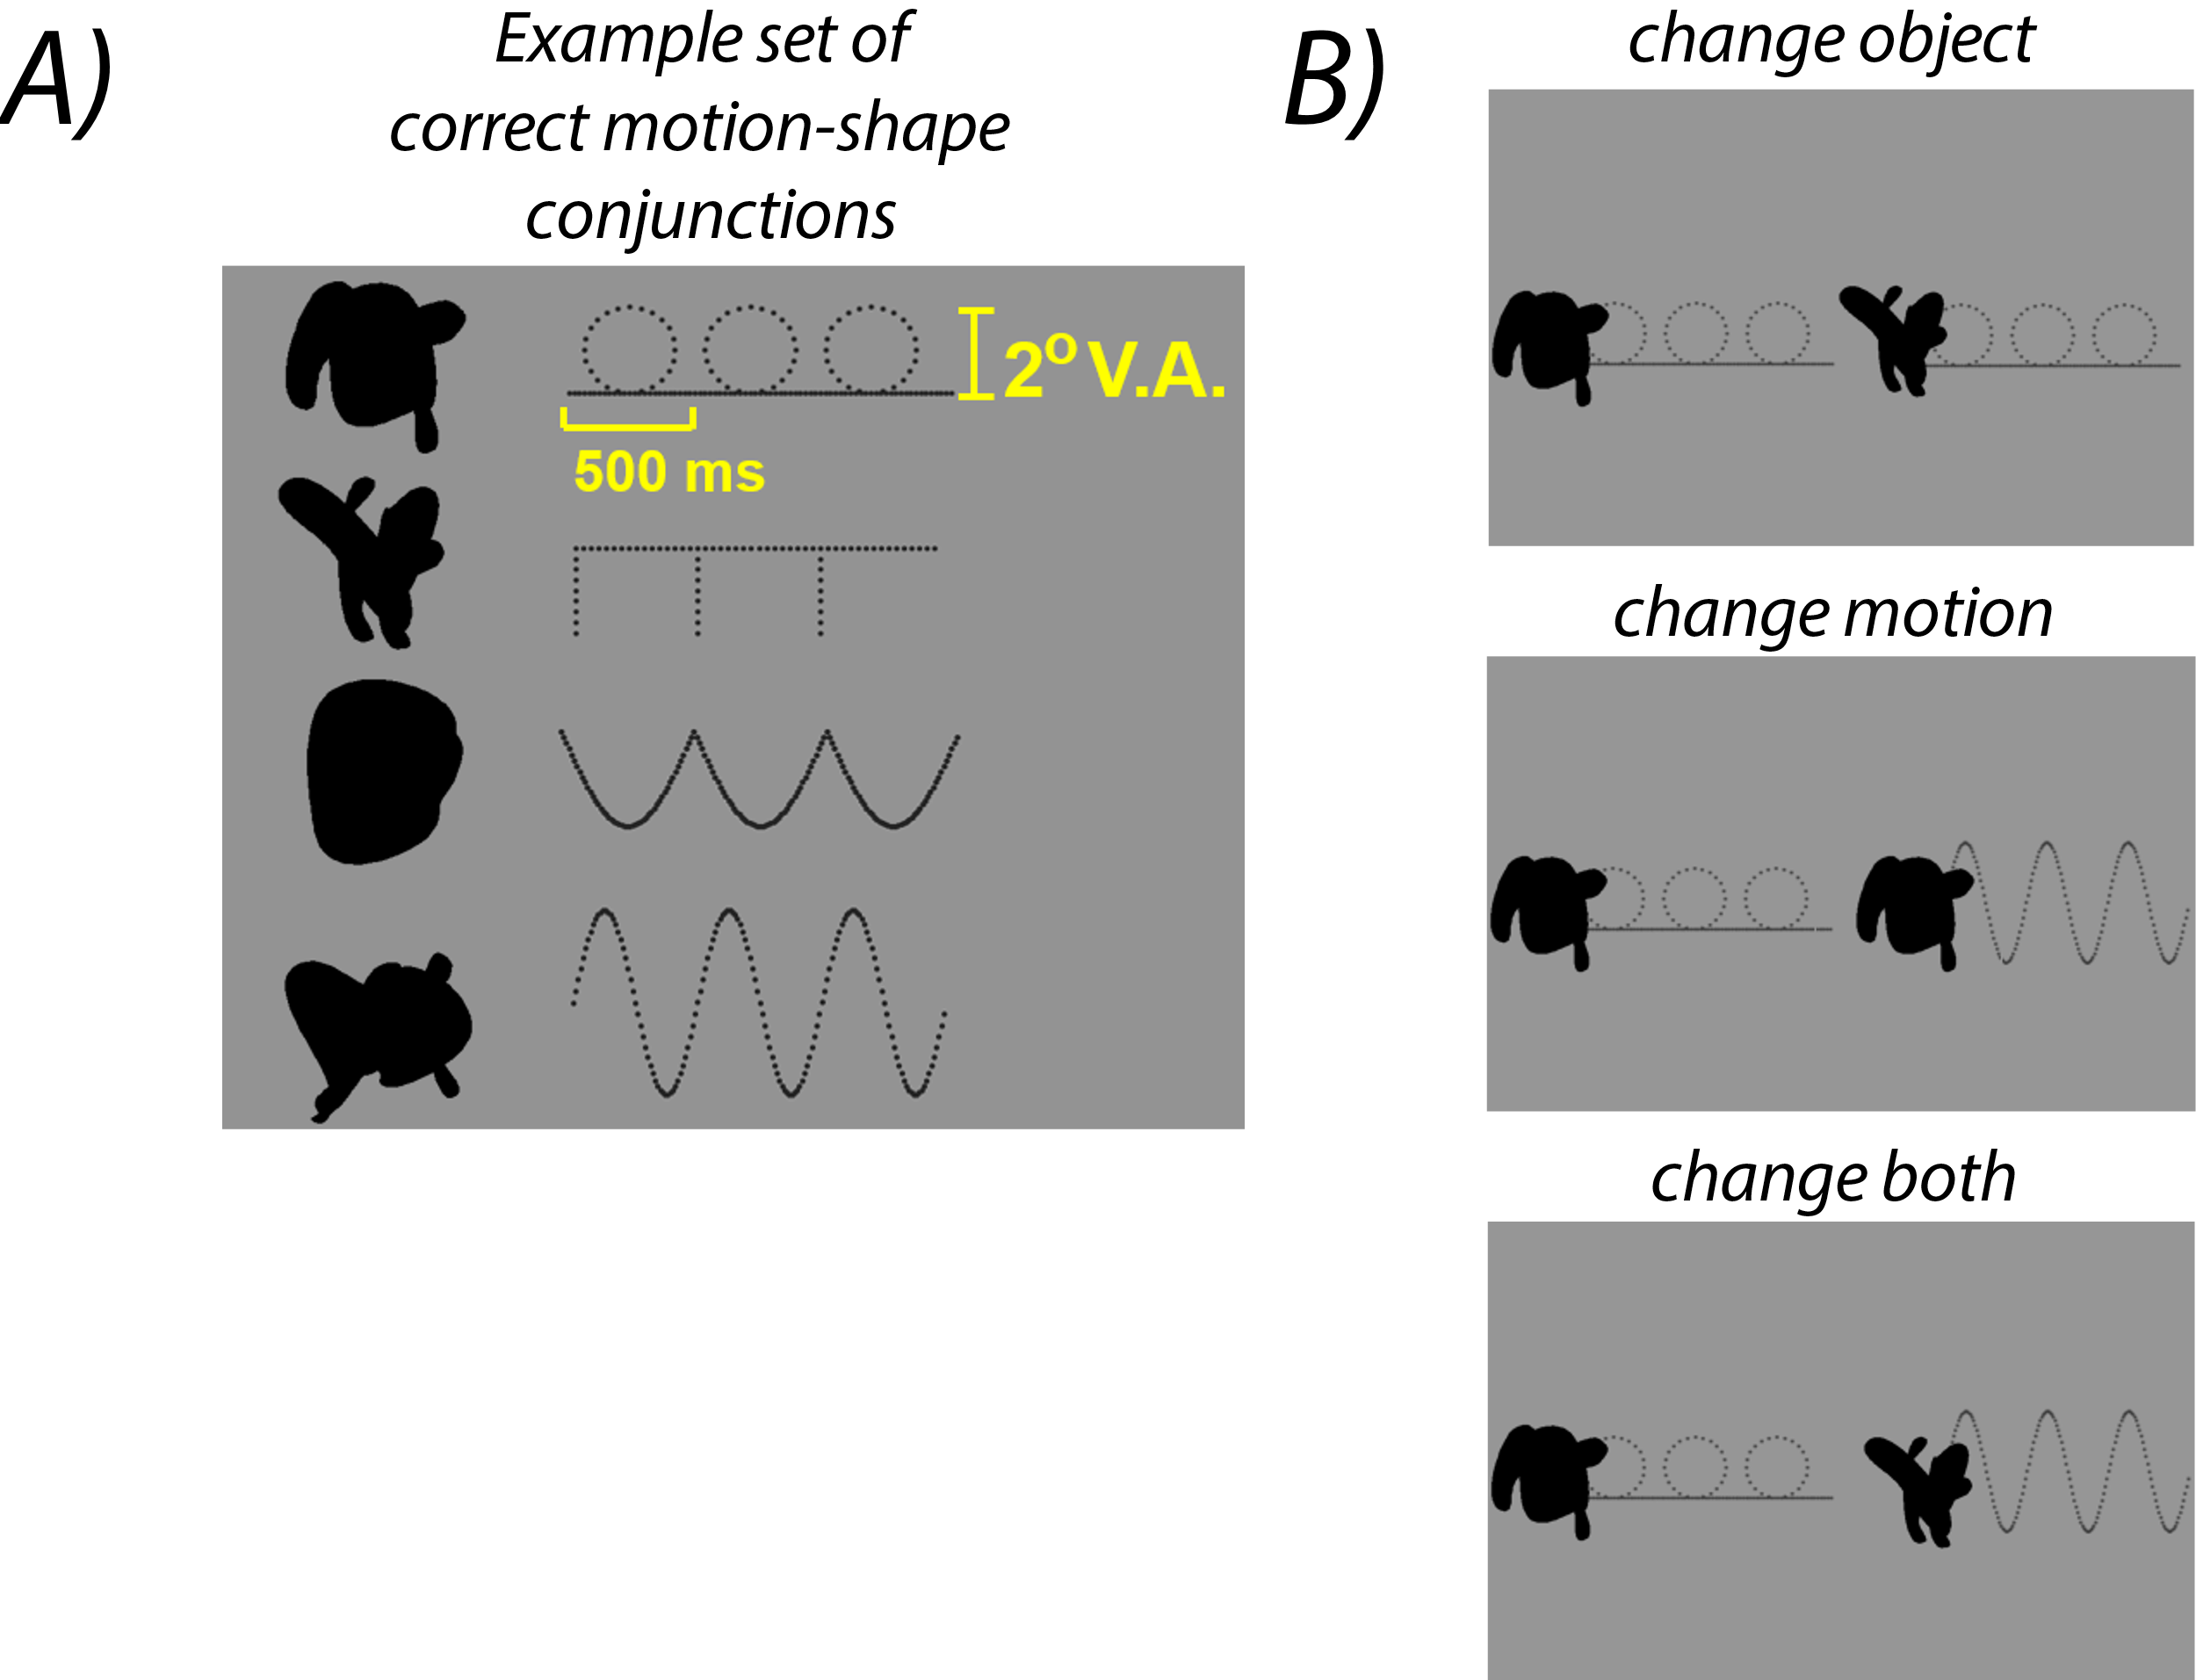
Figure 4-6. Example trajectories used in motion-shape conjunction task. Each subject had a different set of 16 stimuli and had to learn the correct combination of motion patterns and shapes without explicit instruction of the conjunction rule. Task structure the same as in Figure 4-5. (A) Example trajectories and correct pairings (B) Possible trial types. “Change both” trials were not included in the experiment. Note that trajectories were not actually visible during the task, black dots are only for demonstration.

4.4.2 Results
Four of the five participants completed the color and motion tasks (in that order). One subject never seemed to learn the color task and did not proceed with the motion task. Figure 4-7 shows the data on the color task for the 5 participants. Four of the participants learned within 8 blocks. Figure 4-7a shows that Subjects 3, 4 and 5 had a sudden improvement in performance around block 7. Subject 2 gradually improved across all four correct conjunctions, suggesting perhaps a different learning strategy.
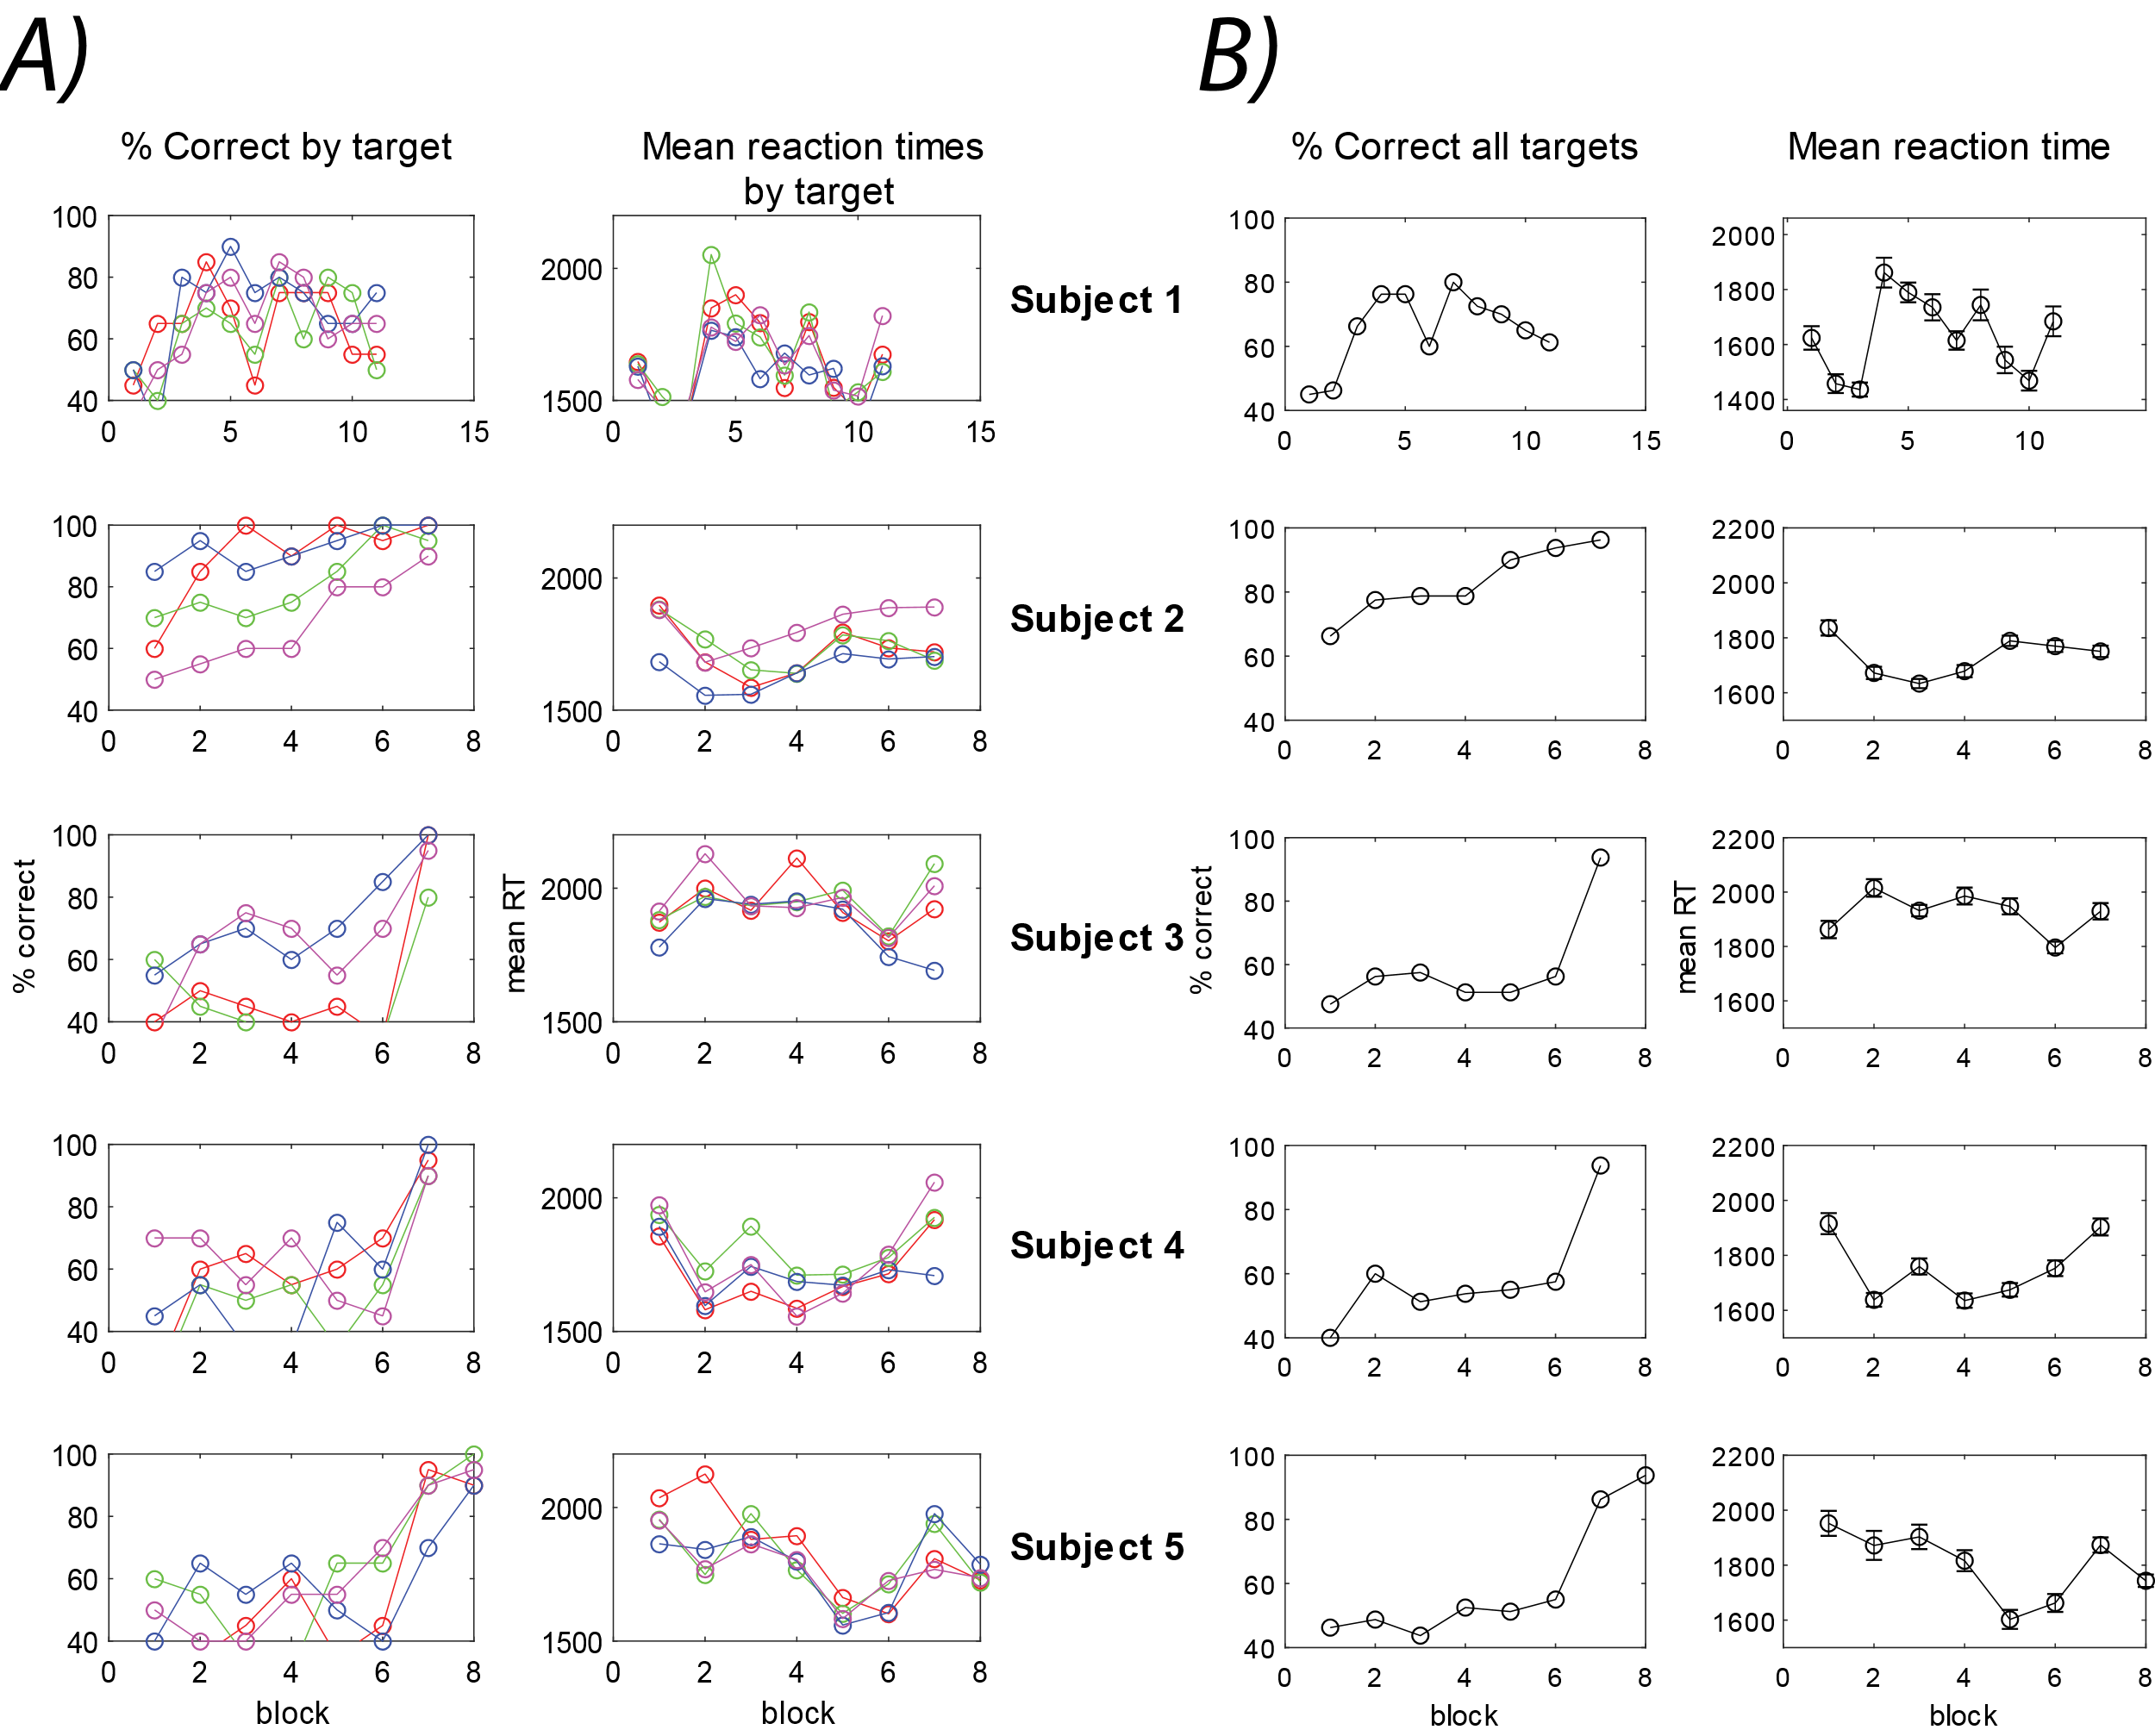
Figure 4-7. Performance and reaction times for color-shape association task (n=5). Each subject had a different set of 16 stimuli and had to learn the correct combination of colors and shapes without explicit instruction of the conjunction rule. (A) Performance and reaction times for each subject (row) split by the 4 individual correct conjunctions. Subject 1 never met the learning criterion. Other subjects reached criterion within 8 blocks. (B) Performance and reaction times across all correct conjunctions.
Interestingly, of the four subjects who did the motion-shape task, Subject 2 was the only subject to reach the learning criterion for the associations within the session (Figure 4-8). As in the color-shape task, Subject 2 demonstrated a gradual improvement across the four correct conjunctions.
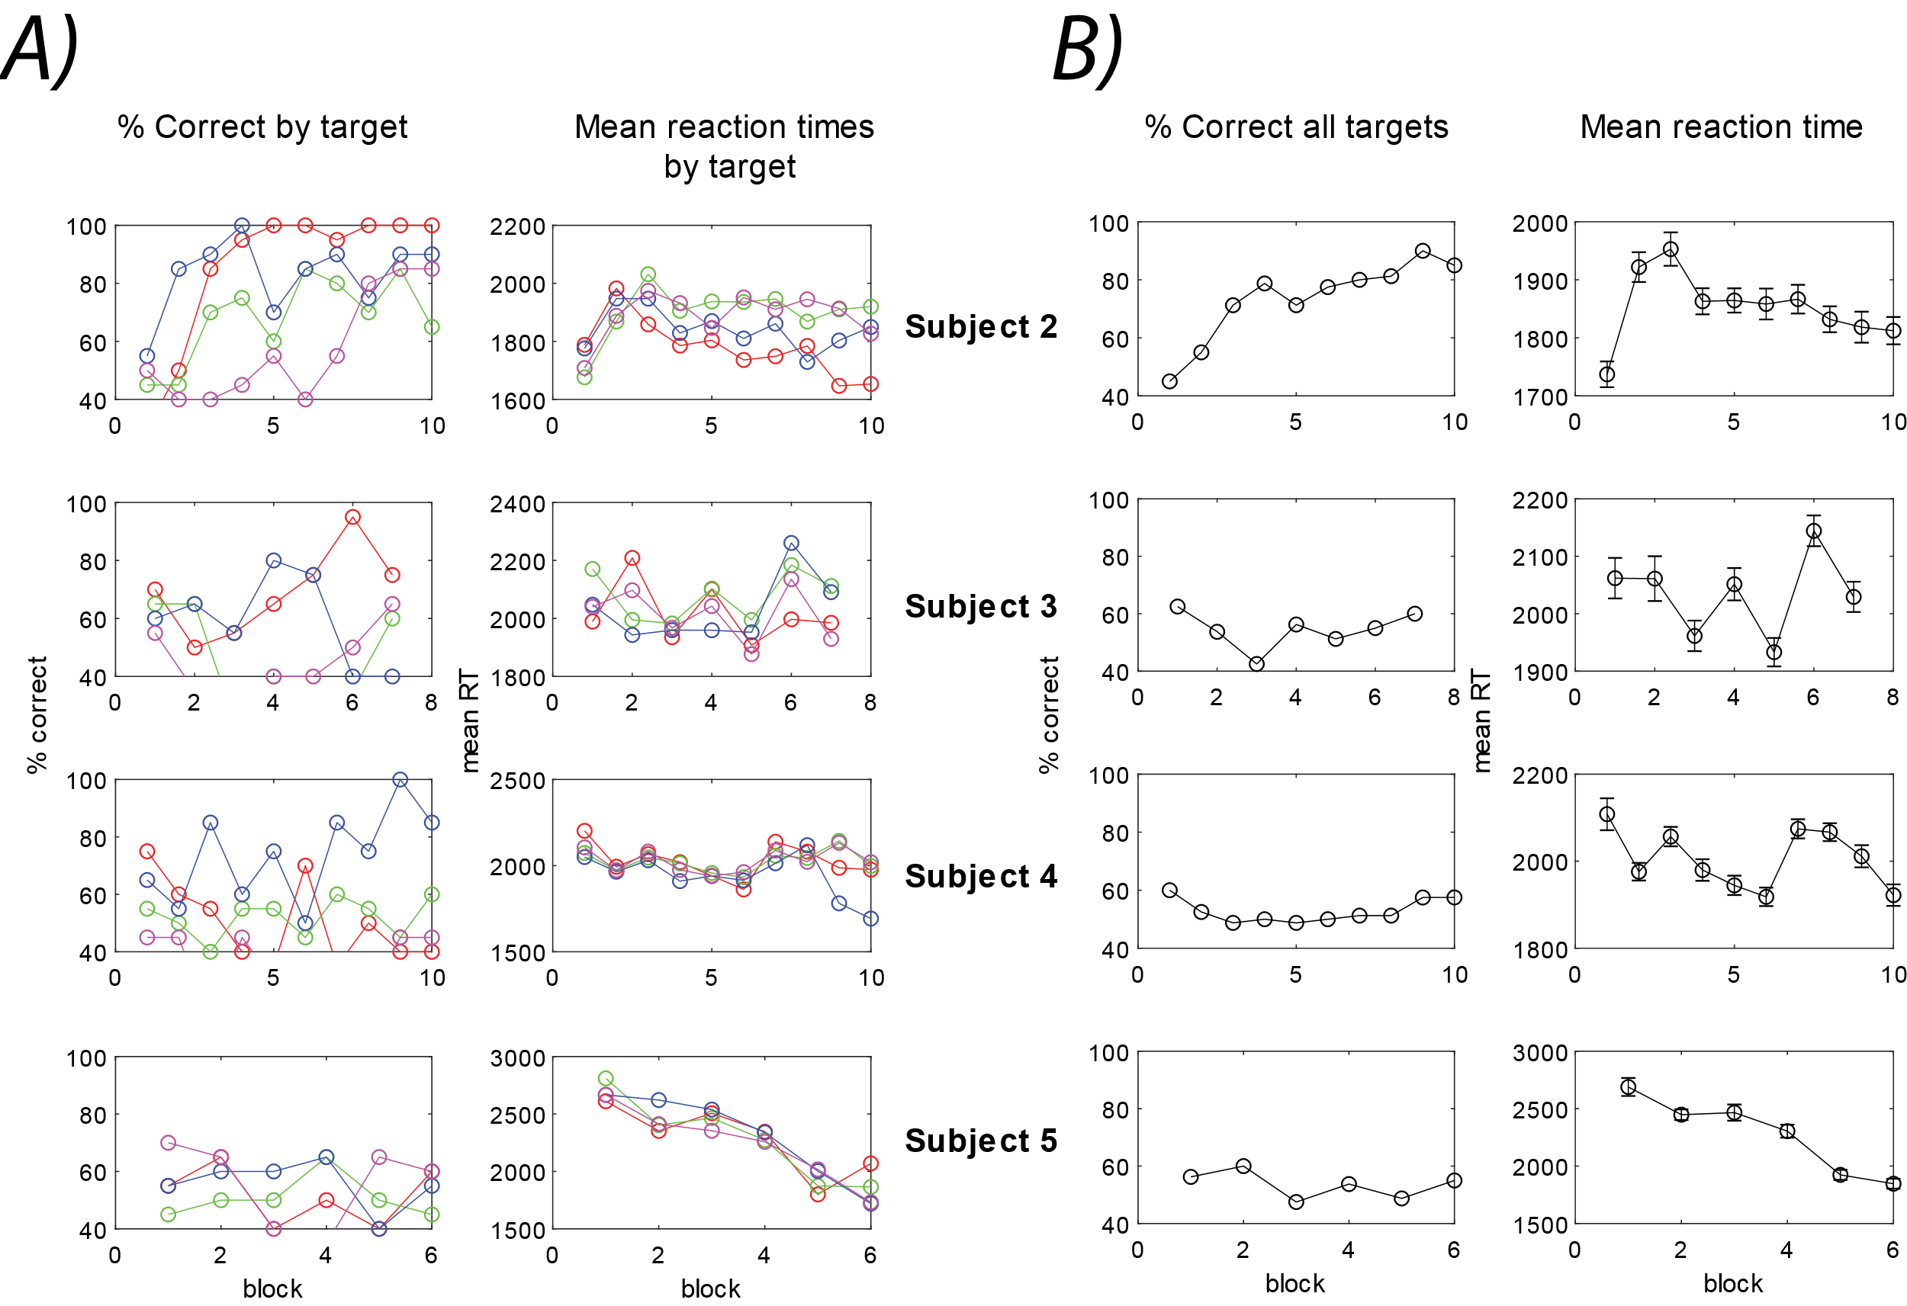
Figure 4-8. Performance and reaction times for motion-shape association task (n=4). Each subject had a different set of 16 stimuli and had to learn the correct combination of motion patterns and shapes without explicit instruction of the conjunction rule. (A) Performance and reaction times for each subject (row) split by the 4 individual correct conjunctions. Subject 2 was the only one to meet the learning criterion. (B) Performance and reaction times across all correct conjunctions.

4.4.3 Discussion
This small experiment was designed to test whether learning the rule (i.e. learn conjunctions) was difficult, and whether learning particular shape-motion conjunctions was difficult even after knowing the rule. Surprisingly, subjects required many trials to learn the correct shape-color conjunctions without instructions, and even after knowing the rule to pay attention to correct combinations of features, only one subject of those tested learned the shape-motion conjunctions. The data showed that learning the rule isn’t the only barrier to learning, and that the motion trajectories were also hard for subjects to combine with the correct shapes. This led us to iterate the monkey task away from periodic, left to right motion patterns, which subjects reported were difficult to track simultaneously, and to local motions that stayed in a local region on the screen.

4.5 Experiment 3: The effect of learned associations on feature extraction
The experiments described in Chapters 4 and 5 were conducted somewhat simultaneously from 2015-2018. Task iterations stemmed from the fact that the monkey was struggling to learn associations between movements and shapes, and despite overcoming obstacles, we had yet to demonstrate that the monkey could use motion information to select corresponding shapes. Experiment 3 emerged after the monkey’s first two recording chambers (Grey Matter over early visual areas, and ball-and-socket over area IT, see Chapter 5), broke off unexpectedly in March 2018, after approximately 1.25 years of recordings and iterations of tasks. Having realized that motion-shape associations are not easy to learn, nor easy to recognize in the visual areas we were recording from, we wondered if we could create a task context where we could demonstrate a perceptual benefit to using motion during shape recognition. This would support a stronger expectation of seeing a neural signature in early visual areas.
To explore the question of whether motion can improve the extraction of shape information, when that motion has been associated with a shape (or group of shapes), we designed a new task. By the time of this experiment, we had learned of the benefits of using simple shape stimuli (i.e. blobs) that had no real-world meaning and had no unique identifying features (like some of the everyday objects). Preliminary single unit recordings in area IT (see Chapter 5), also showed that having a large set of possible shapes made acquiring good neural responses much, much more tractable. Lastly, we’d learned through the monkey behavior that periodicity in the motion seemed to help the monkey recognize the motion patterns, and that the left to right trajectories posed an attentional issue for both human and monkey subjects. These considerations led to the design of the task described here.

4.5.1 Specific methods
18 human subjects (with ages ranging from 24 to 35) in total participated in Experiment 3. The task was a shape match-to-sample task with variable levels of target noise. The noise was generated differently than other experiments and consisted of a dynamic, flickering patch of gaussian-blurred greyscale patches (See Figure 4-9); the noisy square itself did not move. The shape stimuli were embedded and moved within the noise patch. The shapes consisted of two categories, curvy shapes (blobs) and sharp-edged shapes (spikeys). Each of the shape categories had a particular 2D motion pattern (different mapping for each subject, 6 possible mappings, 3 subjects per mapping). Motion patterns were the same closed shape patterns as those described in Chapter 2 (triangular, circular, bimodal). Earlier pilots of this experiment, (Experiment 3 Chapter 4), led to the design and ultimate use of those particular trajectories, based on their discriminability. Furthermore, this was the first task that subjects were allowed to pursue the target motions, after earlier reports of attentional switching between motion and shape features of the target.
Figure 4-9. Match to sample task with shape categories. Task structure for experiment 3. Subjects were told to select the best match to the target shape. Targets moved within a flickering square of noise. Subjects were allowed to pursue the target.
Choices on most trials were within-category choices, as shown in Figure 4-9. Subjects experienced cross-category choices during training to train the motion-shape associations, and during testing to reinforce the associations.
Leveraging what we had already learned from previous psychophysics tasks in this area, we designed a training and testing structure. Subjects participated in two types of training (low noise and high noise) and testing with intermediate to high level noise. All subjects received the same amount of training. The two types of trials from the testing block were analyzed separately.
Training Part (1): low noise within-category choices:
- 55 % noise
- Two blocks of 40 trials
- Choices: two blobs or two spikeys
- Subjects were instructed on the general structure of the task and were asked to pay attention to movement. They were asked to try to determine which movements were unique to each shape class and which were common to both shape classes.
Training Part (2): high noise cross-category choices:
- 72% noise (chosen because this is not used in testing and is slightly harder than the cross-category trials used in testing).
- 210 trials (70 informative, 35 uninformative movement trials per shape class, split into 2 blocks
- Choices: one blob and one spikey, not random, but the items of a single pair (the spikey being the non-interpolated version of the blob)
Testing: mostly within category choices:
- 65, 70, 75, 80% noise
- 10 blocks of 96 trials (72 within category trials at 4 noise levels, 24 cross category trials at 70% noise)
- Instructed that testing just includes both types of trials seen in training.

4.5.2 Results
The goal of this experiment was to demonstrate that motion could serve as a useful cue for what the choice items would be, and evoke increased perception of the target stimulus. Unfortunately, subject performance during training and testing was inconsistent across subjects. Of the 18 subjects tested in the various movement-shape class mappings, all of them learned the associations between both shape categories by the end of the high noise training (Figure 4-10). High performance in the first high noise training block indicates that subjects learned the associations during the low noise training block.
Each subject’s testing data was analyzed separately to determine whether informative, associated motion provided a benefit to performance. Figure 4-11 shows a single subject’s data that demonstrates improved performance for both shape classes on high noise, within category trials. Performance for the informative motion patterns is significantly better than the uninformative motion when trials are very difficult, but not so difficult that the subject’s performance was at chance.
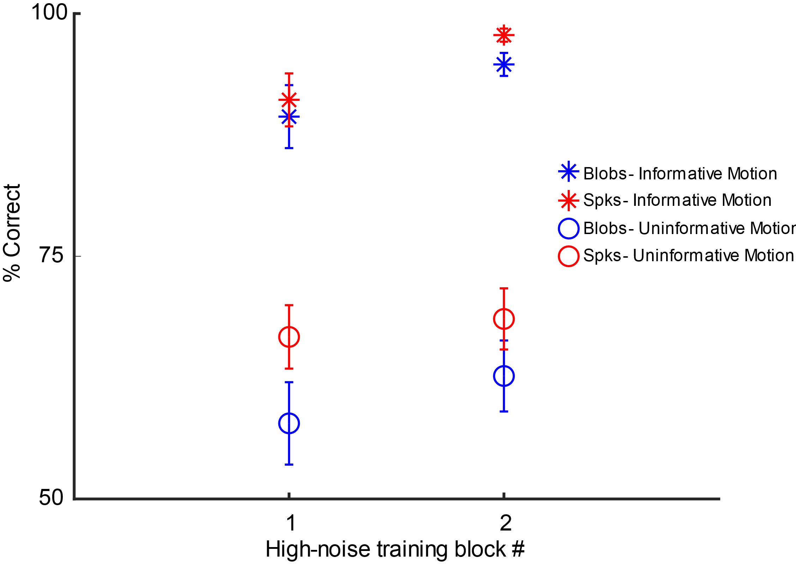
Figure 4-10. Average performance on high noise training blocks (n=18 subjects). Subjects demonstrated learning of both shape classes (blue, red) with their associated, informative motion patterns, as indicated by the high performance on high-noise targets (*). Targets moving with uninformative motion patterns (o) were occluded and led to lower performance despite training. Subjects improved their performance slightly from the first to the second block for both kinds of moving targets, and for both shape classes. Error bars s.e.m.
Unfortunately, this result was not consistent across all subjects, and the group averages are shown in Figure 4-12. 13 subjects showed some kind of benefit in at least one shape class, but for some subjects the benefit emerged in the second half of trials, or was present only for one shape class.

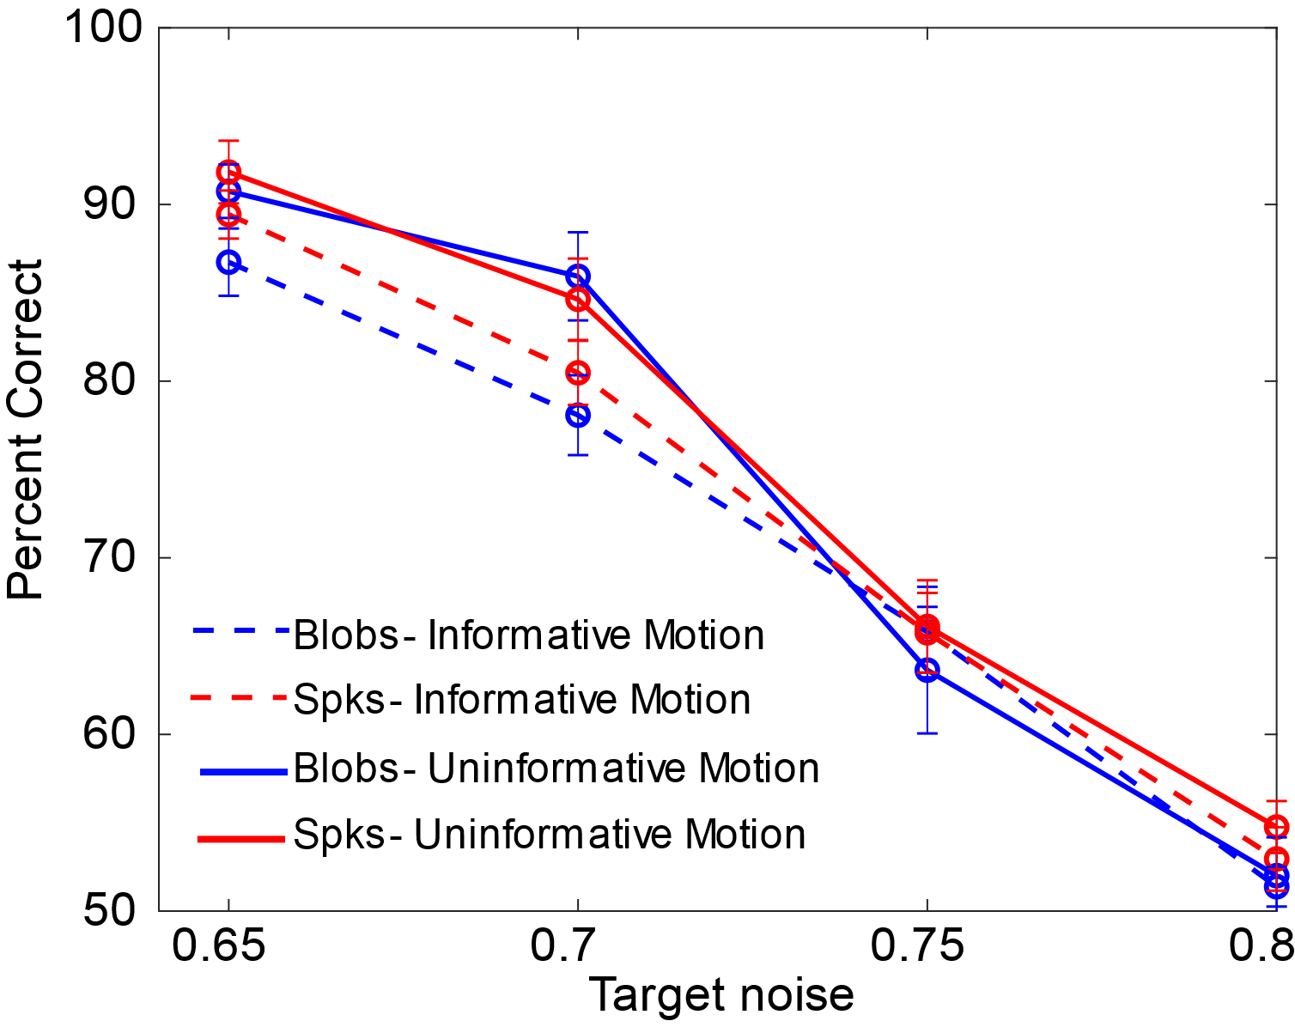
Figure 4-12. Average performance for all subjects (n=18) shows no consistent benefit across shape classes. Percent correct is plotted as a function of target noise. As noise increases, overall performance decreases. There is a small but insignificant benefit for the blob shape class, and a consistent decrease in performance for informative motion for the spikey class.
Figure 4-11. Average performance for a single subject demonstrating a perceptual benefit of informative motions. Percent correct is plotted as a function of target noise for both shape classes: blobs (circles) and spikeys (diamonds). Subjects performed better on trials with informative motion (gray) for both shape classes when target noise was very high (noise=0.75), but not so high as to lead to chance performance across all targets (noise = 0.8).

4.5.3 Discussion
This task was designed to probe whether motion could be helpful cue for extracting additional shape information during a matching task of ambiguous stimuli. The hypothesis was that if motion could be a useful cue in this way, that this might shift the actual perception of the ambiguous shape stimuli, and lead to better extraction of shape information. It is unclear what would be benefitting, perhaps curvature feature extraction in the case of the curvy and spikey stimuli. If the motion cues had been consistently useful, then it would have been a useful paradigm for neurophysiology in the visual pathway. The results were not consistent across subjects, but there were hints that motion was useful for some subjects to perform better on very difficult trials. Future directions might involve tuning the stimuli difficulty to each subject to reach their threshold, and to use a reaction time version of the task (forced quicker responses) to see biases induced by informative motion and uninformative motion cues. By allowing effects to show up in reaction times and average performance, this might blunt the effects that are visible at the group level.

4.6 Discussion: how these tasks inspired monkey task design
The experiments designed in this section were critical steps in arriving at the final monkey task described in Chapter 2. Before these experiments, we had thought that based on previous work on feature integration that that motion and shape information would be easily accessible and combined, particularly when both motion and shape information were helpful for maximizing accuracy. The experiments in this section showed that learning shape motion associations could be counterintuitively slow and only overcome with extensive, structured training or verbal instruction.
The first experiment described, which involved associating simple 2D trajectories with real world objects with variable levels of salt and pepper noise, demonstrated that trajectory motions and pictures of real world objects could be associated, but required additional training on harder conditions was required for subjects to consistently learn within an hour session. The issue was not the difficulty of the stimuli, rather the lack of attention to motion information and over-attentiveness to shape information. Subjects reported trying to find hints of object features in 100% noise rather than pay attention to the way the noise blob moved on the screen. Extensive training in the 100%/10% conditions could overcome this bias and shift attention to motion, after which subjects learned fairly quickly what the motions were and how they were associated with the shapes. Furthermore, a weak verbal cue to attend to motion also led to rapid learning of the shape-motion associations. We did not pursue this route extensively and chose to focus on training, as the goal of task design was to design a task for the non-human primates, who could not benefit from verbal instruction. This led us to think deeper about how the noise, shapes used, and motion patterns could be selected to shift attention more to the motion patterns rather than shape information. By using simpler shapes (e.g. blobs and spikeys) and a more natural progression between clear and degraded shapes (e.g. blur), we hoped the shape information would be reduced and motion information could become more salient for the monkey.
The second main experiment described in this section, the conjunction experiment, showed that there were two obstacles to be overcome in conjunction learning: first that learning that combinations of features was the task goal, and then which conjunctions. However, the shape-color experiment proved to be easier for most subjects than the shape-motion experiment, even after learning the primary task goal. This enabled us to see that the motion trajectories themselves (the simultaneous presentation, left-to-right design, and size) made this a difficult multiple object tracking problem. Surprisingly, the first monkey was able to learn this task (See Chapter 5.4.3) but learning new conjunctions daily was still challenging even with extensive experience. The experiment with human subjects suggested that the barrier might be the multiple object tracking and discriminating the trajectories. Thus, trajectories were simplified to be more local and foveal and the task was transitioned back to a matching task to ensure that only one moving object would be shown at a time.
The last experiment described in this section suggested that perhaps motion could be a beneficial cue for extracting shape information, but that there were individual differences in levels of attention to shape and motion information that had to be accounted for with human subjects. We did not pursue this task further as the first monkey had begun having success on the matching paradigm with blur described in Chapter 2. However, a future direction would be tuning the difficulty of the noise to threshold for each subject in the experiment described in 4.5.
In summary, the experiments described in this section demonstrated that integration of motion and shape information does not always come easily and naturally to human subjects, and that task design can influence the extent to which these features are integrated. Furthermore, the results elucidated which task features were useful to reconsider and modify for the non-human primate task.
4.7 Appendix
4.7.1 Preliminary work on a motion-shape visual search paradigm
After multiple years of working with a matching task, the question arose whether a different task paradigm, such as visual search, might allow for the implicit learning of shape-motion conjunctions. A large body of work has previously characterized perceptual learning of single feature conjunctions (shape, color, motion) in visual search (Recent annual review: Wolfe et al., 2020). Specifically, the Tse lab at Dartmouth designed a visual search task for perceptual learning of movement trajectories in visual search and using functional magnetic resonance imaging (fMRI), demonstrated that early visual areas changed their activity patterns in response to learning to discriminate the motion trajectories (Frank et al., 2016; Reavis et al., 2015; Reavis et al., 2016). The goals of this subproject were to improve our understanding of (1) how task context promotes motion-shape binding and (2) whether arbitrary associations of motions and shapes can be learned without direct training in a visual search context. This project was one that was designed near the end of 2019 for an undergraduate to finish in Spring and Summer 2020. The world events during the time precluded running subjects beyond the preliminary experiments, but the data that was collected is described here.
The goal of this subproject was to determine whether shape-movement conjunctions could be implicitly learned during visual search. The hypothesis was that with training, subjects would improve their performance in a shape + movement conjunction task at a slower rate than tasks using just one feature dimension, but that subjects would demonstrate transfer from learning the conjunction task to the single-feature tasks, and demonstrate implicit learning of shape + movement conjunctions.
The task leveraged existing single-feature visual search tasks (Figure 4-13). The Tse lab task (Figure 4-13a), consisting of dots moving in a lambda or V-shape pattern, was the motion-only task. One of the dots was moving differently than the others and was the target; the subject’s task was to say on each trial whether the target was present or absent (all distractors). The details of the timing and stimulus construction were borrowed from the previously published version (Frank et al., 2016). The shape task was a slight modification of previous study on shape conjunctions in visual search (Wolfe & Horowitz 2017). The shape visual search consisted of a + sign target among X distractors (Figure 4-13b). Both of these individual feature tasks have been shown previously to induce perceptual learning. The conjunction task combined the motion-only and shape-only task (Figure 4-13c).
Figure 4-13. Visual search tasks: motion only, shape-only, motion + shape. The targets in each task are circled in yellow; the remaining items were distractors. (A) Motion visual search task as used in Frank et al., 2015. The target is a dot moving with the V-shaped motion pattern among dots moving with lambda-shape motion patterns. The red trajectories are only shown for visualization and were not visible during the task. (B) Shape visual search of a shifted plus sign among Xs. (C) Motion and shape visual search that combined the features from the single-dimension tasks.
Two subjects were run in this pilot experiment. Each subject was pre-tested on the individual feature tasks, trained on the conjunction task, and then tested on the individual feature tasks for transfer. Results are shown in Figures 4-14 and 4-15. Learning index was calculated with Equation 4-1:
$$Equation 4-1 Learning Index=log⁡(\frac{overall mean reaction time }{overall accuracy})$$

The learning index is a useful metric for assessing learning as it incorporates both speed and accuracy, which are both areas where performance can improve during perceptual learning, and often a tradeoff between the two areas for improvement (Heitz 2014, review of SAT). The average performance plots in Figure 4-14 and learning indices in Figure 4-15 suggest that there was indeed transfer from conjunction training to both individual feature tasks, shape and motion for both subjects. Subjects were not cued to attend to shape or motion, yet seemed to have opposite preferred features (Subject 1 performed better on the motion task, Subject 2 performed better on the shape task). This preliminary dataset suggested that perhaps visual search could be a task context for natural integration of shape and motion information.
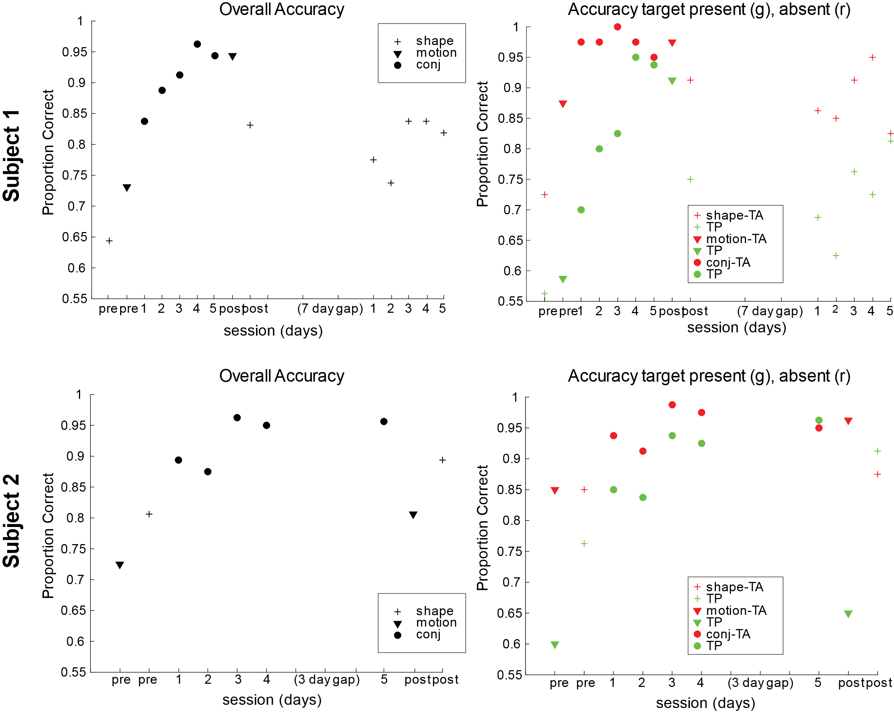
Figure 4-14. Performance data for 2 subjects in multi-session visual search experiment. Subjects were pre-tested on the individual feature tasks and trained on the conjunction task across multiple days. Subjects were then post-tested on each of the individual feature tasks for perceptual learning transfer. Overall accuracy improved for both subjects across sessions (left) and both subjects improved their accuracy on target absent trials over sessions (right).

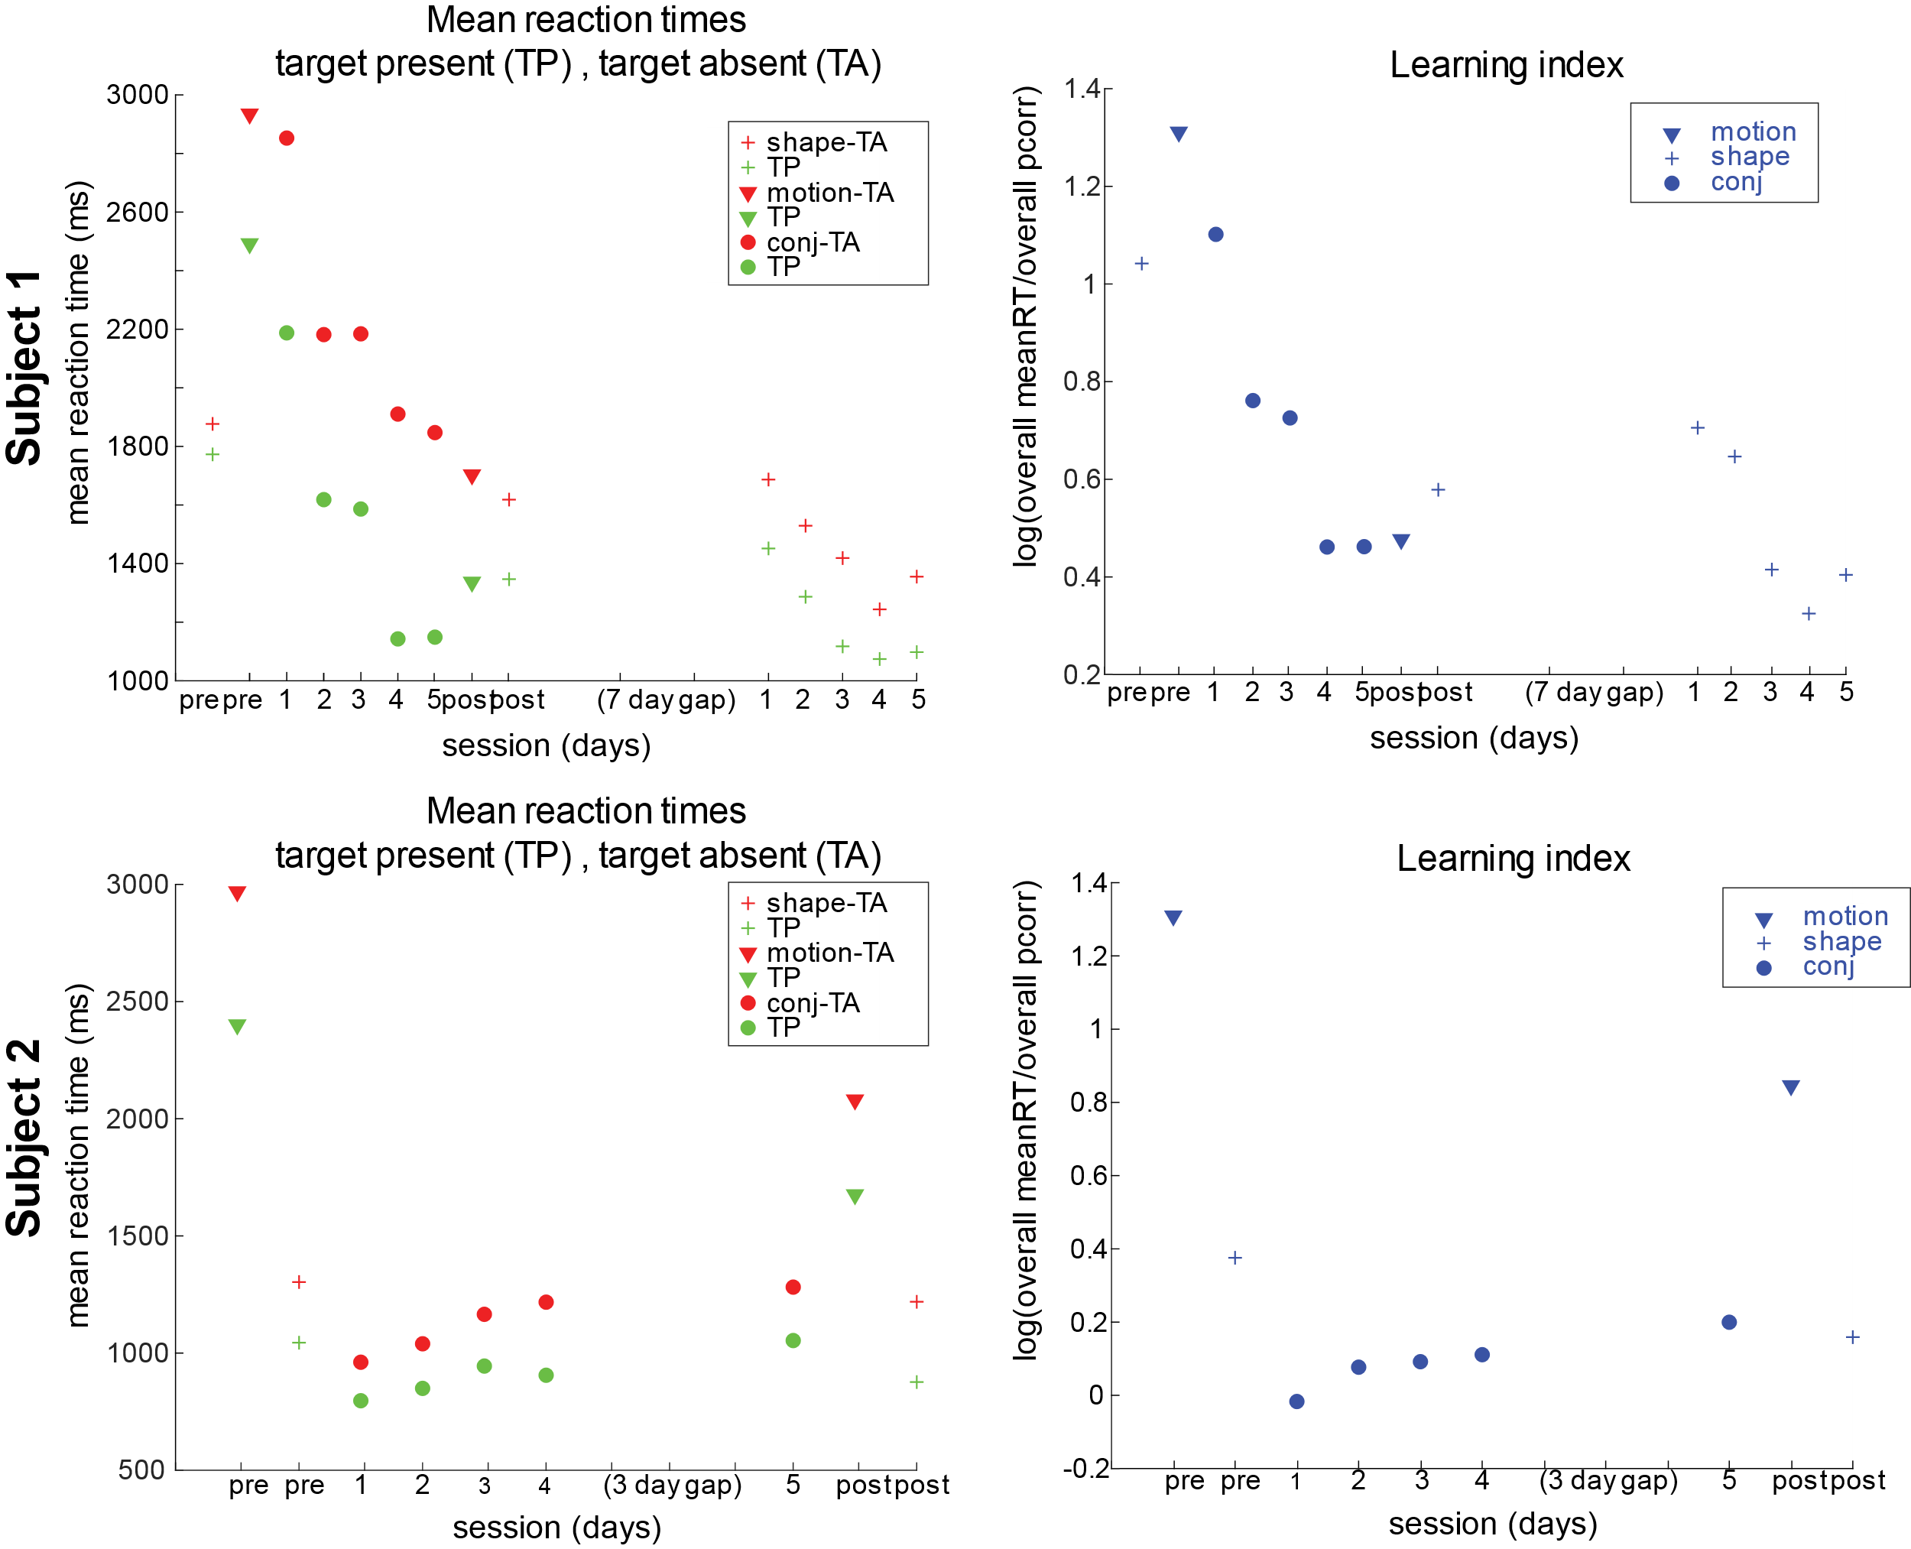
Figure 4-15. Reaction time and learning index data for 2 subjects in multi-session visual search experiment. Subjects were pre-tested on the individual feature tasks and trained on the conjunction task across multiple days. Subjects were then post-tested on each of the individual feature tasks for perceptual learning transfer. Mean reaction times decreased for both subjects across sessions (left). Right: learning indices for each session for both subjects. Learning index, which is a logarithmic ratio of mean reaction time and accuracy, decreased with learning.

Chapter 5: Responses in early visual areas during motion-shape associative learning

5.1 Introduction
This chapter discusses the neural and behavioral data from Monkey Y in an initial design of experiments that included recording from early visual motion-sensitive areas and area IT simultaneously. The main goal was to assess motion-sensitive areas for shape-selectivity (and extend the work of Schlack & Albright 2007, as described in Chapter 1), and assess area IT for motion sensitivity. The purpose of recording simultaneously from these areas was also to potentially link activity in MT/MST to activity in area IT.
This was the original project design, that for multiple reasons turned out to be intractable at the time. The data described in this section was collected over the course of approximately three years (2015-2018), and merely scratches the surface of the analyses attempted during this period. After implantation of the Gray Matter array, which was a chronic array with 32 independently controllable electrodes, it became clear that few of the electrodes were definitely in the target areas MT & MST, and that the nature of Gray Matter recordings led to heterogeneity in the population data that made analysis particularly troublesome, as some electrodes would hold the same signal for months, and others could fluctuate even within a session. The project was interrupted when the Gray Matter chamber was dislodged unexpectedly, and unfortunately compromised the existing IT chamber as well. Both were removed, without event, but we chose not to continue down the exact path and reproduce the Gray Matter chamber with a second animal because the data collected was non-conclusive, and the chamber was not hitting the original target areas. Furthermore, this phase of experiments became a cautionary tale, that more data does not necessarily lead to clear conclusions. The task was not well matched for the styles of recording, and the task itself had pitfalls that made merging the neural data with the behavioral data seemingly impossible. Following the demise of the first set of chambers, the project was streamlined down to a task that clearly demonstrated the animal was integrating motion and shape information (see Chapter 2) and to only record from IT cortex (see Chapter 3). A new IT chamber was eventually placed over the opposite hemisphere (see Chapter 3).

5.2 Materials & methods
Methods covered in previous chapters are not repeated in this section. The particular visual stimuli used in each of the tasks are described in section 5.3 along with an overview of the behavioral data that came from each task. These tasks are very similar to those described in Chapter 4, as the human psychophysics tasks served as an iterating platform for task development for Monkey Y.

5.2.1 Animal subjects & preparation
One adult male macaque monkey (Monkey Y, 11 kg) was used in the experiments described in this chapter, which took course over mid 2015 until March 2018. Before any metal was implanted, a MRI scan was performed to establish a 3D structural model of the monkey’s brain. The monkey then had a titanium headpost implanted and was chair trained, rig trained, and trained on basic match-to-sample tasks before any chambers were implanted.
During training and recording days when the animal’s fluid intake was regulated, his weight and other health signs were closely monitored on a daily basis. All procedures were approved by the Brown University IACUC and following NIH guidelines for animal care and use.

Gray Matter Array
After training on behavioral tasks, the monkey was implanted with a form-fitted titanium chamber and the semi-chronic 16mm travel, SC-32 microdrive (Gray Matter Research), designed to hit MT & MST in the let hemisphere (Figure 5-1a). The array had 32 independently movable electrodes (vertically) with 1.5mm horizontal spacing. Chamber localization was guided using the stereotaxic coordinates (-6.6P, +14.8L) thought to target MT/MST specifically in Monkey Y. These coordinates were generated in collaboration with Gray Matter Research using a hand-drawn MT/MST target, Monkey Y’s MRI data, and the chamber dimensions (Figure 5-1b).
Figure 5-1. Gray Matter chamber and planning images for Monkey Y. (A) Form-fitted 32 chamber Gray Matter array in titanium recording chamber. (B) Monkey Y’s structural MRI, chamber drawing and MT/MST target overlay. Coronal view of structural MRI from Monkey Y with drawings of the skull (gray), GM chamber (orange), and electrodes (black) through the desired MT/MST target region. (C) 3D cutaway skull and GM chamber CAD drawing showing placement on left side of skull.
The implantation of the chamber took two surgeries and multiple steps (Figure 5-2). Following implantation of the array, the 32 electrodes were lowered through dura over the course of two to three weeks (2-5 per day). However, some of the electrodes broke upon dura penetration and were not lowered any further. About a month after the beginning of this electrode lowering process, it became apparent that some of the electrodes previously lowered had exited the dura (as indicated by noise ranges and LFP signal). It remains unclear exactly how this happened, but we hypothesize that this style of array in this location can lead to fluid build up and cause pressure on the brain, causing the tissue to move downward away from the electrodes. There were no signs of infection or any issues with Monkey Y, but electrodes were repeatedly lowered to re-encounter similar signals to those previously encountered, which also supports this theory of the brain compression.
Figure 5-2. Multi-stage process for implanting the Gray Matter array and lowering the electrodes. (A) Stage 1: exploded view illustrating the placement of the metabond, chamber, o-ring, short plug, and cap. This surgery leaves the skull intact inside the chamber (B) Stage 2: (C) Stage 3: Electrodes were lowered over the course of multiple successive days by turning the lead screws to a subset of electrodes (2-5) until dura was punctured. The presence of dura was indicated by a variety of auditory cues, including an increase in noise immediately before puncturing dura and a decrease after. Figure modified from Gray Matter Research
Unfortunately, we learned after the surgery that the anterior/posterior coordinate was about 3mm too posterior and the chamber would hit a variety of early visual areas, and only some electrodes had a chance of hitting MT or MST. This was confirmed by using the original MRI, D99 Macaque brain atlas (Reveley et al., 2017), and a CT-scan triple co-localization to confirm chamber placement (Figure 5-3b). There were indications of tissue compression underneath the array during the initial electrode lowering and during subsequent weeks and months that the array was on Monkey Y (11/2016-03/2018). Thus the atlas only provided an estimate of which areas the electrodes could have potentially been located (Figure 5-4).
Figure 5-3. CT-MRI-NIH Macaque atlas to confirm Gray Matter chamber location. (A) Co-registered pre-surgery structural MRI and post-surgery CT scan from Monkey Y. From left to right: sagittal, coronal, horizontal views. (B) Triple-registration of the images in (A) with the D99-NIH Macaque atlas using NIH-AFNI software. Colored areas indicate different brain regions.
Electrodes depths were tweaked to maximize the number of units across the array. Sometimes an electrode would hold the “same” signal across days, weeks and even months, while others would fluctuate daily, sometimes within a session. Moving an electrode did not always ensure getting a signal, so if there was a unit on the electrode, the electrode was not moved. A recording log was kept to document the approximate depth of each electrode based on the number of turns. Some electrodes broke after re-entry into dura, or broke for other reasons inside the brain (hypothesized scar tissue); this was also kept in the longitudinal log.
Figure 5-4. Potential brain areas that each GM electrode could target, as determined by the triple MRI/CT/D99 Atlas triple-registration. (A) Co-registered pre-surgery structural MRI and post-surgery CT scan from Monkey Y, horizontal view showing electrodes. (B) Potential locations of each electrode in the array, broken electrodes as of 3/2017 (this number increased with time). Each brown box represents an electrode in the array, and within that box there are the estimated regions the electrode could hit across depths. Each area is color-coded to go with the expanded coronal section from the Saleem and Logothetis (2012) atlas shown in (C). (C) Partial section of monkey brain at last (coronal view) of early visual areas targeted by the GM array.

Area IT Ball & Socket Chamber
After Monkey Y demonstrated improvement on the motion-shape behavioral tasks, and had fully recovered from the Gray Matter chamber surgeries, a ball-and-socket chamber was placed over the left hemisphere (anterior to the Gray Matter chamber), to target area IT. The procedures regarding this type of chamber were described and shown in detail in Chapter 3. Monkey Y’s first ball and socket chamber was on from 5/2017-3/2018, when both chambers came off.

5.2.2 Neural data acquisition
Procedures for recordings in the ball and socket chamber as described in Section 3.2.2.; technical issues slowed data collection from the ball and socket chamber, so there were many sessions with Gray Matter recordings only.
Sessions either involved recording only using the Gray Matter array, the Gray Matter array with a single electrode in the ball and socket chamber (33 electrodes total), or a 16 channel V-Probe in the ball and socket chamber (48 electrodes total). The Gray Matter drive was assessed for the number of units across the array; electrodes were lowered or tweaked to maximize the number of units in a session, but no more than 4 electrodes were adjusted at a time, in an attempt to minimize further tissue compression. Electrodes with robust spontaneous signals were not adjusted. Number of turns were tracked in a spreadsheet to keep track of depth across weeks and months, although this was only an approximation because the tissue was not always stable in its location.
The neural data was processed as previously described: amplified and digitized (25 kHz), and then processed in a Tucker-Davis Technologies (TDT) neurophysiology system. The raw data from each channel (electrode) was band-filtered with two frequency ranges: local field potential (LFP, 0.3-300Hz) and single units (SU, 300-3000Hz). Thresholding was used to detect spikes from the SU signal. Thresholds for single tungsten electrodes were set dependent on the quality of the signal, but in most cases 5.0x the standard deviation of the signal for well isolated single units. The threshold was set lower (3.5-4.0stdev) on days when the single electrode only picked up a smaller signal or mixture of multiunit and single unit activity that was not clearly separable online. The threshold for spike detection for the Gray Matter array recordings was typically 3.5x s.d., as the impedance of the GM electrodes was much lower than the impedance of a single tungsten electrode. The threshold for some electrodes was lowered to 3.0x s.d. as electrode impedance dropped over weeks and months. Plexon offline software was used for both initial clustering followed by manual spike sorting.

5.2.3 Eye signal
Eye position was recorded as described in Chapter 2.2.

5.2.4 Stimulus presentation & behavioral control
The same behavioral apparatus described in Chapter 2.2 was used for all experiments described in this section.

5.2.5 Behavioral paradigms & daily recordings
Behavioral sessions on neural recording days mainly consisted of passive viewing pre-task, the active task, followed by passive viewing post- active task, with the goal of tracking changes due to learning of shape-motion associations. Summaries of the behavioral paradigms are below, but were described in more detail in Chapter 4.
5.2.6 Data analysis
All data analysis was performed with custom-written scripts in Tcl and Matlab (MathWorks).

Firing rate based analyses
To analyze the spike data, raw binned rates or smoothed spike density functions were used. For any statistical comparisons, normalized, raw rates were used. To visualize activity across multiple trials and conditions, binned rates (5 or 10 ms bins) were convolved with a truncated Gaussian kernel with σ=1 ms, edge=10 ms. Firing rate was calculated as this convolution divided by the number of trials x bin size.

Population analyses: SSIMS, DataHigh neural trajectories
Multiple population-based analyses were used in an attempt to understand the population of responses that were recorded using the Gray Matter Array. SSIMS, or Spike train SIMilarity Space, is a tool for assessing single neuron and ensemble coding developed at Brown University (Vargas-Irwin et al., 2015). Briefly, this method computes the similarity of individual spike trains and clusters either individual trials or neurons (depending on the way the method is used) based on this calculated similarity. The method was used here to assess similarity of responses of Grey Matter channels to stimuli under different conditions. All analyses and figures were generated using task-related modifications of Matlab code that is publicly available code on BitBucket:
https://bitbucket.org/donoghuelabbrown/ssims-toolbox/src/18830d30a4cb9de6481de74fcc47c9500bfa9efd/?at=master
A second population analyses, called DataHigh, was used to visualize neural trajectories of population activity (Cowley et al. 2012). Briefly, this method uses dimensionality reduction of spiking activity across the neural population and time to produce a 2D or 3D representation of population activity. This method was used to visualize population activity across the different task conditions in Monkey Y’s conjunction selection task. Unfortunately, the neural trajectories did not appear to differ consistently in an interpretable manner that related to hypotheses about shape coding in the motion-sensitive areas. The DataHigh Matlab toolbox is also publicly available: https://users.ece.cmu.edu/~byronyu/software/DataHigh/download.html.

Behavioral modeling: Q-learning
One behavioral variant, the conjunction selection task (Section 5.4.3), became a daily-learning task for the animal, as he was required to learn new shape + motion pairs within each session through juice reward and auditory feedback alone. There were no other task rules or cues that would allow the monkey to infer the correct answer except experience. This meant that the task was a reinforcement learning task, which allowed us to use traditional methods to model behavioral performance across time using reinforcement learning and logistic regression, to determine which task features (e.g. reinforcement, reward, side history, choice history, etc) were affecting choices. The two methods of behavioral modeling are described below.
Q-learning is a simple form of model-free reinforcement learning that was originally designed as a machine learning model for agents to learn how to act optimally (Watkins 1989; Watkins & Dayan 1992). The model can be used to also learn how an agent is making choices, given a set of repeated options, choices, and outcomes (e.g. reward). Q- learning captures the expected value of a stimulus and updates the value for the chosen item on a trial-by-trial basis.
Q-learning was used to model Monkey Y’s behavior during the conjunction selection space. The state space Q, was setup as the possible movement-shape pairs (4 shapes, 4 motion patterns, 4 correct pairs, 12 incorrect pairs led to a 4x4 matrix of all possible combinations), and was initialized as 0s at the start of a behavioral session. There was a corresponding true reward matrix, R, comprised of 0s and 1s, where the diagonal corresponded to the correct conjunctions (value =1). This corresponded to the monkey getting a juice reward for selecting the correct conjunction, given a set of alternatives. When the monkey (or agent) is learning to optimize reward, the matrix Q should evolve to become close to the reward matrix, R. Simulated data was generated using a series of layered equations. The matrix Q was updated using Equation 5-1a:
$$Equation 5-1a Q_{t+1}\left({choice}_{t}\right)= Q_{t}\left({choice}_{t}\right)+ α * δ_{t}$$
where α is a parameter called the learning rate, and δ_{t} is the prediction error for the choice at time t, described by the difference between the actual reward for the chosen item and expected value of the chosen item, Equation 5-1b:
Simulating data using Q-learning involved modeling the probability of a choice (in this case, right button selection, Equation 5-2) using softmax function to convert choice values into action probabilities.
$$Equation 5-1b δ_{t}= R_{t}\left({choice}_{t}\right)- Q_{t}\left({choice}_{t}\right)$$
$$Equation 5-2 P\left({choice}_{t}=R\right| Q_{t}\left(L\right), Q_{t}\left(R\right) )=\frac{e^{β*Q_{t}(R)} }{e^{β*Q_{t}(R)}+ e^{β*Q_{t}(L)}}$$

Parameters were fit by maximizing the log likelihood across a pattern of behavioral choices. Model parameter ß in Equation 5-2 represents the inverse temperature, which determines how steep the cutoff is for an action based on the difference in expected value for the two options (i.e. for high values of ß, all actions have nearly the same probability, and for low values of ß, the more the expected values affect the probability of choice). The Matlab function fmincon was used to loop over behavioral data to maximize the likelihood of the parameters.

Behavioral modeling: logistic regression
Logistic regression of choice behavior can capture the effects of different lengths and components of choice history (Lau & Glimcher 2005). The model is flexible and can include any number of predictor features (variables) that might affect choice. In this case, we chose a simple starting point to model probability choice as a logistic function of 9 predictor variables that would be combined with a history matrix generated from the data. The history matrix in plain terms was what the monkey did the last time each of the two choices in the conjunction task was observed, and which side (button) was picked on the previous trial. The combination of the coefficients and history matrix can be formalized using Equation 5-3:
Equation 5-3
$$h\left(t\right)= β_{o}+ β_{RPicked}*c+β_{RRewarded}*r+β_{RightInteraction}*\left(c*r\right)+β_{LPicked}*c+β_{LRewarded}*r+β_{LeftInteraction}*\left(c*r\right)+ β_{SidePicked}*c+β_{SideRewarded}*r+β_{SideInteraction}*(c*r)$$

where c = -1 if picked, +1 if picked and r= +1 if rewarded and -1 if not rewarded. The 10 ß coefficients were fit to the data using maximum likelihood of the choice function, Equation 5-4:
$$Equation 5-4 P({choice}_{t}=Right)=\frac{1 }{1+ e^{h(t)}}$$

This fit was done using the Matlab function glmfit. ß coefficients were tested for whether they were significantly different than 0 using a two-sided t-test with correction for multiple comparisons.

5.3 Neural responses during passive viewing tasks (GM Array)
Passive viewing tasks were used extensively to characterize the neural responses on the Gray Matter array (see Figure 5-5). A passive viewing task using small, 1ºV.A. spots or stars across the screen was used to map receptive field locations was used at the beginning of each session. Spot mapping demonstrated that on most sessions, the receptive fields of the Gray Matter responses were very peripheral and large. Monkey Y was also trained to fixate in the upper left corner of the screen at (-15,8) degrees V.A. to place even the most eccentric receptive fields on the display. Figure 5-6 shows the results of these two passive viewing paradigms with different fixation locations. Each heatmap represents a channel on the Gray Matter array. Most receptive fields did not change significantly across electrode depths. Massive shifts in receptive field location or size (not shown) suggested the electrode had passed into either a new brain area or fold of the same brain area that represented a different visual eccentricity. The location of the majority of the receptive fields posed a challenge for evoking task- related activity, when the task was a near-foveal task. Many channels did not respond to task-related events or passive viewing stimuli unless the fixation spot was shifted or the stimuli were made full screen.
Figure 5-5. Types of passive viewing stimuli used to assess neural responses for Gray Matter recordings. Left: stimuli used without motion Right: stimuli that included patches of motion or full screen motion.
Figure 5-6. Receptive field mapping with two different fixation points of Gray Matter array shows many receptive fields were large and peripheral. Each heatmap represents a channel (electrode) in the Gray Matter array. This data comes from a session around 4 months after the array was implanted, but is representative of those first four months. In each heatmap, red indicates more activity and blue indicates less activity in response to the small spots at each location on the screen. Completely dark blue boxes represent a broken electrode (most of these were lateral). Left: fixation at center of screen. Right: Same spot mapping passive viewing task, but Monkey Y was fixating at -15, 8 degrees V.A.
While many electrodes were clearly not in area MT/MST, the majority of the responses on the Gray Matter array responded to moving stimuli, including simple full screen random dot motion (RDM). This led us to conclude that RDM is not that useful for determining whether a channel is in area MT, MST or another early visual area. Figure 5-7 shows examples of this, both neighboring channels and distant channels, across the array could respond to random dot motion and in different ways.
Because random dot motion did not seem to be diagnostic of whether electrodes were in motion sensitive areas of interest, we used a variety of moving stimuli to assess how different units responded. One stimulus set that was explored extensively was a database of short 2 second movie clips generated from the BBC Planet Earth documentary (courtesy of R. Miller & D. Sheinberg). Monkey Y was trained to fixate at (0,0) or (-15,8) while passively viewing these clips. Firing rate patterns differed depending on fixation location for some channels. Figure 5-8 (A, top) shows an example of a channel whose small receptive field was near foveal, that had different responses to different movies, but surprisingly, a similar initial transient to one of the movies independent of fixation location.
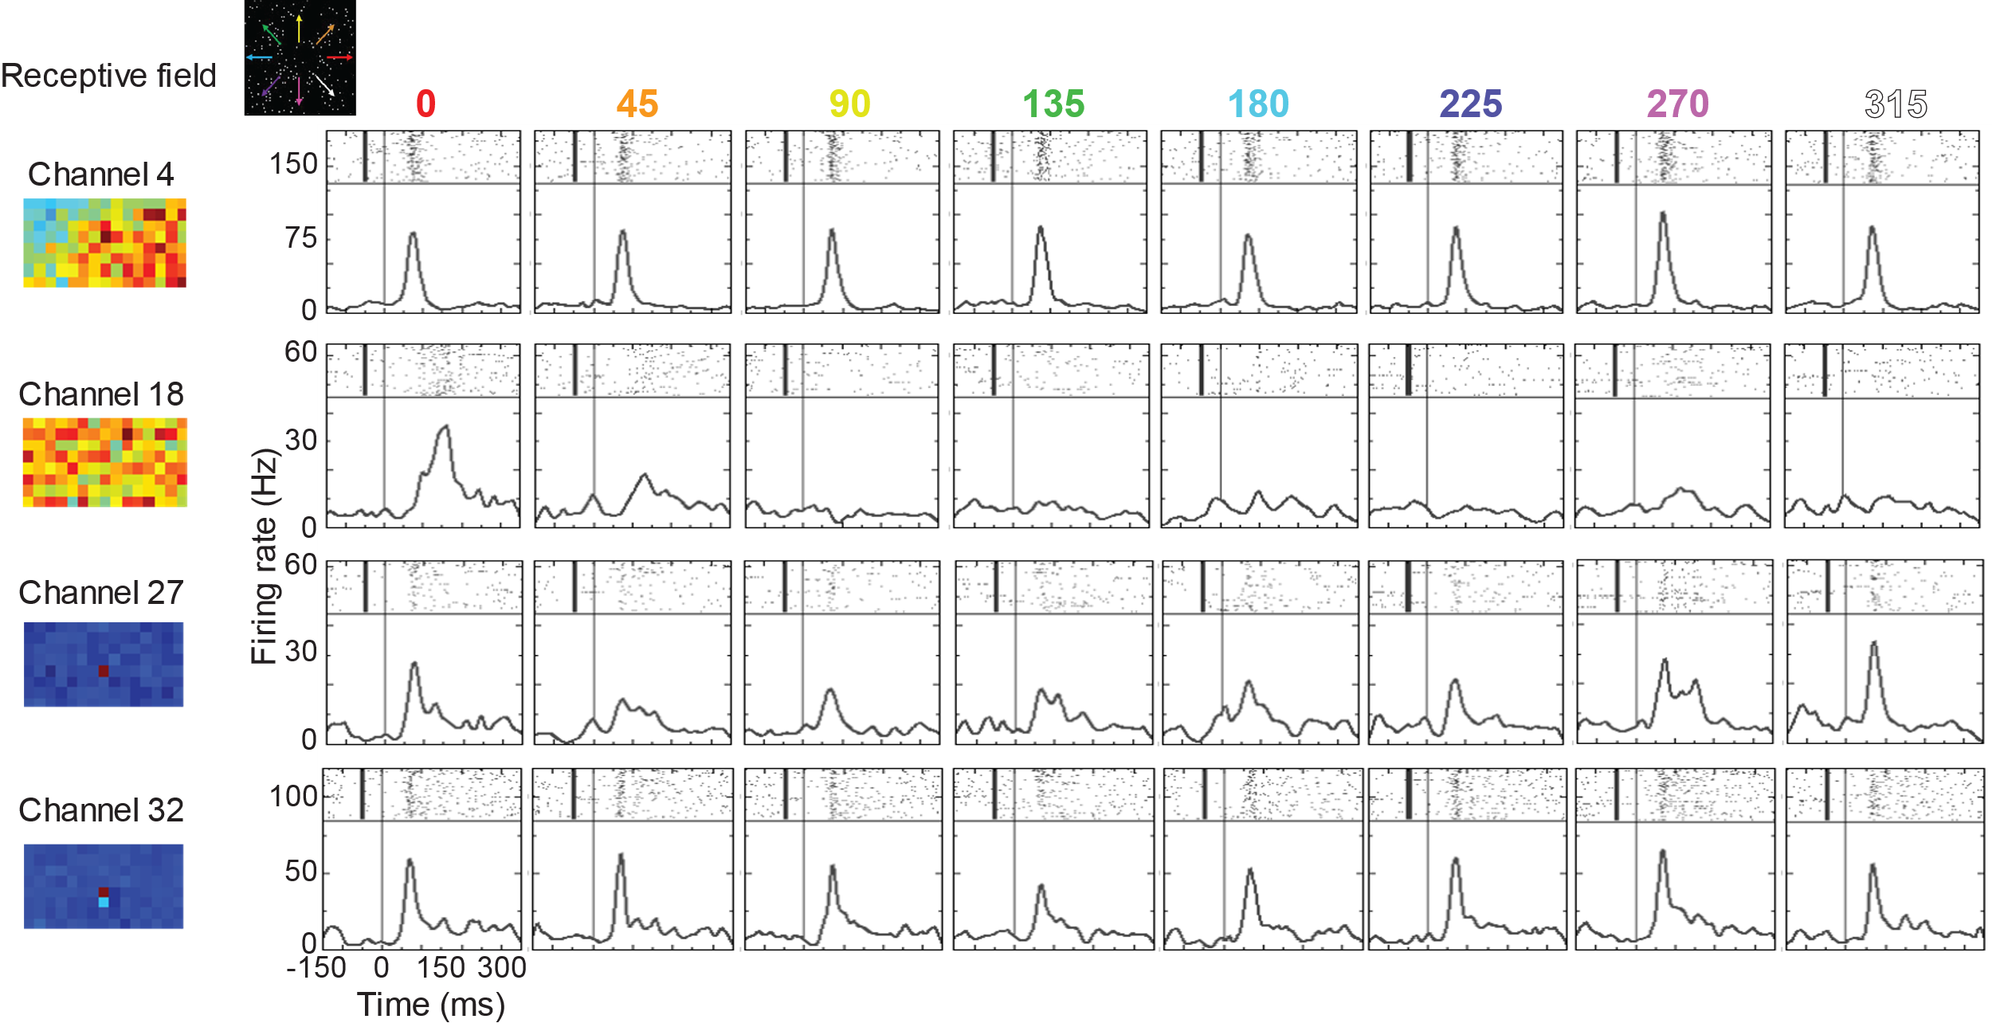
Figure 5-7. Many channels across the array responded to random dot motion with variable direction selectivity. Each row shows the average responses of a single channel on the Gray Matter array and its spatial receptive field. Distant channels (e.g. 4 and 32) could respond similarly to random dot motion with a brief transient and fairly direction invariant response, while neighboring channels (e.g. 27 and 32) could show very different responses, with one showing rightward and downward selectivity (Channel 27) and the other showing direction invariance.
This suggested that response was not only related to spatial location of the receptive fields, but their feature selectivity, and not in an obvious way. To understand this better, we used a tool for assessing spike train similarity, SSIMS, across different movies and in different fixation locations. The goal of this analysis was to determine how well neural responses to particular movies could be clustered, and how those clusters compared across different neural responses. We had hoped that we could see channels with similar coding of movie properties and fixation locations and use this information to determine whether electrodes were sitting in the same brain areas or not. Figure 5-8 shows SSIMS clustering results for two different channels and the entire population for a set of movies at two different fixation locations. In these examples, each point represents an individual trial, and each color is a movie at a particular fixation location (so each movie is present twice). Channel 32 showed clustering based on movie identity and fixation location, while Channel 4 was dominated mostly by fixation location. The SSIMS results for the population (Figure 5-8B) shows that using all of the population responses, the responses to the individual movies were fairly well-clustered and separable. Two major clusters formed due to fixation location, and smaller clusters formed within those large clusters based on movie identity. As promising as this seemed, the analysis just ended up reinforcing what was already observable through the receptive field mapping, that smaller receptive fields were more influenced by shifts in fixation, and that shifting the fixation position for the larger, more peripheral receptive fields, led to bigger and better responses to the movies, that were more easily clustered during analysis. Perhaps a future project could extract the features of the movies that were driving responses and come up with a clearer understanding of what drove each of the units on the array.
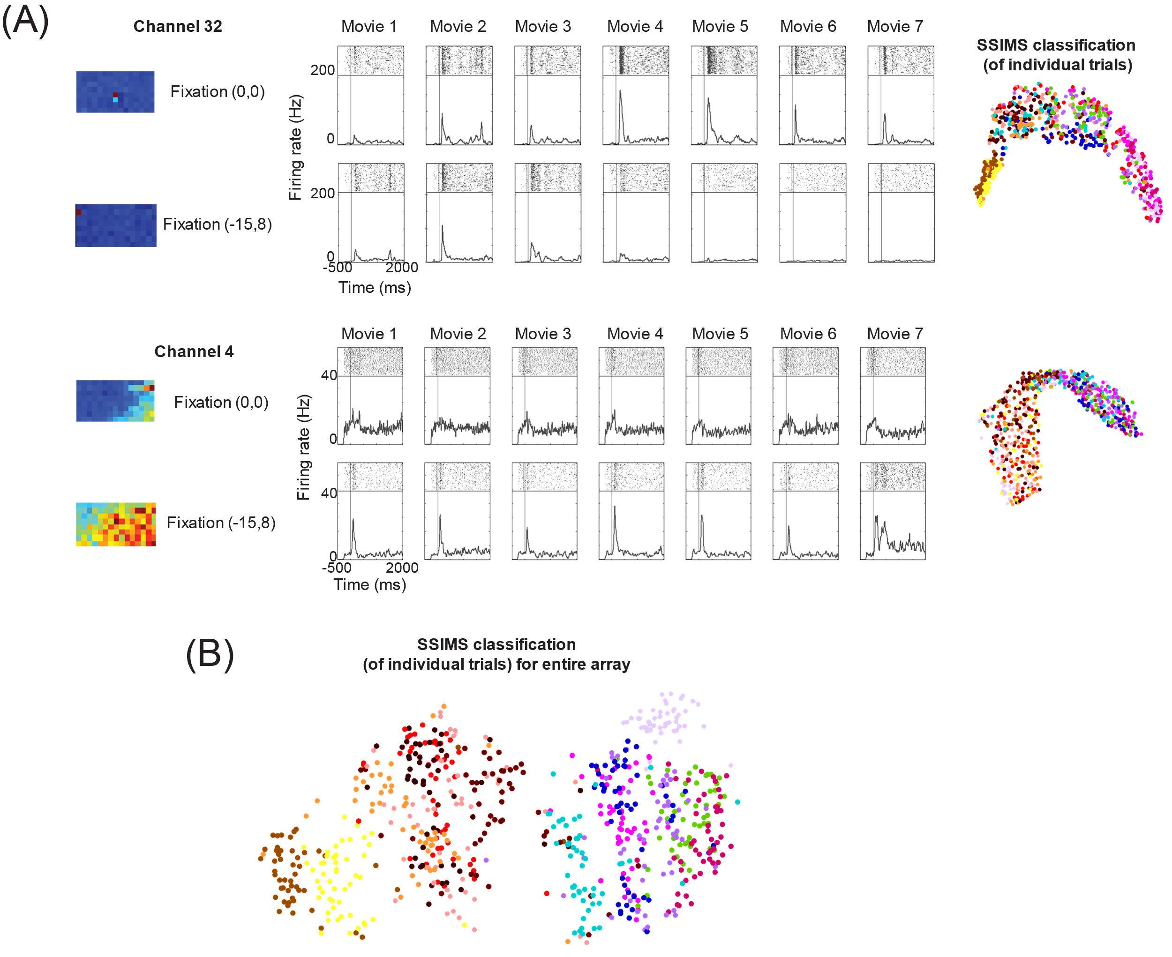
Figure 5-8. Neural responses to passive viewing of natural scene movie clips and SSIMS clustering analyses. (A) Average responses for two channels (Channel 32, top and Channel 4, bottom) for seven different movie clips, at two different fixation locations. Clustering analyses using SSIMS method for each channel is shown to the right. Each data point in the cloud represents a trial, and each color represents a particular movie at a particular fixation location. (B) SSIMS clustering for the active channels on the Gray Matter array for the same movie clips. Two major clouds formed from fixation location and the smaller clusters formed within each larger cluster are individual movies at those respective locations.

5.4 Behavior & neural responses during active tasks
5.4.1 Match-to-sample tasks: salt & pepper noise, motion matching
This task was described in Chapter 4.3 and was the starting point for Monkey Y’s behavioral training. First Monkey Y was trained for multiple months on matching objects (2D pictures of real-world objects), and a noise cloud was added to the objects. Monkey Y demonstrated flexibility in matching objects under various levels of noise, but despite training with the previously described 10%/100% blocking paradigm, never demonstrated knowledge of movement shape associations. New pictures were introduced daily and Monkey Y demonstrated behavioral flexibility in matching different shapes and pictures, with and without color. After three months of shaping and training, it seemed that Monkey Y was unable to learn the motion-shape associations in that paradigm, and was subsequently trained on a motion matching task with various periodic 2D-motion trajectories (trajectories also previously described in Chapter 4). We mention this here, because this motion-matching experience could have affected later training, as the monkey did eventually learn to match simple motion trajectories. However, Monkey Y never gained the flexibility in matching new motion patterns and took multiple sessions to reach 80% performance in matching motion patterns. This led us to try a task that might demonstrate a benefit of using motion, a priming task.

5.4.2 Motion-shape association priming task
Priming has been shown to be a useful tool for testing associations. This task was based on a study that paired color-object associations with semantic pairing (e.g. red apple= congruent, purple apple= incongruent), and incongruent stimuli led to slower reaction times and lower hit rates (Forder et al., 2016). We created a simple task to test whether an object could be primed by its associated movement pattern. Monkey Y had demonstrated shape matching and motion matching capabilities, so we sought to determine whether a congruent or incongruent feature might affect reaction times in a 2AFC choice task. Figure 5-9 shows the experiment layout. A critical component to the design is that the monkey was not required to know the associations to achieve good performance, rather just needed to know the correct objects and movement patterns. We hypothesized that the associations would make the task much easier, but as Monkey Y had yet to demonstrate associative knowledge of motion-shape pairings, we tried to leverage what the monkey was able to do at the time.
Figure 5-9. Priming task for testing visual shape-motion associations. Left: Shapes and movement patterns that were paired during training. Task was to select the correct object, motion, or moving object during the choice period. An example congruent trial is shown, where the shape prime is followed by the corresponding motion pattern (left) and an incorrect, foil motion pattern (right).Right: different combinations of primes and choices for congruent and incongruent pairings.
Monkey Y learned to perform well on this task, and there appeared to be small benefits to reaction time when trials were congruent (Figure 5-10A). However, when trials with all the “good” objects (primes) were randomly interleaved with these trials, Monkey Y did not demonstrate knowledge of the shape-motion associations (Figure 5-10B). We recognized the possibility that the prime might not be truly beneficial, and that Monkey Y might not have been using it at all. Instead of trying to find a neural correlate for a small reaction time effect, we instead pivoted the task to iterate once again, to a conjunction selection task, by removing the priming period completely. That task is described in the next section.
Figure 5-10. Behavioral results for priming task for testing visual shape-motion associations. (A) Mean reaction times for the four shape-motion conjunctions for congruent and incongruent primes. Left: moving shape prime, static choices. Right: moving shape prime, moving dot choices. (B) Average performance on match to sample trials randomly interleaved with priming trials, showing that associations were not well learned.

5.4.3 Motion-shape conjunction selection task
This section describes the conjunction selection task that emerged as a result of the priming task described in Section 5.4.2. Monkey Y had demonstrated the ability to select correct motions and shapes, so through reinforcement he was able to learn which shape-motion conjunctions were the correct ones to select. Figure 5-11 shows the four shapes and motion patterns used for the first conjunction experiment, a schematic of a sample trial, and behavioral data showing good performance across the three kinds of trials. The three trial types were change motion (CM), change shape (CS) and change both (CB), which described whether one or both of the visual features had been changed from the correct combination. The example trial in Figure 5-11 shows a schematic of a change motion trial, where one of the choices has the incorrect motion paired with the shape.
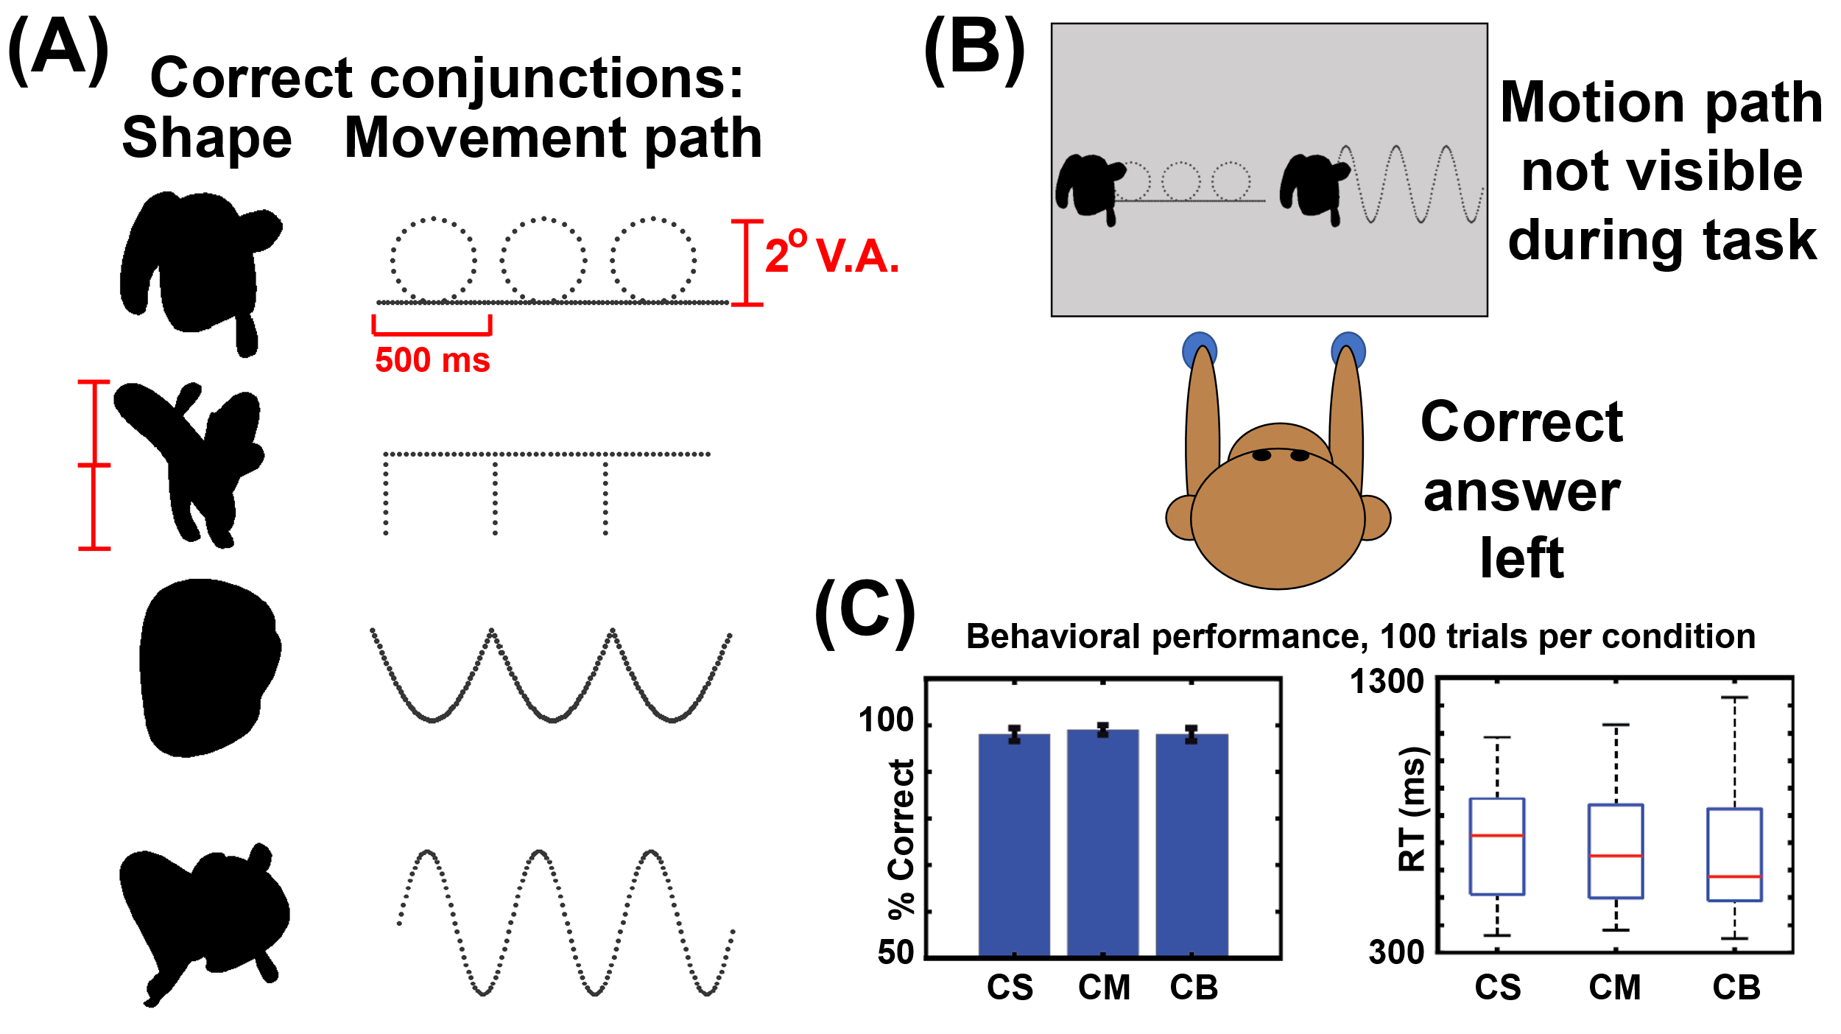
Figure 5-11. Summary figure of first conjunction selection task showing Monkey Y had learned the four shape-motion pairs. (A) Four shape-motion pairs that were trained (B) Schematic of an example trial (C) Example behavioral block from Monkey Y with the three trial types interleaved, change shape (CS), change motion (CM), change both (CB).
Preliminary neural data was collected from both the Gray Matter array and area IT during this task. Having only four objects made IT recordings particularly challenging, as it was difficult to find neural responses that were selective for the particular shapes the monkey had learned. This led to the expansion of the task to learning new conjunctions of shapes and motion patterns within a given session. The experimental routine for this task is shown in Figure 5-12.
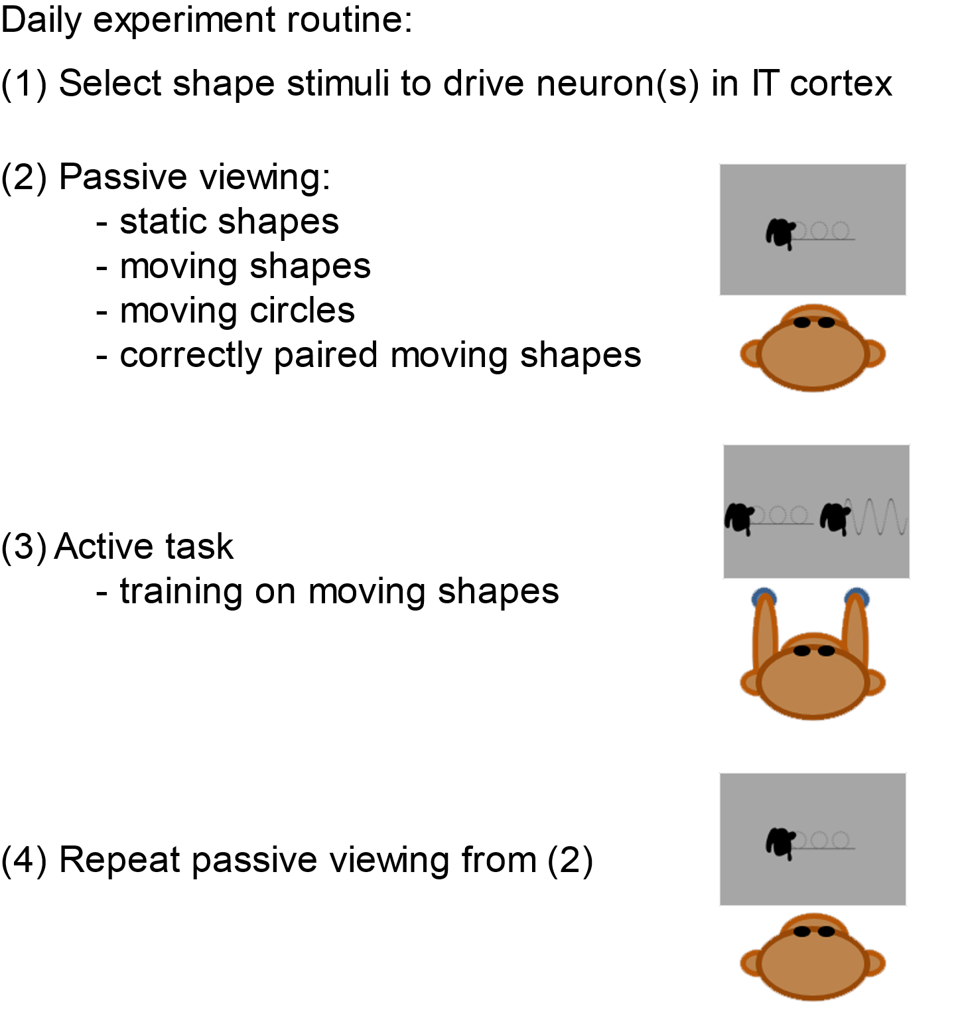
Figure 5-12. Behavioral and recording strategy for daily conjunction learning. Monkey Y was trained on new shape-motion conjunctions daily and completed passive viewing of the components and full conjunctions before and after training on the active task. Shape stimuli were selected to drive the neurons on a given session using a large database of blob shapes.
Monkey Y was able to learn the shape-motion conjunctions, but behavior was variable. An example behavioral session is shown in Figure 5-13. As noted in Chapter 4.2, human subjects also struggled with this task even after learning the association rule through a color-shape conjunction task first (Figure 4-8). Even after Monkey Y became familiar with the daily task structure, performance on the four daily conjunctions was not always above criterion, but the behavioral session could not be extended without sacrificing the post-training passive viewing trials, which were the main trials being analyzed. The neural data during the active task was nearly impossible to interpret given that there were two moving objects on the screen simultaneously, and the monkey was free to move his eyes. There was an attempt to use an occluder over one of the objects so the monkey had to determine whether the visible object was correct, or the occluded (not visible) but implied alternative was correct. This did not significantly clean up the neural data or make it interpretable.
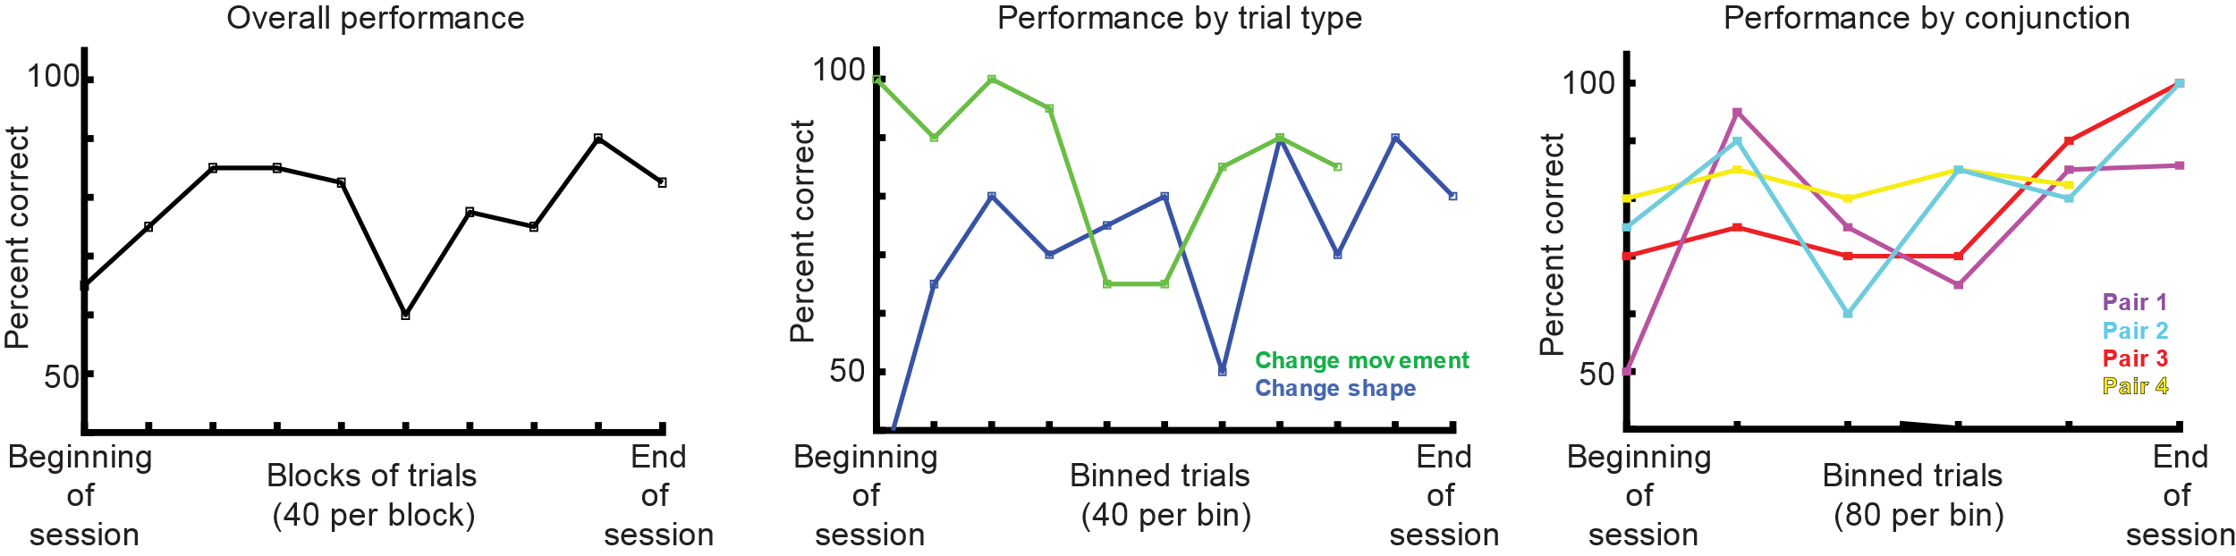
Figure 5-13. Example behavioral session from Monkey Y showing partial learning of four daily shape-motion conjunctions. Left: overall average performance for a single session of the shape-motion conjunction task. Middle: same behavior broken down by two trial types, change movement and change shape. Right: the same behavior broken down differently into the four shape-motion pairs.
Nevertheless, a large dataset was collected on this task for both the Gray Matter array and some preliminary recordings in area IT. It seemed as there were changes in the neural responses to the passive viewing stimuli before and after training, but not in a consistent or easily explicable manner. Figure 5-14 shows an example of the passive viewing data for a single Gray Matter channel that was hypothesized to be in MT or MST at the time of the recording. The overall activity patterns did not change for the various stimuli, rather, the magnitudes of the responses became smaller for some stimuli, in this case the control shapes (not trained) and one of the motion trajectories, and larger for one peak during one of the conjunctions. Similar small changes were observed in the preliminary recordings in area IT, as shown in Figure 5-15. These small changes led to the question of whether the variability in the behavior could be linked to the variability and small changes in the neural data. This is what motivated using reinforcement learning models and regression to model the behavioral data, which is described in the next section.
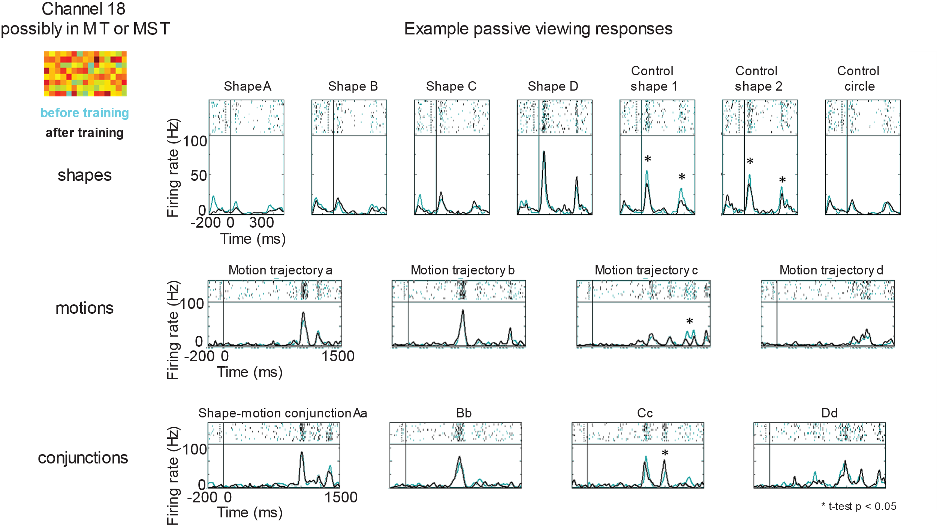
Figure 5-14. Example of Gray Matter data collected during passive viewing before and after training on shape-motion conjunctions. Monkey Y was trained on new shape-motion conjunctions daily and completed passive viewing of the components and full conjunctions before and after training on the active task. Shape stimuli were selected to drive the neurons on a given session using a large database of blob shapes.

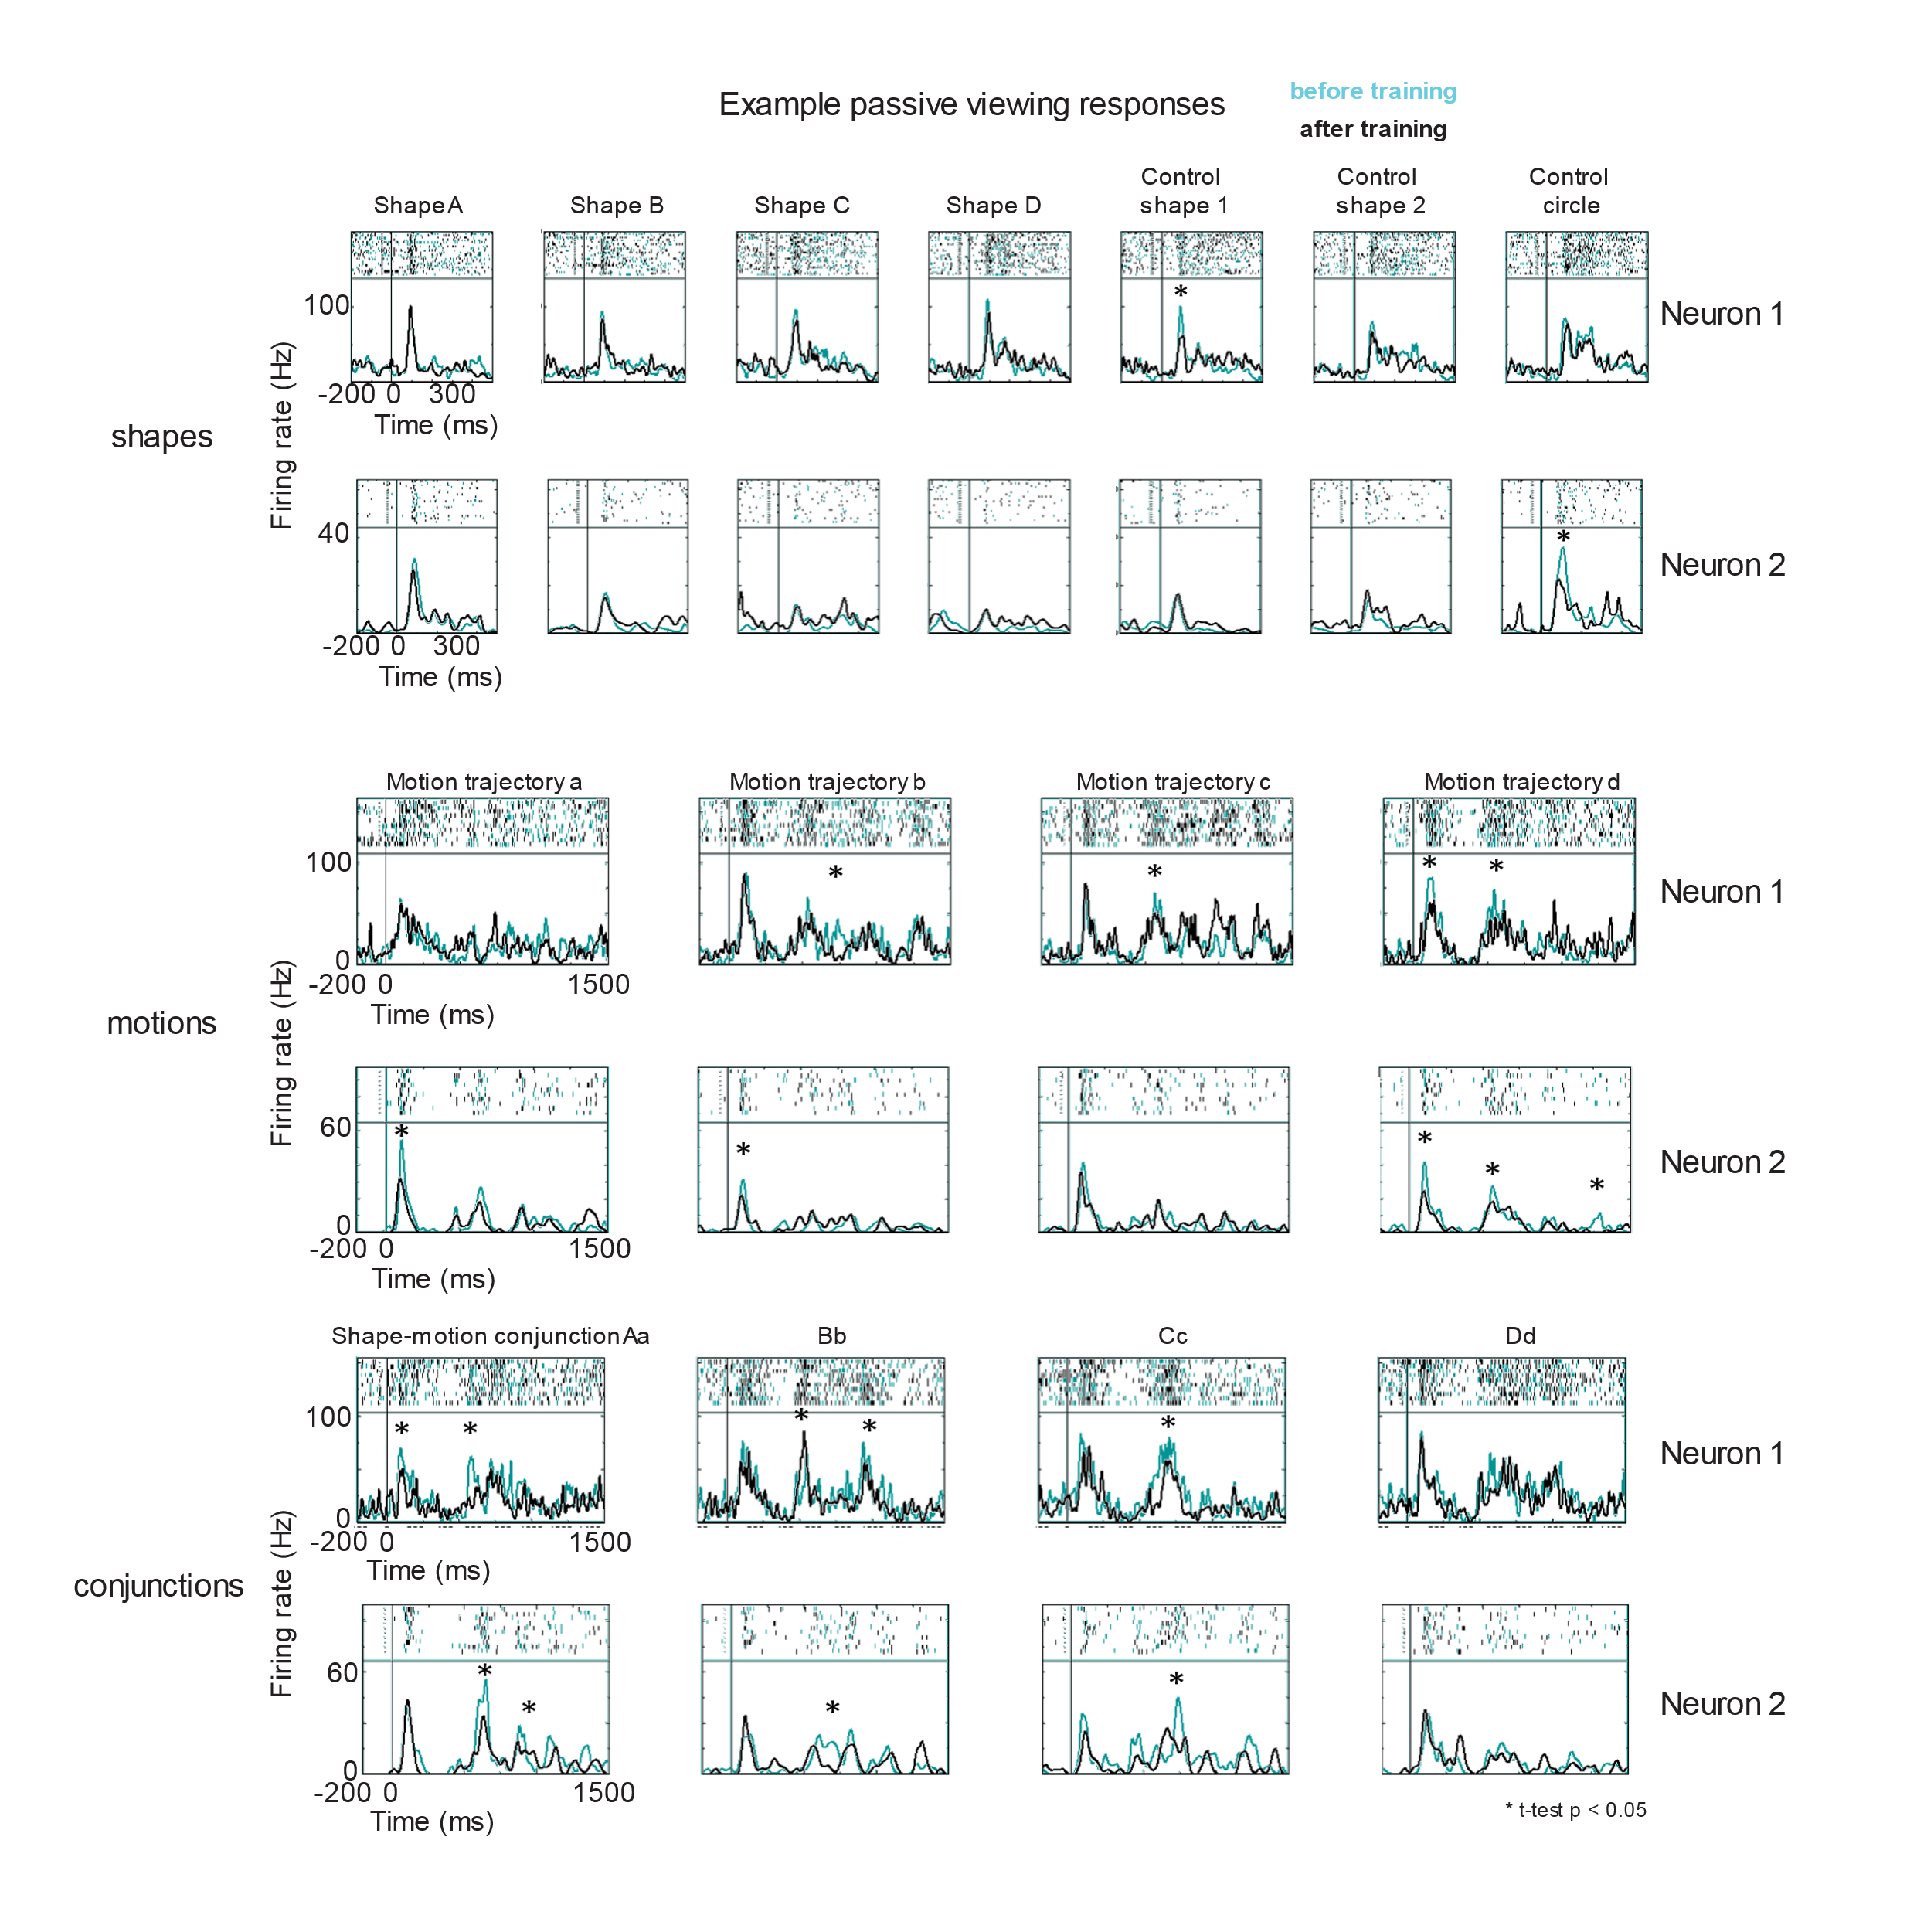
Figure 5-15. Example of two IT neurons with different shape selectivity during pre-training and post-training passive viewing of shapes, motions and conjunctions. Monkey Y was trained on new shape-motion conjunctions daily and completed passive viewing of the components and full conjunctions before and after training on the active task. Shape stimuli were selected to drive the neurons on a given session using a large database of blob shapes. Top two rows: neural responses from two sample IT neurons to static shapes, trained 1-4, 2 untrained control shapes, and the black circle. Middle rows: neural responses for the same two neurons to a black circle moving along the four motion trajectories. Bottom two rows: neural responses to the trained shape-motion conjunctions.

5.4.4 Modeling behavior in the conjunction selection task
Small changes in the neural responses in the Gray Matter array recordings and in early IT recordings suggested that maybe learning of new shape-motion conjunctions could evoke changes in neural responses during passive viewing of the stimuli. However, as learning was not robust across all conjunction pairs, it was difficult to say what a statistically significant change in rate at a certain time actually meant. This motivated the approach to model Monkey Y’s behavior using reinforcement learning, specifically Q-learning, and logistic regression.
As described in Section 5.2, behavioral data was simulated using a Q-learning reinforcement learning (RL) model fit to Monkey Y’s behavioral data. The results of this simulation for one behavioral session are shown in Figure 5-16A. The RL model tracked average performance during this session very well and deviated during the middle of the block. The model did not capture differences in individual target performance (data not shown), even though average performance across all trials matched well. Furthermore, the model was simple, in that it did not take choice history into account directly, except to update expected values based on rewards. After years of observing Monkey Y do various tasks, it seemed as if he did tend to be very biased to which button he pressed on the previous few trials in 2AFC tasks (e.g. multiple correct trials with a rightward button press might cause him to miss an easy left button press on the subsequent trial). This led us to explore a model that might capture features of choice history, logistic regression. Figure 5-16B shows the results of the logistic regression fit to the same behavioral session. In this case, three coefficients were statistically significant, an interaction term for left choice x left side rewarded (ß_{L_Int}), which side was picked on the previous trial (ß_{Side_Picked}), and a reward x side interaction term (ß_{Side_Int}), not only demonstrating the influence of choice history, but the bias of left choice history over right choice history to influence future trials. This analysis was only one trial back, further analysis might have demonstrated less of a left side bias and a stronger bias solely based on side picked. There was potential for much more analysis using these two modeling methods, but they were not pursued after the chambers came off (about a week after this analysis was completed) and the task was going to be revamped.
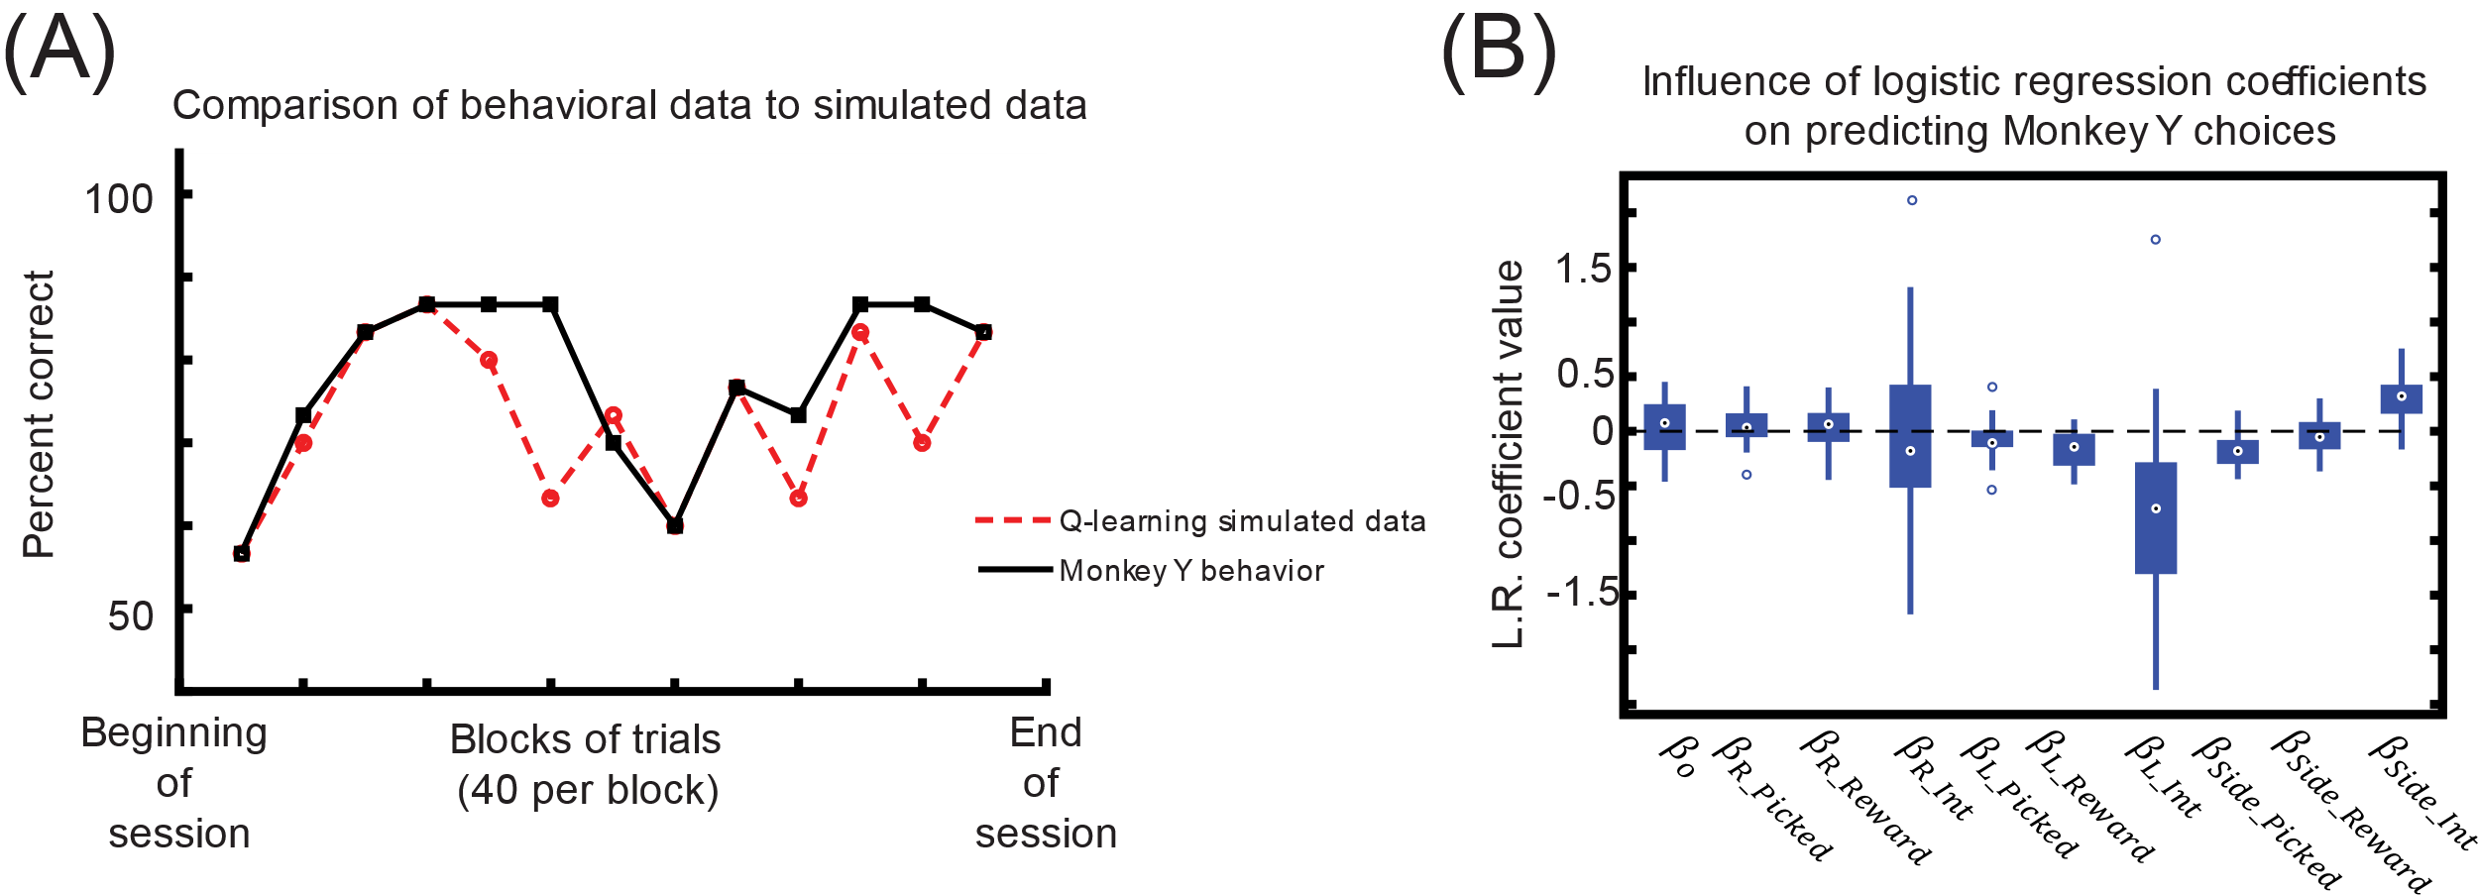
Figure 5-16. Modeling Monkey Y’s behavior during the conjunction selection task in two ways. (A) Average behavioral performance for Monkey Y during a single session versus data that was simulated using Q-learning. The Q-learning model parameters were first fit using the behavioral data and computing the maximum likelihood of p(choice) for all trials in the session. Black= Monkey Y behavior, Red dashed line= simulated data. (B) Logistic regression parameters for the same behavioral data. Error bars are the standard errors of the coefficient estimates. Black stars indicate coefficients that were significantly different than zero, using a t-test with Bonferroni correction for multiple comparisons.

5.5 Discussion
We explored the responses of early visual areas during motion-shape conjunction learning. There appeared to be subtle changes before and after training on new shape-motion conjunctions both in the early visual areas and preliminary IT recordings, but the result was ultimately inconclusive. The behavioral task morphed over the course of years to capitalize on what Monkey Y was able to do, but both the task structure and recording approach were limiting. This data guided us to redesign the behavioral task and to trim down the recording approach to focus on area IT.
This data taught me a major lesson, that having a ton of data does not ensure an answer. It also raised the question, what kind of experiment is ideal for the style of recording in the Gray Matter array? One cannot ensure new units across days or sessions, or ensure stability of the same units, either. There’s a mixture that emerges from this chronic but flexible approach. Having a ground truth for which brain region the electrodes are located is a useful start, but ultimately one must design their task wisely to be able to use this kind of recording approach.
Despite the outcome of this set of experiments, many pieces were informative and useful for designing the final experiment described in Chapters 2 and 3. The preliminary IT data and difficulty in finding neural responses to just a few stimuli, led to the development of a categorical shape task to improve data acquisition. The motion trajectories were difficult for the monkey to learn and made neural responses difficult to interpret, thus the number of trajectories was reduced and the trajectories were refined to be discriminable but highly overlapping and foveal, to make interpretation of the neural data more feasible. Lastly, the experience doing recordings during behavior, analysis and interpretation were invaluable for training and made the main experiment possible.

Chapter 6: Discussion
6.1 Conclusions

Main experimental summary what we can say
Limitations
Where we started in literature and hypotheses
Lessons learned from gray matter, learning in monkey Y
Shape+ motion not a given! Completely wrong. But can be combined with training and tasks
Active =/= passive sometimes, neural activity differs, maybe we should be more careful
Bias of sampling in IT- maybe IT function is ambiguous because we are biased in the way that we sample from it (rapid presentation of images)
Many factors at play

6.2 Future directions
Major project 1: Are these neurons that are sensitive to motion, ambiguity neurons? Future project- look at other features like color and texture, maybe these same neurons are ambiguity neurons, not just motion sensitive. Data from other projects with noise in the lab shows neurons that respond best to noise, is it a general property? Is it some kind of frequency tuning?

Blur in v4 paper- are the v4 neurons connected to the IT neurons? What information is being sent?

What is the glue
Context
Physics
Articulated motion
Ethological motions
2d and 3d
Bayesian perspective of integration of features

6.3 Final remarks

Chapter 7: Appendix
7.1 General surgical procedures
All major surgical procedures were performed in the Brown University surgical facility using the following general protocol. The animal was restrained with a presurgical intramuscular dose of Ketamine (15 mg/kg at concentration of 100mg/ml).
An intravenous catheter was placed aseptically in the saphenous vein and fixed to the surrounding tissue and secured with a dry dressing. The larynx and epiglottis were sprayed with approximately 10mg lidocaine and the monkey was intubated. Surgical sites were shaved free of hair. An analgesic (Buprenorphrine 0.01mg/kg IM) and antibiotic (Claforan 50 mg/kg IM) were administered. Once placed onto the surgical table, the animal was connected to the anesthesia machine. Isoflurane was administered for 2-3 minutes at the rate of 2.5 MAC with 0.8 L/min flow. Maintenance of anesthesia is accomplished with isoflurane (1.1 to 1.3 MAC).
Placement in a stereotaxic frame was preceded by local application of Emla (2.5% Lidocaine & 2.5% Prilocaine). Once the monkey was appropriately fixed, surgical sites were scrubbed with Betadine. Throughout the surgical procedure the animal received a constant i.v. infusion of Lactated Ringer's solution. Once the animal was prepped, the drip was set at a rate of 10ml/kg/hr. Body temperature is measured by rectal thermometer.
At the end of the surgical procedure, the animal was removed from the stereotax and the anesthetic is turned off. Careful monitoring of respiration and heart rate is done before turning down the oxygen. As soon as the monkey begins to breathe on its own, the oxygen is turned off and upon reflux, is extubated. When the monkey appeared capable of holding his own weight, he was returned to his home cage. All animals with increased risk of infection were given antibiotics (either Claforan IM or Amoxicillin orally) for seven to ten days, and analgesics (Buprenophrine) for 2-3 days after the operation or as deemed necessary.

References
APA / need to be formatted and added:

Albright, T. D. (1984). Direction and orientation selectivity of neurons in visual area MT of the macaque. Journal of Neurophysiology, 52(6), 1106–30. Retrieved from http://www.ncbi.nlm.nih.gov/pubmed/6520628
Albright, T. D. (2012). On the perception of probable things: neural substrates of associative memory, imagery, and perception. Neuron, 74(2), 227–45. http://doi.org/10.1016/j.neuron.2012.04.001
Albright, T. D., Desimone, R., & Gross, C. G. (1984). Columnar organization of directionally selective cells in visual area MT of the macaque. Journal of Neurophysiology, 51(1), 16–31. Retrieved from http://www.ncbi.nlm.nih.gov/pubmed/6693933
Allefeld, C., Görgen, K., & Haynes, J. D. (2016). Valid population inference for information-based imaging: From the second-level t-test to prevalence inference. NeuroImage, 141, 378–392.
Anderson, B., & Sheinberg, D. L. (2008). Effects of temporal context and temporal expectancy on neural activity in inferior temporal cortex. Neuropsychologia, 46(4), 947–957. http://doi.org/10.1016/j.neuropsychologia.2007.11.025
Anstis, S. M. (1974). Letter: A chart demonstrating variations in acuity with retinal position. Vision Research, 14(7), 589–92. Retrieved from http://www.ncbi.nlm.nih.gov/pubmed/4419807
Arterberry, M. E., & Yonas, A. (1988). Infants’ sensitivity to kinetic information for three-dimensional object shape. Perception & Psychophysics, 44(1), 1–6. Retrieved from http://www.ncbi.nlm.nih.gov/pubmed/3405724
Babolhavaeji, A., Karimi, S., Ghaffari, A., Hamidinekoo, A., & Vosoughi-Vahdat, B. (2014, November). Optimal temporal resolution for decoding of visual stimuli in inferior temporal cortex. In 2014 21th Iranian Conference on Biomedical Engineering (ICBME) (pp. 109-112). IEEE.
Badler, J. B., & Heinen, S. J. (2006). Anticipatory movement timing using prediction and external cues. The Journal of Neuroscience : The Official Journal of the Society for Neuroscience, 26(17), 4519–25. http://doi.org/10.1523/JNEUROSCI.3739-05.2006
Bartleson, C. J. (1960). Memory colors of familiar objects. Journal of the Optical Society of America, 50, 73–7. Retrieved from http://www.ncbi.nlm.nih.gov/pubmed/13797246
Baurès, R., Bennett, S. J., & Causer, J. (2015). Temporal estimation with two moving objects: overt and covert pursuit. Experimental Brain Research, 233(1), 253–61. http://doi.org/10.1007/s00221-014-4110-y
Biederman, I., & Cooper, E. E. (1991). Evidence for complete translational and reflectional invariance in visual object priming. Perception, 20(5), 585–593. http://doi.org/10.1068/p200585
Bingham, G. P. (1995) Dynamics and the problem of visual event recognition. In R. F. Port & T. van Gelder (Eds.) Mind as motion: Dynamics, behavior and cognition. Cambridge, MA: MIT Press. 403-448.
Blair, C. D., Goold, J., Killebrew, K., & Caplovitz, G. P. (2014). Form features provide a cue to the angular velocity of rotating objects. Journal of Experimental Psychology. Human Perception and Performance, 40(1), 116–28. http://doi.org/10.1037/a0033055
Bode, S., Feuerriegel, D., Bennett, D., & Alday, P. M. (2019). The Decision Decoding ToolBOX (DDTBOX)–A multivariate pattern analysis toolbox for event-related potentials. Neuroinformatics, 17(1), 27-42.
Born, R. T., & Bradley, D. C. (2005). Structure and function of visual area MT. Annual Review of Neuroscience, 28, 157–89. http://doi.org/10.1146/annurev.neuro.26.041002.131052
Born, R. T., & Tootell, R. B. (1992). Segregation of global and local motion processing in primate middle temporal visual area. Nature, 357(6378), 497–9. http://doi.org/10.1038/357497a0
Britten, K. H., Newsome, W. T., Shadlen, M. N., Celebrini, S., & Movshon, J. A. A relationship between behavioral choice and the visual responses of neurons in macaque MT. Visual Neuroscience, 13(1), 87–100. Retrieved from http://www.ncbi.nlm.nih.gov/pubmed/8730992
Britten, K. H., Shadlen, M. N., Newsome, W. T., & Movshon, J. A. (1992). The analysis of visual motion: a comparison of neuronal and psychophysical performance. The Journal of Neuroscience : The Official Journal of the Society for Neuroscience, 12(12), 4745–65. Retrieved from http://www.ncbi.nlm.nih.gov/pubmed/1464765
Britten, K. H., Shadlen, M. N., Newsome, W. T., & Movshon, J. A. (1993). Responses of neurons in macaque MT to stochastic motion signals. Visual Neuroscience, 10(6), 1157–69. Retrieved from http://www.ncbi.nlm.nih.gov/pubmed/8257671
Caclin, A., Paradis, A.-L., Lamirel, C., Thirion, B., Artiges, E., Poline, J.-B., & Lorenceau, J. (2012). Perceptual alternations between unbound moving contours and bound shape motion engage a ventral/dorsal interplay. Journal of Vision, 12(7). http://doi.org/10.1167/12.7.11
Caplovitz, G. P., Shapiro, A. G., & Stroud, S. (2011). The maintenance and disambiguation of object representations depend upon feature contrast within and between objects. Journal of Vision, 11(14), 1. http://doi.org/10.1167/11.14.1
Cedras, C., & Shah, M. (1995). Motion-Based Recognition: A Survey. Image and Vision Computing, 13(2), 129–155. Retrieved from http://citeseerx.ist.psu.edu/viewdoc/summary?doi=10.1.1.32.2626
Celebrini, S., & Newsome, W. T. (1994). Neuronal and psychophysical sensitivity to motion signals in extrastriate area MST of the macaque monkey. The Journal of Neuroscience : The Official Journal of the Society for Neuroscience, 14(7), 4109–24. Retrieved from http://www.ncbi.nlm.nih.gov/pubmed/8027765
Celebrini, S., & Newsome, W. T. (1995). Microstimulation of extrastriate area MST influences performance on a direction discrimination task. Journal of Neurophysiology, 73(2), 437–48. Retrieved from http://www.ncbi.nlm.nih.gov/pubmed/7760110
Chelazzi, L., Duncan, J., Miller, E. K., & Desimone, R. (1998). Responses of neurons in inferior temporal cortex during memory-guided visual search. Journal of neurophysiology, 80(6), 2918–2940. https://doi.org/10.1152/jn.1998.80.6.2918
Combrisson, E., & Jerbi, K. (2015). Exceeding chance level by chance: The caveat of theoretical chance levels in brain signal classification and statistical assessment of decoding accuracy. Journal of Neuroscience Methods, 250, 126–136.

Conway, B. R. (2018). The organization and operation of inferior temporal cortex. Annual review of vision science, 4, 381-402.
Cornilleau-Pérès, V., & Gielen, C. C. A. M. (1996). Interactions between self-motion and depth perception in the processing of optic flow. Trends in Neurosciences, 19(5), 196–202. http://doi.org/10.1016/S0166-2236(96)10025-4
Cowley, B. R., Kaufman, M. T., Butler, Z. S., Churchland, M. M., Ryu, S. I., Shenoy, K. V., & Byron, M. Y. (2013). DataHigh: graphical user interface for visualizing and interacting with high-dimensional neural activity. Journal of neural engineering, 10(6), 066012.
Crane, J. (1957). Imaginal Behavior in Butterflies of the Family Heliconiidae: Changing Social Patterns and Irrelevant Actions. Zoologica, 42, 135–145. Retrieved from http://www.jourlib.org/references/7523251
de Lussanet, M. H. E., & Lappe, M. (2012). Depth perception from point-light biological motion displays. Journal of Vision, 12(11). http://doi.org/10.1167/12.11.14
DeAngelis, G. C., & Newsome, W. T. (1999). Organization of disparity-selective neurons in macaque area MT. The Journal of Neuroscience : The Official Journal of the Society for Neuroscience, 19(4), 1398–415. Retrieved from http://www.ncbi.nlm.nih.gov/pubmed/9952417
den Ouden, H. E. M., Kok, P., & de Lange, F. P. (2012). How prediction errors shape perception, attention, and motivation. Frontiers in Psychology, 3, 548. http://doi.org/10.3389/fpsyg.2012.00548

DiCarlo J, Maunsell JHR (2000) Form representation in monkey inferotemporal cortex is virtually unaltered by free viewing. Nat Neurosci 3:814–821.
Ditterich, J., Mazurek, M. E., & Shadlen, M. N. (2003). Microstimulation of visual cortex affects the speed of perceptual decisions. Nature Neuroscience, 6(8), 891–8. http://doi.org/10.1038/nn1094
Dodge, S., Laube, P., & Weibel, R. (2012). Movement similarity assessment using symbolic representation of trajectories. International Journal of Geographical Information Science, 26(9), 1563-1588.
Duffy, C. J., & Wurtz, R. H. (1991). Sensitivity of MST neurons to optic flow stimuli. II. Mechanisms of response selectivity revealed by small-field stimuli. Journal of Neurophysiology, 65(6), 1346–59. Retrieved from http://www.ncbi.nlm.nih.gov/pubmed/1875244
Duffy, C. J., & Wurtz, R. H. (1997). Medial superior temporal area neurons respond to speed patterns in optic flow. The Journal of Neuroscience : The Official Journal of the Society for Neuroscience, 17(8), 2839–51. Retrieved from http://www.ncbi.nlm.nih.gov/pubmed/9092605
Emadi, N., & Esteky, H. (2013). Neural representation of ambiguous visual objects in the inferior temporal cortex. PloS One, 8(10), e76856. http://doi.org/10.1371/journal.pone.0076856

Emadi, N., & Esteky, H. (2014). Behavioral demand modulates object category representation in the inferior temporal cortex. Journal of neurophysiology, 112(10), 2628-2637.
Engel, A. K., & Singer, W. (2001). Temporal binding and the neural correlates of sensory awareness. Trends in Cognitive Sciences, 5(1), 16–25. http://doi.org/10.1016/S1364-6613(00)01568-0
Erickson, C. A., & Desimone, R. (1999). Responses of Macaque Perirhinal Neurons during and after Visual Stimulus Association Learning. J. Neurosci., 19(23), 10404–10416. Retrieved from http://www.jneurosci.org/content/19/23/10404.full
Ericson, J. M., & Beck, M. R. (2013). Changing target trajectories influences tracking performance. Psychonomic Bulletin & Review, 20(5), 951–6. http://doi.org/10.3758/s13423-013-0424-1
Ewert, J.-P. (1987). Neuroethology of releasing mechanisms: Prey-catching in toads. Behavioral and Brain Sciences, 10(03), 337. http://doi.org/10.1017/S0140525X00023128
Farah, M. J. (1985). Psychophysical evidence for a shared representational medium for mental images and percepts. Journal of Experimental Psychology, 114(1), 91–103. http://doi.org/http://dx.doi.org/10.1037/0096-3445.114.1.91
Felleman, D. J., & Van Essen, D. C. (1991). Distributed hierarchical processing in the primate cerebral cortex. Cerebral Cortex, 1(1), 1–47. Retrieved from http://www.ncbi.nlm.nih.gov/pubmed/1822724
Fetsch, C. R., Kiani, R., Newsome, W. T., & Shadlen, M. N. (2014). Effects of cortical microstimulation on confidence in a perceptual decision. Neuron, 83(4), 797–804. http://doi.org/10.1016/j.neuron.2014.07.011
Fine, M. S., & Minnery, B. S. (2009). Visual salience affects performance in a working memory task. The Journal of Neuroscience : The Official Journal of the Society for Neuroscience, 29(25), 8016–21. http://doi.org/10.1523/JNEUROSCI.5503-08.2009
Folstein, J. R., Palmeri, T. J., & Gauthier, I. (2014). Perceptual advantage for category- relevant perceptual dimensions: the case of shape and motion. Frontiers in psychology, 5, 1394. https://doi.org/10.3389/fpsyg.2014.01394
Forder, L., Taylor, O., Mankin, H., Scott, R. B., & Franklin, A. (2016). Colour terms affect detection of colour and colour-associated objects suppressed from visual awareness. PLoS One, 11(3), e0152212.
Frank, S. M., Reavis, E. A., Greenlee, M. W., & Tse, P. U. (2016). Pretraining cortical thickness predicts subsequent perceptual learning rate in a visual search task. Cerebral Cortex, 26(3), 1211-1220.
Freedman, D. J., Riesenhuber, M., Poggio, T., & Miller, E. K. (2006). Experience- dependent sharpening of visual shape selectivity in inferior temporal cortex. Cerebral Cortex, 16(11), 1631-1644.
Gallant, J. L., Braun, J., & Van Essen, D. C. (1993). Selectivity for polar, hyperbolic, and Cartesian gratings in macaque visual cortex. Science (New York, N.Y.), 259(5091), 100–3. Retrieved from http://www.ncbi.nlm.nih.gov/pubmed/8418487
Giard, M. H., & Peronnet, F. (1999). Auditory-Visual Integration during Multimodal Object Recognition in Humans: A Behavioral and Electrophysiological Study. Journal of Cognitive Neuroscience, 11(5), 473–490. http://doi.org/10.1162/089892999563544
Gibson, E., Owsley, C., & Johnston, J. (1978). Perception of invariants by five-month-old infants: Differentiation of two types of motion. Developmental Psychology, 14(4), 407–415. Retrieved from http://psycnet.apa.org/index.cfm?fa=buy.optionToBuy&id=1979-25619-001
Giese, M. A., & Poggio, T. (2003). Neural mechanisms for the recognition of biological movements. Nature Reviews. Neuroscience, 4(3), 179–92. http://doi.org/10.1038/nrn1057
Goldstone R. L. (1994). Influences of categorization on perceptual discrimination. J. Exp. Psychol. Gen. 123, 178–200. 10.1037/0096-3445.123.2.178
Gosselin, F., & Schyns, P. G. (2001). Bubbles: a technique to reveal the use of information in recognition tasks. Vision Research, 41(17), 2261–2271. http://doi.org/10.1016/S0042-6989(01)00097-9
Gould, K., & Shah, M. (1989). The trajectory primal sketch: a multi-scale scheme for representing motion characteristics. In Proceedings CVPR ’89: IEEE Computer Society Conference on Computer Vision and Pattern Recognition (pp. 79–85). IEEE Comput. Soc. Press. http://doi.org/10.1109/CVPR.1989.37831
Gozli, D. G., Moskowitz, J. B., & Pratt, J. (2014). Visual attention to features by associative learning. Cognition, 133(2), 488–501. http://doi.org/10.1016/j.cognition.2014.07.014
Granger, C. W. (1969). Investigating Causal Relations by Econometric Models and Cross-spectral Methods. Econometrica, 37(3). Retrieved from http://www.jstor.org/stable/1912791?origin=crossref&seq=1#page_scan_tab_contents
Gray, C. M. (1999). The Temporal Correlation Hypothesis of Visual Feature Integration. Neuron, 24(1), 31–47. http://doi.org/10.1016/S0896-6273(00)80820-X
Graziano, M. S., Andersen, R. A., & Snowden, R. J. (1994). Tuning of MST neurons to spiral motions. The Journal of Neuroscience : The Official Journal of the Society for Neuroscience, 14(1), 54–67. Retrieved from http://www.ncbi.nlm.nih.gov/pubmed/8283251
Grill-Spector, K. (2003). The neural basis of object perception. Current Opinion in Neurobiology, 13(2), 159–66. Retrieved from http://www.ncbi.nlm.nih.gov/pubmed/12744968
Grill-Spector, K., Henson, R., & Martin, A. (2006). Repetition and the brain: neural models of stimulus-specific effects. Trends in Cognitive Sciences, 10(1), 14–23. http://doi.org/10.1016/j.tics.2005.11.006
Groh-Bordin, C., Zimmer, H. D., & Mecklinger, A. (2005). Feature binding in perceptual priming and in episodic object recognition: evidence from event-related brain potentials. Brain Research. Cognitive Brain Research, 24(3), 556–67. http://doi.org/10.1016/j.cogbrainres.2005.03.006
Gross, C. G., Desimone, R., Albright, T. D., & Schwartz, E. L. (1984). Inferior Temporal Cortex as a Visual Integration Area. In Cortical Integration (pp. 291–315). New York: Raven Press. Retrieved from https://www.princeton.edu/~cggross/IT_in_Cortical_Integration.pdf
Gross, C. G., Rocha-Miranda, C. E., & Bender, D. B. (1972). Visual properties of neurons in inferotemporal cortex of the Macaque. Journal of Neurophysiology, 35(1), 96–111. Retrieved from http://www.ncbi.nlm.nih.gov/pubmed/4621506
Grossman, E. D., Battelli, L., & Pascual-Leone, A. (2005). Repetitive TMS over posterior STS disrupts perception of biological motion. Vision Research, 45(22), 2847–53. http://doi.org/10.1016/j.visres.2005.05.027
Grossman, E. D., Jardine, N. L., & Pyles, J. A. (2010). fMR-Adaptation Reveals Invariant Coding of Biological Motion on the Human STS. Frontiers in Human Neuroscience, 4, 15. http://doi.org/10.3389/neuro.09.015.2010
Haijiang, Q., Saunders, J. A., Stone, R. W., & Backus, B. T. (2006). Demonstration of cue recruitment: change in visual appearance by means of Pavlovian conditioning. Proceedings of the National Academy of Sciences of the United States of America, 103(2), 483–8. http://doi.org/10.1073/pnas.0506728103
Heider, F., & Simmel, M. (1944). An experimental study of apparent behavior. The American Journal of Psychology, 57, 243–259.
Hein, G., & Knight, R. T. (2008). Superior temporal sulcus--It’s my area: or is it? Journal of Cognitive Neuroscience, 20(12), 2125–36. http://doi.org/10.1162/jocn.2008.20148
Heitz, R. P. (2014). The speed-accuracy tradeoff: history, physiology, methodology, and behavior. Frontiers in neuroscience, 8, 150.
Hering, E. (1878). Zur Lehre vom Lichtsinne. K. Akademie der Wissenschaften. Retrieved from https://books.google.com/books?hl=en&lr=&id=3mRCAQAAMAAJ&pgis=1
Heuer, H. W., & Britten, K. H. (2002). Contrast dependence of response normalization in area MT of the rhesus macaque. Journal of Neurophysiology, 88(6), 3398–408. http://doi.org/10.1152/jn.00255.2002.
Hong, H., Yamins, D. L., Majaj, N. J., & DiCarlo, J. J. (2016). Explicit information for category-orthogonal object properties increases along the ventral stream. Nature neuroscience, 19(4), 613.
Hu, W., Tan, T., Wang, L., & Maybank, S. (2004). A Survey on Visual Surveillance of Object Motion and Behaviors. IEEE Transactions on Systems, Man and Cybernetics, Part C (Applications and Reviews), 34(3), 334–352. http://doi.org/10.1109/TSMCC.2004.829274
Hubel, D. H., & Wiesel, T. N. (1968). Receptive fields and functional architecture of monkey striate cortex. The Journal of Physiology, 195(1), 215–43. Retrieved from http://www.pubmedcentral.nih.gov/articlerender.fcgi?artid=1557912&tool=pmcentrez&rendertype=abstract
Hummel, J. E. (2001). Complementary solutions to the binding problem in vision: Implications for shape perception and object recognition. Visual Cognition, 8(3-5), 489–517. http://doi.org/10.1080/13506280143000214
Hurlbert, A. C., & Ling, Y. (2005). If it’s a banana, it must be yellow: The role of memory colors in color constancy. Journal of Vision, 5(8), 787–787. http://doi.org/10.1167/5.8.787
Ince, R. A., Panzeri, S., & Kayser, C. (2013). Neural codes formed by small and temporally precise populations in auditory cortex. The Journal of neuroscience : the official journal of the Society for Neuroscience, 33(46), 18277–18287. https://doi.org/10.1523/JNEUROSCI.2631-13.2013
Ishai, A., & Sagi, D. (1997). Visual imagery facilitates visual perception: psychophysical evidence. Journal of Cognitive Neuroscience, 9(4), 476–89. http://doi.org/10.1162/jocn.1997.9.4.476
Ito M, Tamura H, Fujita I, Tanaka K (1995) Size and position invariance of neuronal responses in monkey inferotemporal cortex. J Neurophysiol 73:218–226.
Janssens, T., Zhu, Q., Popivanov, I. D., & Vanduffel, W. (2014). Probabilistic and single-subject retinotopic maps reveal the topographic organization of face patches in the macaque cortex. The Journal of Neuroscience : The Official Journal of the Society for Neuroscience, 34(31), 10156–67. http://doi.org/10.1523/JNEUROSCI.2914-13.2013
Jastorff, J., Popivanov, I. D., Vogels, R., Vanduffel, W., & Orban, G. A. (2012). Integration of shape and motion cues in biological motion processing in the monkey STS. NeuroImage, 60(2), 911–21. http://doi.org/10.1016/j.neuroimage.2011.12.087
Jazayeri, M., Wallisch, P., & Movshon, J. A. (2012). Dynamics of macaque MT cell responses to grating triplets. The Journal of Neuroscience : The Official Journal of the Society for Neuroscience, 32(24), 8242–53. http://doi.org/10.1523/JNEUROSCI.5787-11.2012
Jellema, T., Maassen, G., & Perrett, D. I. (2004). Single cell integration of animate form, motion and location in the superior temporal cortex of the macaque monkey. Cerebral Cortex, 14(7), 781–90. http://doi.org/10.1093/cercor/bhh038
Jogan, M., & Stocker, A. A. (2015). Signal Integration in Human Visual Speed Perception. Journal of Neuroscience. http://doi.org/10.1523/JNEUROSCI.4801-14.2015
Johansson, G. (1973). Visual perception of biological motion and a model for its analysis. Perception & Psychophysics, 14(2), 201–211. http://doi.org/10.3758/BF03212378
Johnson, N., & Hogg, D. (1996). Learning the distribution of object trajectories for event recognition. Image and Vision Computing, 14(8), 609–615. http://doi.org/10.1016/0262-8856(96)01101-8
Jokisch, D., & Troje, N. F. (2003). Biological motion as a cue for the perception of size. Journal of Vision, 3(4), 252–64. http://doi.org/10.1167/3.4.1
Kaldy, Z., & Leslie, A. M. (2003). Identification of objects in 9-month-old infants: integrating “what” and “where” information. Developmental Science, 6(3), 360–373. http://doi.org/10.1111/1467-7687.00290
Kawasaki, K., & Sheinberg, D. L. (2008). Learning to recognize visual objects with microstimulation in inferior temporal cortex. Journal of Neurophysiology, 100(1), 197–211. http://doi.org/10.1152/jn.90247.2008
Kersten, D., Mamassian, P., & Yuille, A. (2004). Object perception as Bayesian inference. Annual Review of Psychology, 55, 271–304. http://doi.org/10.1146/annurev.psych.55.090902.142005
Khawaja, F. A., Liu, L. D., & Pack, C. C. (2013). Responses of MST neurons to plaid stimuli. Journal of Neurophysiology, 110(1), 63–74. http://doi.org/10.1152/jn.00338.2012
Kim, J., Jung, E. L., Lee, S.-H., & Blake, R. (2015). A new technique for generating disordered point-light animations for the study of biological motion perception. Journal of Vision, 15(11), 13. http://doi.org/10.1167/15.11.13
Koerfer, K., & Lappe, M. (2020). Pitting optic flow, object motion, and biological motion against each other. Journal of Vision, 20(8), 18-18.
Kohn, A., & Movshon, J. A. (2004). Adaptation changes the direction tuning of macaque MT neurons. Nature Neuroscience, 7(7), 764–72. http://doi.org/10.1038/nn1267
Kourtzi, Z., & Connor, C. E. (2011). Neural representations for object perception: structure, category, and adaptive coding. Annual Review of Neuroscience, 34, 45–67. http://doi.org/10.1146/annurev-neuro-060909-153218.
Kuboki, R., Sugase-Miyamoto, Y., Matsumoto, N., Richmond, B. J., & Shidara, M. (2017). Information Accumulation over Time in Monkey Inferior Temporal Cortex Neurons Explains Pattern Recognition Reaction Time under Visual Noise. Frontiers in integrative neuroscience, 10, 43.
Kriegeskorte, N., Mur, M., Ruff, D. A., Kiani, R., Bodurka, J., Esteky, H., … Bandettini, P. A. (2008). Matching categorical object representations in inferior temporal cortex of man and monkey. Neuron, 60(6), 1126–41. http://doi.org/10.1016/j.neuron.2008.10.043
Kumbhani, R. D., El-Shamayleh, Y., & Movshon, J. A. (2015). Temporal and spatial limits of pattern motion sensitivity in macaque MT neurons. Journal of Neurophysiology, 113(7), 1977–88. http://doi.org/10.1152/jn.00597.2014
Lagae, L., Maes, H., Raiguel, S., Xiao, D. K., & Orban, G. A. (1994). Responses of macaque STS neurons to optic flow components: a comparison of areas MT and MST. Journal of Neurophysiology, 71(5), 1597–626. Retrieved from http://www.ncbi.nlm.nih.gov/pubmed/8064337
Lagae, L., Raiguel, S., & Orban, G. A. (1993). Speed and direction selectivity of macaque middle temporal neurons. Journal of Neurophysiology, 69(1), 19–39. Retrieved from http://www.ncbi.nlm.nih.gov/pubmed/8433131
Lange, J., Georg, K., & Lappe, M. (2006). Visual perception of biological motion by form: a template-matching analysis. Journal of Vision, 6(8), 836–49. http://doi.org/10.1167/6.8.6
Lange, J., & Lappe, M. (2006). A model of biological motion perception from configural form cues. The Journal of Neuroscience : The Official Journal of the Society for Neuroscience, 26(11), 2894–906. http://doi.org/10.1523/JNEUROSCI.4915-05.2006
Larkum, M. (2013). A cellular mechanism for cortical associations: an organizing principle for the cerebral cortex. Trends in Neurosciences, 36(3), 141–51. http://doi.org/10.1016/j.tins.2012.11.006
Lau, B., & Glimcher, P. W. (2005). Dynamic response-by-response models of matching behavior in rhesus monkeys. Journal of the experimental analysis of behavior, 84(3), 555–579. https://doi.org/10.1901/jeab.2005.110-04
Lee, J.-G., Han, J., & Whang, K.-Y. (2007). Trajectory clustering: a partition-and-group framework. In Proceedings of the 2007 ACM SIGMOD international conference on Management of data - SIGMOD ’07 (p. 593). New York, New York, USA: ACM Press. http://doi.org/10.1145/1247480.1247546
Lehky, S. R., & Sereno, A. B. (2007). Comparison of shape encoding in primate dorsal and ventral visual pathways. Journal of Neurophysiology, 97(1), 307–19. http://doi.org/10.1152/jn.00168.2006
Li, L., Miller, E. K., & Desimone, R. (1993). The representation of stimulus familiarity in anterior inferior temporal cortex. Journal of Neurophysiology, 69(6), 1918–29. Retrieved from http://www.ncbi.nlm.nih.gov/pubmed/8350131
Liu Z. (1999). Perceptual learning in motion discrimination that generalizes across motion directions. Proceedings of the National Academy of Sciences of the United States of America, 96(24), 14085–14087. https://doi.org/10.1073/pnas.96.24.14085
Liu, Y., & Jagadeesh, B. (2008). Modulation of neural responses in inferotemporal cortex during the interpretation of ambiguous photographs. The European journal of neuroscience, 27(11), 3059–3073. https://doi.org/10.1111/j.1460- 9568.2008.06263.x
Liu, H., & Schneider, M. (2012). Similarity measurement of moving object trajectories. In Proceedings of the Third ACM SIGSPATIAL International Workshop on GeoStreaming - IWGS ’12 (pp. 19–22). New York, New York, USA: ACM Press. http://doi.org/10.1145/2442968.2442971
Liu, J., & Newsome, W. T. (2005). Correlation between speed perception and neural activity in the middle temporal visual area. The Journal of Neuroscience : The Official Journal of the Society for Neuroscience, 25(3), 711–22. http://doi.org/10.1523/JNEUROSCI.4034-04.2005
Logothetis, N. K., & Sheinberg, D. L. (1996). Visual object recognition. Annual Review of Neuroscience, 19, 577–621. http://doi.org/10.1146/annurev.ne.19.030196.003045
Masselink, J., & Lappe, M. (2015). Translation and articulation in biological motion perception. Journal of Vision, 15(11), 10. http://doi.org/10.1167/15.11.10
Mast, F. W., Berthoz, A., & Kosslyn, S. M. (2001). Mental imagery of visual motion modifies the perception of roll-vection stimulation. Perception, 30(8), 945–957. http://doi.org/10.1068/p3088
Maunsell, J. H., & Van Essen, D. C. (1983). Functional properties of neurons in middle temporal visual area of the macaque monkey. II. Binocular interactions and sensitivity to binocular disparity. Journal of Neurophysiology, 49(5), 1148–67. Retrieved from http://www.ncbi.nlm.nih.gov/pubmed/6864243
Mcconnell, D. S., Muchisky, M. M., & Bingham, G. P. (1998). The use of time and trajectory forms as visual information about spatial scale in events. Perception & Psychophysics, 60(7), 1175–1187. http://doi.org/10.3758/BF03206167
McKee, J. L., Riesenhuber, M., Miller, E. K., & Freedman, D. J. (2014). Task dependence of visual and category representations in prefrontal and inferior temporal cortices. The Journal of neuroscience : the official journal of the Society for Neuroscience, 34(48), 16065–16075. https://doi.org/10.1523/JNEUROSCI.1660-14.2014
Messinger, A., Squire, L. R., Zola, S. M., & Albright, T. D. (2001). Neuronal representations of stimulus associations develop in the temporal lobe during learning. Proceedings of the National Academy of Sciences of the United States of America, 98(21), 12239–44. http://doi.org/10.1073/pnas.211431098
Meyer, T., & Olson, C. R. (2011). Statistical learning of visual transitions in monkey inferotemporal cortex. Proceedings of the National Academy of Sciences, 108(48), 19401-19406.
Mijatović, A., La Scaleia, B., Mercuri, N., Lacquaniti, F., & Zago, M. (2014). Familiar trajectories facilitate the interpretation of physical forces when intercepting a moving target. Experimental Brain Research, 232(12), 3803–11. http://doi.org/10.1007/s00221-014-4050-6
Miller, R. L., Pluta, S. R., Stein, B. E., & Rowland, B. A. (2015). Relative unisensory strength and timing predict their multisensory product. Journal of Neuroscience, 35(13), 5213-5220.
Miskiewicz, A., Buffat, S., Paradis, A. L., & Lorenceau, J. (2008). Shape and motion interactions at perceptual and attentional levels during processing of structure from motion stimuli. Journal of vision, 8(16), 1–14. https://doi.org/10.1167/8.16.17.
Moody, S. L., Wise, S. P., di Pellegrino, G., & Zipser, D. (1998). A model that accounts for activity in primate frontal cortex during a delayed matching-to-sample task. Journal of Neuroscience, 18(1), 399-410.
Mruczek, R. E. B., Blair, C. D., Strother, L., & Caplovitz, G. P. (2015). The Dynamic Ebbinghaus: motion dynamics greatly enhance the classic contextual size illusion. Frontiers in Human Neuroscience, 9, 77. http://doi.org/10.3389/fnhum.2015.00077
Mruczek, R. E., & Sheinberg, D. L. (2007a). Activity of inferior temporal cortical neurons predicts recognition choice behavior and recognition time during visual search. J Neurosci, 27(11), 2825–2836. http://doi.org/10.1523/jneurosci.4102-06.2007
Mruczek, R. E., & Sheinberg, D. L. (2007b). Context familiarity enhances target processing by inferior temporal cortex neurons. J Neurosci, 27(32), 8533–8545. http://doi.org/10.1523/jneurosci.2106-07.2007
Muchisky, M. M., & Bingham, G. P. (2002). Trajectory forms as a source of information about events. Perception & Psychophysics, 64(1), 15–31. Retrieved from http://www.ncbi.nlm.nih.gov/pubmed/11916299
Murta, A. (2000). A general polygon clipping library. Advanced Interfaces Group, Department of Computer Science, University of Manchester, Manchester, UK.
Oleskiw, T. D., Nowack, A., & Pasupathy, A. (2018). Joint coding of shape and blur in area V4. Nature communications, 9(1), 1-13.
Op de Beeck, H. P., Deutsch, J. A., Vanduffel, W., Kanwisher, N. G., & DiCarlo, J. J. (2008). A stable topography of selectivity for unfamiliar shape classes in monkey inferior temporal cortex. Cerebral Cortex (New York, N.Y. : 1991), 18(7), 1676–94. http://doi.org/10.1093/cercor/bhm196
Op de Beeck H, Vogels R (2000) Spatial sensitivity of macaque inferior temporal neurons. J Comp Neurol 426:505–518.
Op de Beeck, H., Wagemans, J., & Vogels, R. (2001). Inferotemporal neurons represent low-dimensional configurations of parameterized shapes. Nature Neuroscience, 4(12), 1244–1252.
Opitz, B. (2010). Neural binding mechanisms in learning and memory. Neuroscience and Biobehavioral Reviews, 34(7), 1036–46. http://doi.org/10.1016/j.neubiorev.2009.11.001
Oram, M. W., & Perrett, D. I. (1996). Integration of form and motion in the anterior superior temporal polysensory area (STPa) of the macaque monkey. Journal of Neurophysiology, 76(1), 109–29. Retrieved from http://www.ncbi.nlm.nih.gov/pubmed/8836213
Orban, G. A., Lagae, L., Verri, A., Raiguel, S., Xiao, D., Maes, H., & Torre, V. (1992). First-order analysis of optical flow in monkey brain. Proceedings of the National Academy of Sciences of the United States of America, 89(7), 2595–9. Retrieved from http://www.pubmedcentral.nih.gov/articlerender.fcgi?artid=48708&tool=pmcentrez&rendertype=abstract
Pack, C. C., Berezovskii, V. K., & Born, R. T. (2001). Dynamic properties of neurons in cortical area MT in alert and anaesthetized macaque monkeys. Nature, 414(6866), 905–8. http://doi.org/10.1038/414905a
Palmer, S. E., Marre, O., Berry, M. J., & Bialek, W. (2015). Predictive information in a sensory population. Proceedings of the National Academy of Sciences of the United States of America, 112(22), 6908–13. http://doi.org/10.1073/pnas.1506855112
Palmeri, T. J., & Gauthier, I. (2004). Visual object understanding. Nature Reviews. Neuroscience, 5(4), 291–303. http://doi.org/10.1038/nrn1364
Parra, M. A., Della Sala, S., Logie, R. H., & Morcom, A. M. (2014). Neural correlates of shape-color binding in visual working memory. Neuropsychologia, 52, 27–36. http://doi.org/10.1016/j.neuropsychologia.2013.09.036
Pavlova, M., & Sokolov, A. (2000). Orientation specificity in biological motion perception. Perception & Psychophysics, 62(5), 889–99. Retrieved from http://www.ncbi.nlm.nih.gov/pubmed/10997036
Perge, J. A., Borghuis, B. G., Bours, R. J. E., Lankheet, M. J. M., & van Wezel, R. J. A. (2005). Dynamics of directional selectivity in MT receptive field centre and surround. European Journal of Neuroscience, 22(8), 2049–2058. http://doi.org/10.1111/j.1460-9568.2005.04363.x
Perrodin, C., Kayser, C., Abel, T. J., Logothetis, N. K., & Petkov, C. I. (2015). Who is That? Brain Networks and Mechanisms for Identifying Individuals. Trends in Cognitive Sciences, 19(12), 783–96. http://doi.org/10.1016/j.tics.2015.09.002
Perrone, J. A. (2012). A neural-based code for computing image velocity from small sets of middle temporal (MT/V5) neuron inputs. Journal of Vision, 12(8), 1. http://doi.org/10.1167/12.8.1
Pittenger, J. B. (2010). Detection of Violations of the Law of Pendulum Motion: Observers’ Sensitivity to the Relation Between Period and Length. Ecological Psychology. Retrieved from http://www.tandfonline.com/doi/abs/10.1207/s15326969eco0201_3
Price, N. S. C., & Born, R. T. (2013). Adaptation to speed in macaque middle temporal and medial superior temporal areas. The Journal of Neuroscience : The Official Journal of the Society for Neuroscience, 33(10), 4359–68. http://doi.org/10.1523/JNEUROSCI.3165-12.2013
Puce, A., & Perrett, D. (2003). Electrophysiology and brain imaging of biological motion. Philosophical Transactions of the Royal Society of London. Series B, Biological Sciences, 358(1431), 435–45. http://doi.org/10.1098/rstb.2002.1221
Raiguel, S. E., Xiao, D. K., Marcar, V. L., & Orban, G. A. (1999). Response latency of macaque area MT/V5 neurons and its relationship to stimulus parameters. Journal of Neurophysiology, 82(4), 1944–56. Retrieved from http://www.ncbi.nlm.nih.gov/pubmed/10515984
Rainer, G., & Miller, E. K. (2000). Effects of visual experience on the representation of objects in the prefrontal cortex. Neuron, 27(1), 179-189.
Reavis, E. A., Frank, S. M., Greenlee, M. W., & Tse, P. U. (2016). Neural correlates of context‐dependent feature conjunction learning in visual search tasks. Human Brain Mapping, 37(6), 2319-2330.

Reavis, E. A., Frank, S. M., & Peter, U. T. (2015). Caudate nucleus reactivity predicts perceptual learning rate for visual feature conjunctions. Neuroimage, 110, 171- 181.
Reeves, A., Fuller, H., & Fine, E. M. (2005). The role of attention in binding shape to color. Vision Research, 45(27), 3343–55. http://doi.org/10.1016/j.visres.2005.07.041
Reid, R., Brooks, A., Blair, D., & van der Zwan, R. (2009). Snap! Recognising implicit actions in static point-light displays. Perception, 38(4), 613–6. Retrieved from http://www.ncbi.nlm.nih.gov/pubmed/19522328
Reveley, C., Gruslys, A., Ye, F. Q., Glen, D., Samaha, J., E. Russ, B., ... & Saleem, K. S. (2017). Three-dimensional digital template atlas of the macaque brain. Cerebral cortex, 27(9), 4463-4477.
Ritchie, J. B., Tovar, D. A., & Carlson, T. A. (2015). Emerging Object Representations in the Visual System Predict Reaction Times for Categorization. PLoS Computational Biology, 11(6), e1004316. http://doi.org/10.1371/journal.pcbi.1004316
Rolls, E. T., Aggelopoulos, N. C., & Zheng, F. (2003). The receptive fields of inferior temporal cortex neurons in natural scenes. Journal of Neuroscience, 23(1), 339- 348.
Rust, N. C., & Dicarlo, J. J. (2010). Selectivity and tolerance (“invariance”) both increase as visual information propagates from cortical area V4 to IT. The Journal of Neuroscience : The Official Journal of the Society for Neuroscience, 30(39), 12978–95. http://doi.org/10.1523/JNEUROSCI.0179-10.2010
Saiki, J. (2016). Location-Unbound Color-Shape Binding Representations in Visual Working Memory. Psychological Science, 27(2), 178–90. http://doi.org/10.1177/0956797615616797
Saito, H., Yukie, M., Tanaka, K., Hikosaka, K., Fukada, Y., & Iwai, E. (1986). Integration of direction signals of image motion in the superior temporal sulcus of the macaque monkey. The Journal of Neuroscience : The Official Journal of the Society for Neuroscience, 6(1), 145–57. Retrieved from http://www.ncbi.nlm.nih.gov/pubmed/3944616
Sakai, K., & Miyashita, Y. (1991). Neural organization for the long-term memory of paired associates. Nature, 354(6349), 152–5. http://doi.org/10.1038/354152a0
Sakai, K., Naya, Y., & Miyashita, Y. (1994). Neuronal tuning and associative mechanisms in form representation. Learning & Memory, 1(2), 83–105. Retrieved from http://www.ncbi.nlm.nih.gov/pubmed/10467588
Sakata, H., Shibutani, H., Ito, Y., Tsurugai, K., Mine, S., & Kusunoki, M. (1994). Functional properties of rotation-sensitive neurons in the posterior parietal association cortex of the monkey. Experimental Brain Research, 101(2), 183–202. Retrieved from http://www.ncbi.nlm.nih.gov/pubmed/7843308
Saleem, K. S., & Logothetis, N. K. (2012). A combined MRI and histology atlas of the rhesus monkey brain in stereotaxic coordinates. Academic Press.
Salzman, C. D., Murasugi, C. M., Britten, K. H., & Newsome, W. T. (1992). Microstimulation in visual area MT: effects on direction discrimination performance. The Journal of Neuroscience : The Official Journal of the Society for Neuroscience, 12(6), 2331–55. Retrieved from http://www.ncbi.nlm.nih.gov/pubmed/1607944
Sáry, G., Vogels, R., & Orban, G. A. (1993). Cue-invariant shape selectivity of macaque inferior temporal neurons. Science (New York, N.Y.), 260(5110), 995–7. Retrieved from http://www.ncbi.nlm.nih.gov/pubmed/8493538
Schiller, P. H., Finlay, B. L., & Volman, S. F. (1976). Quantitative studies of single-cell properties in monkey striate cortex. I. Spatiotemporal organization of receptive fields. Journal of Neurophysiology, 39(6), 1288–319. Retrieved from http://www.ncbi.nlm.nih.gov/pubmed/825621
Schlack, A., & Albright, T. D. (2007). Remembering visual motion: neural correlates of associative plasticity and motion recall in cortical area MT. Neuron, 53(6), 881–90. http://doi.org/10.1016/j.neuron.2007.02.028
Scholl, B., & Tremoulet, P. (2000). Perceptual causality and animacy. Trends in Cognitive Sciences, 4(8), 299–309. Retrieved from http://www.ncbi.nlm.nih.gov/pubmed/10904254
Schultz, J., & Bülthoff, H. H. (2013). Parametric animacy percept evoked by a single moving dot mimicking natural stimuli. Journal of Vision, 13(4), 15. http://doi.org/10.1167/13.4.15
Schultz, J., Friston, K. J., O’Doherty, J., Wolpert, D. M., & Frith, C. D. (2005). Activation in posterior superior temporal sulcus parallels parameter inducing the percept of animacy. Neuron, 45(4), 625–35. http://doi.org/10.1016/j.neuron.2004.12.052
Sheinberg, D. L., & Logothetis, N. K. (2001). Noticing Familiar Objects in Real World Scenes: The Role of Temporal Cortical Neurons in Natural Vision. J. Neurosci., 21(4), 1340–1350. Retrieved from http://www.jneurosci.org/content/21/4/1340.full

Sheinberg, D. L., & Logothetis, N. K. (2001). Noticing familiar objects in real world scenes: the role of temporal cortical neurons in natural vision. Journal of Neuroscience, 21(4), 1340-1350.
Shipley, T. F. (2003). The effect of object and event orientation on perception of biological motion. Psychological Science, 14(4), 377–80. Retrieved from http://www.ncbi.nlm.nih.gov/pubmed/12807414
Siegel, M., Buschman, T. J., & Miller, E. K. (2015). Cortical information flow during flexible sensorimotor decisions. Science, 1–5.
Siegel, M., Buschman, T. J., & Miller, E. K. (2015). Supplemental: Cortical information flow during flexible sensorimotor decisions. Science, 348(6241), 1352–1355. http://doi.org/10.1126/science.aab0551
Sigurdardottir, H. M., Michalak, S. M., & Sheinberg, D. L. (2014). Shape beyond recognition: form-derived directionality and its effects on visual attention and motion perception. Journal of Experimental Psychology. General, 143(1), 434–54. http://doi.org/10.1037/a0032353
Singer, J. M., & Sheinberg, D. L. (2010). Temporal cortex neurons encode articulated actions as slow sequences of integrated poses. J Neurosci, 30(8), 3133–3145. http://doi.org/10.1523/jneurosci.3211-09.2010
Singer, W., & Gray, C. M. (1995). Visual Feature Integration and the Temporal Correlation Hypothesis. Annu Rev Neurosci. http://doi.org/10.1146/annurev.ne.18.030195.003011
Siple, P., & Springer, R. M. (1983). Memory and preference for the colors of objects. Perception & Psychophysics, 34(4), 363–370. http://doi.org/10.3758/BF03203049
Smith, M. A., Majaj, N. J., & Movshon, J. A. (2005). Dynamics of motion signaling by neurons in macaque area MT. Nature Neuroscience, 8(2), 220–8. http://doi.org/10.1038/nn1382
Smolyanskaya, A., Ruff, D. A., & Born, R. T. (2013). Joint tuning for direction of motion and binocular disparity in macaque MT is largely separable. Journal of Neurophysiology, 110(12), 2806–16. http://doi.org/10.1152/jn.00573.2013
Srihasam, K., Vincent, J. L., & Livingstone, M. S. (2014). Novel domain formation reveals proto-architecture in inferotemporal cortex. Nature Neuroscience, 17(12), 1776–83. http://doi.org/10.1038/nn.3855
Stampe, D.M. (1993). Heuristic filtering and reliable calibration methods for video-based pupil-tracking systems. Behavior Research Methods, Instruments, & Computers. 25, 137–142. https://doi.org/10.3758/BF03204486
Staresina, B. P., & Davachi, L. (2006). Differential encoding mechanisms for subsequent associative recognition and free recall. The Journal of Neuroscience : The Official Journal of the Society for Neuroscience, 26(36), 9162–72. http://doi.org/10.1523/JNEUROSCI.2877-06.2006
Stojanoski, B., & Cusack, R. (2014). Time to wave good-bye to phase scrambling: creating controlled scrambled images using diffeomorphic transformations. Journal of Vision, 14(12), 6. http://doi.org/10.1167/14.12.6
Sugita, Y., & Tanaka, K. (1991). Occlusion-related cue used for analysis of motion in the primate visual cortex. Neuroreport, 2(12), 751–4. Retrieved from http://www.ncbi.nlm.nih.gov/pubmed/1793817
Tamura, H., & Tanaka, K. (2001). Visual response properties of cells in the ventral and dorsal parts of the macaque inferotemporal cortex. Cerebral Cortex (New York, N.Y. : 1991), 11(5), 384–99. Retrieved from http://www.ncbi.nlm.nih.gov/pubmed/11313291
Tanaka, K., Hikosaka, K., Saito, H., Yukie, M., Fukada, Y., & Iwai, E. (1986). Analysis of local and wide-field movements in the superior temporal visual areas of the macaque monkey. J. Neurosci., 6(1), 134–144. Retrieved from http://www.jneurosci.org/content/6/1/134.short
Tanaka, K., Sugita, Y., Moriya, M., & Saito, H. (1993). Analysis of object motion in the ventral part of the medial superior temporal area of the macaque visual cortex. Journal of Neurophysiology, 69(1), 128–42. Retrieved from http://www.ncbi.nlm.nih.gov/pubmed/8433128
Thomson, M. G. (1999). Visual coding and the phase structure of natural scenes. Network (Bristol, England), 10(2), 123–32. Retrieved from http://www.ncbi.nlm.nih.gov/pubmed/10378188
Thurman, S. M., & Grossman, E. D. (2008). Temporal “Bubbles” reveal key features for point-light biological motion perception. Journal of Vision, 8(3), 28.1–11. http://doi.org/10.1167/8.3.28
Touryan, J., & Mazer, J. A. (2015). Linear and non-linear properties of feature selectivity in V4 neurons. Frontiers in Systems Neuroscience, 9, 82. http://doi.org/10.3389/fnsys.2015.00082
Tovee MJ, Rolls ET, Treves A, Bellis RP (1993) Information encoding and the responses of single neurons in the primate temporal visual cortex. J Neurophysiol 70:640– 654.
Träuble, B., Pauen, S., & Poulin-Dubois, D. (2014). Speed and direction changes induce the perception of animacy in 7-month-old infants. Frontiers in Psychology, 5, 1141. http://doi.org/10.3389/fpsyg.2014.01141
Treisman, A. (1996). The binding problem. Current Opinion in Neurobiology.
Tremoulet, P. D., & Feldman, J. (2000). Perception of animacy from the motion of a single object. Perception, 29(8), 943-951.
Treue, S., & Maunsell, J. H. (1996). Attentional modulation of visual motion processing in cortical areas MT and MST. Nature, 382(6591), 539–41. http://doi.org/10.1038/382539a0
Ungerleider, L. G., & Haxby, J. V. (1994). “What” and “where” in the human brain. Current Opinion in Neurobiology, 4(2), 157–65. Retrieved from http://www.ncbi.nlm.nih.gov/pubmed/8038571
Vatti, B. R. (1992). A generic solution to polygon clipping. Communications of the ACM, 35(7), 56-63.
Vargas-Irwin, C. E., Brandman, D. M., Zimmermann, J. B., Donoghue, J. P., & Black, M. J. (2015). Spike train SIMilarity Space (SSIMS): a framework for single neuron and ensemble data analysis. Neural computation, 27(1), 1-31.
Vinck, M., Huurdeman, L., Bosman, C. A., Fries, P., Battaglia, F. P., Pennartz, C. M. A., & Tiesinga, P. H. (2015). How to detect the Granger-causal flow direction in the presence of additive noise? NeuroImage, 108, 301–18. http://doi.org/10.1016/j.neuroimage.2014.12.017
Vogels, R. (1999). Effect of image scrambling on inferior temporal cortical responses. Neuroreport, 10(9), 1811–6. Retrieved from http://www.ncbi.nlm.nih.gov/pubmed/10501512
Wang, Z., & Simoncelli, E. P. (n.d.). Local Phase Coherence and the Perception of Blur. In [19] (Vol. 16). Retrieved from http://www.cns.nyu.edu/~lcv/pubs/makeAbs.php?loc=Wang03a
Watkins, C.J.C.H. (1989). Learning from delayed rewards. PhD Thesis, University of Cambridge, England.
Watkins, C., Dayan, P. (1992). Technical note: Q-learning. Machine Learning. 8, 279- 292.
Wexler, M., & Klam, F. (2001). Movement prediction and movement production. Journal of Experimental Psychology. Human Perception and Performance, 27(1), 48–64. Retrieved from http://www.ncbi.nlm.nih.gov/pubmed/11248940
Whitney, D. (2009). Neuroscience: toward unbinding the binding problem. Current Biology : CB, 19(6), R251–3. http://doi.org/10.1016/j.cub.2009.01.047
Wickelgren, E. A., & Bingham, G. P. (2008). Trajectory forms as information for visual event recognition: 3-D perspectives on path shape and speed profile. Perception & Psychophysics, 70(2), 266–78. Retrieved from http://www.ncbi.nlm.nih.gov/pubmed/18372748
Wolfe, J. M. (2020). Visual Search: How Do We Find What We Are Looking For?. Annual Review of Vision Science, 6.
Wong, J. X., de Chastelaine, M., & Rugg, M. D. (2013). Comparison of the neural correlates of encoding item-item and item-context associations. Frontiers in Human Neuroscience, 7, 436. http://doi.org/10.3389/fnhum.2013.00436
Wong, Y. T., Fabiszak, M. M., Novikov, Y., Daw, N. D., & Pesaran, B. (2016a). Coherent neuronal ensembles are rapidly recruited when making a look-reach decision. Nature Neuroscience, (January), 1–11. http://doi.org/10.1038/nn.4210
Wong, Y. T., Fabiszak, M. M., Novikov, Y., Daw, N. D., & Pesaran, B. (2016b). Coherent neuronal ensembles are rapidly recruited when making a look-reach decision. Nature Neuroscience, 19(2), 327–334. http://doi.org/10.1038/nn.4210
Wu, D.-A., Kanai, R., & Shimojo, S. (2004). Vision: Steady-state misbinding of colour and motion. Nature, 429(6989), 262–262. http://doi.org/10.1038/429262a
Wyatte, D., Herd, S., Mingus, B., & O’Reilly, R. (2012). The Role of Competitive Inhibition and Top-Down Feedback in Binding during Object Recognition. Frontiers in Psychology, 3, 182. http://doi.org/10.3389/fpsyg.2012.00182
Yamane, Y., Carlson, E. T., Bowman, K. C., Wang, Z., & Connor, C. E. (2008). A neural code for three-dimensional object shape in macaque inferotemporal cortex. Nature Neuroscience, 11(11), 1352–60. http://doi.org/10.1038/nn.2202
Yan, J., & Pollefeys, M. (2006, May). A general framework for motion segmentation: Independent, articulated, rigid, non-rigid, degenerate and non-degenerate. In European conference on computer vision (pp. 94-106). Springer, Berlin, Heidelberg.
Zago, M., & Lacquaniti, F. (2005). Visual perception and interception of falling objects: a review of evidence for an internal model of gravity. Journal of Neural Engineering, 2(3), S198–208. http://doi.org/10.1088/1741-2560/2/3/S04
Zhang, Y., Zhang, X., Wang, Y., & Fang, F. (2016). Misbinding of color and motion in human early visual cortex: Evidence from event-related potentials. Vision Research, 122, 51–9. http://doi.org/10.1016/j.visres.2015.12.010
Zhivago, K. A., & Arun, S. P. (2016). Selective IT neurons are selective along many dimensions. Journal of Neurophysiology, 115(3), 1512–20. http://doi.org/10.1152/jn.01151.2015

